* Musa website is all done from our side. There some small places where we have update the text.
  + The colour scheme not matching throughout the site.
  + Not some small places for text update, over 50%. I want to change some of the existing text too.
  + Some buttons do nothing.
* Graphical user interface, text, application

  Description automatically generated

What is getting started and DEFI? Shall we briefly talk about the DEFI ecosystem that is being built? Swap, DEX, Bridge and launchpad?

* Mobile compatibility is also done
  + I don’t agree, text too big sometimes.

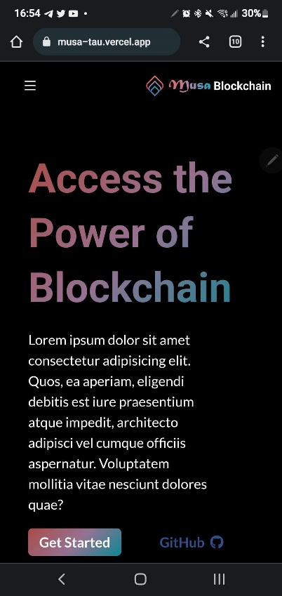

* All testnet and mainnet links are added in the website
  + done
* Pdf of white paper added
  + I have been working on the WP you created. I will give you it to upload or I can once you host it.
* Community and validators pages are added
  + Looks good
* Everything is mobile friendly
  + Mobile friendly yes, looks 100% on mobile…no.
* Need Twitter medium and social media links, so we add them with the icons
  + <https://t.me/Pomeranian_portal>
  + <https://twitter.com/MusaChain>
  + No medium yet