|  |  |  |
| --- | --- | --- |
| Heuristics | Alessandra Pasini | Stefano Bagarin |
| Interaction Consistency | 4 | 4 |
| Group Navigation | 2 | 3 |
| Structural Navigation | 4 | 5 |
| Semantic Navigation | 2 | 2 |
| Landmarks | 3 (da 0 a 4) 🡪 4 (da 0 a 5) | 4 |

|  |  |  |
| --- | --- | --- |
| Heuristics | Alessandra Pasini | Stefano Bagarin |
| Information Overload | 3 | 4 |
| Quality of Contents | 4 | 4 |

|  |  |  |
| --- | --- | --- |
| Heuristics | Alessandra Pasini | Stefano Bagarin |
| Text Layout | 3 | 3 |
| Interaction Placeholder | 5 | 3 |
| Spatial Allocation | 4 | 4 |
| Consistency of Page Structure | 2 | 4 |

|  |  |  |
| --- | --- | --- |
| Heuristics | Score | Comment |
| Interaction Consistency |  | The site has a rigid interaction structure and respects it almost always. There are elements present in every screen such as the header, the bottom bar, the shortcut. **Sometimes different links for lists of items.** |
| Group Navigation |  | The navigation from a list of items to its members is easy and intuitive (most of the times) but the navigation between group members as well as the navigation from a group member to the list is not always easily accessible. |
| Structural Navigation |  | The structural navigation is nice because each element of a topic has a title, an image (most of the times) and a short description. |
| Semantic Navigation |  | There are almost never links to related contents. |
| Landmarks |  | Landmarks cover all the major contents of the site but they could be more readable. They are static but could highlight the group in which we are navigating |

|  |  |  |
| --- | --- | --- |
| Heuristics | Score | Comment |
| Information Overload |  | In the majority of the pages the information is well organized and distributed. |
| Quality of Contents |  | Each event, accomodation and general information is well explained and are also provided external links when needed,  images are not always present though. |

|  |  |  |
| --- | --- | --- |
| Heuristics | Score | Comment |
| Text Layout |  | Text layout is pretty standard, it is easily readable and understandable but could be better.  Ale: sometimes text is justified sometimes not. In events cards titles are too big, in some accommodations titles aren’t bold |
| Interaction Placeholder |  | Although labels for interactive elements of a topic are nice and well organized, those for elements of lists does not reflect at all the importance they have. |
| Spatial Allocation |  | The spatial allocation is fine, but a bit more effort could have helped. |
| Consistency of Page Structure |  | Page structure is kept consistent among pages of the same topic but between different groups similar pages changes structure too often. |

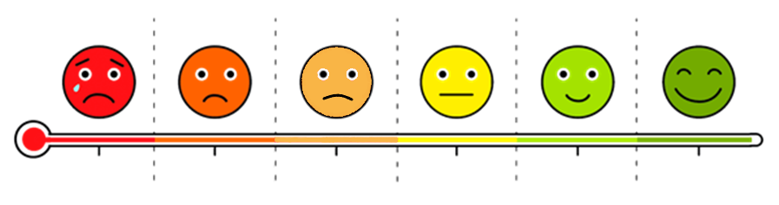

1

Severe issues

detected

2

Quite severe issues

detected

3

Small issues detected

4

No issues detected, with imperfections

5

Extremely satisfied

0

Severe issues

and severe violations