|  |  |  |
| --- | --- | --- |
| Heuristics | Alessandra Pasini | Stefano Bagarin |
| Interaction Consistency | 4 | 4 |
| Group Navigation | 2 | 3 |
| Structural Navigation | 4 | 5 |
| Semantic Navigation | 2 | 2 |
| Landmarks | 4 | 4 |

|  |  |  |
| --- | --- | --- |
| Heuristics | Alessandra Pasini | Stefano Bagarin |
| Information Overload | 3 | 4 |
| Quality of Contents | 4 | 4 |

|  |  |  |
| --- | --- | --- |
| Heuristics | Alessandra Pasini | Stefano Bagarin |
| Text Layout | 3 | 3 |
| Interaction Placeholder | 5 | 3 |
| Spatial Allocation | 4 | 4 |
| Consistency of Page Structure | 2 | 4 |

|  |  |  |
| --- | --- | --- |
| Heuristics | Score | Comment |
| Interaction Consistency | 4 | The site has a rigid interaction structure and respects it almost always. There are elements present in every screen such as the header, the topbar, the leftbar and the footer. There could be more consistency in links shape. |
| Group Navigation | 2.5 | The navigation from a list of items to its members is easy and intuitive most of the times, but the navigation between group members as well as the navigation from a group member to the list is not always easily accessible. It is really complex to navigate to previous pages. |
| Structural Navigation | 4.5 | The structural navigation is nice because each element of a topic has a title, an image (most of the times) and a short description. |
| Semantic Navigation | 2 | There are almost never links to related contents. |
| Landmarks | 4 | Landmarks cover all major contents of the website, but they could be more readable. |

|  |  |  |
| --- | --- | --- |
| Heuristics | Score | Comment |
| Information Overload | 3.5 | Information are well organized and distributed in most of the pages, but there are some of them with a real lack of text. |
| Quality of Contents | 4 | Events, accommodations and general information are well explained and organized; images are not always present though. |

|  |  |  |
| --- | --- | --- |
| Heuristics | Score | Comment |
| Text Layout | 3 | Text layout is standard, it is easily readable and understandable but could be better. |
| Interaction Placeholder | 4 | Although labels for interactive elements of a topic are nice and well organized, those for elements of lists does not reflect at all the importance they have. |
| Spatial Allocation | 4 | The spatial allocation is fine, but a bit more effort could have helped. |
| Consistency of Page Structure | 3 | Page structure is kept consistent among pages of the same topic but between different groups similar pages changes structure too often. |

Although these elements help the navigation a user can get confused because there isn't concistency between pages' contents and dropdown menù and because it is not possible to easly move between topics of a same group.

Text layout 🡪 Some subtitles and important information aren’t well highlighted, some titles are too big and use too much space and into card text is cut in the middle of words



0 1 2 3  **3.5** 45

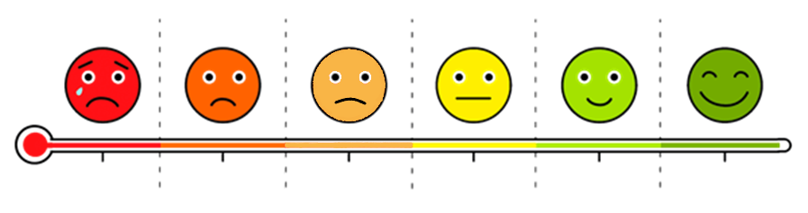

1

Severe issues

detected

2

Quite severe issues

detected

3

Small issues detected

4

No issues detected, with imperfections

5

Extremely satisfied

0

Severe issues

and severe violations