**Human Computer Interaction – Assignment 2**

**Mohit Deol**

**P1) Procedure of Need Finding (25%)**

**1. Who are the end users (audience) of the app you designed prototype for?**

The end users of the app can generally be divided into 3 categories. People from all walks of life looking for one place stop for all the latest news about and ways to protect yourself and your loved ones from Covid-19. In addition, the app is meant for two other groups of people, people due to personal or medical issues , such as the elderly, need help dealing with the situation that the pandemic and people who wish to help others with the difficulties they experience while living during a pandemic.

**2. What should you consider for each group of audience for your app?**

For the first group of people the key is providing the relevant information tailored tot hem such as how to go about accessing testing in their location, simply put the information that the app provides to them must be useful to them. For both the group that needs help and the group that wants to hep it’s important to properly match up people who can ideally help each other which can potentially be a big issue in terms as that might involve categorising all the different types of support people need and the volunteers ability to give it.

**3. Find similar successful apps to your application, and investigate what users liked or**

**disliked about the application. Mention top five apps almost similar to yours.**

1. Canada COVID-19

Likes

* Well organised
* Provides many resources that would be useful in terms of keeping ones self safe and dealing with all sorts of side effects of the pandemic ranging from dealing with being stuck in bad home situation or how one should access testing and vaccines
* Provides a self assessment and symptom tracker to better help users assess their risks
* Search function for different categories such as resources or updates on their respective pages
* The wall of kindness feature where you can see posts
* Simply put it’s the most comprehensive of all of these apps

Dislikes

* The wall of kindness is kept separate in a window with setting completely out of the way of the rest of the app

1. WHO COVID-19 Updates/WHO Info

Likes

* All information comes from a very respectable and trusted source

Dislikes

* The Covid-19 app is unavailable outside of Nigeria using their links which cuts out a large chunk of the potential userbase and my ability to properly assess it
* The WHO Info app mainly provides resources and Info regarding Covid -19 that isn’t useful for the average person
* Available Information is dominated by WHO Directors opening Remarks at events
* Al articles are presented chronologically without regards to relevance to user without even a search function
* (While the covid-19 specific app fixes all these issues with the generic who app it is simply unavailable)

1. GoodSAM Responder (Due to its connection to NHS Volunteer Responders for Covid-19)

Likes

* Provides a way for Covid Volunteers to get in touch and aid people who need it

Dislikes

* This is repurposing of an app that is mainly for first aiders and as such there are many issues in its use for Covid Volunteers.
* Registering is a trap option for Covid volunteers who should just sign in and not attempt to register
* No message notifications in comms section
* Accepting an alert is difficult due to many options unrelated to covid volunteering and instead relevant to first aid responders
* Need to go through multiple menus to set yourself to be ‘on duty’ to receive any alerts

1. Covid Alert

Likes

* It provides a way for people to keep themselves safe by communication with blue tooth with other devices and keeping every device that the user has come into contact with in memory and asks user to report when they’ve become infected so that everyone that they’ve been in contact with can be informed so that they can get tested.
* Has an out of app notification if Bluetooths is inactive so that the user will be reminded to run it on which is incredibly important for such and important app.
* Symptom Tracking is useful to assess the risk of infection

Dislikes

* It doesn’t tell you the time and date of when you came into contact with an infected individual, presumably for privacy reasons, which can lead to a vagueness in one’s own condition of being asymptomatic or in an incubation phase potentially.

1. COVID Coac

Likes

* Well organized and simple to use
* Has a search function
* It focuses on helping people deal with an aspect of living in the pandemic, the psychological tolls of isolation, which many of these other apps do not address at all
* Provide way to track your progress and properly set goals for your mental health
* Provides access to resources ranging from local benefits that can be extremely useful in living during the pandemic terms of meeting physical needs that have been affected or gaining more knowledge regarding staying safe from Coved or guides on how to explain school closures to your children
* Ability to assign favourites to add to the main screen to make accessing often used animations and features faster without having to find it again
* Strong personalization features such as pinning resources to the main screen

Dislikes

* Many resources are US specific as this is a US based application
* Search functions only scans through titles leaving it underwhelming
* A lot of what it provides in terms of tips and exercises often feel like empty platitudes and are no replacement from proper human connection

**1. What examples of latent needs can you think of?**

Something that happens quite a lot is people with medical issue that impar their senses or cause chronic pain or other issues such as stress of breath often don’t even realise that the way they feel and what there are experiencing isn’t normal and their need for medicine or surgery goes completely unnoticed as a latent need. which. A more software-oriented example would the collaboration that services such as google docs easily allow that people were not clamoring for originally but now consider indispensable. Furthermore, while many people during the pandemic are understand their need for a vaccine but might not be understanding the emotional toll self isolation has been doing to their mental health and their need to communicate with others to deal with that.

**2. What are good ways of finding latent needs?**

A good way to find latent needs would most likely involve observing a group people performing tasks and seeing what they have difficulties with but deal with without realising it, essentially finding a problem that they aren’t even aware is a problem. Of course, this is harder than it sounds and requires as many was of analyzing what you see with as many people as possible and the ability to interview the people to better understand their perspectives.

**1. List three combinations of user group + activities. Keep the scope appropriate.**

A) People who want the latest information Regarding Covid + Keeping themselves safe

B) People who want to volunteer + volunteering where they can make a difference

C) People Struggling during Covid + Living day to day life

**2. Gather data, through desk and field research, about the chosen activity.**

A)

**Hypothesis**: People who want more information often due so to wanting to keep themselves and their family safe

**Results**: It’s true

B)

**Hypothesis**: Volunteers are often able to help in completely different ways

**Results**: Volunteers have vastly varying skillsets

C)

**Hypothesis**: One of the Major issues during the pandemic is lack of human connection

**Results**: There has been a huge uptick in depression and substance abuse due to social isolations

**3. Identify needs/product opportunities**

A) In that case providing a Covid alerting system based on who a person has been in contact with might fulfill a need of protecting oneself and loved ones better then staying up to date with say statistics such as Covid Infection rates

B) People who want to volunteer need to eb categorized and shown the people they are the best suited to helping in whatever ways they can be to properly fullfill their need of helping others.

C) People who are struggling during the pandemic generally are having issues with their mental health and one of the major ways in which people can help them is helping to bolster their social support networks so being able to put many of them who don’t have anyone to talk to with another person

**Sources**

Interviewing Individuals that belong to the specific group regarding the respective activity

<https://www.kff.org/coronavirus-covid-19/issue-brief/the-implications-of-covid-19-for-mental-health-and-substance-use/>

<https://www.ncbi.nlm.nih.gov/pmc/articles/PMC2921311/>

<https://www.nature.com/articles/s41598-020-79000-y>

**P2) Procedure of Competitive Analysis (25%)**

**Top 5 competitors**

1) Canada COVID-19

2) WHO Info

3) GoodSAM Responder

4) Covid Alert

5) COVID Coac

**Competitor Analysis Matric**

|  |  |  |  |  |  |  |  |
| --- | --- | --- | --- | --- | --- | --- | --- |
| **Features** | **Scores** | **Canada Covid-19** | **WHO Info** | **GoodSAM**  **Responder** | **Covid Alert** | **Covid Coach** | **My App** |
| **Covid Statsitics** | **5** |  |  |  |  |  |  |
| **Local Statistics** | **2** |  |  |  |  |  |  |
| **Covid Resources** | **10** |  |  |  |  |  |  |
| **Local resources** | **10** |  |  |  |  |  |  |
| **Search Feature** | **5** |  |  |  |  |  |  |
| **Search by Category** | **2** |  |  |  |  |  |  |
| **Symptom/health Tracking** | **10** |  |  |  |  |  |  |
| **Mental Health support** | **10** |  |  |  |  |  |  |
| **Covid Contact Tracking** | **25** |  |  |  |  |  |  |
| **User Profiles/ Login/signup** | **2** |  |  |  |  |  |  |
| **Volunteering Option** | **10** |  |  |  |  |  |  |
| **Help Alert** | **5** |  |  |  |  |  |  |
| **Categorization of Volunteering** | **5** |  |  |  |  |  |  |
| **Total Scores** | **111** | **49** | **15** | **17** | **25** | **49** | **54** |

**UX/HCI Issues**

1. Canada COVID-19
   * Having a menu in the corner away from all the other option which only contains two features which is posts from users and settings which is hard to see and notice
2. WHO COVID-19 Updates
   * No search feature
   * Information on covid is not sorted or categorised in anyway
3. GoodSAM Responder
   * This is repurposing of an app that is mainly for first aiders and as such there are many issues in its use for Covid Volunteers.
   * Registering is a trap option for Covid volunteers who should just sign in and not attempt to register
   * No message notifications in comms section
   * Accepting an alert is difficult due to many options unrelated to covid volunteering and instead relevant to first aid responders
   * Need to go through multiple menus to set yourself to be ‘on duty’ to receive any alerts
4. Covid Alert
   * No major flaws (Very Simple and does it’s job
5. COVID Coac
   * No Major Flaws
6. My Application
   * No way to create user profile which is necessary for messaging
   * Not able to search by category of content
   * Home screen is cluttered with options in clashing styles
   * Searching as an option is on a separate screen from the content you would want search
   * Looks incredibly unappealing

**‘**

**P3) Your second prototype using Figma (25%)**

**Figma URL:** [**https://www.figma.com/file/tUCjQSSIjng9WOuCozbe2K/Covid-App-2?node-id=0%3A1**](https://www.figma.com/file/tUCjQSSIjng9WOuCozbe2K/Covid-App-2?node-id=0%3A1)

**Youtube URL:** [**https://www.youtube.com/watch?v=0c4dRLuE0WY&ab_channel=MohitDeol**](https://www.youtube.com/watch?v=0c4dRLuE0WY&ab_channel=MohitDeol)

**Screenshots:**

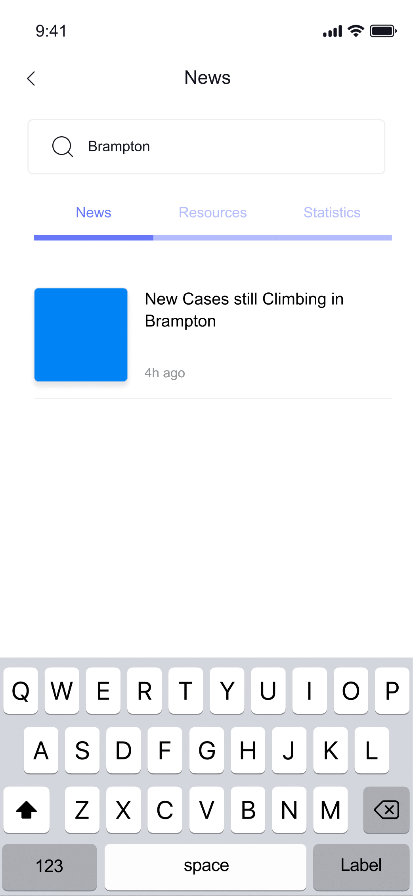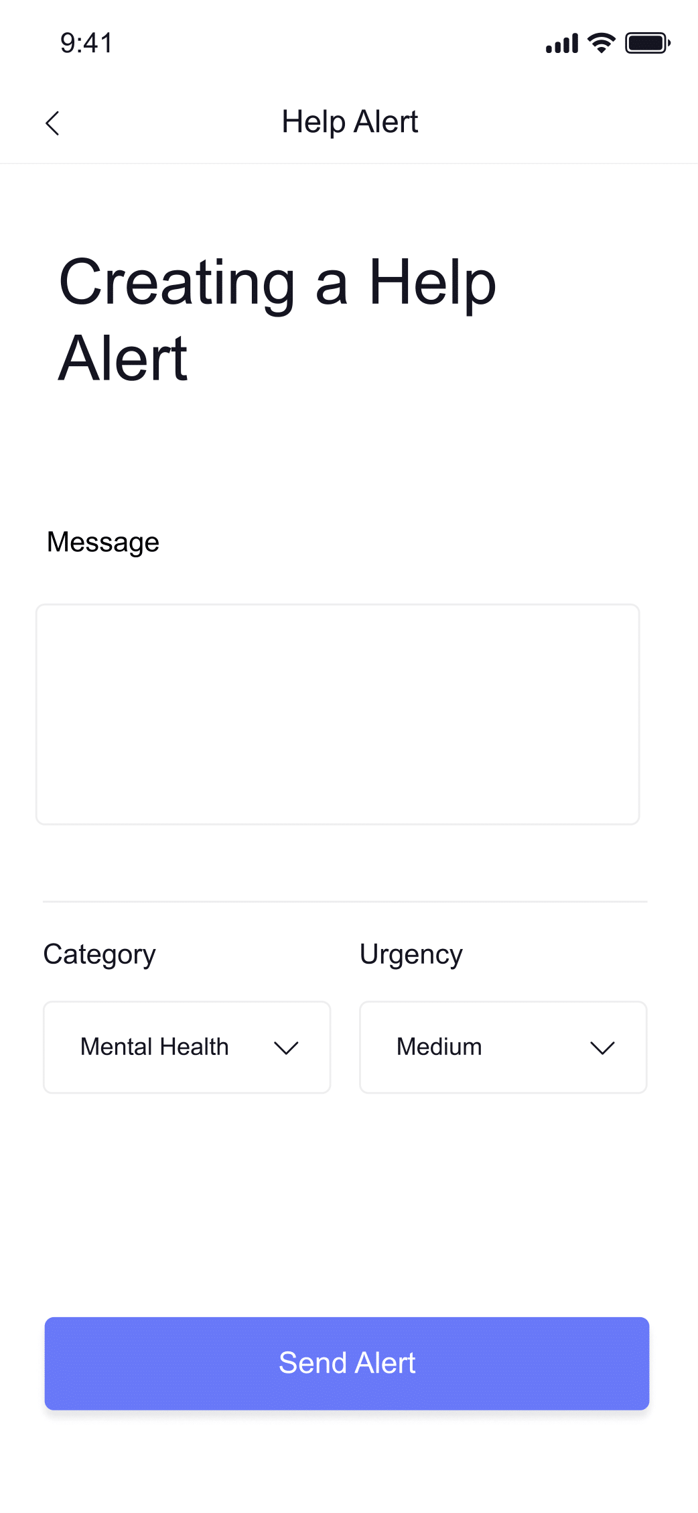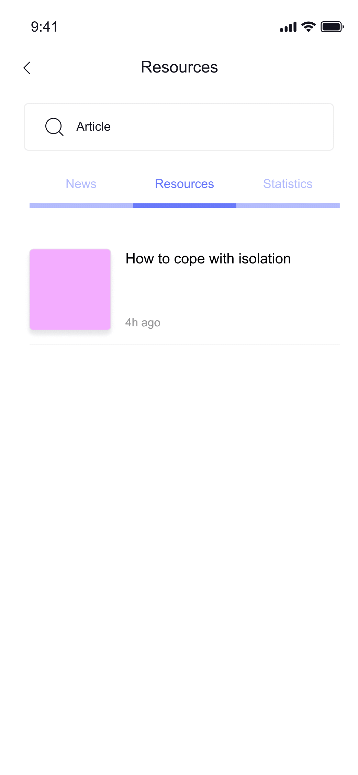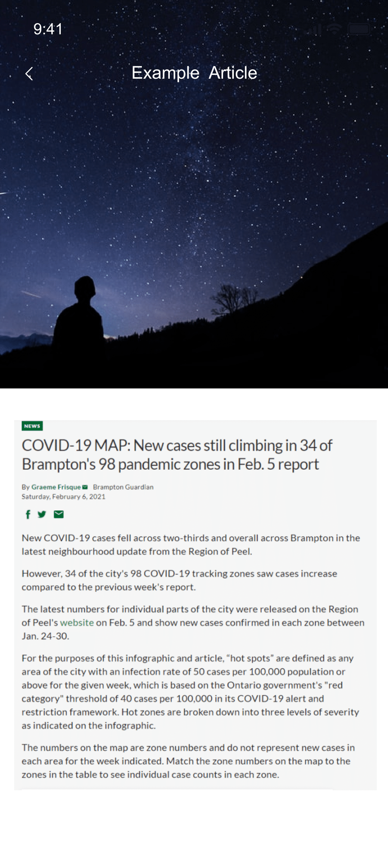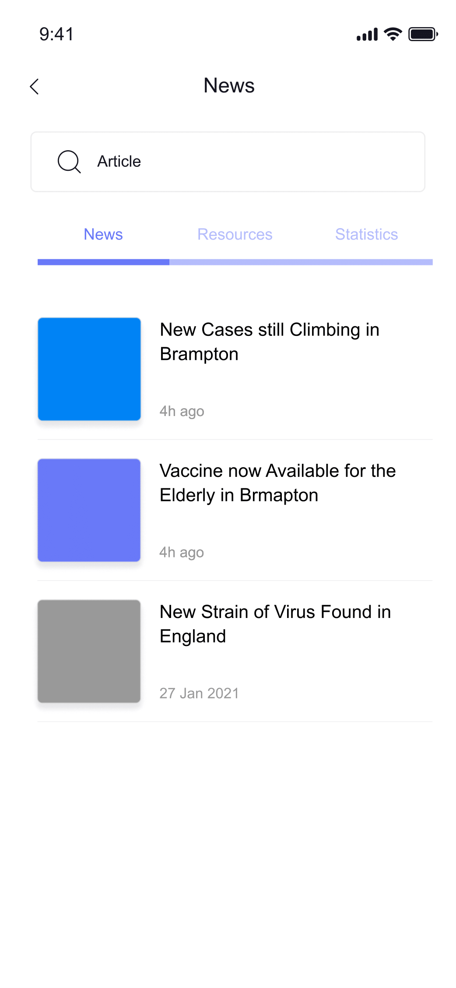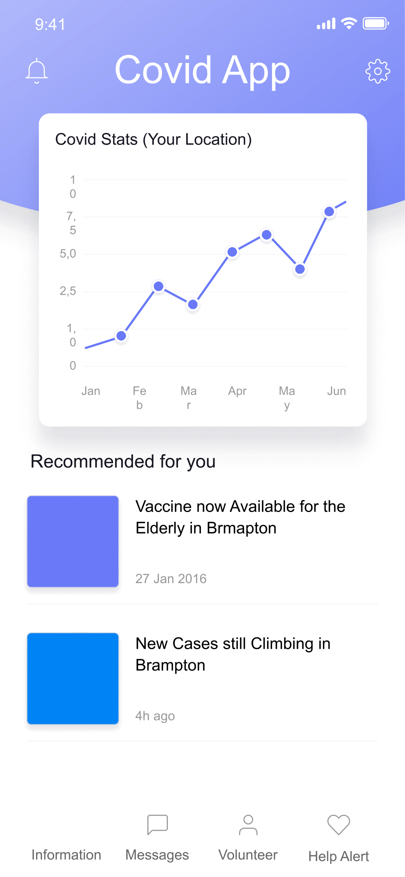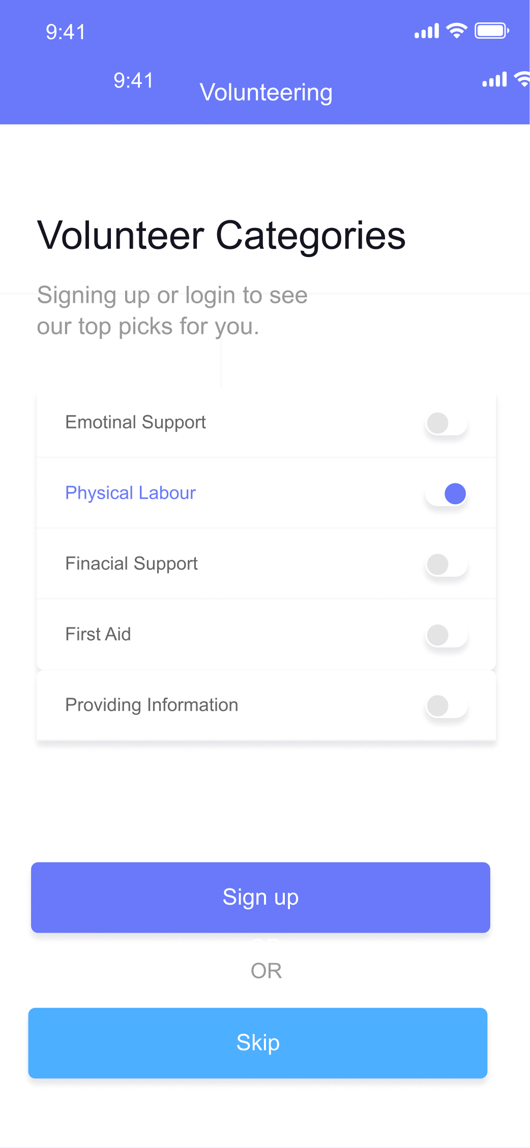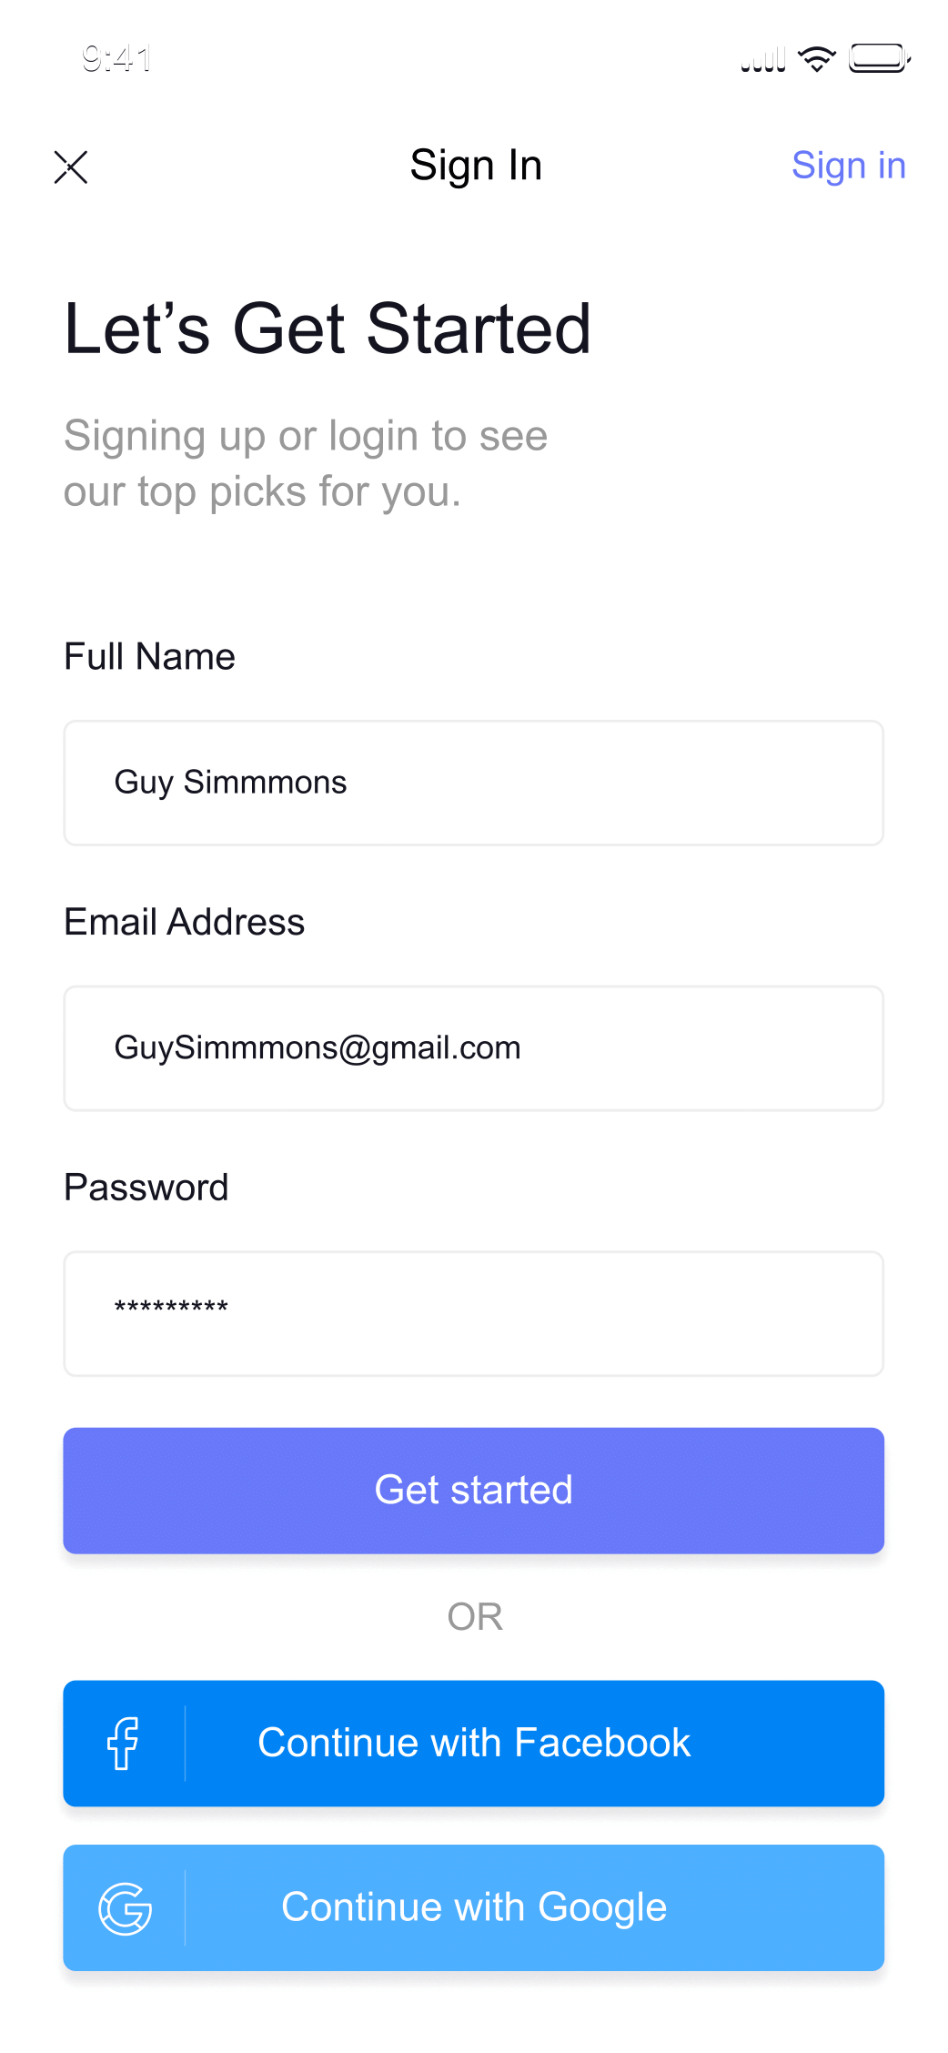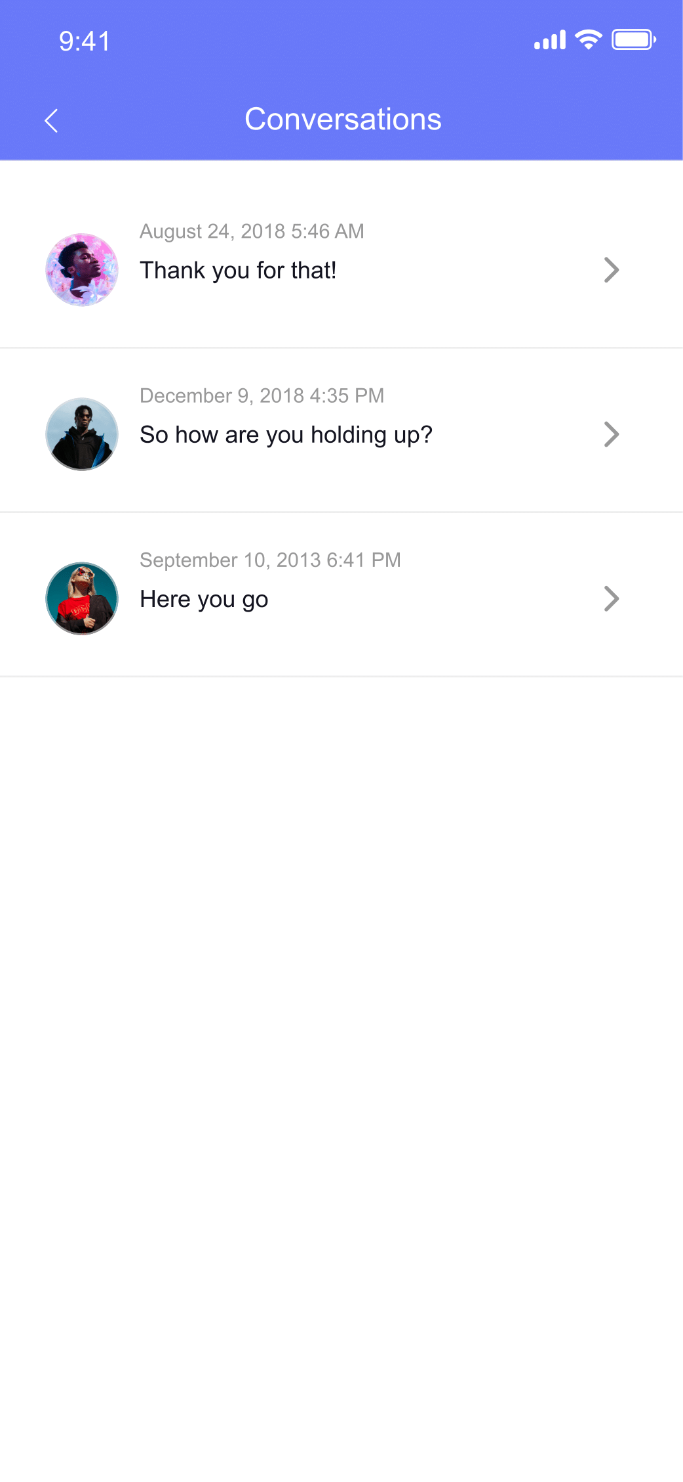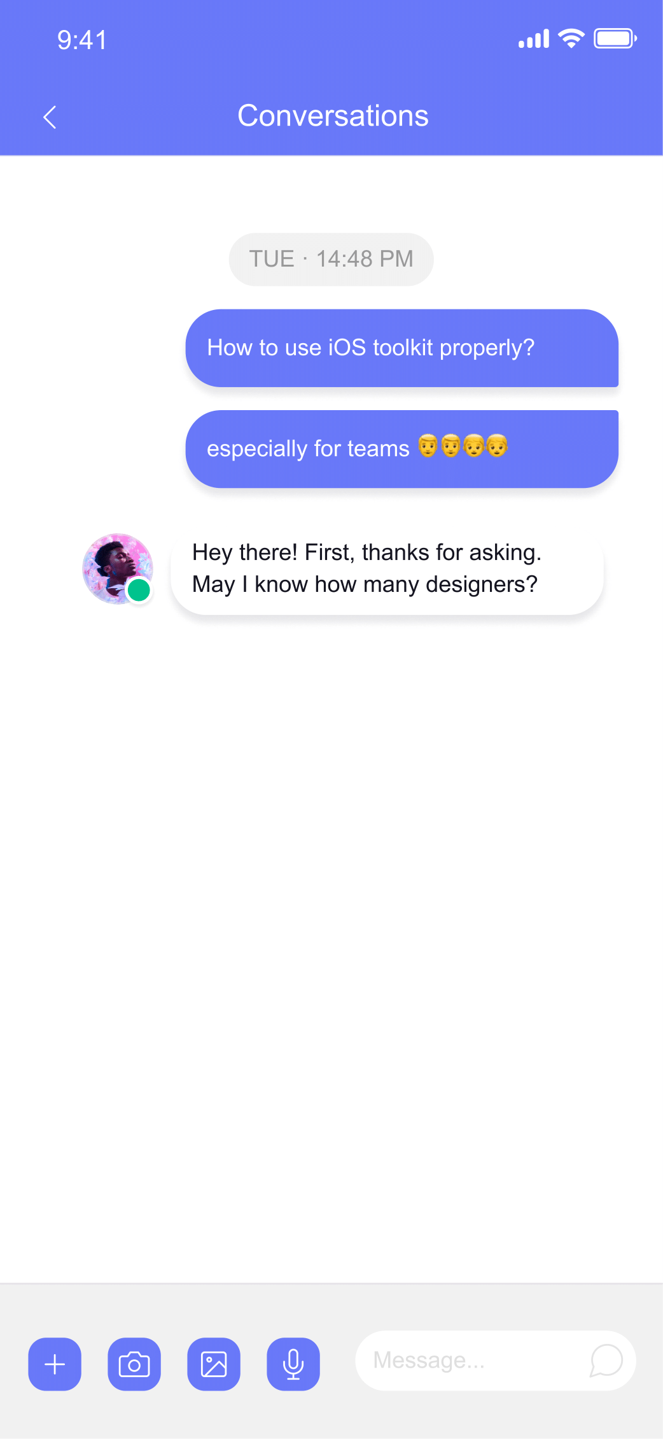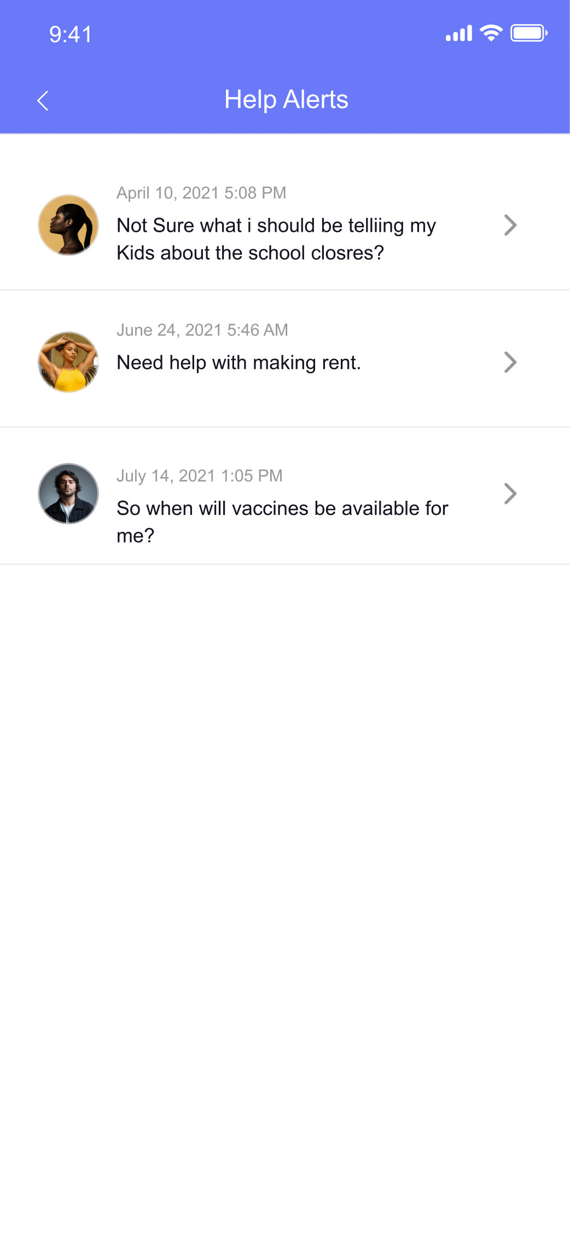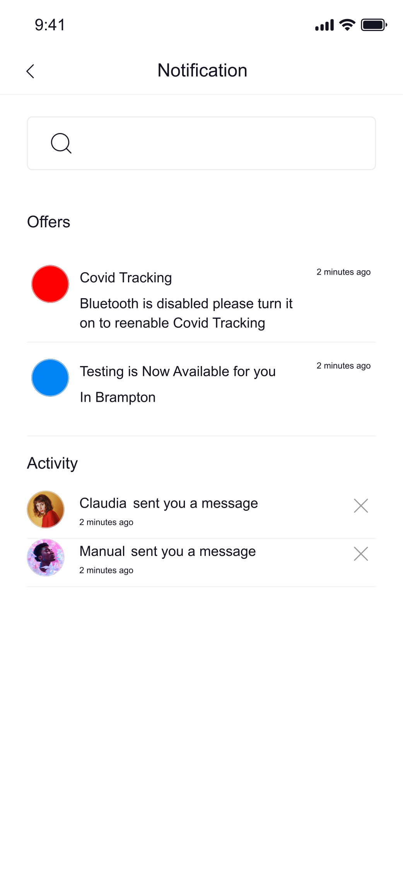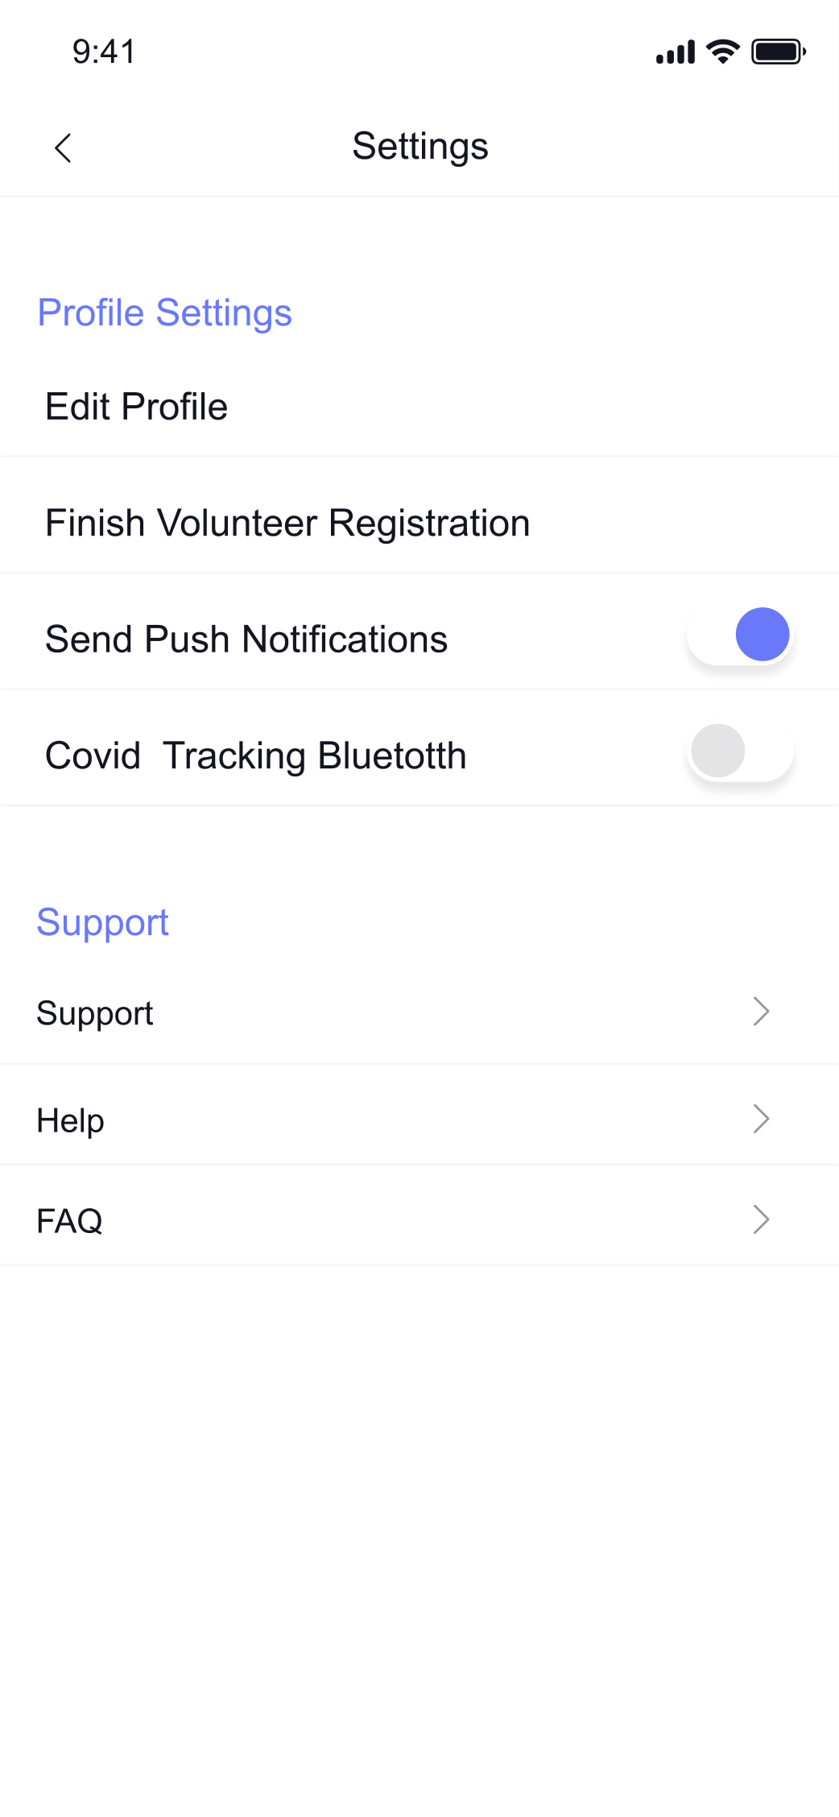

**P4) GitHub and new features (25%)**

**URL:**

**Top 5 Features to Add**

1) Covid Contact Tracking

2) Locaion based Information

3) Health/Symptom Tracking

4) Additional Categories for volunteer skills/help alerts

5) Share feature to share info with family and friends