Dual Extruder Setup V1.2 (Javelin Prototype)

- Make sure machine is off with the extruder at least 100mm

- Attach dual to x-carriage

- Plug the included harness into the second extruder port on rambo and use zip ties to hold in in place along the same path as the standard extruder harness. Zip tie harness into left harness holder.

- Replace the M5 screw at the back rear of the electronics box with the included buttonhead screw (this is needed because the new dual extruder is more compact than the budaschnozzle based ones).
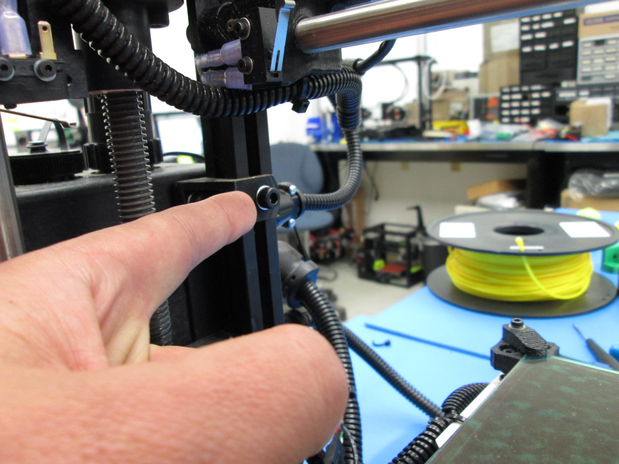

- Attach 2nd spool arm above the first.

- Follow this Ohai-Kit for the calibration procedure. Note that the thumbscrew has been replaced with a steel socket cap bolt; use the included wrench to level the 2 nozzles to the bed.

- https://ohai-kit.alephobjects.com/project/dual_extruder_calibration/#step_1

- Start your dual printing!

