Congratulations!
You just upgraded your LulzBot desktop 3D printer with a second generation Dual Extruder Tool Head. After following this setup guide, your LulzBot will be more capable than ever. Let's get started!

Completely power off your LulzBot 3D printer and unplug the power supply before proceeding.

Included Materials
Included materials in the Dual Extruder v2.0 package you just opened:

- Dual Extruder v2.0 Tool Head
- Secondary filament guide tube
- Secondary power harness
- Secondary filament spool arm
- Aluminum bed holster plates
- Screw and drop-in T-nut for secondary filament spool arm
- Jumper cables (only required for TAZ 4)

You will also need:

- Metric hex key set (included in LulzBot TAZ toolkit)
- Scissors (or wire cutters) for cutting zip ties
- LulzBot TAZ 4 or LulzBot TAZ 5 desktop 3D printer

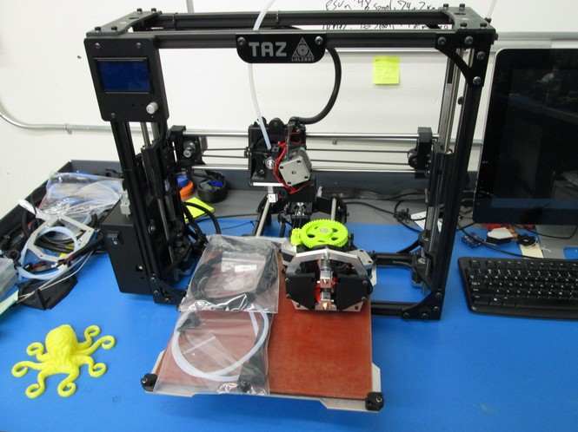

Step 1: Remove M5 Bolt and Replace with Button Cap Screw
Your new Dual Extruder has a different nozzle path length than the standard tool head on your LulzBot TAZ. Therefore you will need to remove the M5 bolt, and replace it with the lower profile Button Cap Screw included with your Dual Extruder (shown in the pictures below).

The T-nut will fall down when you remove the M5 bolt! Mitigate this by holding the T-nut in place before loosening the screw, or bring the T-nut back up into place after it falls by using another allen key.
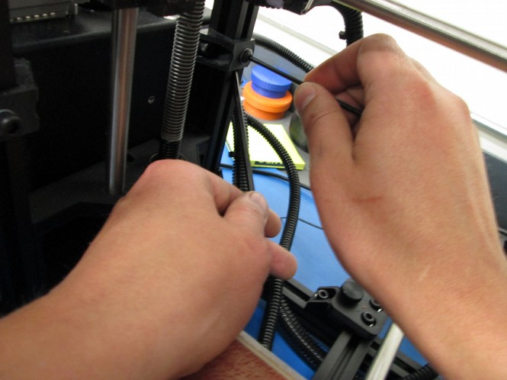
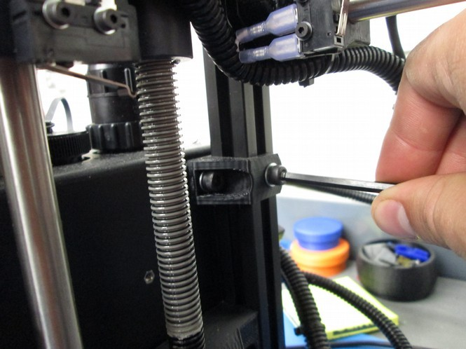

Step 2: Remove Stock Bed Corners and Replace with New Aluminum Bed Holster Plates

Remove the four stock bed corners, and replace them with the new low profile aluminum bed holster plates using the included flat head screws. This additional clearance is necessary for the extrusion fan ducts on your new Dual Extruder Tool Head.
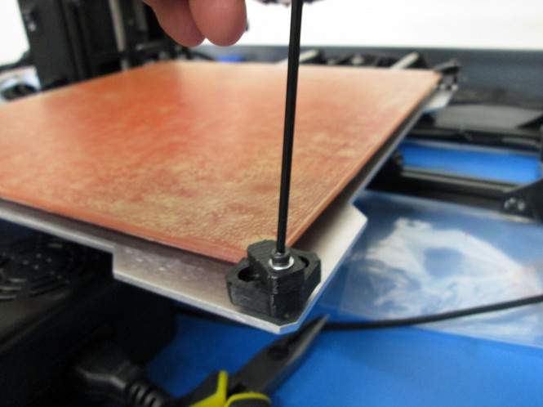
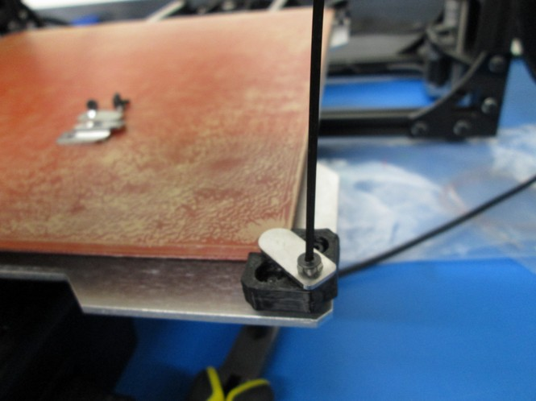

Step 3: Install Secondary Filament Spool Arm
3A Start by loosening the existing spool arm and sliding it down about 2 inches (50mm), then retighten it. Insert in the new T-nut included with your Dual Extruder on the same z-axis vertical frame member (the front right bar).

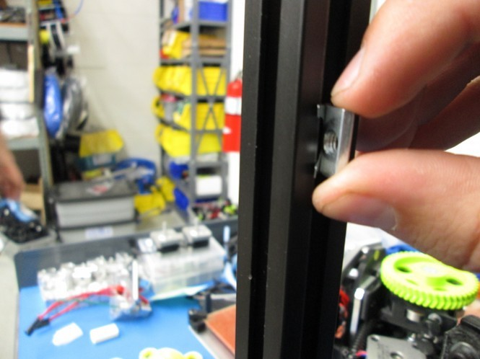
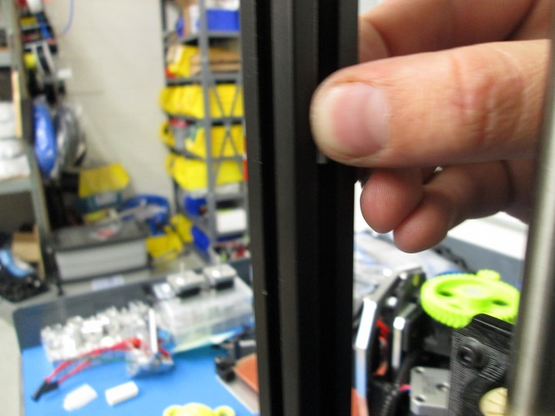
i ii

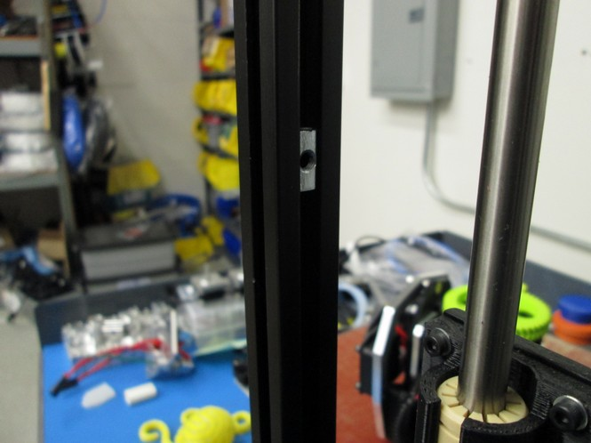
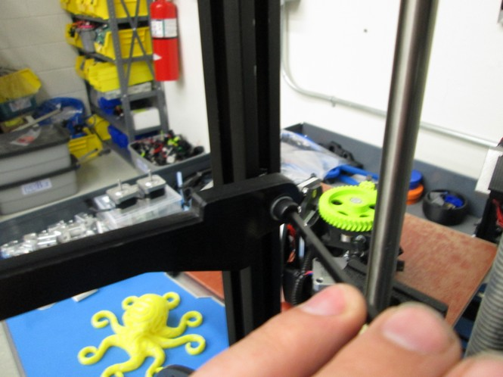
iii iv

3B Place two spools of filament on the spool arms to ensure they are mounted with sufficient space to rotate during printing. Next, snap the secondary feed tube included with your new Dual Extruder to the existing feed tube holder mounted on your LulzBot TAZ 3D printer.
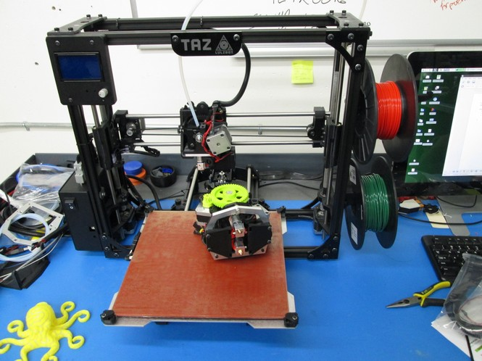
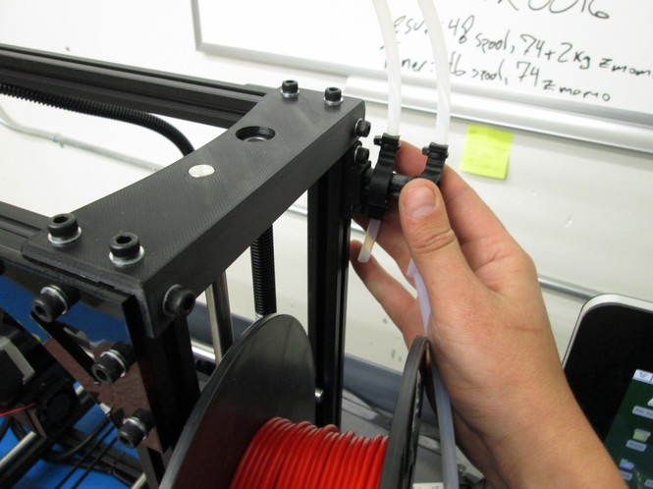

Step 4: Connect and Secure Secondary Power Harness
4A Unscrew the capped port on top of the electronics box on your LulzBot TAZ, then plug the secondary power harness into the uncapped port.

4B Route the new harness next to existing one already on your printer, using zip ties to secure it in the same spots.

4C Use a zip tie to secure the empty harness holder on the top left side of the x-carriage.

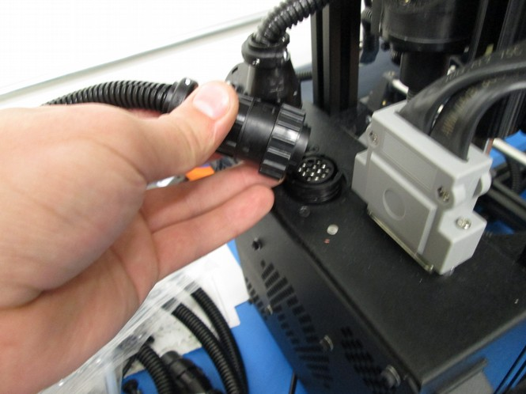
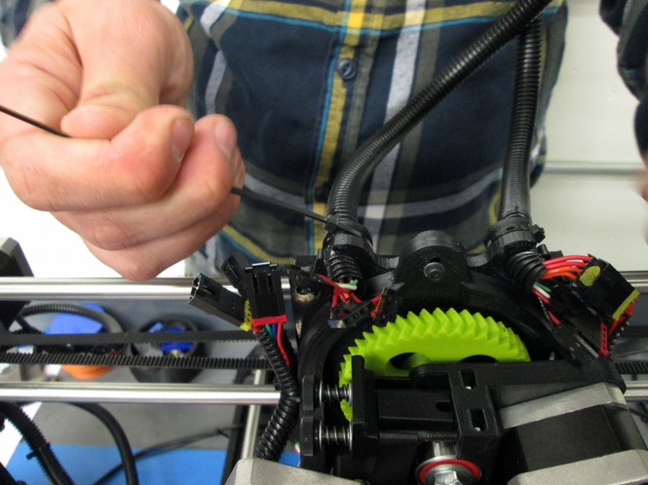

Step 5 Remove Existing Tool Head and Mount Dual Extruder Tool Head
5A Unplug the connections for your current toolhead, unscrew the M3 bolt securing it, and remove it from the printer.

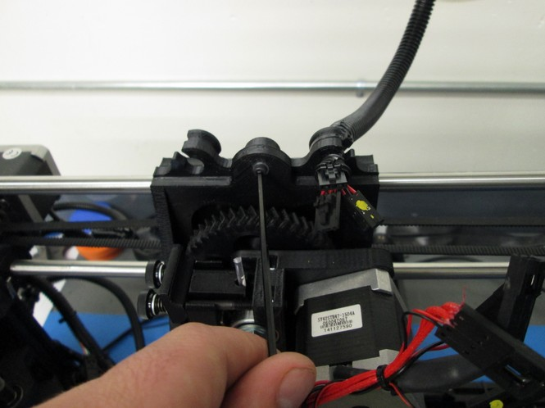

5B Install the dual extruder toolhead and secure it with the M3 screw that you removed taking off the stock extruder.
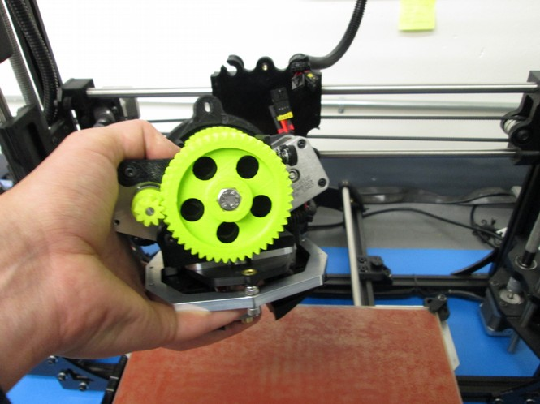
Confirm your LulzBot TAZ is powered off and the power supply is unplugged before proceeding.

5C Connect the five pinned connectors, make sure to match them based on the colors painted on the connectors. Note: You will have a spare fan connector that will not be used.
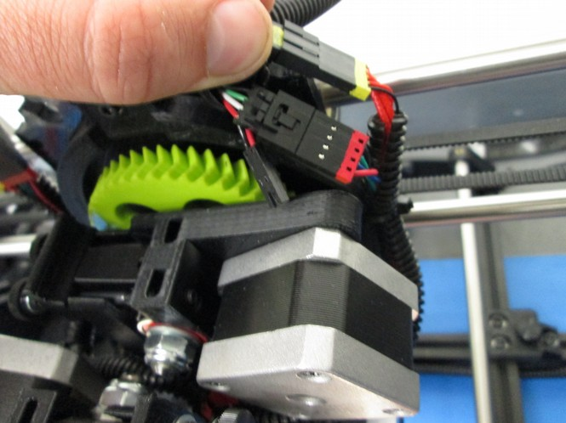
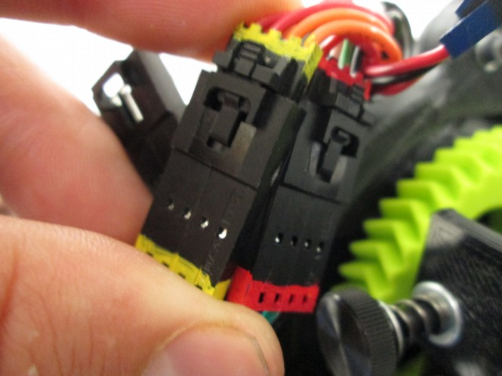
Verify the five pinned connectors are appropriately connected before proceeding.

6 OPTIONAL: Insert Electronics Jumper Box (LulzBotTAZ 4 only)
6A If you have a LulzBot TAZ 4, you will need to add a jumper cable to your control box to power the 5V fans used by the LulzBot Hexagon Hot Ends.

LulzBot TAZ 5 and newer printers all have these pins populated from the factory and can skip this step.

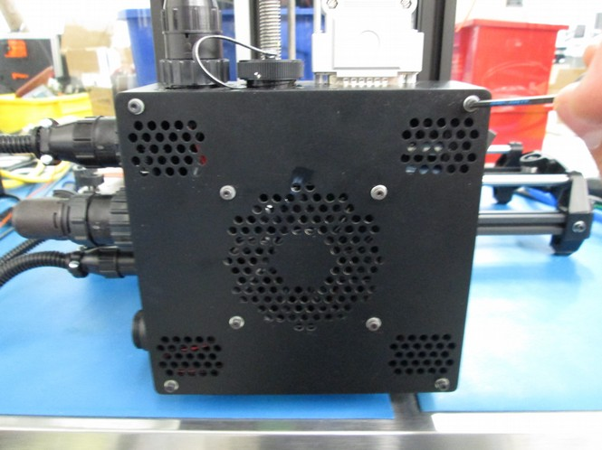
6B Start by removing the 4 M3 screws that hold the electronics box on your LulzBot TAZ 4.

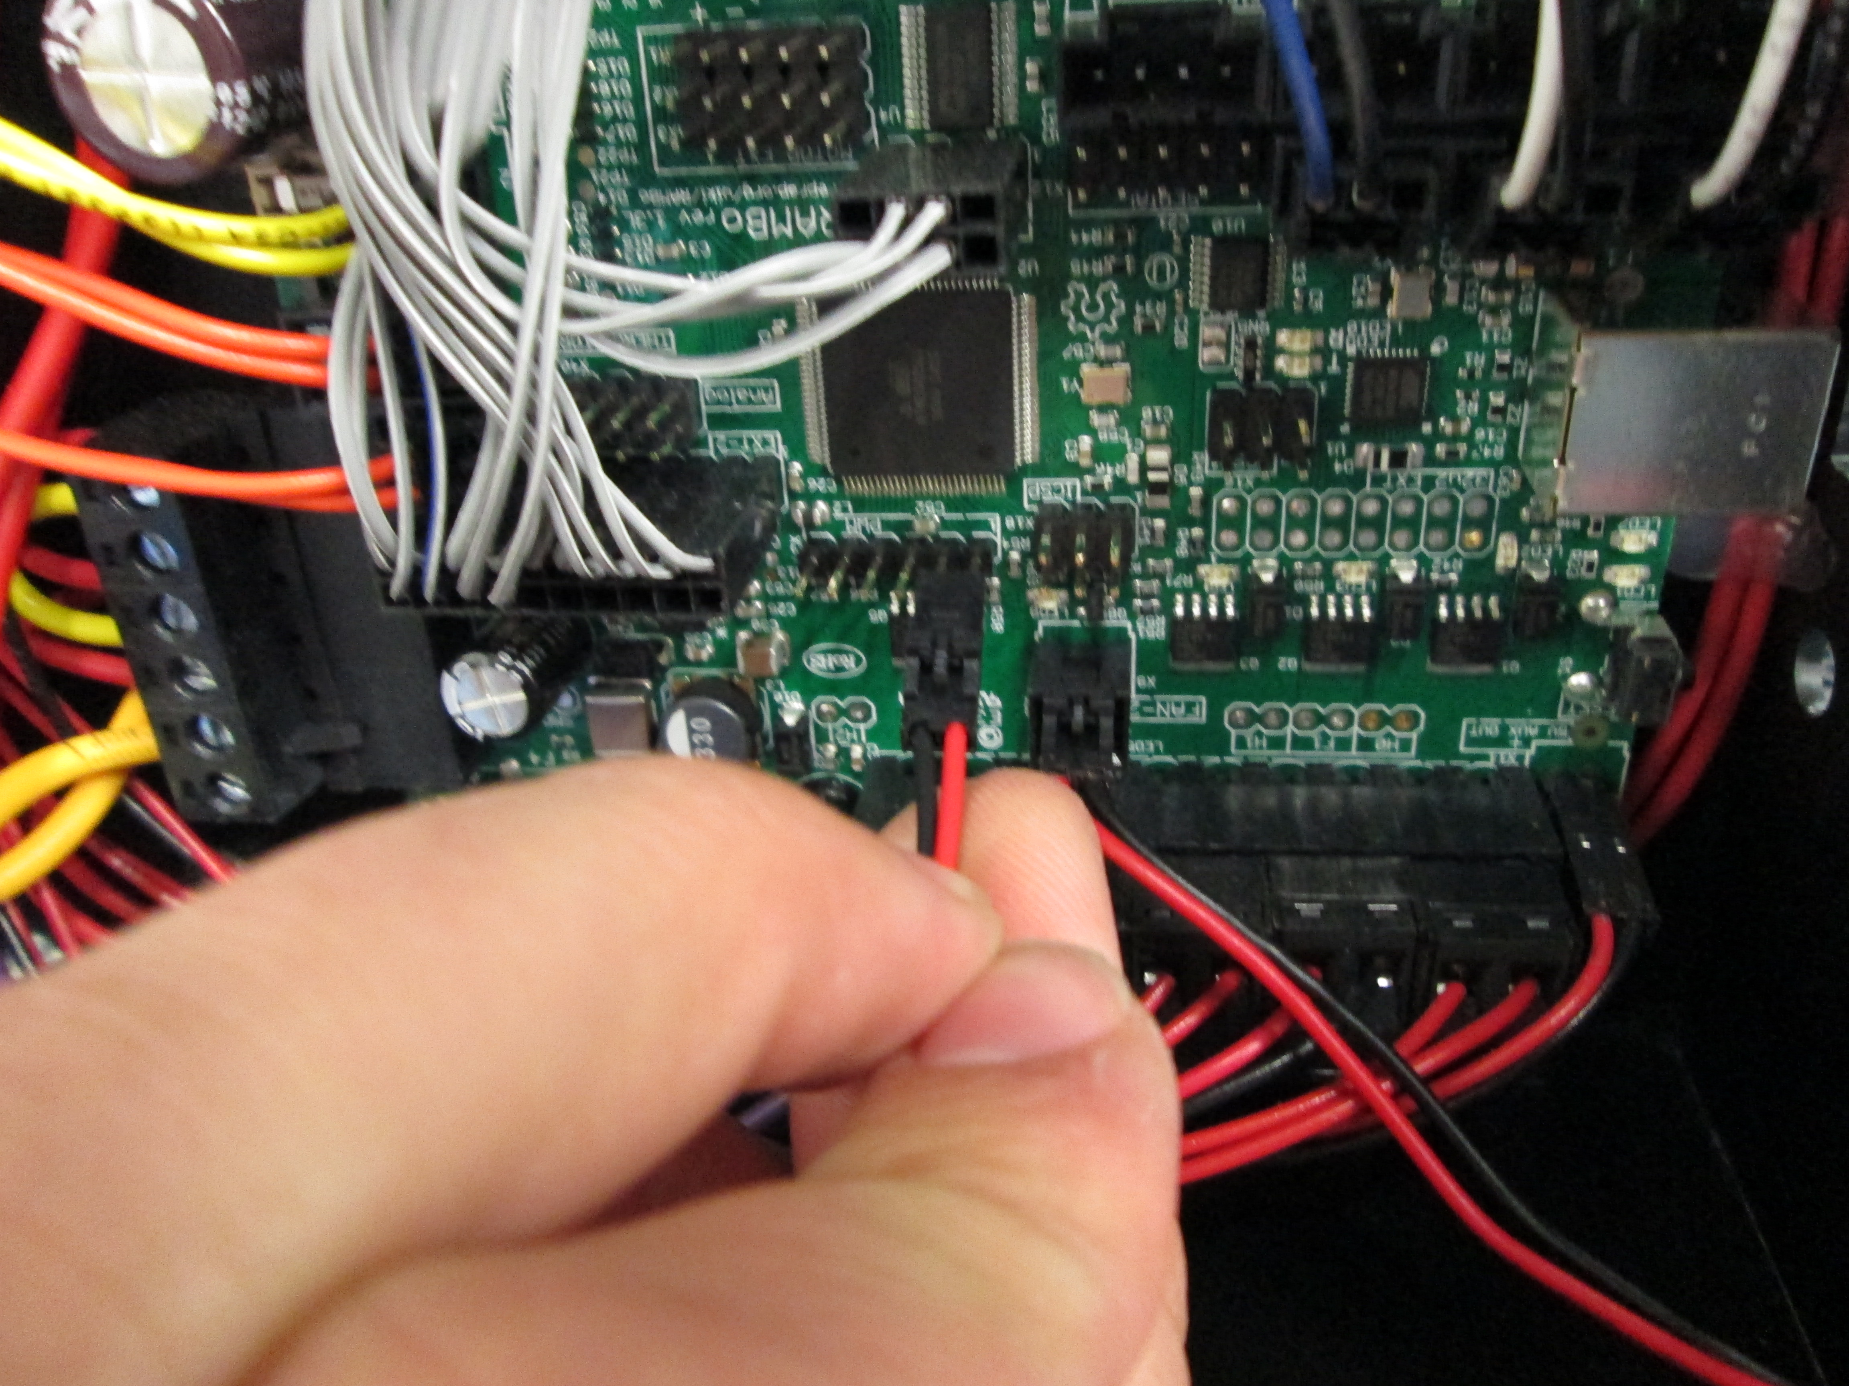

6C Insert the two-pin connector on the pins on the RAMBo as shown, making sure that the latching side of the connector is facing upwards.

6D Connect the pins on the other end of the wires to the capped off extruder connector. The red wire goes into slot 5 and the black wire goes into slot 6 as shown below.

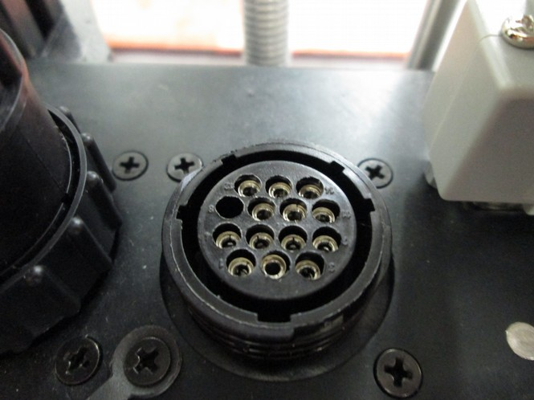
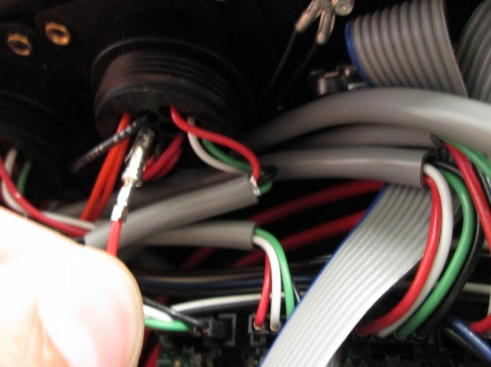

PIN 5 (Red)

PIN 6 (Black)

6E Now replace the control box cover, making sure that none of the wires are interfering with the fan.

Step 7: Configure Cura and Install Dual Extruder v2.0 Firmware
7A Start by making sure that you have LulzBot TAZ 4 or 5 Selected as the Current Machine, then open up machine settings and change the Extruder Count to 2.
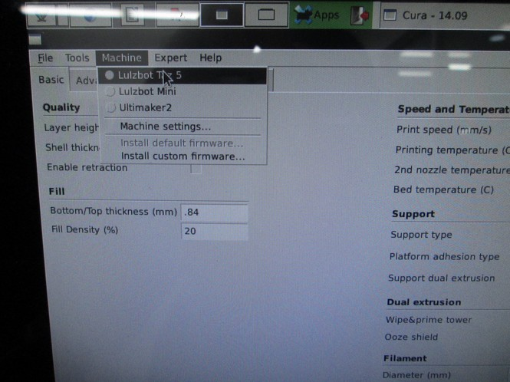
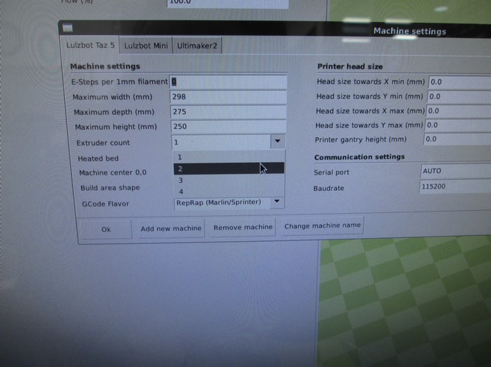

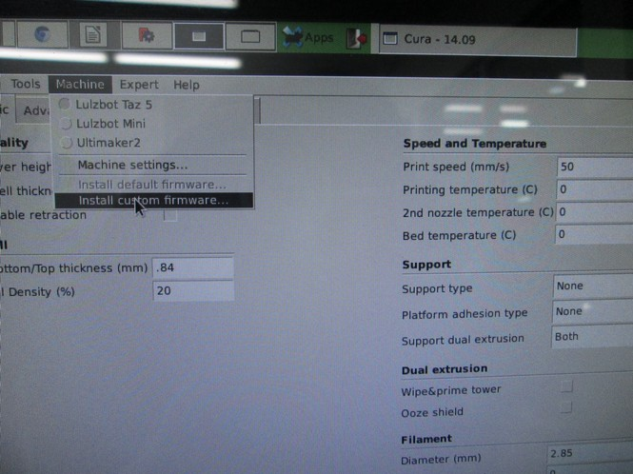
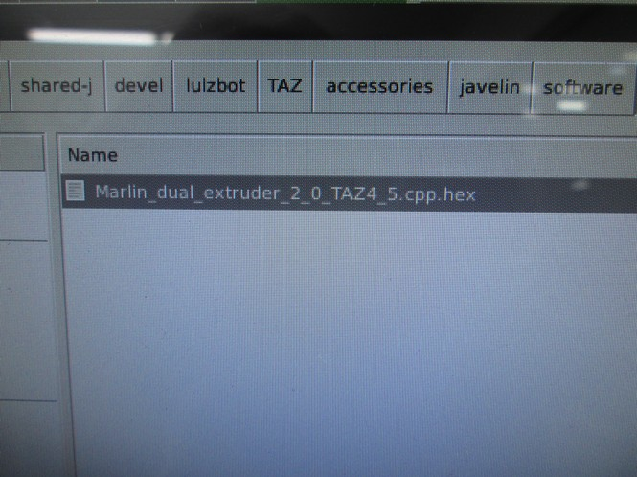
7B Select the option to Install Custom Firmware and choose the Marlin_dual...hex file that can be downloaded here: http://devel.lulzbot.com/TAZ/accessories/javelin/software/marlin_dual_4-5_hex/

7C Confirm firmware flashing was successful. After the firmware is successfully flashed, both the Printer Interface Window in Cura LulzBot Edition and the LCD screen will display a second extruder temperature reading, and the name of the printer will be changed to DualMetalTAZ.

You will also have new temperature presets for common dual extruder filament combinations like PLA/PLA, PLA/PVA, and ABS/HIPS accessible through the LCD screen.

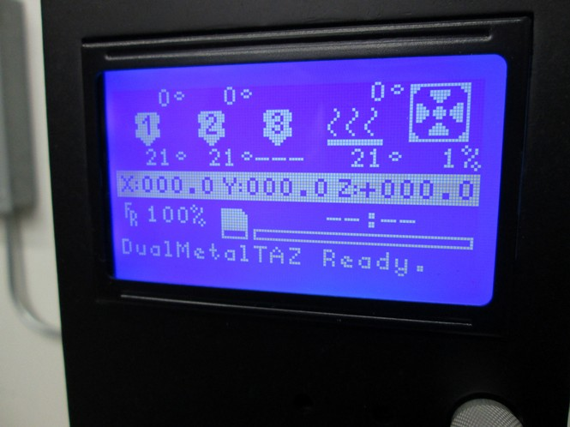

Step 8: Calibrate Your Dual Extruder
8A Adjust the homing height by homing the print head and turning the z-adjustment screw until a folded in half sheet of paper just barely slides under the rear extruder.

8B Turn the leveling screw on the front of the dual extruder until the two nozzles are the same height above the bed.

8C Home the printer again and check the level of each nozzle with the folded in half sheet of paper to make sure that they're at a good height above the bed.

8D Now load filament into each extruder as you normally would and you are ready to print.
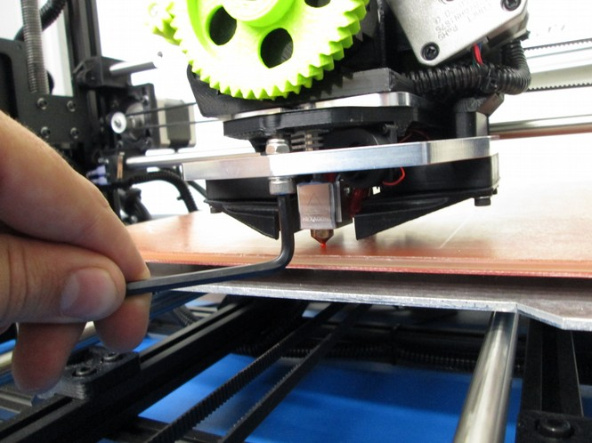

Step 8 Start Printing!
8A You are now set up to start printing with your Dual Extruder Tool Head, but there are several things to keep in mind that differ from standard single extruder 3D printing.

- The back extruder is Extruder 1, and the front extruder is Extruder 2. This is the convention for how they will read temperatures, which extruder is active and which part is printed by which extruder.
- The order that you import STL files into Cura LulzBot Edition matters. For dual color parts, import the part that you want the rear (far) extruder to print first, then the part for the front (near) extruder second. Then right click anywhere in the cura window and select the option “dual extrusion merge”
- For the best quality prints, have the Ooze Shield option turned on. It creates a shell around your part that breaks away easily, and ensures that there will be minimal color blending or ooze spots.

8B Give one of our novelty prints a shot! You can download one by accessing the files located here: file:///home/aleph/shared-j/devel/lulzbot/TAZ/accessories/javelin/novelties/.

8C Download a LulzBot print profile, which you can find located here: http://devel.lulzbot.com/TAZ/accessories/javelin/software/print_profiles/. Select a profile that is designed for the two materials you plan to print with.

8D Using Cura LulzBot Edition, import the part you want printed with the rear (far) extruder first and the front (near) extruder second. Then, merge the parts by right clicking and selecting Dual Extrusion Merge.

8E Preheat the printer by selecting the preheat option that matches what you will be printing with through the LCD interface.

Before starting your print, confirm that the rear (far) extruder is the primary extruder and the front (near) extruder is the secondary extruder.

8F Once the printer is heated up, click print as you normally would. Happy printing!


