Congratulations!
You just upgraded your LulzBot desktop 3D printer with a second generation Dual Extruder Tool Head. After following this setup guide, your LulzBot will be more capable than ever. Let's get started!

Completely power off your LulzBot 3D printer and unplug the power supply before proceeding.

Included Materials
- Dual Extruder v2.0 Tool Head
- Secondary filament guide tube
- Secondary power harness
- Secondary filament spool arm
- Screw (1) and drop-in T-nut (1) for secondary filament spool arm
- Button head screw (1) to replace one control box mounting screw
- Aluminum bed holster plates (4)
- Jumper cables (only required for TAZ 4)
- Zip ties (12)

You will also need:
- Metric hex key set (4mm, 3mm, 2.5mm driver) (included in LulzBot TAZ toolkit)
- Scissors (or wire cutters) for cutting zip ties
- LulzBot TAZ 4 or LulzBot TAZ 5 desktop 3D printer

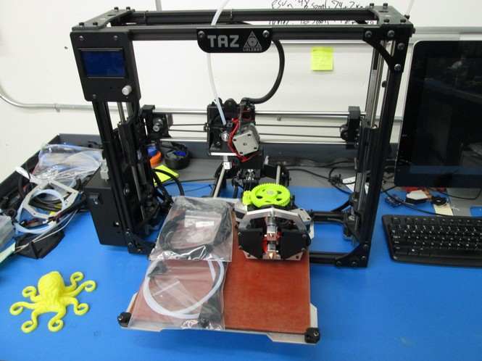

LulzBot TAZ 4 only: Insert Electronics Jumper in Control Box
1 If you have a LulzBot TAZ 4, you will need to add a jumper cable to your control box to power the 5V fans used by the LulzBot Hexagon Hot Ends.
LulzBot TAZ 5 & newer printers all have these pins populated from the factory and can skip this page.

A Remove the 4 M3 screws that hold the control box lid on your LulzBot TAZ 4. Take care with the fan wiring. Remove the second connector cover.
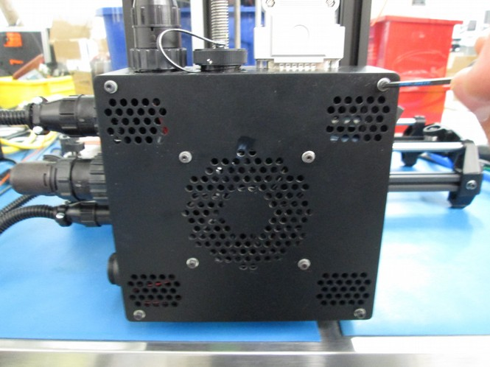

C Use the driver as a guide to insert the pin into the connector housing. Press firmly upwards. You may need to rotate the pin slightly to allow it to slide into place. Repeat the procedure for pin 6, the black wire and connector socket in the previous step image.

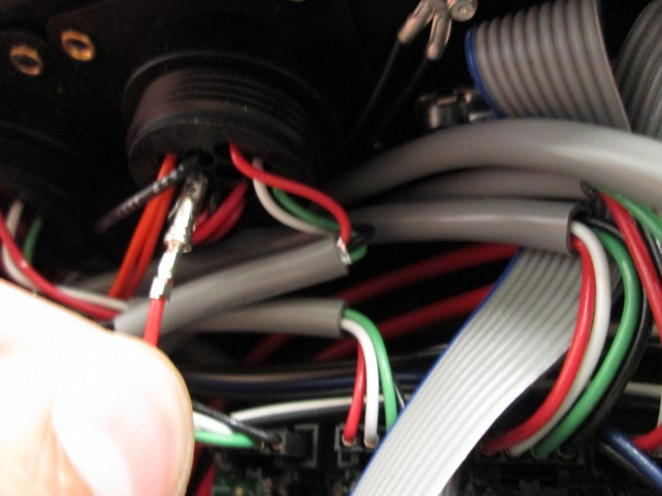
B Insert a 2mm driver into the pin socket indicated by the red arrow in the image below.
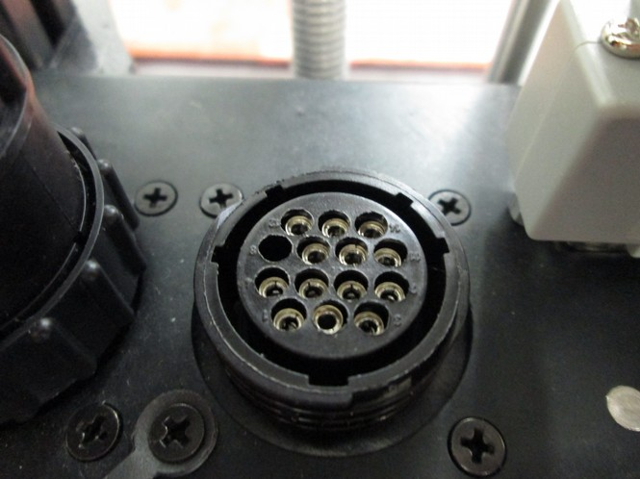
PIN 5 (Red)
PIN 6 (Black)

D Insert the two-pin connector on the pins on the RAMBo as shown, making sure that the latching side of the connector is facing upwards. If you have previously used a Hexagon hot end with this printer unplug the microblower fan wires from the RAMBo and plug in the new jumper. Replace the control box cover, making sure that none of the wires are interfering with the control box fan.
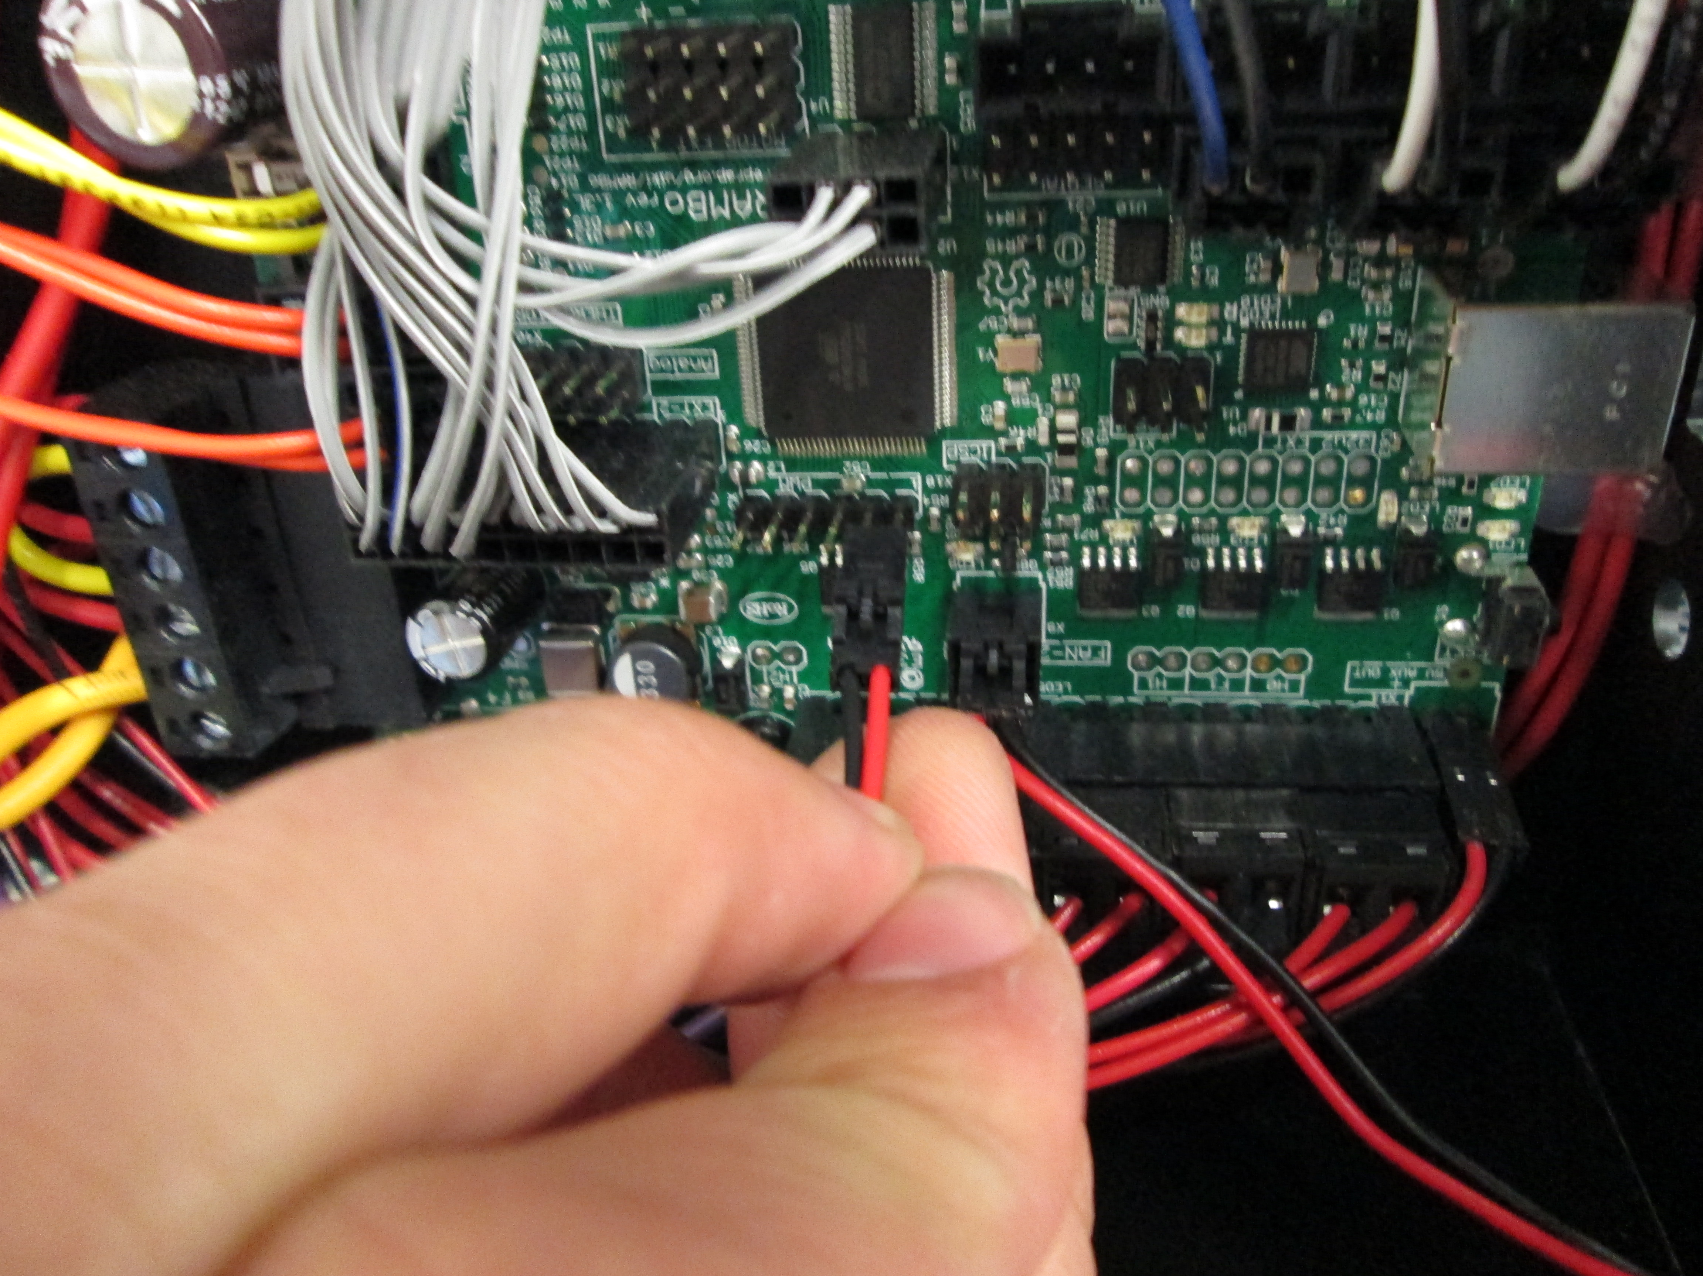

Step 1a: Download this file to the Sdcard included with your 3D printer and run the “z_shipping_235.gcode” file: Link

Step 1b: Completely power off your LulzBot 3D printer and unplug the power supply/USB cable before proceeding.

Step 1c: Switch Top Rear Control Box Mounting Screw
Your new Dual Extruder has a different nozzle path length than the standard tool head on your LulzBot TAZ. You will need to remove the 10mm M5 bolt, and replace it with the lower profile 8mm M5 included with your Dual Extruder (shown in the pictures below). The original washer will not be used.
Keep the T-nut in place by holding the T-nut in place with a piece of filament, cut to 130mm and inserted into the aluminum extrusion channel prior to removing the screw. If it does fall lift it back up.

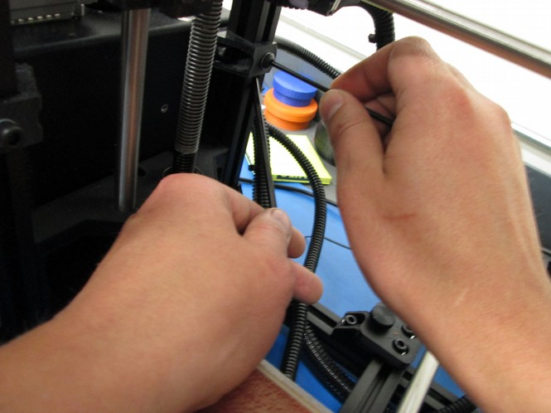
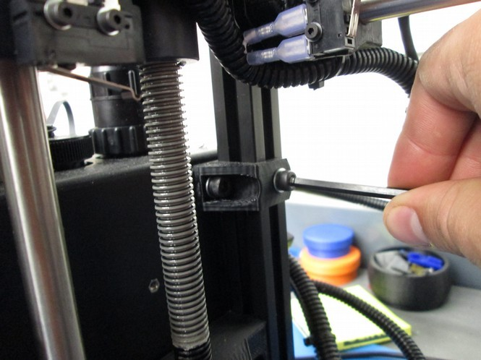
Step 2: Remove Stock Bed Fingers and Replace with New Aluminum Bed Holster Plates

Remove the four stock bed corners using a 2.5mm driver, and replace them using a 2mm driver with the new low profile aluminum bed holster plates using the included 3mm flat head screws. This additional clearance is necessary for the extrusion fan ducts on your new Dual Extruder Tool Head.
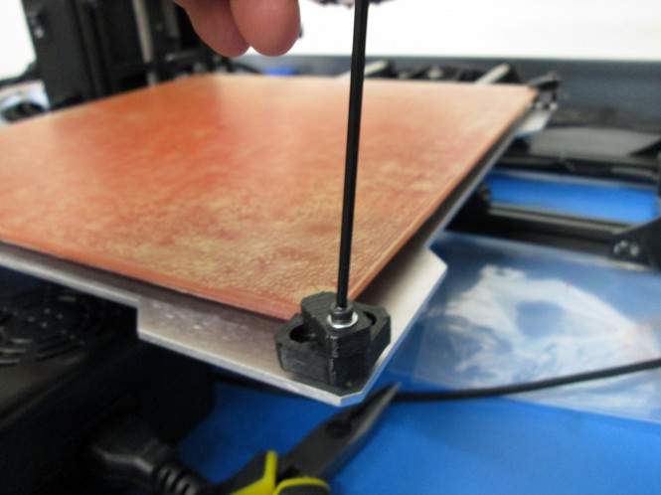
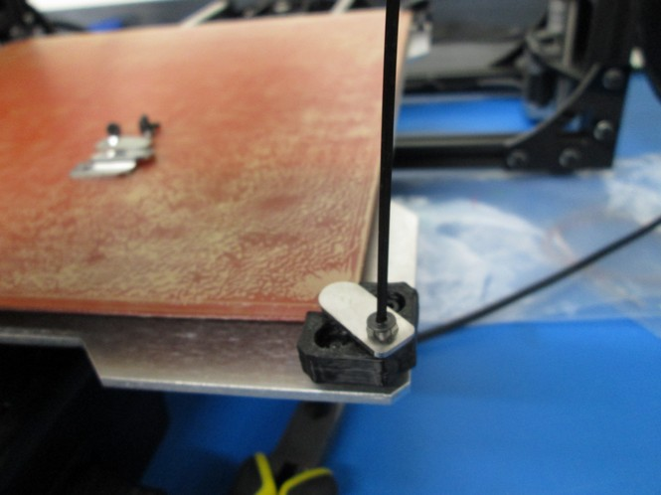

Step 3: Install Secondary Filament Spool Arm
3A Start by loosening the existing spool arm and sliding it down about 2 inches (50mm), then tighten it. Insert in the new T-nut included with your Dual Extruder on the same z-axis vertical frame member (the front right bar), in the same channel.
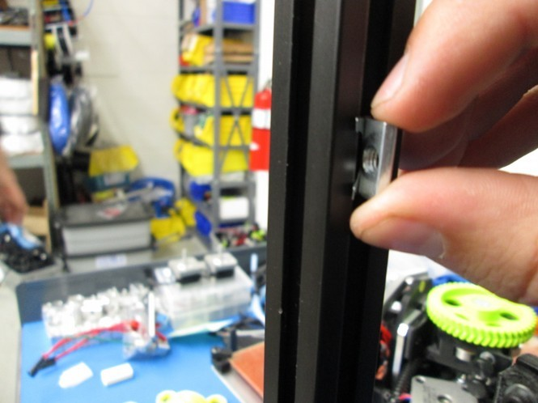
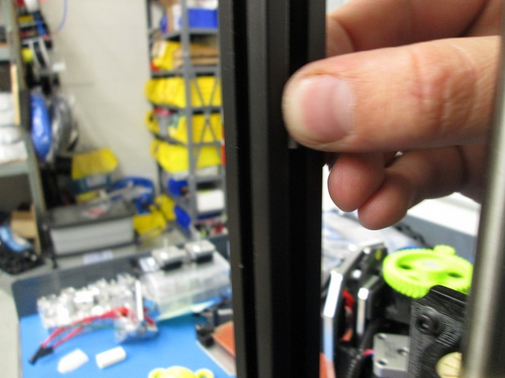
i ii

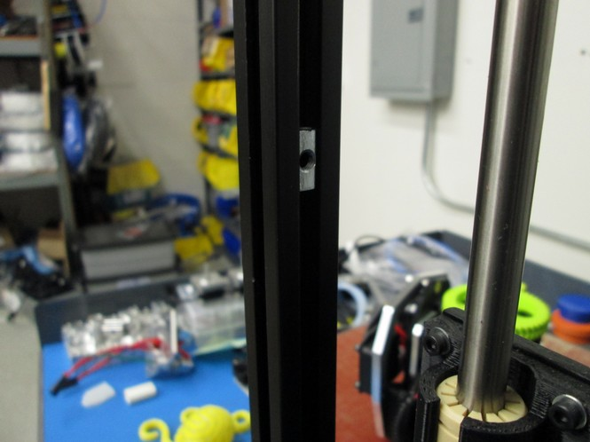
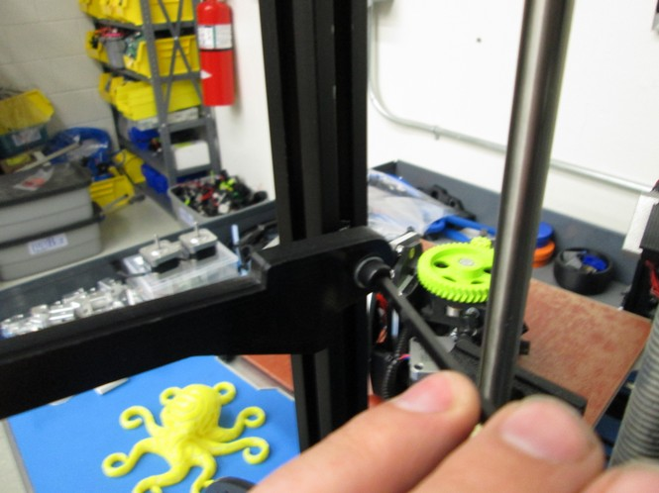
iii iv

3B Place two spools of filament on the spool arms to ensure they are mounted with sufficient space to rotate during printing. Match the existing feed tube orientation when you install the secondary feed tube included with your new Dual Extruder.
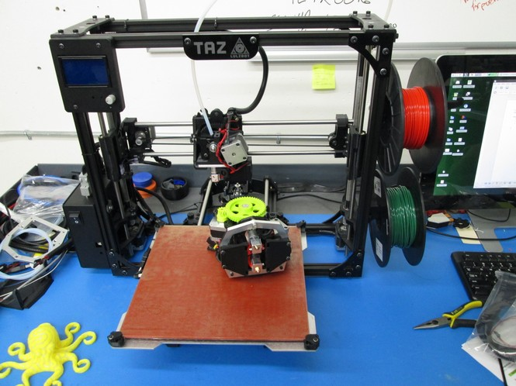
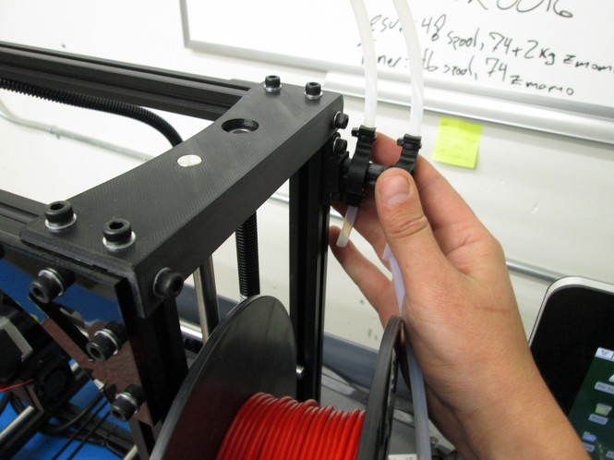

Step 4: Connect and Secure Secondary Power Harness
4A Unscrew the cap on the second port on top of the electronics box on your LulzBot TAZ, then plug the secondary power harness into the uncapped port.

4B Route the new harness next to existing one on your printer, using zip ties to secure it in the same spots.

4C Use a zip tie to secure the new harness into the empty harness holder on the top left side of the x-carriage.

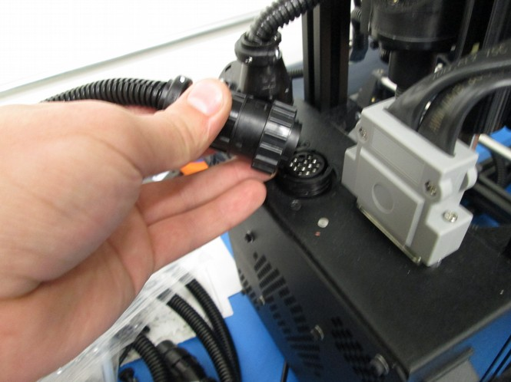
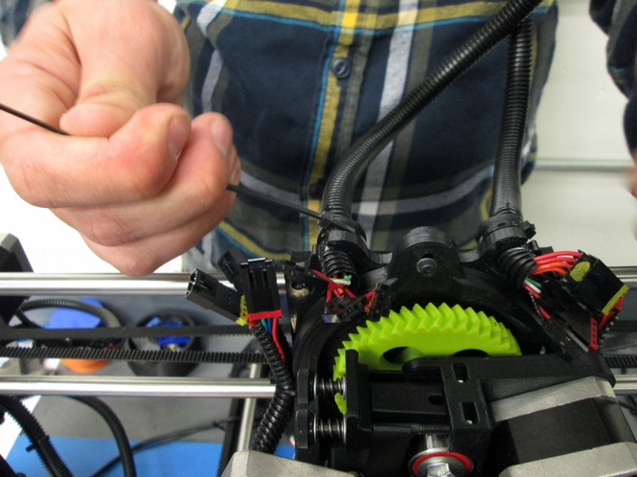

Step 5 Remove Existing Tool Head and Mount Dual Extruder Tool Head
5A Unplug the connectors for your current tool head. With one hand support the tool head and unscrew the single M3 bolt securing it to the X axis carriage, and remove it from the printer by lifting the tool head up.
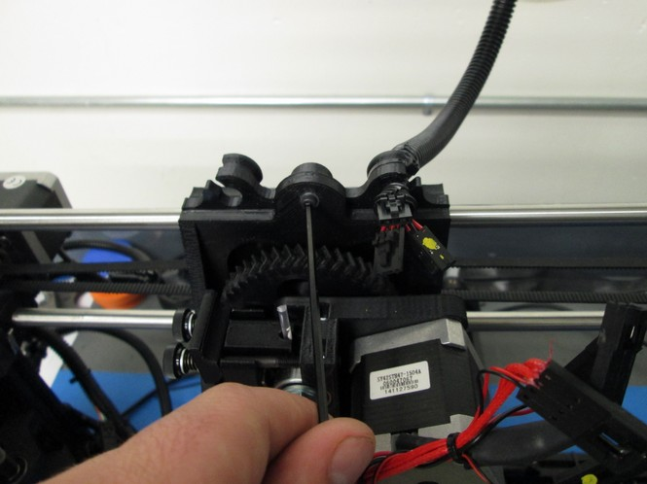

5B Install the dual extruder tool head by seating it on the X axis carriage and secure it with the M3 screw that you removed in the previous step.
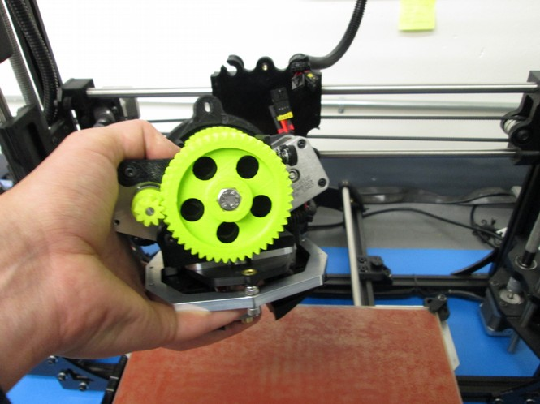
5C Connect the five pinned connectors, make sure to match them based on the colors painted on the connectors. Note: You will have one or two spare fan connectors that will not be used.
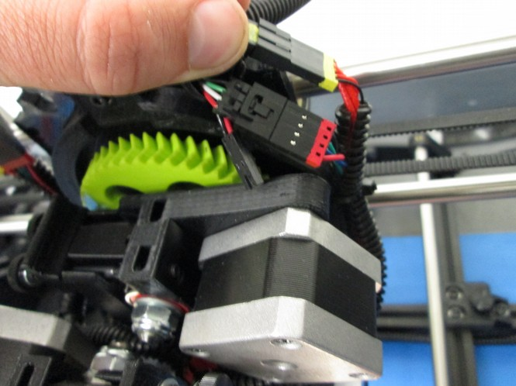
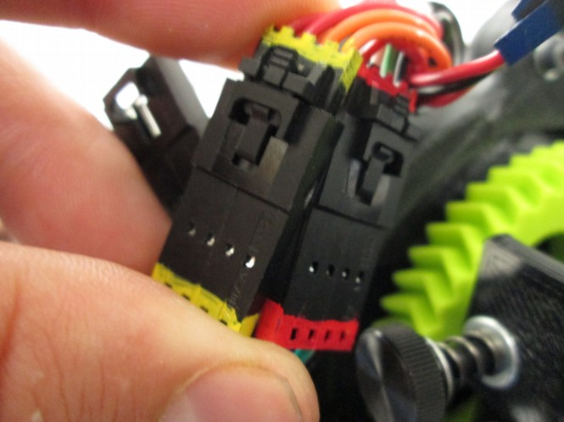
Verify the five pinned connectors are appropriately connected before proceeding.

Step 6a. Install or load Cura.
Cura is available from http://LulzBot.com/Cura. Once installed and open plug in your printer to the power supply and power the TAZ 3D printer on. Once powered on, use your USB cable to connect the TAZ 3D printer to your computer.

Step 6a: Download the Firmware
In a web browser on your computer download the hex file available from: http://devel.lulzbot.com/TAZ/accessories/javelin/software/marlin_dual_4-5_hex/

Step 7: Configure Cura and Install Dual Extruder v2.0 Firmware
7A Once Cura is open, Select Machine > Machine Settings and select your TAZ version. In the new Machine settings window, select appropriate tab for your 3D printer model. Under machine settings update the Extruder Count to 2. Update the Extruder 2 offsets with: Offset X: 0 & Offset Y: -50. Select OK and the Machine Settings window will close.
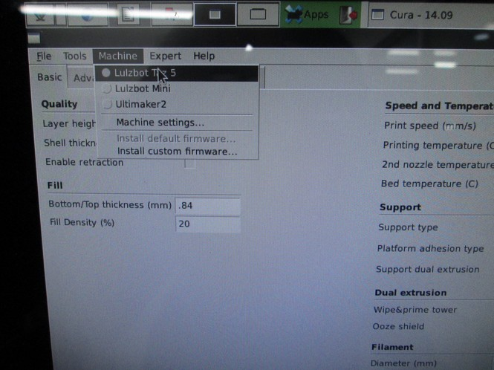
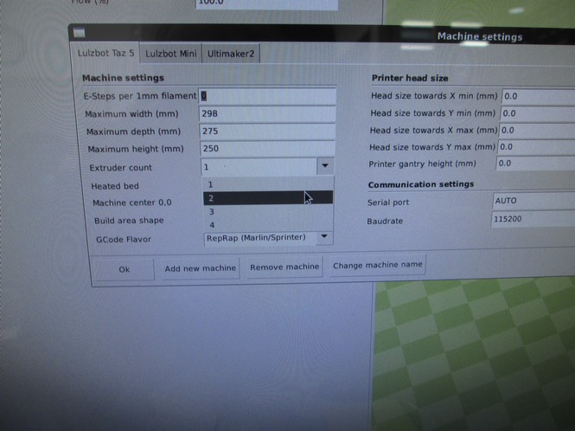

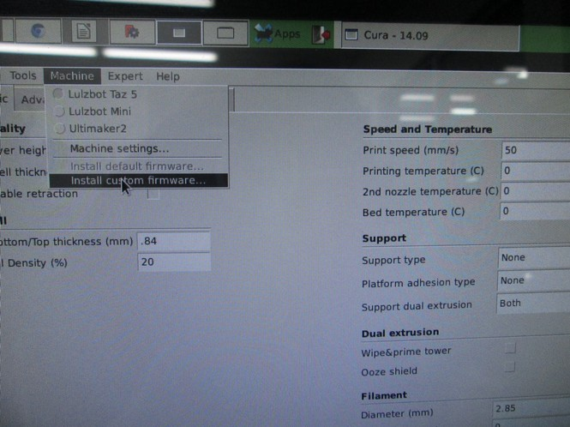
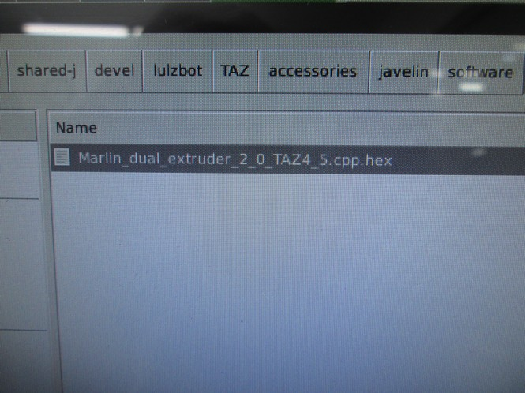
7B Flash the Dual Extruder Firmware. In the top menu select: Machine and select the option: Install Custom Firmware and choose the Marlin_dual...hex file that you downloaded earlier.

7C Confirm firmware flashing was successful. After the firmware is successfully flashed the LCD screen will display a second extruder temperature reading, and the name of the printer will be changed to DualMetalTAZ.

You will also have new temperature presets for common dual extruder filament combinations like PLA/PLA, PLA/PVA, and ABS/HIPS accessible through the LCD screen.

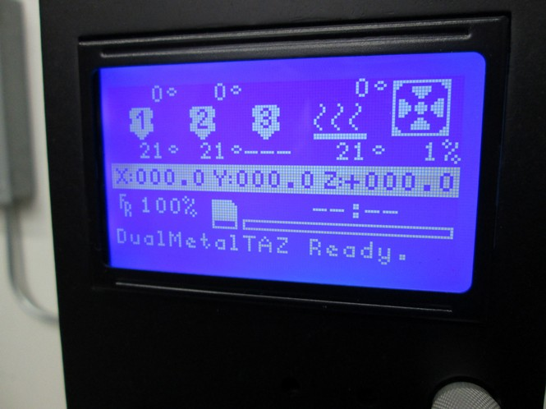
Step 8: Level the Dual Extruder
8A Home the printer. Adjust the homing height by homing the print head and turning the z-adjustment screw until a sheet of paper folded in half just barely slides under the rear extruder.

8B Turn the leveling screw found on the dual extruder mount with a 4mm driver until the two nozzles are the same height above the bed. Turning the screw counter-clockwise lowers the front nozzle. Turning the screw clockwise raises the front nozzle.
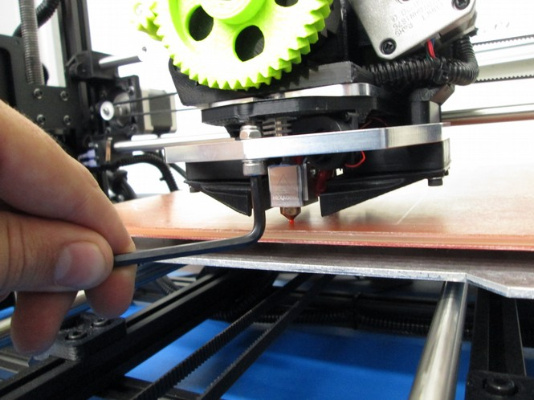
8C Home the printer again and check the level of each nozzle with the folded in half sheet of paper to make sure that tension felt when moving the paper underneath each nozzle feels the same.

8D Now load filament into each extruder as you normally would and you are almost ready to print!

Step 8 Start Printing!
8A You are now set up to start printing with your Dual Extruder Tool Head, but there are several things to keep in mind that differ from standard single extruder 3D printing.
- The back extruder is Extruder 0, and the front extruder is Extruder 1. This is the convention for how they will read temperatures, which extruder is active and which part is printed by which extruder.
- The order that you import STL files into Cura LulzBot Edition matters. For dual color parts, import the part that you want the rear (far) extruder to print first, then the part for the front (near) extruder second. Then right click in the cura window on the first part and select the option “dual extrusion merge”.
- For the best quality prints, have the Ooze Shield option turned on. It is found on the Basic tab and creates a shell around your part that breaks away easily, and ensures that there will be minimal color blending or ooze spots. This option is found on the Basic tab, under Dual Extrusion.

8B Give one of our novelty prints a shot! You can download one by accessing the files located here: http://devel.lulzbot.com/TAZ/accessories/javelin/novelties/.

8C Download a LulzBot print profile, which you can find located here: http://devel.lulzbot.com/TAZ/accessories/javelin/software/print_profiles/. Select a profile that is designed for the two materials you will be using.

8D Open Cura LulzBot Edition, and import the part you want printed with the rear (far) extruder first and the front (near) extruder second. Left click on the part to be printed with the rear extruder,and right click on the part to be printed with the front extruder, then select Dual Extrusion Merge

8E Preheat the printer by selecting the preheat option that matches what you will be printing with through the LCD interface. You can also use the command T0 in the Cura Printer Interface window to specify rear extruder commands and T1 to specify a command for the front extruder.

Before starting your print, confirm that the rear (far) extruder is the primary extruder and the front (near) extruder is the secondary extruder.

8F Once the printer is heated up, click print as you normally would. Happy printing!
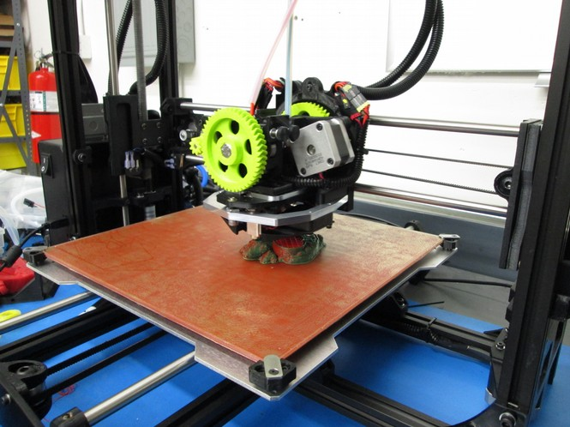
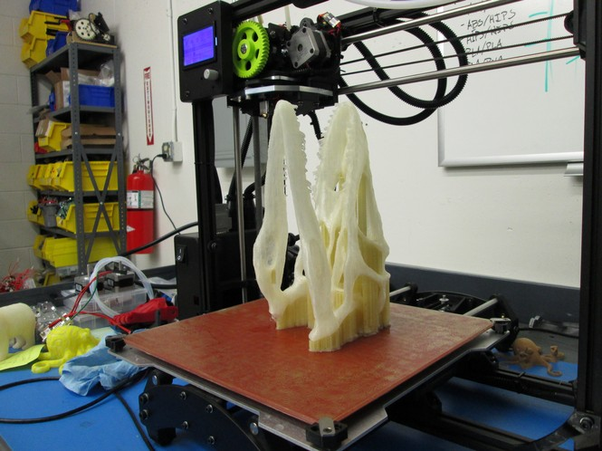

Your first Dual Extruder print!
8. Remember:
A The extruder in the rear is Extruder 0, and the front extruder is Extruder 1. The command T0 switches to the rear Extruder 0. The command T1 switches to the front Extruder 1. You may need to send those commands to switch between to set and read temperatures, and even manually extrude.

B The order that you import STL files into Cura LulzBot Edition matters. For dual color parts, import the part that you want printed with Extruder 0 (rear) first, then the part for Extruder 1 (front) second.

C For the best quality prints, have the Ooze Shield option turned on. It is found on the Basic tab and creates a shell around your part that breaks away easily, and ensures that there will be minimal color blending or ooze spots. This option is found on the Basic tab, under Dual Extrusion

Let's Get Started!
We'll be printing our favorite model, the Rocktopus!

