LulzBot TAZ 4 only: Insert Control Box Jumper into Connector
1 If you have a LulzBot TAZ 4, you will need to add a jumper cable to your control box to power the 5V microblower fans used to cool the LulzBot Hexagon Hot Ends on your Dual Extruder Tool Head.
LulzBot TAZ 5 & newer printers all have these pins populated from the factory and can skip this page.

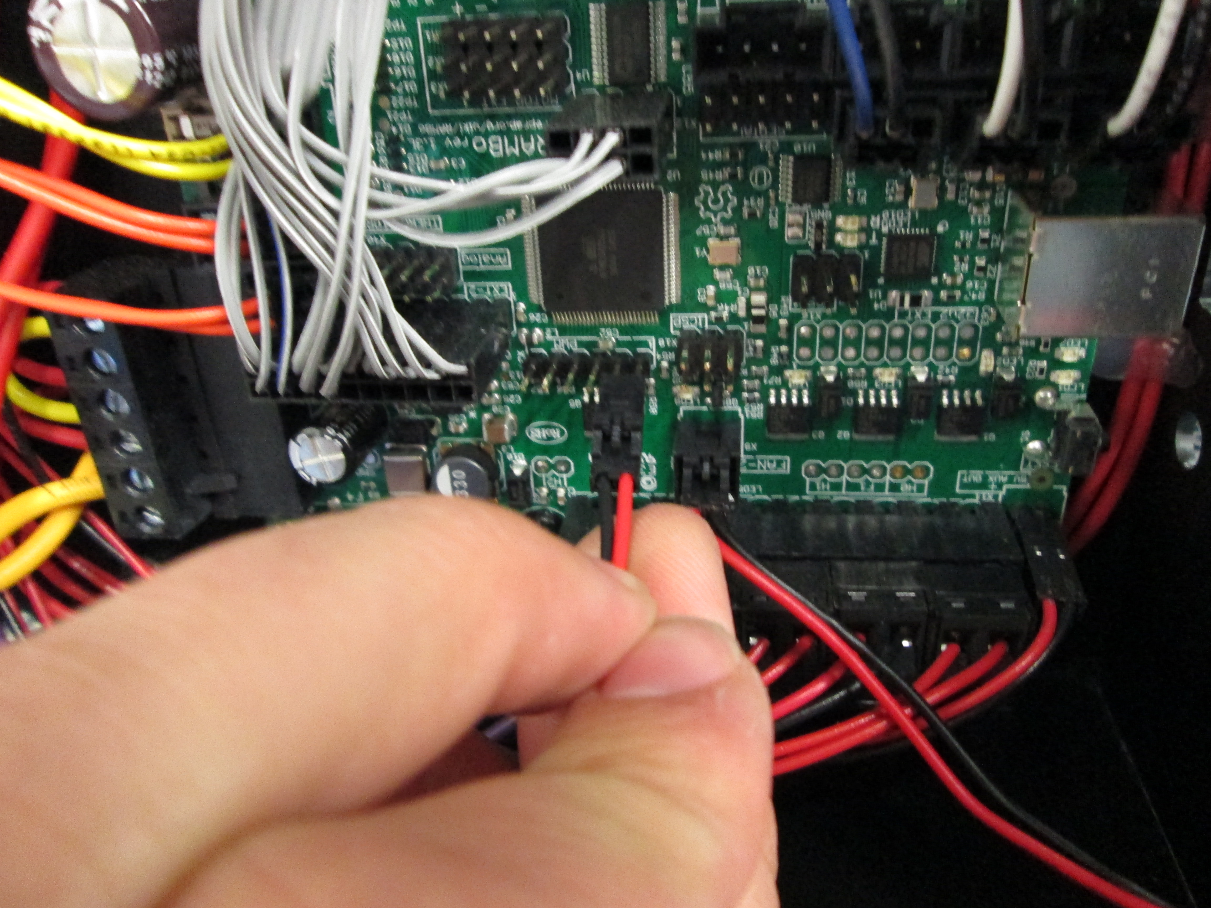  A Remove the four (4) M3 screws on each corner of the LulzBot TAZ 4 control box. Take care with the fan wiring. Unscrew the cap on the second connector cover found on the top of the control box.  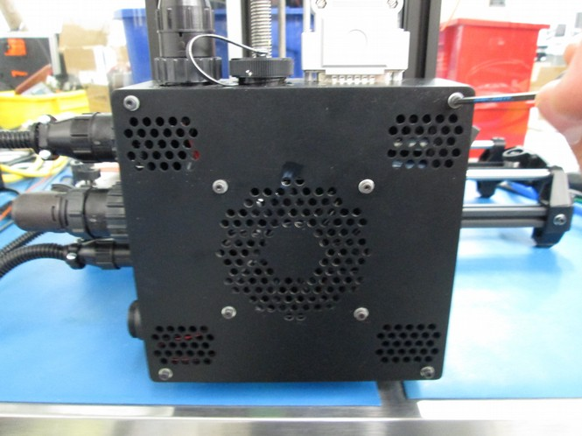  C Use the driver as a guide to insert the pin 5, the red wire, into the connector socket. Press firmly upwards. You may need to rotate the pin slightly to allow it to slide into place. Repeat this procedure for pin 6, the black wire, into the connector socket from the image in Step 1B.  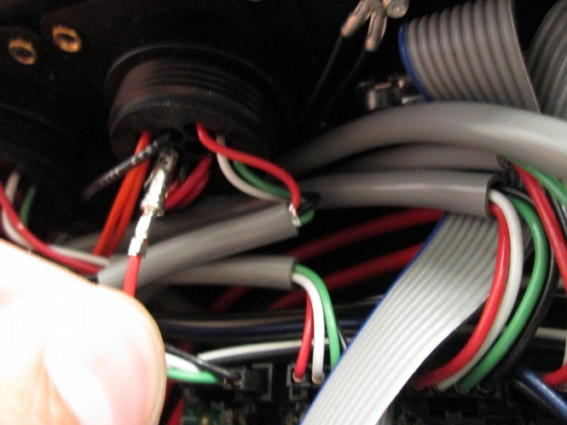 | B Insert a 2 mm driver into the pin socket indicated by the red arrow in the image below.  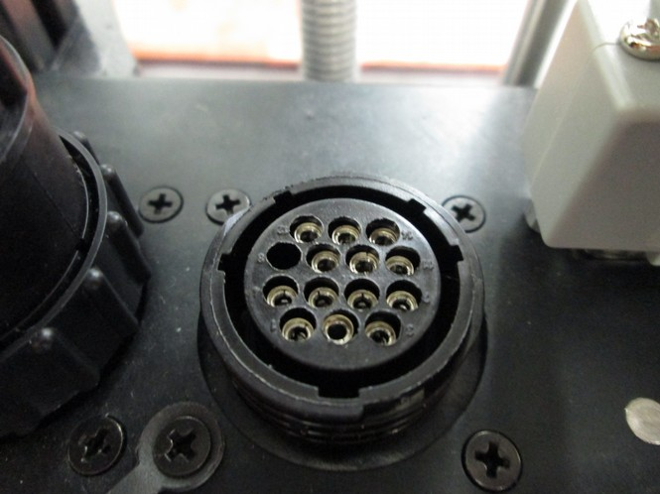  PIN 5 (Red)  PIN 6 (Black)  D Insert the two-pin connector on the pins on the RAMBo as shown, making sure that the latching side of the connector is facing upwards. If you have previously used a tool head equipped with a LulzBot Hexagon Hot End on your LulzBot 3D printer, unplug the micro-blower fan wires from the RAMBo and plug in the new jumper. Replace the control box cover, making sure that none of the wires are interfering with the control box fan. Continue with the rest of the TAZ Dual Extruder v2 Quick Start Guide.

