Congratulations!
You just upgraded your LulzBot desktop 3D printer with a Dual Extruder Tool Head v2. After following this Quick Start Guide, your LulzBot 3D printer will be more capable than ever. Let's get started!

Included Materials
- Dual Extruder v2.0 Tool Head
- Secondary filament guide tube
- Secondary extruder harness
- 3D printed secondary filament spool arm
- 10 mm M5 screw (1) and drop-in T-nut (1) for secondary filament spool arm
- 8 mm M5 button head screw (1) to replace one control box mounting screw
- Aluminum bed holster plates (4)
- Extruder harness jumper cable
- Control box jumper cable (only required for LulzBot TAZ 4)
- Zip ties (12)
- 3D printed T-nut jig

You will also need:
- Metric hex key set (4mm, 3mm, 2.5mm driver) (included in LulzBot TAZ toolkit,)
- Scissors or wire cutters for cutting zip ties
- LulzBot TAZ 4 or LulzBot TAZ 5 desktop 3D printer

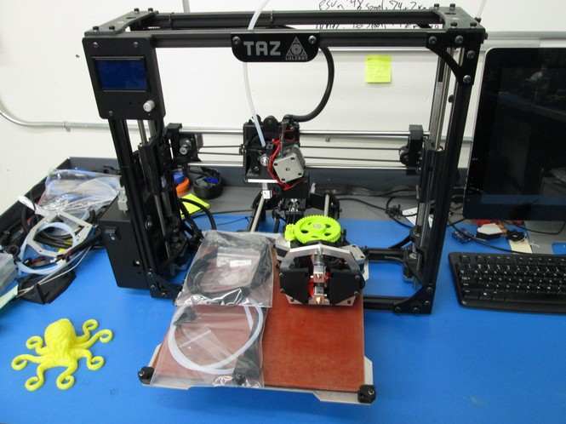

LulzBot TAZ 4 only: Insert Electronics Jumper in Control Box
1 If you have a LulzBot TAZ 4, you will need to add a jumper cable to your control box to power the 5V fans used by the LulzBot Hexagon Hot Ends.

Refer to the guide found here: LINK

LulzBot TAZ 5 & newer printers all have these pins populated from the factory and can skip that step.

1. Let's get started!

Step 1a: Raise the Z axis by using the Graphical LCD controller to print the calibration/z_shipping_235.gcode file found on the SD card included with your 3D printer. The file can also be downloaded from: http://devel.lulzbot.com/TAZ/juniperberry/calibration/z_shipping_235.gcode
Alternatively, you can also manually move the Z axis up by using the Graphical LCD controller by navigating to: Prepare > Move Axis > 1.0 > Z axis > Change the value to at least 200.

Step 1b:

Completely power off your LulzBot 3D printer and unplug the power supply before proceeding.

.

Step 1c: Switch Top Rear Control Box Mounting Screw
Your new Dual Extruder Tool Head v2 has a different hot end length than the standard tool head on your LulzBot TAZ. You will need to remove the 10mm M5 bolt, and replace it with the lower profile 8mm M5 screw included with Dual Extruder v2 Tool Head (shown in the pictures below). The original washer will not be used.
Keep the T-nut in place by holding the T-nut in place with the T-nut jig. Insert the jig into the aluminum extrusion channel prior to removing the screw. If it does fall lift it back up. Remove the jig once the screw has been replaced.
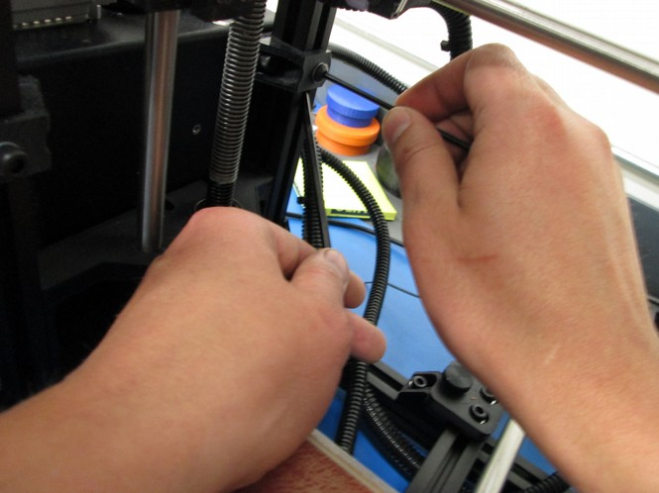
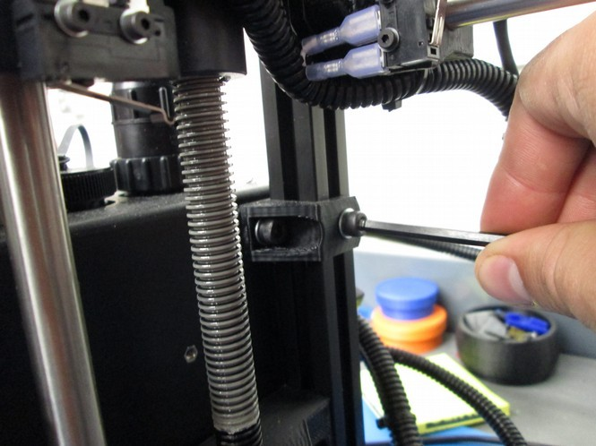

Step 2: Remove Stock Plastic Bed Clips and Replace with New Aluminum Bed Holster Plates

Remove the four stock plastic bed corners using a 2.5mm driver, and replace them using a 2mm driver with the new lower profile aluminum bed holster plates using the included 3mm flat head screws. This additional clearance is necessary for the extrusion fan ducts on your new Dual Extruder Tool Head v2.
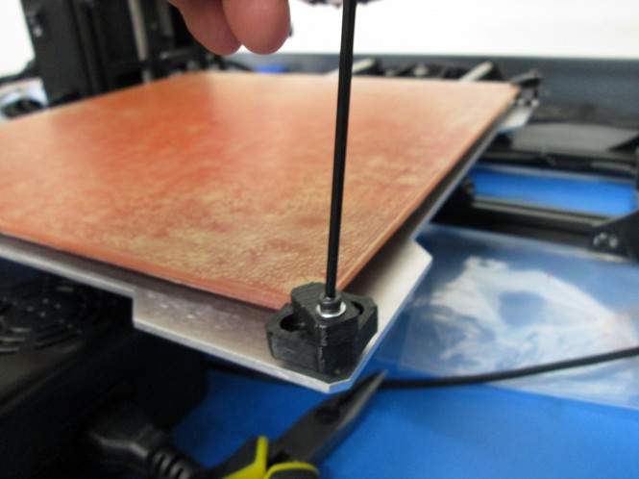
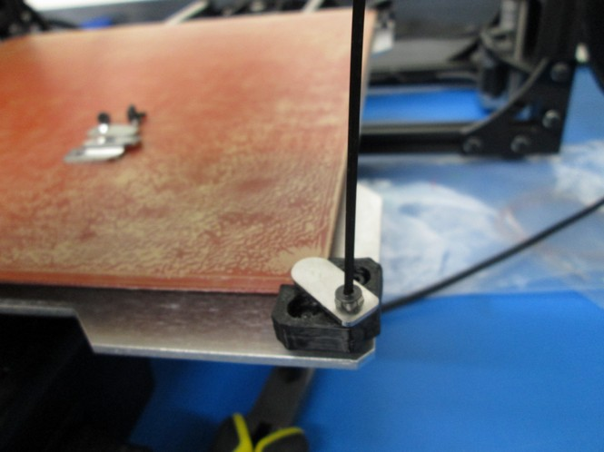

Step 3: Install Secondary Filament Spool Arm

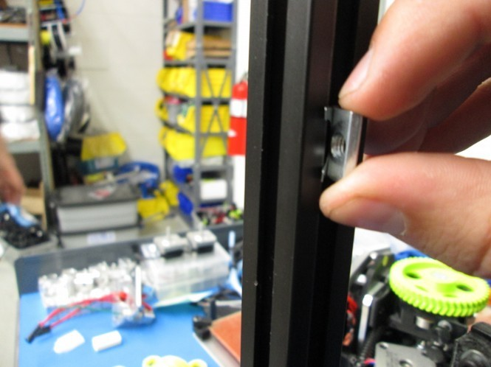
3A Loosen the existing spool arm and slide it down about 2 inches (50mm), and tighten it. Insert the new T-nut included with your Dual Extruder Tool Head v2 on the same z-axis vertical frame (the front right extrusion), in the same channel. Use the M5 screw to install the 3D printed secondary filament spool arm.
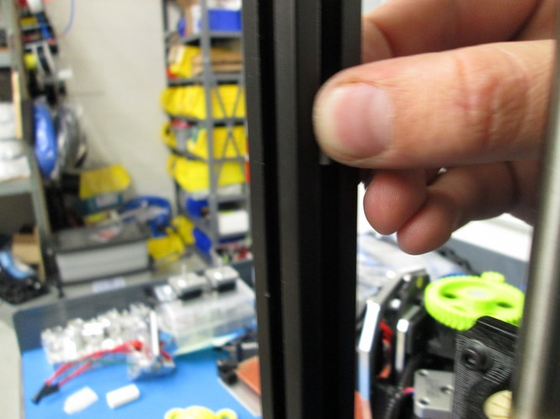
i ii

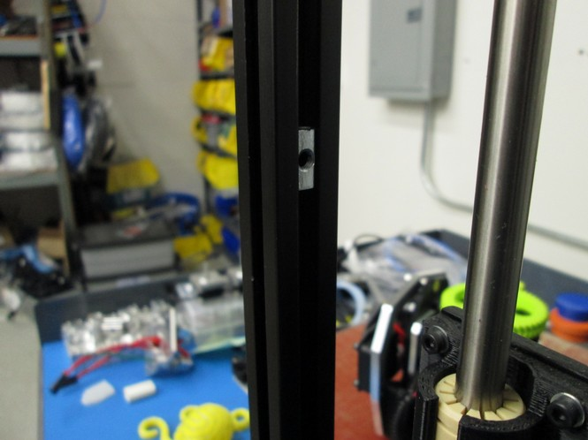
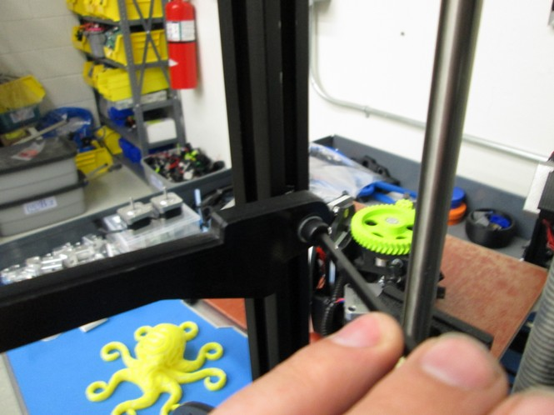
iii iv

3B Place two spools of filament on the spool arms to ensure they are mounted with sufficient space to rotate during printing. Match the existing feed tube orientation when you install the secondary filament guide tube included with your new Dual Extruder Tool Head v2.
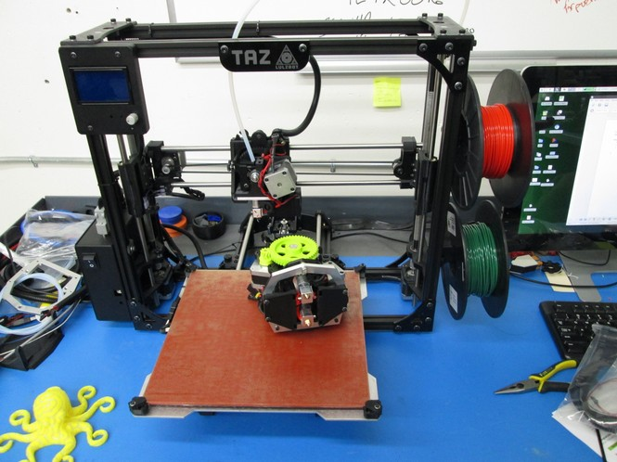
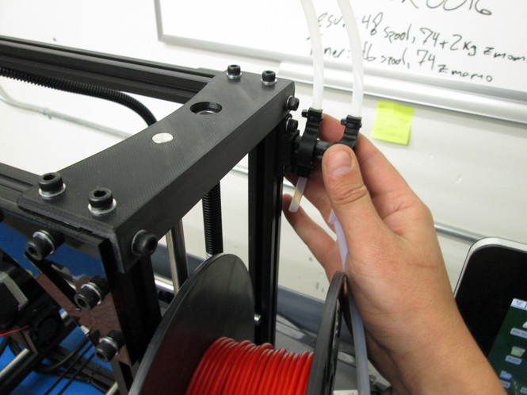

Step 4: Connect and Secure Secondary Extruder Harness
4A Unscrew the cap on the second port on top of the electronics box on your LulzBot TAZ, then plug the secondary extruder harness into the uncapped port.

4B Route the new harness next to existing one on your printer, using zip ties to secure it in the same spots.

4C Use a zip tie to secure the new secondary extruder harness into the empty harness holder on the top left side of the x-carriage.

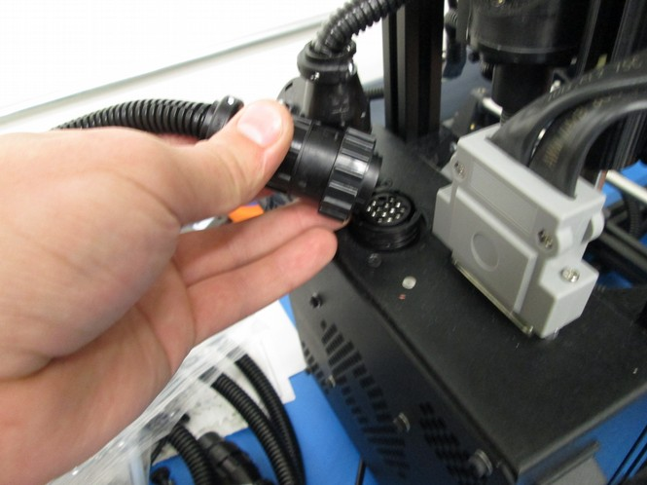
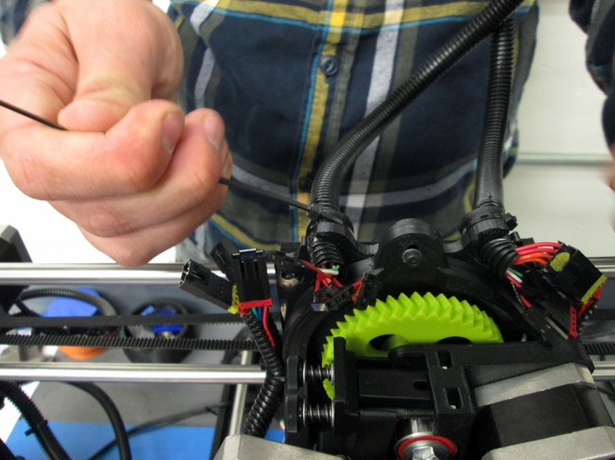

Step 5 Remove Existing Tool Head and Mount Dual Extruder Tool Head v2
5A Unplug the connectors for your current tool head. With one hand support the tool head and unscrew the single M3 bolt securing it to the X axis carriage, and remove it from the printer by lifting the tool head up.
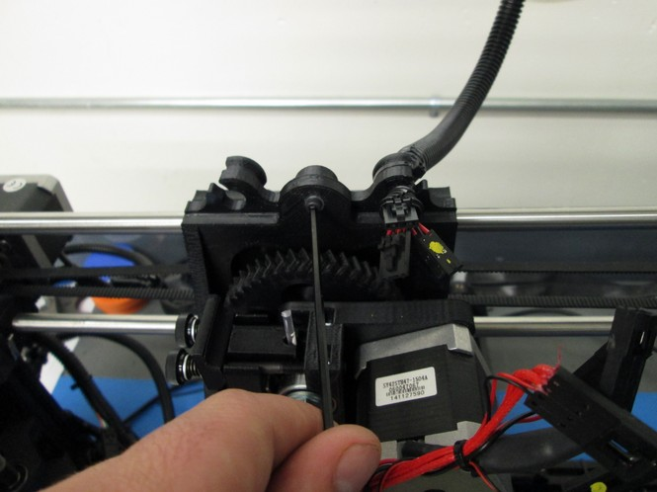

5B Install the Dual Extruder Tool Head v2 by seating it on the X axis carriage and secure it with the M3 screw that you removed in the previous step.
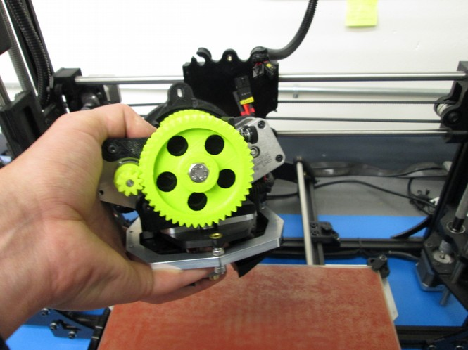
5C Connect the Extruder harness jumper cable to the original tool head wiring harness. Connect the two 16 pin connectors, making sure to match them based on the pins and colors painted on the connectors. Note: You will have one or two spare fan connectors that will not be used.
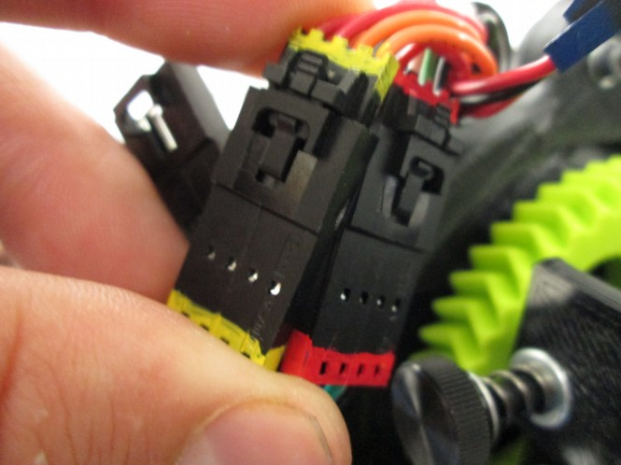
Verify the five pinned connectors are appropriately connected before proceeding.

Step 6. Install or load Cura LulzBot Edition.
Cura LulzBot Edition is available from http://LulzBot.com/Cura. Install Cura LulzBot Edition if not installed on your computer.
Plug in your TAZ 3D printer to the power supply and power the TAZ 3D printer on. Use your USB cable to connect the TAZ 3D printer to your computer. Open Cura LulzBot Edition.
IMG: Cura.png

Step 6a: Download the Firmware
Open a web browser and download the firmware file from: http://devel.lulzbot.com/TAZ/accessories/javelin/software/marlin_dual_4-5_hex/

Step 7: Configure Cura and Install Dual Extruder Tool Head v2 Firmware
7A In Cura LulzBot Edition, Select Machine > Add a new machine.
IMG: Menu_014.png
IMG: Configuration Wizard_015.png

7B Select your TAZ version. Click Next to proceed to the next window. Your Dual Extruder Tool Head v2 is equipped with two 0.50mm nozzles. Select 0.50 mm. TAZ 4 or other 3D printer users: This value will be present in the 0.50mm nozzle slicing profiles. Continue to the next step after selecting your 3D printer model.
IMG: Configuration Wizard_016.png
IMG: Configuration Wizard_017.png

7C Select Finish to close the configuration window. Select Machine > Machine settings to open the Machine settings window. Select the tab with the last 3D printer added.
IMG: Selection_013.png

7D Under machine settings update the Extruder Count to 2. Press OK to save the settings. Open the Machine Settings window again by selecting Machine > Machine Settings.
IMG: Selection_018.png

7E Open the Machine Settings window again by selecting Machine > Machine Settings.
IMG: Selection_021.png

7F Update the Extruder 2 offsets with:
Offset Y: -50.
If the Machine Settings window does not have Extruder 2 settings close and reopen the Machine Settings window.

7G Update the Printer head size with the following settings:
Head size towards X min (mm): 65
Head size towards Y min (mm): 38
Head size towards X max (mm): 63
Head size towards Y max (mm): 90
Printer gantry height (mm): 50

7H Change the 3D printer name by selecting Change machine name. Change it to: LulzBot TAZ (model number) with Dual Extruder (0.5mm nozzles).
IMG: Selection_022.png

7I Select OK to save the updated name. Select OK to save the updated settings and the Machine Settings window will close.

8 Flash the Dual Extruder Tool Head v2 Firmware.
8A In the top menu select: Machine > Install Custom Firmware and choose the Marlin_dual...hex file that you downloaded earlier. The firmware will be flashed to your 3D printer once you select the file.
IMG Selection_025.png

8B Confirm firmware flashing was successful. After the firmware is successfully flashed the LCD screen will display a second extruder temperature reading, and the name of the printer will be changed to DualMetalTAZ.

You will also have new temperature presets for common multiple material filament combinations like PLA/PLA, PLA/PVA, and ABS/HIPS accessible through the LCD screen.
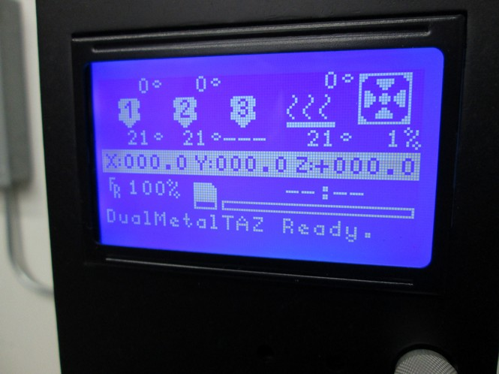

Greenbox:
When homing, if the Z axis doesn't seem to stop soon enough, turn off your 3D printer before it contacts the print surface. You may need to remove the spring on the Z axis endstop trigger. By removing the spring and washers the endstop trigger screw can be adjusted downward enough to trigger the Z axis endstop.

Step 9: Align the Dual Extruder Tool Head v2
9A In Cura LulzBot Edition, load any STL file. Make sure your TAZ 3D printer is still connected through USB to your computer and powered on. Press the Control button. Once the Printer Interface window opens, home the printer. Adjust the homing height by homing the print head and turning the Z axis end stop trigger until a sheet of paper folded in half just barely slides under the rear extruder.

9B To adjust the level of the T1 (front) extruder push the bed away to have access to the leveling screw. The leveling screw is found on the front dual extruder mount. Adjust it with a 4mm driver until the two nozzles are the same height above the bed. Turning the screw counter-clockwise lowers the front nozzle. Turning the screw clockwise raises the front nozzle.
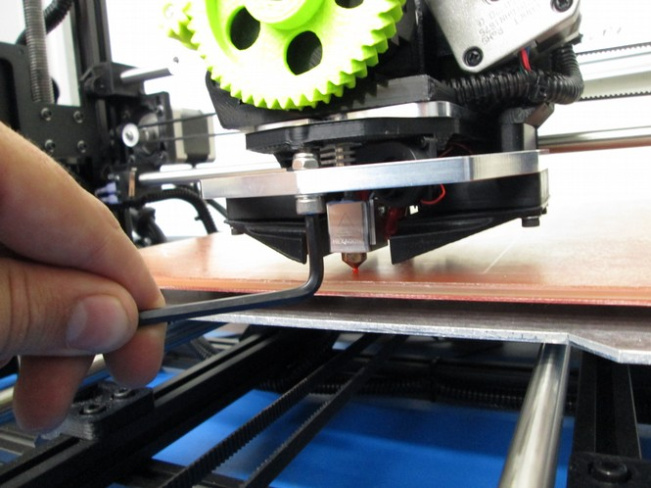
9C Home the printer again and check the level of each nozzle with the folded sheet of paper to make sure that tension felt when moving the paper underneath each nozzle feels the same.

10 Load filament into each extruder. You are almost ready to print!

Your first dual extruder print!
Remember:
- The extruder in the rear is Extruder 0, and the front extruder is Extruder 1. The command T0 switches to the rear Extruder 0. The command T1 switches to the front Extruder 1. You may need to send those commands to switch between to set and read temperatures, and even manually extrude.
- The order that you import STL files into Cura LulzBot Edition matters. For dual color parts, import the part that you want printed with Extruder 0 (rear) first, then the part for Extruder 1 (front) second.
- For the best quality prints, have the Ooze Shield option turned on. It is found on the Basic tab, under Dual Extrusion. This ceates a shell around your part that breaks away easily, and ensures that there will be minimal color blending or ooze spots.

Let's Get Started!
We will be printing a two colored die. After it finishes printing, you should print it again on your own so that you can have your very own 3D printed set of two colored dice!

1 Download the files:
Die Body
IMG: die_body.jpg
Die Dots
- IMG: die_dots.jpg

2 Load the two models

2A. In Cura LulzBot Edition, press Load Model and select die_body.stl. The model should now be displayed on the virtual print surface.
IMG: load-die_body.png
or
IMG: Selection_026.png

2B. Press Load Model again and select die_dots.stl. The model should now be displayed on the virtual print surface next to the other model.
IMG: load-die_dots.png
or
IMG: Selection_027.png

3 Rotate the virtual print surface as desired so that both models are visible. Do this by holding down the right mouse button while moving the mouse/trackpad to rotate the work plane. Your virtual print surface may look different.

4 Merge the models
4A Left click on the die_body model to be printed with the T0 (rear) extruder.

IMG: Selection_028.png

4B Right click on the model to be printed with the T1 (front) extruder and select Dual Extrusion Merge. The models should merge together. Your virtual print surface should look similar to the image below.
IMG: Selection_030.png
IMG: Menu_029.png

4C The models are now merged. The new model can be moved around the build plate. It's now time to turn on some additional options, to ensure we have a clean dual material print and to load the specific Print Profile for your material.

5 Download a Medium Print Profile for your loaded material from: https://www.lulzbot.com/support/taz-cura-profiles

5A Start with a Medium Print Profile, making sure to select the 0.50mm version.

5B To switch from Quick Print mode, select Expert > Switch to full settings. When asked about copying over the current Print Profile select No.
IMG: Selection_032.png

5C Cura LulzBot Edition should look like the image below, with more detailed options instead of the usual Quickprint options. Load the desired Print Profile you downloaded earlier by selecting: File > Open profile.

IMG: Cura – 15.02-1.02_034.png
IMG: Menu_033.png

5D Select the desired Medium Print Profile for your filament.
IMG: Selection_035.png

6 With the profile loaded, the settings should be noticeably different. On the Basic tab, under the Dual Extrusion section, turn on Wipe & prime tower and Ooze shield.

For the best results, measure the average filament diameter of each loaded filament and update the Filament Diameter for both extruders.

IMG: Selection_036.png
Selection_040-1.png

7 Printing with the Dual Extruder Tool Head v2
7A Press Control to open the printing interface. The top of the Printing Interface should display the current printer status. When opened it will display Opening > Connecting > Operational.

IMG: Operational, Temperature: 25 Bed: 25_037.png

Make sure the print surface is clean, or if required, prep the bed with the recommended print surface treatment. More information can be found at https://www.lulzbot.com/support/taz-cura-profiles.

7B Bring the printer up to the recommended temperatures for your material. The example below shows the process for printing with ABS in both extruders. Use your recommended temperature settings from the LulzBot TAZ Cura Profiles page: https://www.lulzbot.com/support/taz-cura-profiles. Set the hot end and the heated bed to the recommended setting.
IMG: Operational, Temperature: 60 Bed: 26_038.png
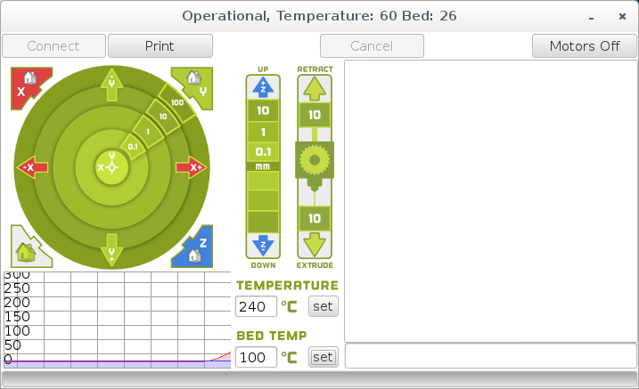
7C Switch to the second extruder by typing T1 in the gcode terminal text box. Make sure to capitalize the command, as it is required. When the command is correctly entered, you'll see confirmation in the gcode command output window:
> T1
< echo: Active Extruder: 1

7D Remember, the first extruder, T0 is to the rear, T1 is in the front. Switch back to the main, rear extruder by sending the command T0.
IMG: Operational, Temperature: 182 Bed: 61_039.png
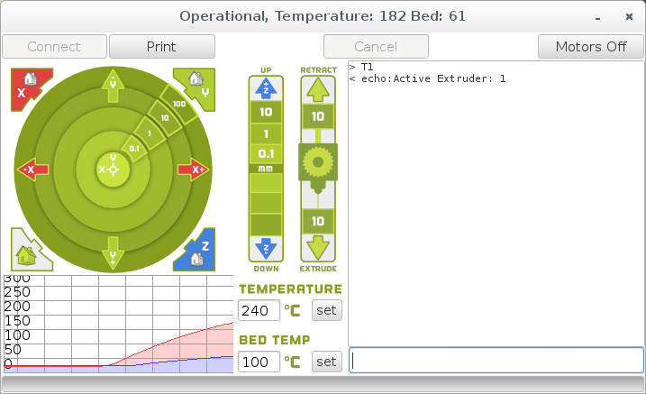

If you notice filament collecting under the hot end nozzles use tweezers to remove the plastic. Be careful as it will be hot.

8 Once the printer has come up to the proper printing temperature for your filament, press Print!

8A The printer will start printing the skirt around your printed object, and also the priming tower and wiping shield. As the print progresses you'll see how the wipe/prime tower, and ooze shield works to keep the printed object clean.

9 Remove your printed object once the printer cools to the recommended part removal temperature found on the Print Profile page.

10 Repeat the steps above, starting with step 2 to print the other die! Have questions, or ideas? Share them with your fellow LulzBot 3D printer users by joining our User Forum at http://Forum.LulzBot.com

For better dual extruder prints, calibrate the X/Y offsets by following the dual extruder calibration guide in the Cura manual, or the online calibration guide found here: https://ohai-kit.alephobjects.com/group/calibration/

