Flexystruder 0.6 Assembly Instructions

- Print one flexystruder_0.6. If you're building a new extruder from scratch, you'll need 1 extruder washer, 1 large and 1 small herringbone gears. Otherwise, you can scavenge these from another Lulzbot extruder. You’ll also need to clean out a small bit of support material from the side of the extruder body (see below).
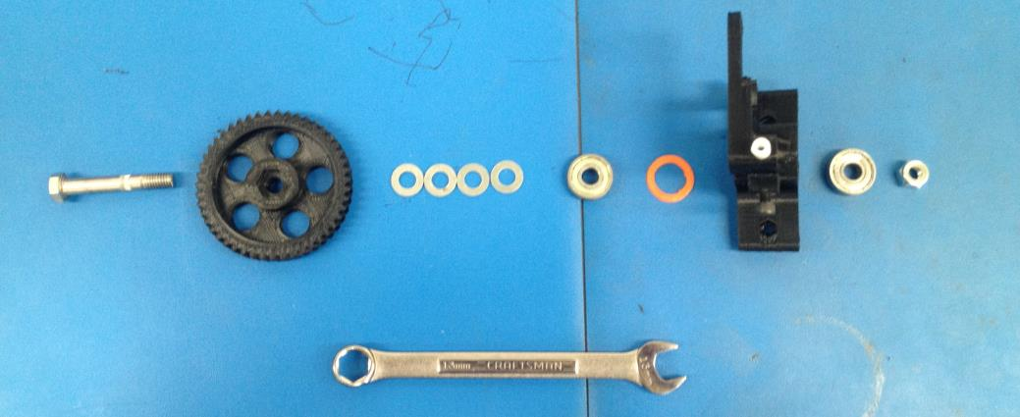
Above: The parts necessary to build a flexystruder. Note that the stepper motor with small herringbone gear is not shown. You can swap this from your existing extruder or assemble a new one. See http://ohai-kit.alephobjects.com/guest_workflow/2/ for these assembly instructions.

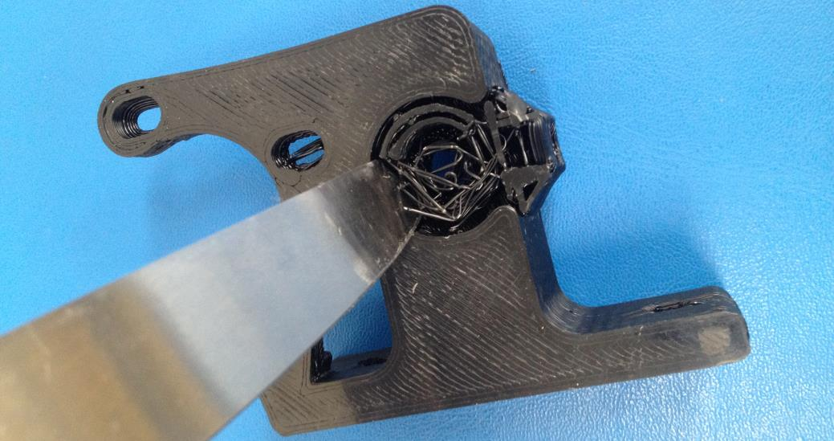
Above: Support material designed into the flexystruder body that must be cleaned before assembly.

- Drill out filament hole with a 17/64” drill bit (or a 6.5mm and really ream it out. You want it to be tight around the PTFE tube, but too tight and it'll split the body. I found that 6.5mm was too small and 7mm too large.)
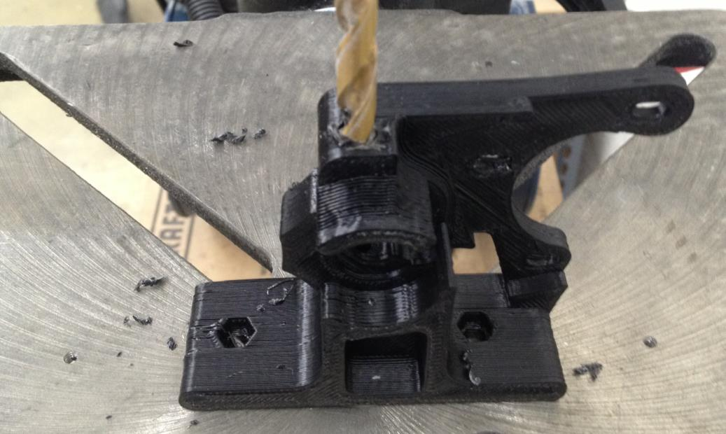
Above: Drilling out the filament hole of the flexystruder body. This ensures a consistent grip of the PTFE tube and eliminates fit issues from over-extrusion.

- Drill the PTFE tube to an inner diameter of 3.5mm, and then slide onto the shaft of a 2.5mm hex driver (in the Lulzbot toolkit). Starting at the top of the extruder body, press the PTFE tube into the extruder body until a small amount is protruding from both top and bottom. Cut these flush with the surfaces.
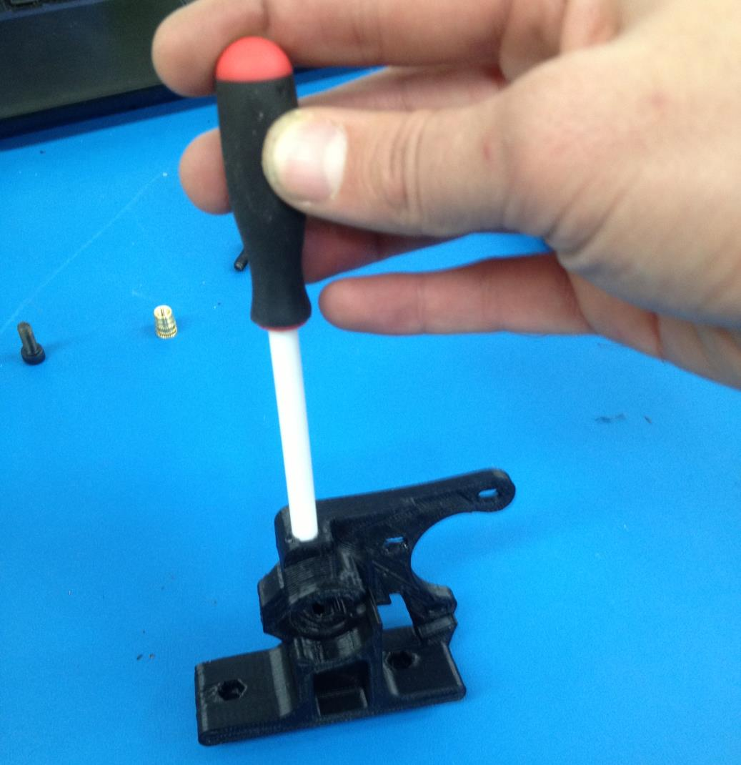

- Using an 8mm drillbit, ream out the center hole for the hobbed bolt. You should be cutting mostly through the PTFE, going slower produces a cleaner cut. You may need to ream the top half of the PTFE tube with the 3.5mm drillbit again, as this step tends to close the tube up a bit.
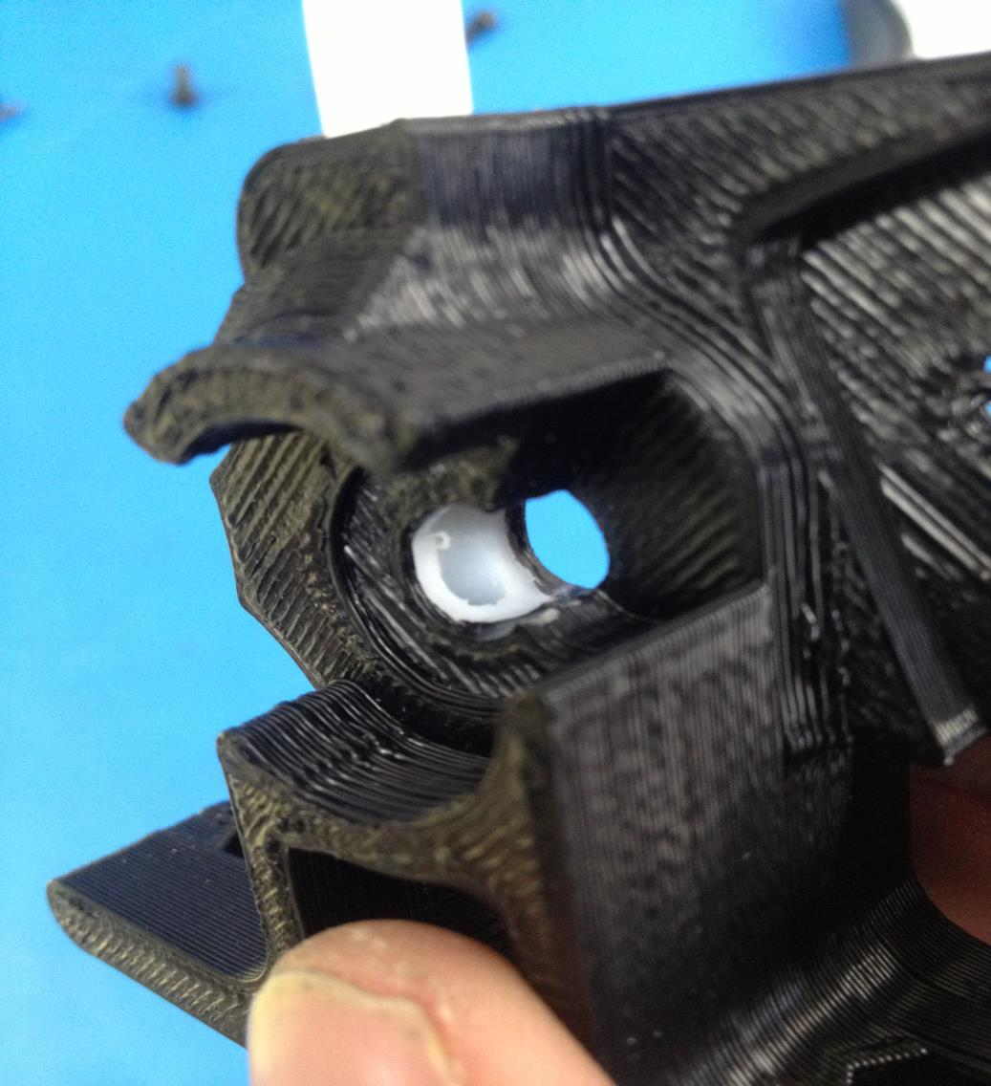
Above: An 8mm cutout drilled through the PTFE. Be sure to clean off any fragments of PTFE as this can clog an extruder nozzle.

- Using a soldering iron, press an M5 thermal insert into the large hole on the side of the flexystruder. The top of the insert should be flush with the side of the extruder. After the insert has cooled, screw in an M5x12 (or longer) bolt finger tight. You'll adjust this later to get more grip on smaller or more flexible materials.
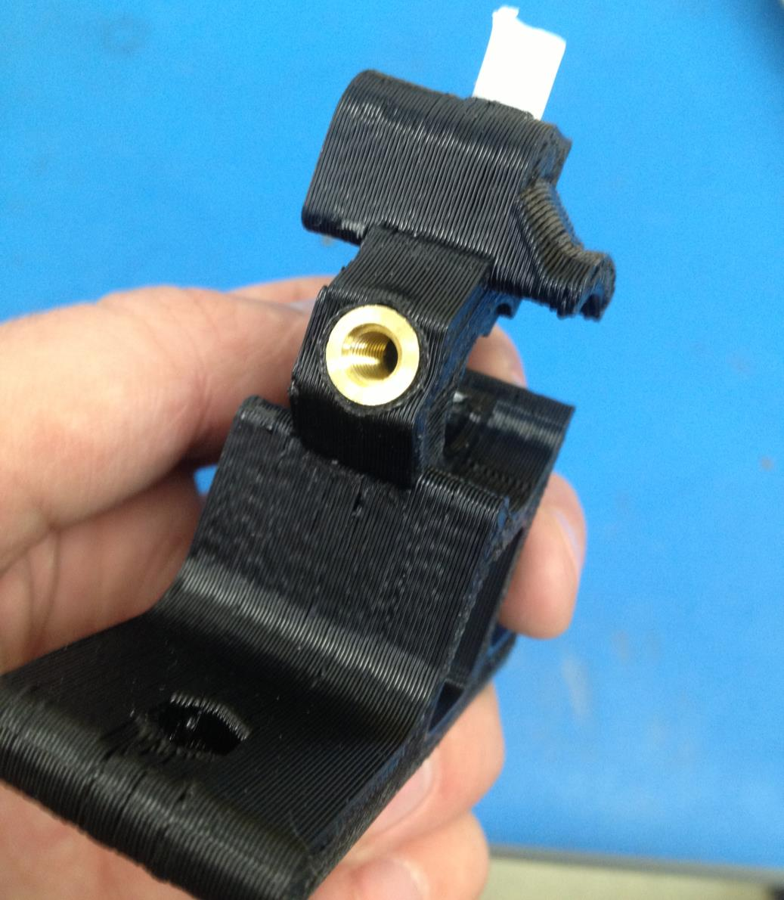Above: An M5 thermal insert installed in the side of the flexystruder. A bolt screws into this to force the PTFE tube and filament closer to the hobbed bolt.

- Press the M8 hobbed bolt into the larger gear, then stack 4 M8 washers, 1 608ZZ bearing and the printed washer on the hobbed bolt. Press it in to the front of the extruder body (the side that printed flat on the glass). On the other side of the extruder, stack 1 M8 washer, 1 608ZZ bearing, another M8 washer and an M8 locking nut onto the hobbed bolt. Tighten and verify that the hobbed section of the bolt lines up with the PTFE tube.
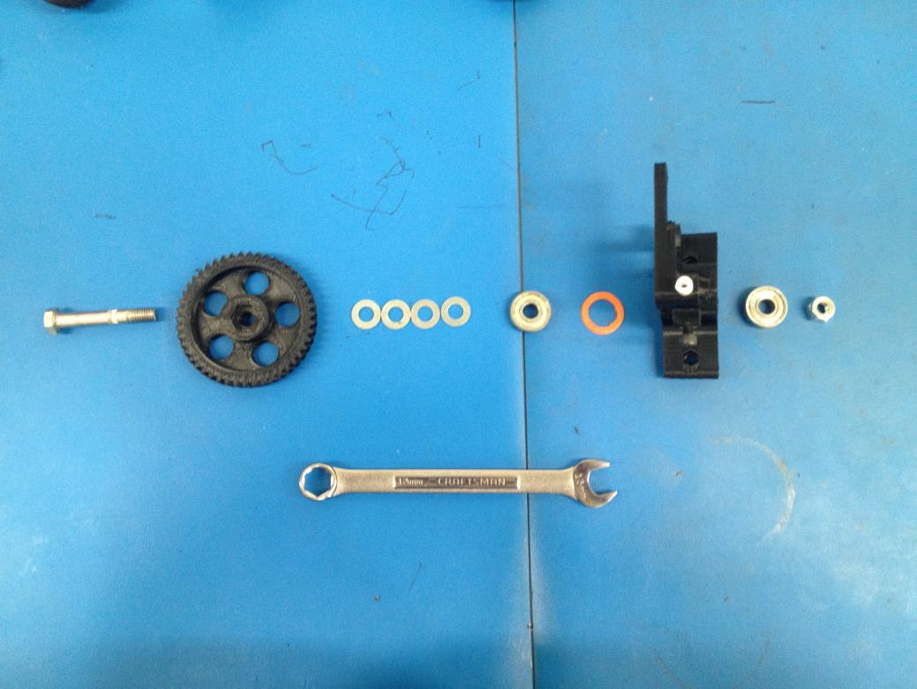
Exploded view of the Flexystruder body assembly.

- Press 2 M4 hex nuts into the holes on the base of the extruder using pliers or channel locks.

- Using 3 M3x10mm bolts with washers, attach the NEMA17 motor to the extruder body so that the teeth of the larger and smaller gears line up. Make sure that the gears are pressed together tight enough that there is no backlash, but not overly tight.

- Mount on printer. Print lots of flexy things.

