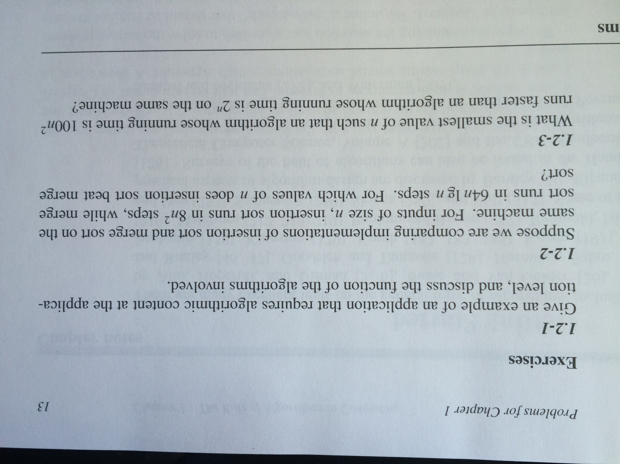

1.2-2
Answer:
Insertion sort with 8n² beats merge sort 64nlgn :
8n²>64nlgn
it happens only for n=1
8>0
on the second step for n=2
32<128
Both functions are increasing for all n>2, so the only answer is n=1

The answer is n=1

1.2-3
Answer:
The functions are increasing with n>0 .The answer could be found by equating the two expressions:
100n²=2^{n}
For n=15 Leftside=19600 and Rightside=16384----> L<R
For n=16 Leftside=22500 and Rightside=32768----> R<L

The answer is n=16.

