Online Pizza Ordering System

<Domain Model>

소프트웨어공학 02분반

20171105 이민욱

20173875 정용준

20170223 신원준

20172609 여일구

20174438 정종민

20173156 김준기



목차

Online Pizza Ordering System 1

<Domain Model> 1

1. Domain Model Details 3

**1.1 SubgroupA(PizzaOrder)** 3

**1.2 SubgroupB(Management)** 13

**1.3 SubgroupC(OrderStatus)** 31

2. Domain Model UML 45

**2.1 SubgroupA(PizzaOrder)** 45

**2.2 SubgroupB(Management)** 49

**2.3 SubgroupC(OrderStatus)** 55

3. Traceability Matrix 61

**3.1 SubgroupA(PizzaOrder)** 61

**3.2 SubgroupB(Management)** 63

**3.3 SubgroupC(OrderStatus)** 64

# Domain Model Details

**1.1 SubgroupA(PizzaOrder)**

A-UC1 Add Menu To Cart

|  |  |  |
| --- | --- | --- |
| **Extracting the Responsibility** | | |
| **Responsibility Description** | **Type** | **Concept Name** |
| Coordinate actions of concepts associated with this use case and delegate the work to other concepts. | D | Controller |
| Render the retrieved records into an HTML document for sending to orderer’s Web browser for display | D | Page Maker |
| HTML document that shows the orderer the current context, what actions can be done, and outcomes of the previous actions | K | Interface Page |
| Authenticate whether the user is logged in or not. | D | Login Checker |
| Container for the collection of menus and available options | K | Menu Storage |
| Container for the collection of menus with options in the orderer’s cart | K | Cart Storage |
| Get menu data from Menu Storage | D | Menu Operator |
| Add menu data with options to Cart Storage | D | Cart Operator |
| Consist of routing information and page parameters | K | Page Request |
| Menu and option information for adding to orderer’s cart | K | Add to Cart Request |

|  |  |  |
| --- | --- | --- |
| **Extracting the Associations** | | |
| **Concept pair** | **Association description** | **Association name** |
| Controller – Page Maker | Controller passes requests to page maker and receive back pages prepared for display | conveys request |
| Controller – Login Checker | Controller passes login-based requests to Login Checker to authenticate where the user is logged in or not | conveys request |
| Controller – Menu Operator | Controller passes whether a list of all menus or a specific menu information is needed to Menu Operator | conveys request |
| Controller – Cart Operator | Controller passes Add to Cart Request to Cart Operator for data manipulation | conveys request |
| Login Checker – Menu Operator | Login Checker provides user authentication data in or not to Menu Operator | authenticates user |
| Login Checker – Cart Operator | Login Checker provides user authentication data in or not to Cart Operator | authenticates user |
| Menu Operator – Menu Storage | Menu Operator retrieves menu data from Menu Storage | retrieves data |
| Cart Operator – Cart Storage | Cart Operator saves menu with options data to Cart Storage | saves data to |
| Page Maker – Interface Page | Page Maker prepares the Interface Page | prepares |
| Page Maker – Menu Operator | Menu Operator provides operation result data to Page Maker | provide data |
| Page Maker – Cart Operator | Cart Operator provides operation result data to Page Maker | provide data |
| Controller – Interface Page | Controller posts Interface Page to display for Web Browser | posts |
| Controller – Page Request | Controller receives Page Request for routing and rendering pages | receives |
| Controller – Add to Cart Request | Controller receives Add to Cart Request to insert new data to the orderer’s cart | receives |

|  |  |  |
| --- | --- | --- |
| **Extracting the Attributes** | | |
| **Concept** | **Attributes** | **Attribute description** |
| Page Maker | data | Data needed to render page, which depends on each page |
| Page Request | Page name | name of page the user wants to go |
| User’s identity | User data for authentication |
| Add to Cart Request | Menu data | Menu data(name, size, options, …) newly added to cart |
| User’s identity | User data for identifying cart owner |

A-UC2 Manage Cart - generalize UC3, UC4

|  |  |  |
| --- | --- | --- |
| **Extracting the Responsibility** | | |
| **Responsibility Description** | **Type** | **Concept Name** |
| Coordinate actions of concepts associated with this use case and delegate the work to other concepts. | D | Controller |
| Render the retrieved records into an HTML document for sending to orderer’s Web browser for display | D | Page Maker |
| HTML document that shows the orderer the current context, what actions can be done, and outcomes of the previous actions | K | Interface Page |
| Authenticate whether the user is logged in or not. | D | Login Checker |
| Container for the collection of menus with options in the orderer’s cart | K | Cart Storage |
| Add menu data with options to Cart Storage | D | Cart Operator |
| Consist of routing information and page parameters | K | Page Request |

|  |  |  |
| --- | --- | --- |
| **Extracting the Associations** | | |
| **Concept pair** | **Association description** | **Association name** |
| Controller – Page Maker | Controller passes requests to page maker and receive back pages prepared for display | conveys request |
| Controller – Login Checker | Controller passes login-based requests to Login Checker to authenticate where the user is logged in or not | conveys request |
| Controller – Cart Operator | Controller passes Add to Cart Request to Cart Operator for data manipulation | conveys request |
| Login Checker – Cart Operator | Login Checker provides user authentication data in or not to Cart Operator | authenticates user |
| Cart Operator – Cart Storage | Cart Operator retrieves menu data in the orderer’s cart from Cart Storage | retrieve data |
| Page Maker – Interface Page | Page Maker prepares the Interface Page | prepares |
| Page Maker – Cart Operator | Cart Operator provides operation result data to Page Maker | provide data |
| Controller – Interface Page | Controller posts Interface Page to display for Web Browser | posts |
| Controller – Page Request | Controller receives Page Request for routing and rendering pages | receives |

|  |  |  |
| --- | --- | --- |
| **Extracting the Attributes** | | |
| **Concept** | **Attributes** | **Attribute description** |
| Page Maker | data | Data needed to render page, which depends on each page |
| Page Request | Page name | name of page the user wants to go |
| User’s identity | User data for authentication |

A-UC3 Modify Cart Item Quantity

|  |  |  |
| --- | --- | --- |
| **Extracting the Responsibility** | | |
| **Responsibility Description** | **Type** | **Concept Name** |
| Coordinate actions of concepts associated with this use case and delegate the work to other concepts. | D | Controller |
| Render the retrieved records into an HTML document for sending to orderer’s Web browser for display | D | Page Maker |
| HTML document that shows the orderer the current context, what actions can be done, and outcomes of the previous actions | K | Interface Page |
| Authenticate whether the user is logged in or not. | D | Login Checker |
| Container for the collection of menus with options in the orderer’s cart | K | Cart Storage |
| Add menu data with options to Cart Storage | D | Cart Operator |
| Consist of routing information and page parameters | K | Page Request |
| Item information and quantity value for changing cart item quantity | K | Modify Cart Item Quantity Request |

|  |  |  |
| --- | --- | --- |
| **Extracting the Associations** | | |
| **Concept pair** | **Association description** | **Association name** |
| Controller – Page Maker | Controller passes requests to page maker and receive back pages prepared for display | conveys request |
| Controller – Login Checker | Controller passes login-based requests to Login Checker to authenticate where the user is logged in or not | conveys request |
| Controller – Cart Operator | Controller passes Add to Cart Request to Cart Operator for data manipulation | conveys request |
| Login Checker – Cart Operator | Login Checker provides user authentication data in or not to Cart Operator | authenticates user |
| Cart Operator – Cart Storage | Cart Operator retrieves and manipulates menu data in the orderer’s cart from Cart Storage | retrieves/manipulates data |
| Page Maker – Interface Page | Page Maker prepares the Interface Page | prepares |
| Page Maker – Cart Operator | Cart Operator provides operation result data to Page Maker | provides data |
| Controller – Interface Page | Controller posts Interface Page to display for Web Browser | posts |
| Controller – Page Request | Controller receives Page Request for routing and rendering pages | receives |
| Controller – Modify Cart Item Quantity Request | Controller receives Modify Cart Item Quantity Request to modify the quantity of cart item in the orderer’s cart | receives |

|  |  |  |
| --- | --- | --- |
| **Extracting the Attributes** | | |
| **Concept** | **Attributes** | **Attribute description** |
| Page Maker | data | Data needed to render page, which depends on each page |
| Page Request | Page name | name of page the user wants to go |
| User’s identity | User data for authentication |
| Modify Cart Item Quantity Request | Item key | Identifier to find item from storage |
| Quantity | Positive integer for which the orderer wants to set the item quantity. |
| User’s identity | User data for authentication |

A-UC4 Remove Cart Item

|  |  |  |
| --- | --- | --- |
| **Extracting the Responsibility** | | |
| **Responsibility Description** | **Type** | **Concept Name** |
| Coordinate actions of concepts associated with this use case and delegate the work to other concepts. | D | Controller |
| Render the retrieved records into an HTML document for sending to orderer’s Web browser for display | D | Page Maker |
| HTML document that shows the orderer the current context, what actions can be done, and outcomes of the previous actions | K | Interface Page |
| Authenticate whether the user is logged in or not. | D | Login Checker |
| Container for the collection of menus with options in the orderer’s cart | K | Cart Storage |
| Add menu data with options to Cart Storage | D | Cart Operator |
| Consist of routing information and page parameters | K | Page Request |
| Item information for deleting from cart | K | Remove Cart Item Request |

|  |  |  |
| --- | --- | --- |
| **Extracting the Associations** | | |
| **Concept pair** | **Association description** | **Association name** |
| Controller – Page Maker | Controller passes requests to page maker and receive back pages prepared for display | conveys request |
| Controller – Login Checker | Controller passes login-based requests to Login Checker to authenticate where the user is logged in or not | conveys request |
| Controller – Cart Operator | Controller passes Add to Cart Request to Cart Operator for data manipulation | conveys request |
| Login Checker – Cart Operator | Login Checker provides user authentication data in or not to Cart Operator | authenticates user |
| Cart Operator – Cart Storage | Cart Operator retrieves and manipulates menu data in the orderer’s cart from Cart Storage | retrieves/manipulates data |
| Page Maker – Interface Page | Page Maker prepares the Interface Page | prepares |
| Page Maker – Cart Operator | Cart Operator provides operation result data to Page Maker | provides data |
| Controller – Interface Page | Controller posts Interface Page to display for Web Browser | posts |
| Controller – Page Request | Controller receives Page Request for routing and rendering pages | receives |
| Controller – Remove Cart Item Request | Controller receives Remove Cart Item Request to remove an item of cart item from the orderer’s cart | receives |

|  |  |  |
| --- | --- | --- |
| **Extracting the Attributes** | | |
| **Concept** | **Attributes** | **Attribute description** |
| Page Maker | data | Data needed to render page, which depends on each page |
| Page Request | Page name | name of page the user wants to go |
| User’s identity | User data for authentication |
| Remove Cart Item Request | Item key | Identifier to find item from storage |
| User’s identity | User data for authentication |

A-UC5 Order

|  |  |  |
| --- | --- | --- |
| **Extracting the Responsibility** | | |
| **Responsibility Description** | **Type** | **Concept Name** |
| Coordinate actions of concepts associated with this use case and delegate the work to other concepts. | D | Controller |
| Render the retrieved records into an HTML document for sending to orderer’s Web browser for display | D | Page Maker |
| HTML document that the orderer the current context | K | Interface Page |
| Form the request for getting orderer’s address | K | GetAddressRequest |
| Form the request for ordering to Clerk | K | OrderRequest |
| Authenticate whether the user is logged in or not. | D | LoginChecker |
| Container for the user information | K | UserInformationStorage |
| Send request for adding the order information | D | OrderOperator |
| Container for orderer’s authentication information | K | OrdererInformation |

|  |  |  |
| --- | --- | --- |
| **Extracting the Associations** | | |
| Concept pair | Association description | Association name |
| Controller – page maker | Controller passes requests to page maker and receive back pages prepared for display | Conveys request |
| Page maker – interface page | Page maker prepared the interface page | Prepares |
| Controller – Interface Page | Controller post InterfacePage containing orderer’s address | Post |
| Controller - OrderRequest | Controller receives OrderRequest that contains orderer’s order information | Receives |
| Controller – GetAddressRequest | Controller receives request that contains orderer’s identity | Receives |
| Controller – LoginChecker | Controller request authentication to LoginChecker and receives back whether the orderer is logged in or not. | Conveys request |
| Controller – Orderer Information | Controller obtains orderer information | obtains |
| LoginChecker – Orderer Information | Login Checker check whether the orderer is logged in or not. | Authenticate |
| Controller – UserInformationStorage | Controller retrieves orderer’s address | retrieves address |
| Controller – OrderOperator | Controller passes OrderRequest to OrderOperator. | Conveys request |

|  |  |  |
| --- | --- | --- |
| **Extracting the Attributes** | | |
| Concept | Attributes | Attribute description |
| GetAddressRequest | Orderer’s identity | Orderer’s identity for checking login |
| OrderRequest | Order parameters | Menu information(pizza, size, toppings), order information (id, name, phone-number, address, extra requirement, payment information) |
| UserInformationStorage | User information | Data of User (id, name, phone-number, address) |
| Orderer Information | Orderer’s authentication information | Whether orderer is logged in or not |

A-UC6 View Order History

|  |  |  |
| --- | --- | --- |
| **Extracting the Responsibility** | | |
| Responsibility Description | Type | Concept Name |
| Coordinate actions of concepts associated with this use case and delegate the work to other concepts. | D | Controller |
| Render the retrieved records into an HTML document for sending to orderer’s Web browser for display | D | Page Maker |
| HTML document that the orderer the current context | K | Interface Page |
| Form the request for getting orderer’s order history | K | GetOrderHistoryRequest |
| Container for the collection of order history | K | OrderHistoryStorage |

|  |  |  |
| --- | --- | --- |
| **Extracting the Associations** | | |
| Concept pair | Association description | Association name |
| Controller – page maker | Controller passes requests to page maker and receive back pages prepared for display | Conveys request |
| Page maker – interface page | Page maker prepared the interface page | Prepares |
| Controller – Interface Page | Controller post InterfacePage containing orderer’s order history | Post |
| Controller – GetOrderHistoryRequest | Controller receives GetRequest for getting orderer’s order history | Receive |
| Controller - OrderHistoryStorage | Controller retrieves orderer’s order history | Retrieves order history |

|  |  |  |
| --- | --- | --- |
| **Extracting the Attributes** | | |
| Concept | Attributes | Attribute description |
| GetOrderHistoryRequest | Orderer’s Id | For searching orderer’s order history by orderer id |
| OrderHistoryStorage | Order Information | the collection of order history (order Id, orderer information, selected menus, order time) |

A-UC7 Cancel Order - include UC6

|  |  |  |
| --- | --- | --- |
| **Extracting the Responsibility** | | |
| Responsibility Description | Type | Concept Name |
| Coordinate actions of concepts associated with this use case and delegate the work to other concepts. | D | Controller |
| Render the retrieved records into an HTML document for sending to orderer’s Web browser for display | D | Page Maker |
| HTML document that the orderer the current context | K | Interface Page |
| Form the request for getting information about whether orderer is logged in or not | K | AuthenticationRequest |
| Form the request for getting detail of order | K | OrderDetailReqeust |
| Authenticate whether the user is logged in. | D | LoginChecker |
| Container for orderer’s authentication information | K | Orderer Information |
| Container for the order history information | K | OrderHistoryStorage |

|  |  |  |
| --- | --- | --- |
| **Extracting the Associations** | | |
| Concept pair | Association description | Association name |
| Controller – page maker | Controller passes requests to page maker and receive back pages prepared for display | Conveys request |
| Page maker – interface page | Page maker prepared the interface page | Prepares |
| Controller – Interface Page | Controller post InterfacePage containing orderer’s order detail | Post |
| Controller – AuthenticationRequest | Controller receives AuthenticationRequest for getting information about whether orderer is logged in or not | Receive |
| Controller - OrderDetailReqeust | Controller receives OrderDetailRequest for getting detail of order | Receive |
| Controller – LoginChecker | Controller request authentication to LoginChecker and receives back whether the orderer is logged in or not. | Conveys request |
| Controller – Orderer Information | Controller obtains orderer information | obtains |
| LoginChecker – Orderer Information | Login Checker check whether the orderer is logged in or not. | Authenticate |
| Controller - OrderHistoryStorage | Controller retrieves orderer’s order history | Retrieves order history |

|  |  |  |
| --- | --- | --- |
| **Extracting the Attributes** | | |
| Concept | Attributes | Attribute description |
| OrderDetailRequest | Order Id | For searching detail of order by order id |
| OrderHistoryStorage | Order information | the collection of order history associated with orderer id |
| Orderer Information | Orderer’s authentication information | Whether orderer is logged in or not |
| Authentication  Request | Orderer infomation | Orderer’s identity |

A-UC8 Pay Online

|  |  |  |
| --- | --- | --- |
| **Extracting the Responsibility** | | |
| Responsibility Description | Type | Concept Name |
| Coordinate actions of concepts associated with this use case and delegate the work to other concepts. | D | Controller |
| Render the retrieved records into an HTML document for sending to orderer’s Web browser for display | D | Page Maker |
| HTML document that the orderer the current context | K | Interface Page |
| Form the request to cancle order | K | CancleOrderRequest |
| Send request to cancle the order to Clerk | D | CancleOrderOperator |

|  |  |  |
| --- | --- | --- |
| **Extracting the Associations** | | |
| Concept pair | Association description | Association name |
| Controller – page maker | Controller passes requests to page maker and receive back pages prepared for display | Conveys request |
| Page maker – interface page | Page maker prepared the interface page | Prepares |
| Controller – Interface Page | Controller post InterfacePage containing result of cancling order | Post |
| Controller – CancleOrderRequest | Controller receives CancleOrderRequest to cancle the order | Receive |
| Controller – CancleOrderOperator | Controller pass the request to CancleOrderOperator | Conveys request |

|  |  |  |
| --- | --- | --- |
| **Extracting the Attributes** | | |
| Concept | Attributes | Attribute description |
| CancleOrderOperator | Order Id | To cancle the order. |

**1.2 SubgroupB(Management)**

B-UC1 AuthenticateUser

|  |  |  |
| --- | --- | --- |
| **Responsibility Description** | **Type** | **Concept Name** |
| Coordinate actions of concepts associated with this use case and delegate the work to other concepts. | D | Controller |
| Form requesting whether the user has the privilege to access. | K | AuthenticateRequest |
| Authenticate whether the user’s role matches with the system’s required role. | D | RoleChecker |
| Container for user’s role data, such as manager, orderer, clerk, delivery man | K | Role |

|  |  |  |
| --- | --- | --- |
| **Concept pair** | **Association description** | **Association name** |
| Controller<->RoleChecker | Controller passes requests to RoleChecker and receives back whether the user has the privilege to access. | Conveys requests |
| Controller<->AuthenticateRequest | Controller receives AuthenticationRequest which contains Manager’s identification information. | Receives requests |
| Controller<->Role | Controller obtains Role of the Manager | Obtains entity |
| RoleChecker<->Role | Role checker authenticates with the Role | Authenticate with entity |

|  |  |  |
| --- | --- | --- |
| Concept | Attributes | Attribute Description |
| AuthenticateRequest | Manager’s identity | Manager’s identification information which used to retrieve role. |
| Role | Manager’s role | Manager’s role according to its identification information. |

B-UC2 ManageMenus

|  |  |  |
| --- | --- | --- |
| **Responsibility Description** | **Type** | **Concept Name** |
| Coordinate actions of concepts associated with this use case and delegate the work to other concepts. | D | Controller |
| HTML document that shows the actor the current context, what actions can be done, and outcomes of the previous actions. | K | InterfacePage |
| Render the menu list into an HTML document for sending to actor’s Web browser for display. | D | PageMaker |
| Form requesting whether the user has the privilege to access. | K | AuthenticateRequest |
| Form requesting for applying modified data by the option(add, update, delete) manager selected. | K | ManageRequest |
| Retrieve menu list from Menulist or request for applying the modified data to Menulist.. | D | MenuConnection |
| Send request for applying modified data to menu list. | D | ManageMenuOperator |
| Authenticate whether the user’s role matches with the system’s required role. | D | RoleChecker |
| Container for user’s role data, such as manager, orderer, clerk, delivery man | K | Role |

|  |  |  |
| --- | --- | --- |
| **Concept pair** | **Association description** | **Association name** |
| Controller<->RoleChecker | Controller passes requests to RoleChecker and receives back whether the user has the privilege to access. | Conveys requests |
| Controller<->AuthenticateRequest | Controller receives AuthenticationRequest which contains Manager’s identification information. | Receives requests |
| Controller<->Role | Controller obtains Role of the Manager | Obtains entity |
| RoleChecker<->Role | Role checker authenticates with the Role | Authenticate with entity |
| Controller<->ManageRequest | Controller receives ManageRequest which contains Option parameter and Modified data. | Receives requests |
| Controller<->PageMaker | Controller requests for page to display to PageMaker and receives back the prepared page. | Requests page |
| Controller<->InterfacePage | Controller posts InterfacePage containing menu list | Posts page |
| PageMaker<->  MenuConnection | PageMaker requests MenuConnection to post menu list. | Requests data |
| Page Maker<->  InterfacePage | PageMaker prepares the InterfacePage. | Prepares |
| Controller<->  ManageMenuOperator | Controller passes ManageRequests to ManageMenu  Operator. | Conveys requests |
| ManageMenuOperator<->MenuConnection | ManageMenuOperator requests MenuConnection to apply the modified data of menu list | Requests apply |

|  |  |  |
| --- | --- | --- |
| Concept | Attributes | Attribute Description |
| AuthenticateRequest | Manager’s identity | Manager’s identification information which used to retrieve role. |
| Role | Manager’s role | Manager’s role according to its identification information. |
| ManageRequest | Option parameter | Add, Update, Delete |
| Modified data | Modified data of menu list by the option(add, update, delete). |

B-UC3 AddMenu

|  |  |  |
| --- | --- | --- |
| **Responsibility Description** | **Type** | **Concept Name** |
| Coordinate actions of concepts associated with this use case and delegate the work to other concepts. | D | Controller |
| HTML document that shows the actor the current context, what actions can be done, and outcomes of the previous actions. | K | InterfacePage |
| Render text blanks into an HTML document for sending to actor’s Web browser for display. | D | PageMaker |
| Form requesting for adding data that manager entered on the blanks. | K | AddRequest |
| Send request for adding the data to Menulist. | D | AddMenuOperator |
| Form requesting whether the user has the privilege to access. | K | AuthenticateRequest |
| Prepare a query that matches the actor’s request or retireve menu list from Menulist. | D | MenuConnection |
| Authenticate whether the user’s role matches with the system’s required role. | D | RoleChecker |
| Container for user’s role data, such as manager, orderer, clerk, delivery man | K | Role |
| Form requesting for redirect to Menulist. | K | RedirectRequest |

|  |  |  |
| --- | --- | --- |
| **Concept pair** | **Association description** | **Association name** |
| Controller<->PageMaker | Controller requests for page to display to PageMaker and receives back the prepared page. | Requests page |
| PageMaker<->  InterfacePage | PageMaker prepares the InterfacePage. | Prepares |
| Controller<->  AddMenuOperator | Controller passes AddRequests to AddMenuOperator. | Conveys requests |
| Controller<->RoleChecker | Controller passes requests to RoleChecker and receives back whether the user has the privilege to access. | Conveys requests |
| Controller<->AuthenticateRequest | Controller receives AuthenticationRequest which contains Manager’s identification information. | Receives requests |
| Controller<->Role | Controller obtains Role of the Manager | Obtains entity |
| RoleChecker<->Role | Role checker authenticates with the Role | Authenticate with entity |
| Controller<->AddRequest | Controller receives AddRequest which contains added data. | Receives requests |
| Controller<->InterfacePage | Controller posts InterfacePage containing menu list | Posts page |
| PageMaker<->  MenuConnection | PageMaker requests MenuConnection to post menu list. | Requests data |
| AddMenuOperator<->MenuConnection | AddMenuOperator requests MenuConnection to apply the added data of menu list | Requests apply |
| AddMenuOperator<->RedirectRequest | AddMenuOperator generates RedirectRequest | Generates |
| RedirectRequest<->PageMaker | RedirectRequest requests PageMaker to remake page | Requests remake |

|  |  |  |
| --- | --- | --- |
| Concept | Attributes | Attribute Description |
| AddRequest | Entered data | Data of menu information entered by manager. |
| AuthenticateRequest | Manager’s identity | Manager’s identification information which used to retrieve role. |
| Role | Manager’s role | Manager’s role according to its identification information. |
| RedirectRequest | What to draw | Data of page information what to draw. |

B-UC4 UpdateMenu

|  |  |  |
| --- | --- | --- |
| **Responsibility Description** | **Type** | **Concept Name** |
| Coordinate actions of concepts associated with this use case and delegate the work to other concepts. | D | Controller |
| HTML document that shows the actor the current context, what actions can be done, and outcomes of the previous actions. | K | InterfacePage |
| Render text blanks into an HTML document for sending to actor’s Web browser for display. | D | PageMaker |
| Form requesting for updating data that manager edits. | K | UpdateRequest |
| Form requesting for information of particular menu. | K | MenuInformationRequest |
| Send request for updating the data to Menulist. | D | UpdateMenuOperator |
| Prepare a query that matches the actor’s request or retrieve menu list from Menulist. | D | MenuConnection |
| Form requesting whether the user has the privilege to access. | K | AuthenticateRequest |
| Authenticate whether the user’s role matches with the system’s required role. | D | RoleChecker |
| Container for user’s role data, such as manager, orderer, clerk, delivery man | K | Role |
| Form requesting for redirect to Menulist. | K | RedirectRequest |

|  |  |  |
| --- | --- | --- |
| **Concept pair** | **Association description** | **Association name** |
| Controller<->PageMaker | Controller requests for page to display to PageMaker and receives back the prepared page. | Requests page |
| PageMaker<->  InterfacePage | PageMaker prepares the InterfacePage. | Prepares |
| Controller<->  UpdateMenuOperator | Controller passes UpdateRequests to UpdateMenuOperator. | Conveys requests |
| Controller<->MenuConnection | Controller passes MenuInformationRequest to MenuConnection. | Conveys requests |
| MenuConnection<->PageMaker | MenuConnection provides menu data to PageMaker. | Provides data |
| Controller<->MenuInformationRequest | Controller receives MenuInformationRequest. | Receives requests |
| Controller<->RoleChecker | Controller passes requests to RoleChecker and receives back whether the user has the privilege to access. | Conveys requests |
| Controller<->AuthenticateRequest | Controller receives AuthenticationRequest which contains Manager’s identification information. | Receives requests |
| Controller<->Role | Controller obtains Role of the Manager | Obtains entity |
| RoleChecker<->Role | Role checker authenticates with the Role | Authenticate with entity |
| Controller<->UpdateRequest | Controller receives UpdateRequest which contains edited data. | Receives requests |
| Controller<->InterfacePage | Controller posts InterfacePage containing menu list | Posts page |
| PageMaker<->  MenuConnection | PageMaker requests MenuConnection to post menu list. | Requests data |
| UpdateMenuOperator<->MenuConnection | UpdateMenuOperator requests MenuConnection to apply the edited data of menu list | Requests apply |
| UpdateMenuOperator<->RedirectRequest | UpdateMenuOperator generates RedirectRequest | Generates |
| RedirectRequest<->PageMaker | RedirectRequest requests PageMaker to remake page | Requests remake |

|  |  |  |
| --- | --- | --- |
| Concept | Attributes | Attribute Description |
| UpdateRequest | Edited data | Data of menu information edited by manager. |
| MenuInformationRequest | Menu ID | ID of menu that manager clicked for editing. |
| AuthenticateRequest | Manager’s identity | Manager’s identification information which used to retrieve role. |
| Role | Manager’s role | Manager’s role according to its identification information. |
| RedirectRequest | What to draw | Data of page information what to draw. |

B-UC5 DeleteMenu

|  |  |  |
| --- | --- | --- |
| **Responsibility Description** | **Type** | **Concept Name** |
| Coordinate actions of concepts associated with this use case and delegate the work to other concepts. | D | Controller |
| HTML document that shows the actor the current context, what actions can be done, and outcomes of the previous actions. | K | InterfacePage |
| Render text blanks into an HTML document for sending to actor’s Web browser for display. | D | PageMaker |
| Form requesting for deleting menu item manager selected. | K | DeleteRequest |
| Send request for deleting the data to Menulist. | D | DeleteMenuOperator |
| Form requesting whether the user has the privilege to access. | K | AuthenticateRequest |
| Prepare a query that matches the actor’s request or retrieve the menu list from Menulist. | D | MenuConnection |
| Authenticate whether the user’s role matches with the system’s required role. | D | RoleChecker |
| Container for user’s role data, such as manager, orderer, clerk, delivery man | K | Role |
| Form requesting for refresh page. | K | RefreshRequest |

|  |  |  |
| --- | --- | --- |
| **Concept pair** | **Association description** | **Association name** |
| Controller<->PageMaker | Controller requests for page to display to PageMaker and receives back the prepared page. | Requests page |
| PageMaker<->  InterfacePage | PageMaker prepares the InterfacePage. | Prepares |
| Controller<->  DeleteMenuOperator | Controller passes DeleteRequests to DeleteMenuOperator. | Conveys requests |
| Controller<->RoleChecker | Controller passes requests to RoleChecker and receives back whether the user has the privilege to access. | Conveys requests |
| Controller<->AuthenticateRequest | Controller receives AuthenticationRequest which contains Manager’s identification information. | Receives requests |
| Controller<->Role | Controller obtains Role of the Manager | Obtains entity |
| RoleChecker<->Role | Role checker authenticates with the Role | Authenticate with entity |
| Controller<->DeleteRequest | Controller receives DeleteRequest which contains deleting data. | Receives requests |
| Controller<->InterfacePage | Controller posts InterfacePage containing menu list | Posts page |
| PageMaker<->  MenuConnection | PageMaker requests MenuConnection to post menu list. | Requests data |
| DeleteMenuOperator<->MenuConnection | DeleteMenuOperator requests MenuConnection to apply the deleted data of menu list | Requests apply |
| DeleteMenuOperator<->RefreshRequest | DeleteMenuOperator generates RefreshRequest | Generates |
| RefreshRequest<->PageMaker | RefreshRequest requests PageMaker to remake page | Requests remake |

|  |  |  |
| --- | --- | --- |
| Concept | Attributes | Attribute Description |
| DeleteRequest | Menu ID | ID of menu that manager selected to delete. |
| AuthenticateRequest | Manager’s identity | Manager’s identification information which used to retrieve role. |
| Role | Manager’s role | Manager’s role according to its identification information. |
| RefreshRequest | What to draw | Data of page information what to draw. |

B-UC6 ManageUsers

|  |  |  |
| --- | --- | --- |
| **Responsibility Description** | **Type** | **Concept Name** |
| Coordinate actions of concepts associated with this use case and delegate the work to other concepts. | D | Controller |
| HTML document that shows the actor the current context, what actions can be done, and outcomes of the previous actions. | K | InterfacePage |
| Render the user list into an HTML document for sending to actor’s Web browser for display. | D | PageMaker |
| Form requesting whether the user has the privilege to access. | K | AuthenticateRequest |
| Form requesting for applying modified data by the option(add, update, delete) user selected. | K | ManageRequest |
| Prepare a query that matches the actor’s request or retrieve the data from User. | D | UserConnection |
| Send request for applying modified data to user list. | D | ManageUserOperator |
| Authenticate whether the user’s role matches with the system’s required role. | D | RoleChecker |
| Container for user’s role data, such as manager, orderer, clerk, delivery man | K | Role |

|  |  |  |
| --- | --- | --- |
| **Concept pair** | **Association description** | **Association name** |
| Controller<->RoleChecker | Controller passes requests to RoleChecker and receives back whether the user has the privilege to access. | Conveys requests |
| Controller<->AuthenticateRequest | Controller receives AuthenticationRequest which contains Manager’s identification information. | Receives requests |
| Controller<->Role | Controller obtains Role of the Manager | Obtains entity |
| RoleChecker<->Role | Role checker authenticates with the Role | Authenticate with entity |
| Controller<->ManageRequest | Controller receives ManageRequest which contains Option parameter and Modified data. | Receives requests |
| Controller<->PageMaker | Controller requests for page to display to PageMaker and receives back the prepared page. | Requests page |
| Controller<->InterfacePage | Controller posts InterfacePage containing user list | Posts page |
| PageMaker<->  UserConnection | PageMaker requests UserConnection to post user list. | Requests data |
| Page Maker<->  InterfacePage | PageMaker prepares the InterfacePage. | Prepares |
| Controller<->  ManageUserOperator | Controller passes manage requests to ManageUser Operator. | Conveys requests |
| ManageUserOperator<->UserConnection | ManageUserOperator requests UserConnection to apply the modified data of user list | Requests apply |

|  |  |  |
| --- | --- | --- |
| Concept | Attributes | Attribute Description |
| AuthenticateRequest | Manager’s identity | Manager’s identification information which used to retrieve role. |
| Role | Manager’s role | Manager’s role according to its identification information. |
| ManageRequest | Option parameter | Add, Update, Delete |
| Modified data | Modified data of user list by the option(add, update, delete). |

B-UC7 AddUser

|  |  |  |
| --- | --- | --- |
| **Responsibility Description** | **Type** | **Concept Name** |
| Coordinate actions of concepts associated with this use case and delegate the work to other concepts. | D | Controller |
| HTML document that shows the actor the current context, what actions can be done, and outcomes of the previous actions. | K | InterfacePage |
| Render text blanks into an HTML document for sending to actor’s Web browser for display. | D | PageMaker |
| Form requesting for adding data that manager entered on the blanks. | K | AddRequest |
| Send request for adding the data to Userlist. | D | AddUserOperator |
| Form requesting whether the user has the privilege to access. | K | AuthenticateRequest |
| Prepare a query that matches the actor’s request or retrieve the data from User. | D | UserConnection |
| Authenticate whether the user’s role matches with the system’s required role. | D | RoleChecker |
| Container for user’s role data, such as manager, orderer, clerk, delivery man | K | Role |
| Form requesting for redirect to Userlist. | K | RedirectRequest |

|  |  |  |
| --- | --- | --- |
| **Concept pair** | **Association description** | **Association name** |
| Controller<->PageMaker | Controller requests for page to display to PageMaker and receives back the prepared page. | Requests page |
| PageMaker<->  InterfacePage | PageMaker prepares the InterfacePage. | Prepares |
| Controller<->  AddUserOperator | Controller passes AddRequests to AddUserOperator. | Conveys requests |
| Controller<->RoleChecker | Controller passes requests to RoleChecker and receives back whether the user has the privilege to access. | Conveys requests |
| Controller<->AuthenticateRequest | Controller receives AuthenticationRequest which contains Manager’s identification information. | Receives requests |
| Controller<->Role | Controller obtains Role of the Manager | Obtains entity |
| RoleChecker<->Role | Role checker authenticates with the Role | Authenticate with entity |
| Controller<->AddRequest | Controller receives AddRequest which contains added data. | Receives requests |
| Controller<->InterfacePage | Controller posts InterfacePage containing user list | Posts page |
| PageMaker<->  UserConnection | PageMaker requests UserConnection to post user list. | Requests data |
| AddUserOperator<->UserConnection | AddUserOperator requests UserConnection to apply the added data of user list | Requests apply |
| AddUserOperator<->RedirectRequest | AddUserOperator generates RedirectRequest | Generates |
| RedirectRequest<->PageMaker | RedirectRequest requests PageMaker to remake page | Requests remake |

|  |  |  |
| --- | --- | --- |
| Concept | Attributes | Attribute Description |
| AddRequest | Entered data | Data of user information entered by manager. |
| AuthenticateRequest | Manager’s identity | Manager’s identification information which used to retrieve role. |
| Role | Manager’s role | Manager’s role according to its identification information. |
| RedirectRequest | What to draw | Data of page information what to draw. |

B-UC8 UpdateUser

|  |  |  |
| --- | --- | --- |
| **Responsibility Description** | **Type** | **Concept Name** |
| Coordinate actions of concepts associated with this use case and delegate the work to other concepts. | D | Controller |
| HTML document that shows the actor the current context, what actions can be done, and outcomes of the previous actions. | K | InterfacePage |
| Render text blanks into an HTML document for sending to actor’s Web browser for display. | D | PageMaker |
| Form requesting for updating data that manager edits. | K | UpdateRequest |
| Form requesting for information of particular user. | K | UserInformationRequest |
| Send request for updating the data to Userlist. | D | UpdateUserOperator |
| Prepare a query that matches the actor’s request or retrieve the data from User. | D | UserConnection |
| Form requesting whether the user has the privilege to access. | K | AuthenticateRequest |
| Authenticate whether the user’s role matches with the system’s required role. | D | RoleChecker |
| Container for user’s role data, such as manager, orderer, clerk, delivery man | K | Role |
| Form requesting for redirect to Userlist. | K | RedirectRequest |

|  |  |  |
| --- | --- | --- |
| **Concept pair** | **Association description** | **Association name** |
| Controller<->PageMaker | Controller requests for page to display to PageMaker and receives back the prepared page. | Requests page |
| PageMaker<->  InterfacePage | Page Maker prepares the InterfacePage. | Prepares |
| Controller<->  UpdateUserOperator | Controller passes Update requests to UpdateUserOperator. | Conveys requests |
| Controller<->UserConnection | Controller passes UserInformationRequest to UserConnection. | Conveys requests |
| UserConnection<->PageMaker | UserConnection provides user data to PageMaker. | Provides data |
| Controller<->UserInformationRequest | Controller receives UserInformationRequest. | Receives requests |
| Controller<->RoleChecker | Controller passes requests to RoleChecker and receives back whether the user has the privilege to access. | Conveys requests |
| Controller<->AuthenticateRequest | Controller receives AuthenticationRequest which contains Manager’s identification information. | Receives requests |
| Controller<->Role | Controller obtains Role of the Manager | Obtains entity |
| RoleChecker<->Role | Role checker authenticates with the Role | Authenticate with entity |
| Controller<->UpdateRequest | Controller receives UpdateRequest which contains edited data. | Receives requests |
| Controller<->InterfacePage | Controller posts InterfacePage containing user list | Posts page |
| PageMaker<->  UserConnection | PageMaker requests UserConnection to post user list. | Requests data |
| UpdateUserOperator<->UserConnection | UpdateUserOperator requests UserConnection to apply the edited data of user list | Requests apply |
| UpdateUserOperator<->RedirectRequest | UpdateUserOperator generates RedirectRequest | Generates |
| RedirectRequest<->PageMaker | RedirectRequest requests PageMaker to remake page | Requests remake |

|  |  |  |
| --- | --- | --- |
| Concept | Attributes | Attribute Description |
| UpdateRequest | Edited data | Data of user information edited by manager. |
| UserInformationRequest | User ID | ID of user that manager clicked for editing. |
| AuthenticateRequest | Manager’s identity | Manager’s identification information which used to retrieve role. |
| Role | Manager’s role | Manager’s role according to its identification information. |
| RedirectRequest | What to draw | Data of page information what to draw. |

B-UC9 DeleteUser

|  |  |  |
| --- | --- | --- |
| **Responsibility Description** | **Type** | **Concept Name** |
| Coordinate actions of concepts associated with this use case and delegate the work to other concepts. | D | Controller |
| HTML document that shows the actor the current context, what actions can be done, and outcomes of the previous actions. | K | InterfacePage |
| Render text blanks into an HTML document for sending to actor’s Web browser for display. | D | PageMaker |
| Form requesting for deleting user item manager selected. | K | DeleteRequest |
| Send request for deleting the data to Userlist. | D | DeleteUserOperator |
| Form requesting whether the user has the privilege to access. | K | AuthenticateRequest |
| Prepare a query that matches the actor’s request or retrieve the data from User. | D | UserConnection |
| Authenticate whether the user’s role matches with the system’s required role. | D | RoleChecker |
| Container for user’s role data, such as manager, orderer, clerk, delivery man | K | Role |
| Form requesting for refresh page. | K | RefreshRequest |

|  |  |  |
| --- | --- | --- |
| **Concept pair** | **Association description** | **Association name** |
| Controller<->PageMaker | Controller requests for page to display to PageMaker and receives back the prepared page. | Requests page |
| PageMaker<->  InterfacePage | PageMaker prepares the InterfacePage. | Prepares |
| Controller<->  DeleteUserOperator | Controller passes DeleteRequests to DeleteUserOperator. | Conveys requests |
| Controller<->RoleChecker | Controller passes requests to RoleChecker and receives back whether the user has the privilege to access. | Conveys requests |
| Controller<->AuthenticateRequest | Controller receives AuthenticationRequest which contains Manager’s identification information. | Receives requests |
| Controller<->Role | Controller obtains Role of the Manager | Obtains entity |
| RoleChecker<->Role | Role checker authenticates with the Role | Authenticate with entity |
| Controller<->DeleteRequest | Controller receives DeleteRequest which contains deleting data. | Receives requests |
| Controller<->InterfacePage | Controller posts InterfacePage containing user list | Posts page |
| PageMaker<->  UserConnection | PageMaker requests UserConnection to post user list. | Requests data |
| DeleteUserOperator<->UserConnection | DeleteUserOperator requests UserConnection to apply the deleted data of user list | Requests apply |
| DeleteUserOperator<->RefreshRequest | DeleteUserOperator generates RefreshRequest | Generates |
| RefreshRequest<->PageMaker | RefreshRequest requests PageMaker to remake page | Requests remake |

|  |  |  |
| --- | --- | --- |
| Concept | Attributes | Attribute Description |
| DeleteRequest | User ID | ID of user that manager selected to delete. |
| AuthenticateRequest | Manager’s identity | Manager’s identification information which used to retrieve role. |
| Role | Manager’s role | Manager’s role according to its identification information. |
| RefreshRequest | What to draw | Data of page information what to draw. |

B-UC10 DisplaySales

|  |  |  |
| --- | --- | --- |
| **Responsibility Description** | **Type** | **Concept Name** |
| Coordinate actions of concepts associated with this use case and delegate the work to other concepts. | D | Controller |
| HTML document that shows the actor the current context, what actions can be done, and outcomes of the previous actions. | K | InterfacePage |
| Render the menu list into an HTML document for sending to actor’s Web browser for display. | D | PageMaker |
| Form requesting whether the user has the privilege to access. | K | AuthenticateRequest |
| Form specifying the search parameters for sales list retrieval | K | SearchRequest |
| Retrieve the sales list that matches the actor’s search criteria from Orderlist. | D | OrderlistConnection |
| Send request for retrieving the sales list from Orderlist. | D | DisplaySalesOperator |
| Authenticate whether the user’s role matches with the system’s required role | D | RoleChecker |
| Container for user’s role data, such as manager, orderer, clerk, delivery man | K | Role |

|  |  |  |
| --- | --- | --- |
| **Concept pair** | **Association description** | **Association name** |
| Controller<->RoleChecker | Controller passes requests to RoleChecker and receives back whether the user has the privilege to access. | Conveys requests |
| Controller<->AuthenticateRequest | Controller receives AuthenticationRequest which contains Manager’s identification information. | Receives requests |
| Controller<->Role | Controller obtains Role of the Manager | Obtains entity |
| RoleChecker<->Role | RoleChecker authenticates with the Role | Authenticate with entity |
| Controller<->SearchRequest | Controller receives SearchRequest which contains search parameters. | Receives requests |
| Controller<->PageMaker | Controller requests for page to display to PageMaker and receives back the prepared page. | Requests page |
| Controller<->InterfacePage | Controller posts InterfacePage containing sales list. | Posts page |
| PageMaker<->  OrderlistConnection | Orderlist passes the retrieved sales list to PageMaker to render them for display | Provides data |
| PageMaker<->  InterfacePage | PageMaker prepares the InterfacePage. | Prepares |
| Controller<->  DisplaySalesOperator | Controller passes SearchRequest to DisplaySalesOperator.. | Conveys requests |
| DisplaySalesOperator<->OrderlistConnection | DisplaySalesOperator requests for retrieving sales list that matches manager’s search parameters to OrderlistConnection | Requests retrieve |

|  |  |  |
| --- | --- | --- |
| Concept | Attributes | Attribute Description |
| AuthenticateRequest | Manager’s identity | Manager’s identification information which used to retrieve role. |
| Role | Manager’s role | Manager’s role according to its identification information. |
| SearchRequest | Search parameters | Start date, end date, menu |

B-UC11 DisplayByPizza

|  |  |  |
| --- | --- | --- |
| **Responsibility Description** | **Type** | **Concept Name** |
| Coordinate actions of concepts associated with this use case and delegate the work to other concepts. | D | Controller |
| HTML document that shows the actor the current context, what actions can be done, and outcomes of the previous actions. | K | InterfacePage |
| Render the menu list into an HTML document for sending to actor’s Web browser for display. | D | PageMaker |
| Form requesting whether the user has the privilege to access. | K | AuthenticateRequest |
| Form requesting sales list of selected menu. | K | BypizzaRequest |
| Retrieve the sales list that matches the actor’s search criteria from Orderlist. | D | OrderlistConnection |
| Send request for retrieving the sales list of selected pizza from Orderlist. | D | DisplayByPizzaOperator |
| Authenticate whether the user’s role matches with the system’s required role | D | RoleChecker |
| Container for user’s role data, such as manager, orderer, clerk, delivery man | K | Role |

|  |  |  |
| --- | --- | --- |
| **Concept pair** | **Association description** | **Association name** |
| Controller<->RoleChecker | Controller passes requests to RoleChecker and receives back whether the user has the privilege to access. | Conveys requests |
| Controller<->AuthenticateRequest | Controller receives AuthenticationRequest which contains Manager’s identification information. | Receives requests |
| Controller<->Role | Controller obtains Role of the Manager | Obtains entity |
| RoleChecker<->Role | RoleChecker authenticates with the Role | Authenticate with entity |
| Controller<->ByPizzaRequest | Controller receives ByPizzaRequest which contains search parameters. | Receives requests |
| Controller<->PageMaker | Controller requests for page to display to PageMaker and receives back the prepared page. | Requests page |
| Controller<->InterfacePage | Controller posts InterfacePage containing sales list. | Posts page |
| PageMaker<->  OrderlistConnection | Orderlist passes the retrieved sales list to PageMaker to render them for display | Provides data |
| PageMaker<->  InterfacePage | PageMaker prepares the InterfacePage. | Prepares |
| Controller<->  DisplayByPizzaOperator | Controller passes ByPizzaRequest to DisplayByPizzaOperator.. | Conveys requests |
| DisplayByPizzaOperator<->OrderlistConnection | DisplayByPizzaOperator requests for retrieving sales list of menu manager selected to OrderlistConnection | Requests retrieve |

|  |  |  |
| --- | --- | --- |
| Concept | Attributes | Attribute Description |
| AuthenticateRequest | Manager’s identity | Manager’s identification information which used to retrieve role. |
| Role | Manager’s role | Manager’s role according to its identification information. |
| BypizzaRequest | Menu ID | Menu ID for retrieving sales list of the menu. |

B-UC12 DisplayByPeriod

|  |  |  |
| --- | --- | --- |
| **Responsibility Description** | **Type** | **Concept Name** |
| Coordinate actions of concepts associated with this use case and delegate the work to other concepts. | D | Controller |
| HTML document that shows the actor the current context, what actions can be done, and outcomes of the previous actions. | K | InterfacePage |
| Render the menu list into an HTML document for sending to actor’s Web browser for display. | D | PageMaker |
| Form requesting whether the user has the privilege to access. | K | AuthenticateRequest |
| Form requesting sales list of specific period. | K | ByperiodRequest |
| Retrieve the sales list that matches the actor’s search criteria from Orderlist. | D | OrderlistConnection |
| Send request for retrieving the sales list of specific period from Orderlist. | D | DisplayByPeriodOperator |
| Authenticate whether the user’s role matches with the system’s required role | D | RoleChecker |
| Container for user’s role data, such as manager, orderer, clerk, delivery man | K | Role |

|  |  |  |
| --- | --- | --- |
| **Concept pair** | **Association description** | **Association name** |
| Controller<->RoleChecker | Controller passes requests to RoleChecker and receives back whether the user has the privilege to access. | Conveys requests |
| Controller<->AuthenticateRequest | Controller receives AuthenticationRequest which contains Manager’s identification information. | Receives requests |
| Controller<->Role | Controller obtains Role of the Manager | Obtains entity |
| RoleChecker<->Role | RoleChecker authenticates with the Role | Authenticate with entity |
| Controller<->ByPeriodRequest | Controller receives ByPeriodRequest which contains search parameters. | Receives requests |
| Controller<->PageMaker | Controller requests for page to display to PageMaker and receives back the prepared page. | Requests page |
| Controller<->InterfacePage | Controller posts InterfacePage containing sales list. | Posts page |
| PageMaker<->  OrderlistConnection | Orderlist passes the retrieved sales list to PageMaker to render them for display | Provides data |
| PageMaker<->  InterfacePage | PageMaker prepares the InterfacePage. | Prepares |
| Controller<->  DisplayByPeriodOperator | Controller passes ByPeriodRequest to DisplayByPeriodOperator.. | Conveys requests |
| DisplayByPeriodOperator<->OrderlistConnection | DisplayByPeriodOperator requests for retrieving sales list of specific period to OrderlistConnection | Requests retrieve |

|  |  |  |
| --- | --- | --- |
| Concept | Attributes | Attribute Description |
| AuthenticateRequest | Manager’s identity | Manager’s identification information which used to retrieve role. |
| Role | Manager’s role | Manager’s role according to its identification information. |
| ByperiodRequest | Period parameters | Start date and end date that user entered for retrieving sales list between that dates. |

B-UC13 SwitchOpening

|  |  |  |
| --- | --- | --- |
| **Responsibility Description** | **Type** | **Concept Name** |
| Coordinate actions of concepts associated with this use case and delegate the work to other concepts. | D | Controller |
| Form requesting for switching state of store. | K | SwitchRequest |
| Switch state of store. | D | SwitchOperator |
| Form requesting whether the user has the privilege to access. | K | AuthenticateRequest |
| Authenticate whether the user’s role matches with the system’s required role. | D | RoleChecker |
| Container for user’s role data, such as manager, orderer, clerk, delivery man | K | Role |

|  |  |  |
| --- | --- | --- |
| **Concept pair** | **Association description** | **Association name** |
| Controller<->  SwitchOperator | Controller passes SwitchRequest to SwitchOperator. | Conveys requests |
| Controller<->RoleChecker | Controller passes requests to RoleChecker and receives back whether the user has the privilege to access. | Conveys requests |
| Controller<->AuthenticateRequest | Controller receives AuthenticationRequest which contains Manager’s identification information. | Receives requests |
| Controller<->Role | Controller obtains Role of the Manager | Obtains entity |
| RoleChecker<->Role | RoleChecker authenticates with the Role | Authenticate with entity |
| Controller<->SwitchRequest | Controller receives SwitchRequest. | Receives requests |

|  |  |  |
| --- | --- | --- |
| Concept | Attributes | Attribute Description |
| AuthenticateRequest | Manager’s identity | Manager’s identification information which used to retrieve role. |
| Role | Manager’s role | Manager’s role according to its identification information. |
| SwitchOperator | state | State of store(opened, closed) |

**1.3 SubgroupC(OrderStatus)**

C-UC1 Accept order

|  |  |  |  |  |
| --- | --- | --- | --- | --- |
| **Responsibility Description** | | **Type** | | **Concept Name** |
| Form requesting whether the clerk change the order status. | | K | | AcceptRequest |
| Coordinate actions of concepts associated with this use case and delegate the work to other concepts. | | D | | Controller |
| Authenticate whether the user’s role matches with the system’s required role. | | D | | AuthenticateUser |
| Form tracking order for maintaining log. | | K | | OrderLogRequest |
| Contact information of the order list who accepts complaints and requests for futher investigation. | | K | | Notifier |
| Connect to database for consistency. | | D | | DatabaseConnection |
| Render the menu list into an HTML document for sending to actor’s Web browser for display. | | D | | PageMaker |
| HTML document that shows the actor the current context, what actions can be done, and outcomes of the previous actions. | | K | | InterfacePage |
| Authenticate whether the user’s role matches with the system’s required role | | D | | RoleChecker |
| Container for user’s role data, such as manager, ordrer, clerk, delivery man | | K | | Role |
| **Concept pair** | **Association description** | | **Association name** | |
| AcceptRequest ↔ Controller | Controller receives AcceptRequest which contains order ID. | | Receives requests | |
| Controller ↔ AuthenticateRequest | Controller generates AuthenticateRequest which contains userKey. | | Generate AuthenticateRequest | |
| Controller ↔ Role | Controller obtains Role of the Manager | | Obtains entity | |
| RolerChecker ↔ Role | RoleChecker authenticates with the Role | | Authenticate with entity | |
| Controller ↔ OrderLogRequest | Controller generates logs for maintaining. | | Generate Log | |
| DatabaseConnection ↔ Notifier | Contact information of the order list who accepts complaints and requests for futher investigation. | | Notify changes | |
| Controller ↔ PageMaker | Controller requests for page to display to PageMaker and receives back the prepared page. | | Requests page | |
| DatabaseConnection ↔ PageMaker | Connection passes the retrieved sales list to PageMaker to render them for display | | Provides data | |
| PageMaker ↔ InterfacePage | PageMaker prepares the InterfacePage. | | Prepares | |
| Controller ↔ InterfacePage | Controller posts InterfacePage | | Posts page | |

|  |  |  |
| --- | --- | --- |
| **Concept** | **Attributes** | **Attribute Description** |
| AuthenticateRequest | User’s identity | User’s identification information which used to retrieve role. |
| AcceptRequest | Order’s Identity | Order’s identification is used to determin which order’s status will change. |
| User’s identity | User’s identification information which is used to generate Authenticate Request. |
| OrderLogRequest | Order’s Identity | Order’s identification is used to determin which will be tracked by OrderTracker. |
| Role | Clerk’s role | Clerk’s role according to its identification information. |

C-UC2 Complete Cook

|  |  |  |  |  |  |
| --- | --- | --- | --- | --- | --- |
| **Responsibility Description** | | | **Type** | **Concept Name** | |
| Form requesting whether the clerk change the order status. | | | K | CompleteRequest | |
| Coordinate actions of concepts associated with this use case and delegate the work to other concepts. | | | D | Controller | |
| Authenticate whether the user’s role matches with the system’s required role. | | | D | RoleChecker | |
| Form requesting whether the user has the privilege to access. | | | K | AuthenticateRequest | |
| Form tracking order for maintaining log. | | | K | OrderLogRequest | |
| Contact information of the order list who accepts complaints and requests for futher investigation. | | | D | Notifier | |
| Connect to database for consistency. | | | D | DatabaseConnection | |
| Render the menu list into an HTML document for sending to actor’s Web browser for display. | | | D | PageMaker | |
| HTML document that shows the actor the current context, what actions can be done, and outcomes of the previous actions. | | | K | InterfacePage | |
| Container for user’s role data, such as manager, ordrer, clerk, delivery man | | | K | Role | |
| **Concept pair** | **Association description** | **Association name** | | |
| CompleteRequest ↔ Controller | Controller receives CompleteRequest which contains order ID. | Receives requests | | |
| Controller ↔ AuthenticateRequest | Controller generates AuthenticateRequest which contains userKey. | Generate AuthenticateRequest | | |
| Controller ↔ Role | Controller obtains Role of the Manager | Obtains entity | | |
| RolerChecker ↔ Role | RoleChecker authenticates with the Role | Authenticate with entity | | |
| Controller ↔ OrderLogRequest | Controller generates logs for maintaining. | Generate Log | | |
| Notifier ↔ DatabaseConnection | Contact information of the order list who accepts complaints and requests for futher investigation. | Notify changes | | |
| Controller ↔ PageMaker | Controller requests for page to display to PageMaker and receives back the prepared page. | Requests page | | |
| DatabaseConnection ↔ PageMaker | Connection passes the retrieved sales list to PageMaker to render them for display | Provides data | | |
| PageMaker ↔ InterfacePage | PageMaker prepares the InterfacePage. | Prepares | | |
| Controller ↔ InterfacePage | Controller posts InterfacePage | Posts page | | |

|  |  |  |
| --- | --- | --- |
| **Concept** | **Attributes** | **Attribute Description** |
| AuthenticateRequest | User’s identity | User’s identification information which used to retrieve role. |
| CompleteRequest | Order’s Identity | Order’s identification is used to determin which order’s status will change. |
| User’s identity | User’s identification information which is used to generate Authenticate Request. |
| OrderLogRequest | Order’s Identity | Order’s identification is used to determin which will be tracked by OrderTracker. |
| Role | Clerk’s role | Clerk’s role according to its identification information. |

C-UC3 Handle emergency

|  |  |  |  |  |
| --- | --- | --- | --- | --- |
| **Responsibility Description** | | **Type** | | **Concept Name** |
| Form requesting whether the clerk change the order status. | | K | | CheckInvalidRequest |
| Coordinate actions of concepts associated with this use case and delegate the work to other concepts. | | D | | Controller |
| Authenticate whether the user’s role matches with the system’s required role. | | D | | RoleChecker |
| Form requesting whether the user has the privilege to access. | | K | | AuthenticateRequest |
| Form tracking order for maintaining log. | | K | | OrderLogRequest |
| Contact information of the order list who accepts complaints and requests for futher investigation. | | D | | Notifier |
| Connect to database for consistency. | | D | | DatabaseConnection |
| Render the menu list into an HTML document for sending to actor’s Web browser for display. | | D | | PageMaker |
| HTML document that shows the actor the current context, what actions can be done, and outcomes of the previous actions. | | K | | InterfacePage |
| Container for user’s role data, such as manager, ordrer, clerk, delivery man | | K | | Role |
| **Concept pair** | **Association description** | | **Association name** | |
| CheckInvalidRequest↔ Controller | Controller receives CheckInvalidRequest which contains order ID. | | Receives requests | |
| Controller ↔ AuthenticateRequest | Controller generates AuthenticateRequest which contains userKey. | | Generate AuthenticateRequest | |
| Controller ↔ Role | Controller obtains Role of the Manager | | Obtains entity | |
| RolerChecker ↔ Role | RoleChecker authenticates with the Role | | Authenticate with entity | |
| Controller ↔ OrderLogRequest | Controller generates logs for maintaining. | | Generate Log | |
| Notifier ↔ DatabaseConnection | Contact information of the order list who accepts complaints and requests for futher investigation. | | Notify changes | |
| Controller ↔ PageMaker | Controller requests for page to display to PageMaker and receives back the prepared page. | | Requests page | |
| DatabaseConnection ↔ PageMaker | Connection passes the retrieved sales list to PageMaker to render them for display | | Provides data | |
| PageMaker ↔ InterfacePage | PageMaker prepares the InterfacePage. | | Prepares | |
| Controller ↔ InterfacePage | Controller posts InterfacePage | | Posts page | |

|  |  |  |
| --- | --- | --- |
| **Concept** | **Attributes** | **Attribute Description** |
| AuthenticateRequest | User’s identity | User’s identification information which used to retrieve role. |
| CheckInvalidRequest | Order’s Identity | Order’s identification is used to determin which order’s status will change. |
| User’s identity | User’s identification information which is used to generate Authenticate Request. |
| OrderLogRequest | Order’s Identity | Order’s identification is used to determin which will be tracked by OrderTracker. |
| Role | Clerk’s role | Clerk’s role according to its identification information. |

C-UC4 Start Delivery

|  |  |  |  |  |
| --- | --- | --- | --- | --- |
| **Responsibility Description** | | **Type** | | **Concept Name** |
| Form requesting whether the delivery man change the order status. | | K | | AcceptDeliveryRequest |
| Coordinate actions of concepts associated with this use case and delegate the work to other concepts. | | D | | Controller |
| Authenticate whether the user’s role matches with the system’s required role. | | D | | RoleChecker |
| Form requesting whether the user has the privilege to access. | | K | | AuthenticateRequest |
| Form tracking order for maintaining log. | | K | | OrderLogRequest |
| Contact information of the order list who accepts complaints and requests for futher investigation. | | D | | Notifier |
| Connect to database for consistency. | | D | | DatabaseConnection |
| Render the menu list into an HTML document for sending to actor’s Web browser for display. | | D | | PageMaker |
| HTML document that shows the actor the current context, what actions can be done, and outcomes of the previous actions. | | K | | InterfacePage |
| Container for user’s role data, such as manager, ordrer, clerk, delivery man | | K | | Role |
| **Concept pair** | **Association description** | | **Association name** | |
| AcceptDeliveryRequest ↔ Controller | Controller receives AcceptDeliveryRequest which contains order ID. | | Receives requests | |
| Controller ↔ AuthenticateRequest | Controller generates AuthenticateRequest which contains userKey. | | Generate AuthenticateRequest | |
| Controller ↔ Role | Controller obtains Role of the Manager | | Obtains entity | |
| RolerChecker ↔ Role | RoleChecker authenticates with the Role | | Authenticate with entity | |
| Controller ↔ OrderLogRequest | Controller generates logs for maintaining. | | Generate Log | |
| Notifier ↔ DatabaseConnection | Contact information of the order list who accepts complaints and requests for futher investigation. | | Notify changes | |
| Controller ↔ PageMaker | Controller requests for page to display to PageMaker and receives back the prepared page. | | Requests page | |
| DatabaseConnection ↔ PageMaker | Connection passes the retrieved sales list to PageMaker to render them for display | | Provides data | |
| PageMaker ↔ InterfacePage | PageMaker prepares the InterfacePage. | | Prepares | |
| Controller ↔ InterfacePage | Controller posts InterfacePage | | Posts page | |

|  |  |  |
| --- | --- | --- |
| **Concept** | **Attributes** | **Attribute Description** |
| AuthenticateRequest | User’s identity | User’s identification information which used to retrieve role. |
| AcceptDeliveryRequest | Order’s Identity | Order’s identification is used to determin which order’s status will change. |
| User’s identity | User’s identification information which is used to generate Authenticate Request. |
| OrderLogRequest | Order’s Identity | Order’s identification is used to determin which will be tracked by OrderTracker. |
| Role | Delivery man’s role | Clerk’s role according to its identification information. |

C-UC5 Complete Delivery

|  |  |  |
| --- | --- | --- |
| **Responsibility Description** | **Type** | **Concept Name** |
| Form requesting whether the delivery man change the order status. | K | CompleteDelivery |
| Coordinate actions of concepts associated with this use case and delegate the work to other concepts. | D | Controller |
| Authenticate whether the user’s role matches with the system’s required role. | D | RoleChecker |
| Form requesting whether the user has the privilege to access. | K | AuthenticateRequest |
| Form tracking order for maintaining log. | K | OrderLogRequest |
| Contact information of the order list who accepts complaints and requests for futher investigation. | D | Notifier |
| Connect to database for consistency. | D | DatabaseConnection |
| Render the menu list into an HTML document for sending to actor’s Web browser for display. | D | PageMaker |
| HTML document that shows the actor the current context, what actions can be done, and outcomes of the previous actions. | K | InterfacePage |
| Container for user’s role data, such as manager, ordrer, clerk, delivery man | K | Role |

|  |  |  |
| --- | --- | --- |
| **Concept pair** | **Association description** | **Association name** |
| CompleteDeliveryRequest ↔ Controller | Controller receives CompleteDeliveryRequest which contains order ID. | Receives requests |
| Controller ↔ AuthenticateRequest | Controller generates AuthenticateRequest which contains userKey. | Generate AuthenticateRequest |
| Controller ↔ Role | Controller obtains Role of the Manager | Obtains entity |
| RolerChecker ↔ Role | RoleChecker authenticates with the Role | Authenticate with entity |
| Controller ↔ OrderLogRequest | Controller generates logs for maintaining. | Generate Log |
| Notifier ↔ DatabaseConnection | Contact information of the order list who accepts complaints and requests for futher investigation. | Notify changes |
| Controller ↔ PageMaker | Controller requests for page to display to PageMaker and receives back the prepared page. | Requests page |
| DatabaseConnection ↔ PageMaker | Connection passes the retrieved sales list to PageMaker to render them for display | Provides data |
| PageMaker ↔ InterfacePage | PageMaker prepares the InterfacePage. | Prepares |
| Controller ↔ InterfacePage | Controller posts InterfacePage | Posts page |

|  |  |  |
| --- | --- | --- |
| **Concept** | **Attributes** | **Attribute Description** |
| AuthenticateRequest | User’s identity | User’s identification information which used to retrieve role. |
| CompleteDeliveryRequest | Order’s Identity | Order’s identification is used to determine which order’s status will change. |
| User’s identity | User’s identification information which is used to generate Authenticate Request. |
| OrderLogRequest | Order’s Identity | Order’s identification is used to determin which will be tracked by OrderTracker. |
| Role | Clerk’s role | Clerk’s role according to its identification information. |

C-UC6 Track order

|  |  |  |  |  |
| --- | --- | --- | --- | --- |
| **Responsibility Description** | | **Type** | | **Concept Name** |
| Form requesting log to track order. | | K | | OrderLogRequest |
| Coordinate actions of concepts associated with this use case and delegate the work to other concepts. | | D | | Controller |
| Form requesting log to track order with lastUpdateTime. | | K | | UpdatingRequest |
| Connect to database for consistency. | | D | | DatabaseConnection |
| **Concept pair** | **Association description** | | **Association name** | |
| OrderLogRequest ↔ Controller | Controller receives UpdateRequest which contains order ID and user ID. | | Receives requests | |
| Controller ↔ UpdatingRequest | Controller generate UpdatingRequest for tracking order. | | Generate | |
| UpdatingRequest ↔ DatabaseConnection | Connection receive UpdatingRequest | | Conveys requests | |

|  |  |  |
| --- | --- | --- |
| **Concept** | **Attributes** | **Attribute Description** |
| OrderLogRequest | Order’s Identity | Order’s identification is used to determin which will be tracked by OrderTracker. |
| UpdatingRequest | Order’s Identity | Order’s identification is used to determin which will be tracked by OrderTracker. |
| Last updated Time | Last updated Time is generated by system.  Last updated Time is current time in passing controller. |

C-UC7 Logout

|  |  |  |  |  |
| --- | --- | --- | --- | --- |
| **Responsibility Description** | | **Type** | | **Concept Name** |
| Form requesting to logout, which contains userKey. | | K | | logoutRequest |
| HTML document that shows the actor the current context, what actions can be done, and outcomes of the previous actions. | | K | | InterfacePage |
| Coordinate actions of concepts associated with this use case and delegate the work to other concepts. | | D | | Controller |
| Render the menu list into an HTML document for sending to actor’s Web browser for display. | | D | | PageMaker |
| Form requesting whether the user has the privilege to access. | | K | | AuthenticateRequest |
| ExpireRequest contains expired user key to authenticated user. | | K | | ExpireRequest |
| Authenticate whether the user’s role matches with the system’s required role. | | D | | RoleChecker |
| Expire user and invalidate all certification  contains userKey. | | D | | Expire User |
| Container for user’s role data, such as manager, ordrer, clerk, delivery man | | K | | Role |
| **Concept pair** | **Association description** | | **Association name** | |
| LogoutRequest ↔ Controller | Controller receives LogoutRequest which contains order ID. | | Receives requests | |
| Controller ↔ AuthenticateRequest | Controller generates AuthenticateRequest which contains userKey. | | Generate AuthenticateRequest | |
| Controller ↔ Role | Controller obtains Role of the Manager | | Obtains entity | |
| RolerChecker ↔ Role | RoleChecker authenticates with the Role | | Authenticate with entity | |
| ExpireUser ↔ ExpireRequest | ExpireUser receives ExpireRequest to expire specific user, which contains userID. | | Expire User | |
| Controller ↔ ExpireRequest | Controller generates ExpireRequest to pass Authenticator | | Generate ExpireRequest | |
| Controller ↔ PageMaker | Controller requests for page to display to PageMaker and receives back the prepared page. | | Requests page | |
| PageMaker ↔ InterfacePage | PageMaker prepares the InterfacePage. | | Prepares | |
| Controller ↔ InterfacePage | Controller posts InterfacePage | | Posts page | |

|  |  |  |
| --- | --- | --- |
| **Concept** | **Attributes** | **Attribute Description** |
| logoutRequest | User’s identity | User’s identification information which of user will be logout. |
| AuthenticateRequest | User’s identity | User’s identification information which used to retrieve role. |
| ExpireRequest | User’s identity | User’s identification information which of user will be logout. |
| Role | User’s role | Clerk’s role according to its identification information. |

C-UC8 Sign up

|  |  |  |
| --- | --- | --- |
| **Responsibility Description** | **Type** | **Concept Name** |
| Form requesting to logout, which contains user information. | K | signupRequest |
| HTML document that shows the actor the current context, what actions can be done, and outcomes of the previous actions. | K | InterfacePage |
| Coordinate actions of concepts associated with this use case and delegate the work to other concepts. | D | Controller |
| Render the menu list into an HTML document for sending to actor’s Web browser for display. | D | PageMaker |
| Form for signup Info, which contains id, pw, email, address and phone number. | K | signupInfo |
| Register User to authenticator for after login. | D | RegisterUser |

|  |  |  |
| --- | --- | --- |
| **Concept pair** | **Association description** | **Association name** |
| SignupRequest ↔ Controller | Controller receives SignupRequest which contains user information. | Receives requests |
| Controller ↔ SignupInfo | Controller generates SignupInfo which contains id, pw, email, address and phone number. | Generate SignUpInfo |
| SignupInfo ↔ RegisterUser | RegisterUser recieves SignupInfo. | Register User |
| Controller ↔ PageMaker | Controller posts InterfacePage | Requests page |
| Controller ↔ Interface Page | Controller posts InterfacePage | Posts page |

|  |  |  |
| --- | --- | --- |
| **Concept** | **Attributes** | **Attribute Description** |
| SignupRequest | User’s Id | User’s Id for next login. |
| User’s Password | User’s Password for next login. It does not encrypted. |
| User’s Email | User’s Email is used in reset password step. |
| User’s Address | User’s Address is used in order step. |
| User’s PhoneNumber | User’s PhoneNumber is provided to delivery man. |
| SignupInfo | User’s Id | User’s Id for next login. It is unique. |
| User’s Password | User’s Password for next login. It does not encrypted. It contains at least one number, upper/lower case and special character. |
| User’s Email | User’s Email is used in reset password step. |
| User’s Address | User’s Address is used in order step. |
| User’s PhoneNumber | User’s PhoneNumber is provided to delivery man. |

C-UC9 Display user's info page

|  |  |  |  |  |  |  |
| --- | --- | --- | --- | --- | --- | --- |
| **Responsibility Description** | | | | **Type** | | **Concept Name** |
| Form requesting to userinfo, which contains userKey to authenticate user. | | | | K | | UserInfoRequest |
| HTML document that shows the actor the current context, what actions can be done, and outcomes of the previous actions. | | | | K | | InterfacePage |
| Coordinate actions of concepts associated with this use case and delegate the work to other concepts. | | | | D | | Controller |
| Render the menu list into an HTML document for sending to actor’s Web browser for display. | | | | D | | PageMaker |
| Form requesting whether the user has the privilege to access. | | | | K | | AuthenticateRequest |
| Form requesting to userinfo, | | | | K | | OrdererInfoRequest |
| Authenticate whether the user’s role matches with the system’s required role. | | | | D | | RoleChecker |
| Connect to database for consistency. | | | | D | | DatabaseConnection |
| Container for user’s role data, such as manager, ordrer, clerk, delivery man | | | | K | | Role |
| **Concept pair** | **Association description** | | | | **Association name** | |
| UserInfoRequest ↔ Controller | Controller receives UserInfoRequest which contains user information. | | | | Receives requests | |
| Controller ↔ AuthenticateRequest | Controller generates AuthenticateRequest which contains userKey. | | | | Generate AuthenticateRequest | |
| Controller ↔ Role | Controller obtains Role of the Manager | | | | Obtains entity | |
| RolerChecker ↔ Role | RoleChecker authenticates with the Role | | | | Authenticate with entity | |
| Controller ↔ OrderInfoRequest | Controller generates ExpireRequest to pass Authenticator | | | | Generate OrderInfoRequest | |
| OrderInfoRequest ↔ DatabaseConnection | Controller requests for page to display to PageMaker and receives back the prepared page. | | | | Requests page | |
| DatabaseConnection ↔ PageMaker | Connection passes the retrieved sales list to PageMaker to render them for display | | | | Provides data | |
| PageMaker ↔ InterfacePage | PageMaker prepares the InterfacePage. | | | | Prepares | |
| Controller ↔ InterfacePage | Controller posts InterfacePage | | | | Posts page | |
| **Concept** | | **Attributes** | **Attribute Description** | | | |
| AuthenticateRequest | | User’s identity | User’s identification information which used to retrieve role. | | | |
| RequestUserInfo | | User’s identity | User’s identification information which used to retrieve role. | | | |
| UserInfoRequest | | User’s identity | User’s identification information which used to retrieve role. | | | |
| Role | | User’s role | Clerk’s role according to its identification information. | | | |

C-UC10 Display Orders

|  |  |  |  |  |
| --- | --- | --- | --- | --- |
| **Responsibility Description** | | **Type** | | **Concept Name** |
| Form requesting to OrderList(which of status is “accepted” and “complete”). | | K | | UpdateRequest |
| Coordinate actions of concepts associated with this use case and delegate the work to other concepts. | | D | | Controller |
| Render the menu list into an HTML document for sending to actor’s Web browser for display. | | D | | PageMaker |
| HTML document that shows the actor the current context, what actions can be done, and outcomes of the previous actions. | | K | | InterfacePage |
| **Concept pair** | **Association description** | | **Association name** | |
| UpdateRequest ↔ Controller | Controller receives UserInfoRequest which contains order list. | | Receives requests | |
| Controller ↔ InterfacePage | Controller posts InterfacePage | | Posts page | |
| Controller ↔ PageMaker | Controller requests for page to display to PageMaker and receives back the prepared page. | | Requests page | |
| PageMaker ↔ InterfacePage | PageMaker prepares the InterfacePage. | | Prepares | |

|  |  |  |
| --- | --- | --- |
| **Concept** | **Attributes** | **Attribute Description** |
| UpdateRequest | OrderList | OrderList will show on screen. |

C-UC11 Login User

|  |  |  |  |  |  |  |
| --- | --- | --- | --- | --- | --- | --- |
| **Responsibility Description** | | | | **Type** | **Concept Name** | |
| Form requesting to login, which contains ID and PW. | | | | K | loginRequest | |
| HTML document that shows the actor the current context, what actions can be done, and outcomes of the previous actions. | | | | K | InterfacePage | |
| Coordinate actions of concepts associated with this use case and delegate the work to other concepts. | | | | D | Controller | |
| Render the menu list into an HTML document for sending to actor’s Web browser for display. | | | | D | PageMaker | |
| Form contains constraint user id and password. The password is encrypted. | | | | K | validateRequest | |
| Form requesting whether the user has the privilege to access. | | | | K | Certification | |
| ValidateUserInfo published certification for next authentication. | | | | D | ValidateUserInfo | |
| **Concept pair** | **Association description** | | | | | **Association name** |
| LoginRequest ↔ Controller | Controller receives LoginRequest which contains order list. | | | | | Receives requests |
| Controller ↔ validateRequest | Controller generates validateRequest which contains userId and userPassword. | | | | | Generate validateRequest |
| ValidateRequest ↔ validateUserInfo | ValidateUserInfo receives validateRequest which contains userId and userPassword. | | | | | Validate UserInfo |
| ValidateUserInfo ↔ Certification | ValidateUserInfo generated userKey which contains userKey. | | | | | Generate Certification |
| Certification  ↔ Controller | Controller recieve certification from validateUserInfo. | | | | | Provides data |
| Controller ↔ PageMaker | Controller requests for page to display to PageMaker and receives back the prepared page. | | | | | Requests page |
| Controller ↔ InterfacePage | Controller posts InterfacePage | | | | | Posts page |
| PageMaker ↔ InterfacePage | PageMaker prepares the InterfacePage. | | | | | Prepares |
| **Concept** | | **Attributes** | **Attribute Description** | | | |
| Certification | | User’s identity | User’s identification information which used to retrieve role.  It can transform to AuthenticateRequest. | | | |
| validateRequest | | User’s Id |  | | | |
| User’s Password | User’s password is encrypted in validateRequest. | | | |
| loginRequest | | User’s Id | User’s Id | | | |
| User’s Password | User’s password is not encrypted in LoginRequest. | | | |

# Domain Model UML

**2.1 SubgroupA(PizzaOrder)**

A-UC1 : Add Menu To Cart

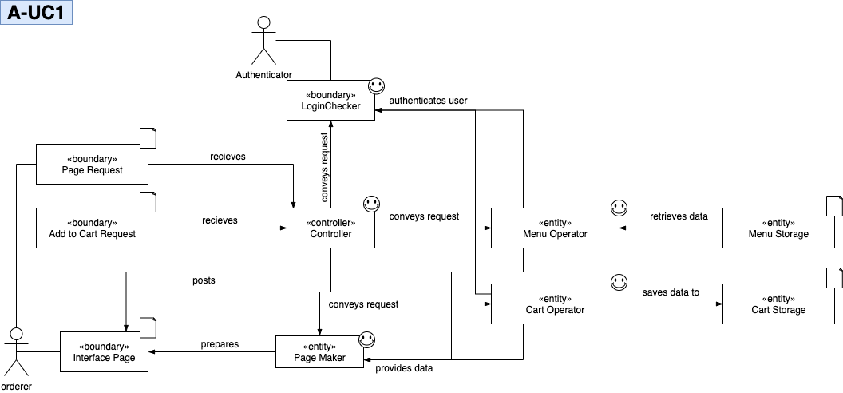

A-UC2 : Manage Cart - generalize UC3, UC4

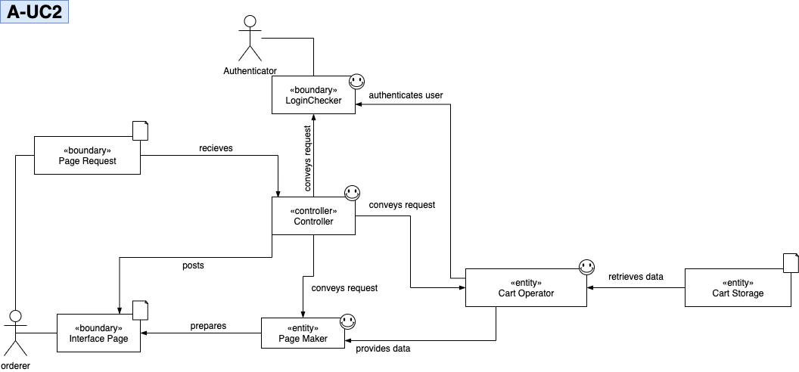

A-UC3 : Modify Cart Item Quantity

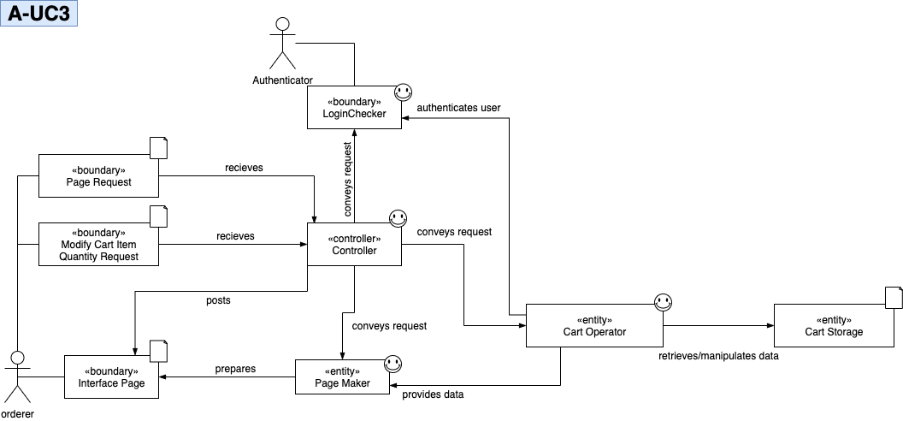

A-UC4 : Remove Cart Item

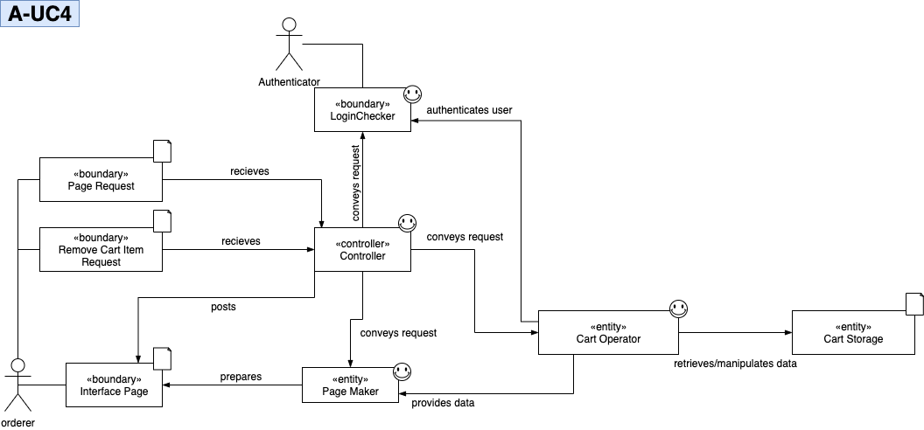

A-UC5 : Order

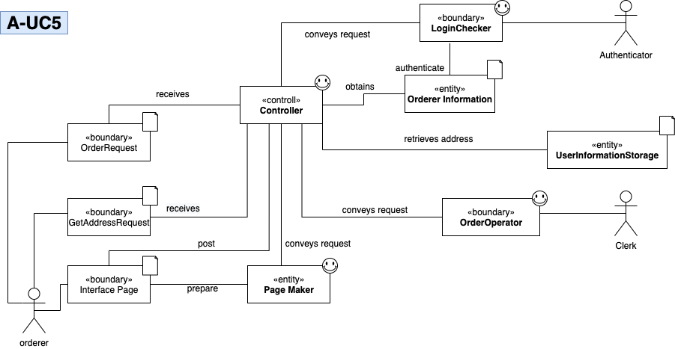

A-UC6 : View Order History

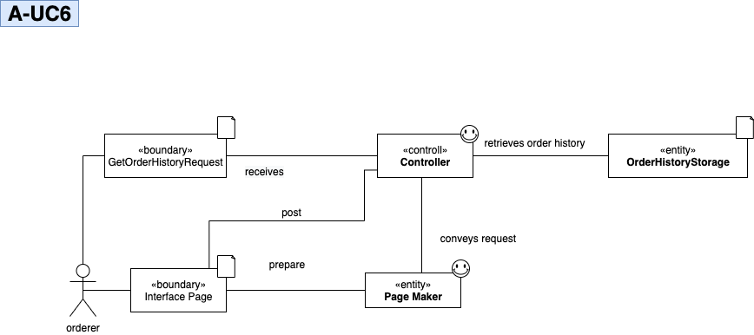

A-UC7 : Cancel Order - include UC6

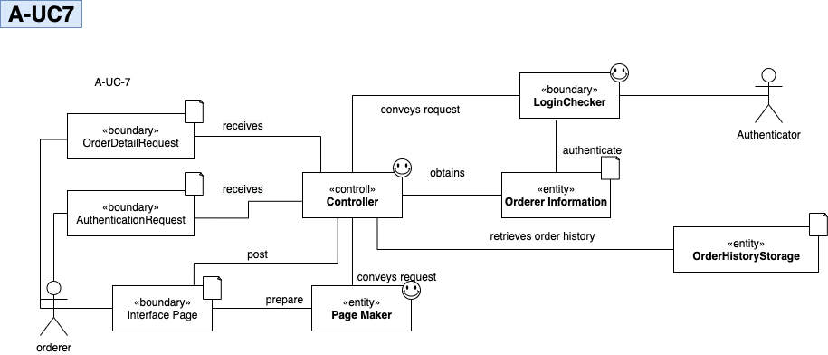

A-UC8 : Pay Online

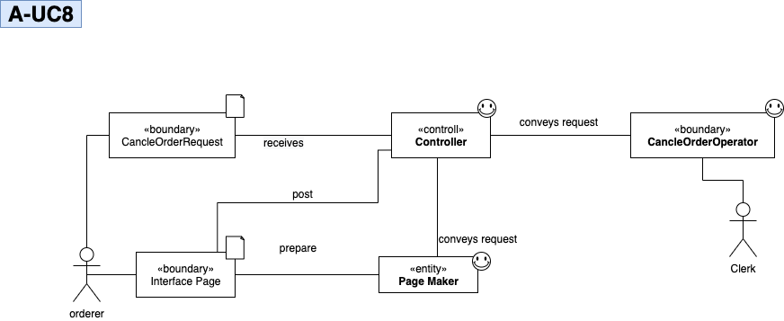

**2.2 SubgroupB(Management)**

B-UC1: AuthenticateUser

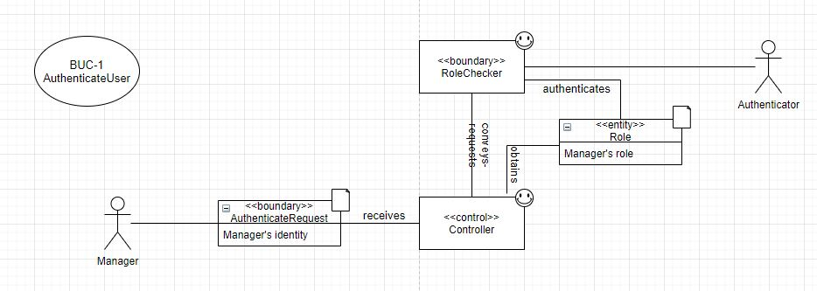

B-UC2:ManageMenus extends B-UC3~B-UC5 includes B-UC1

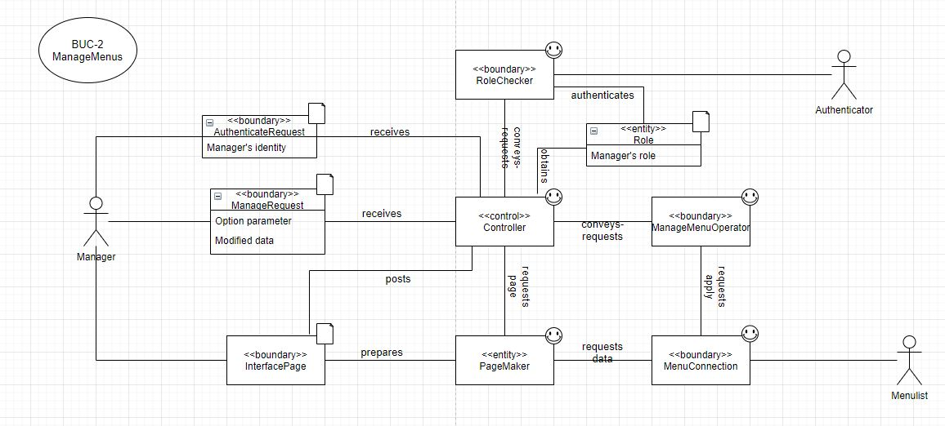

B-UC3:AddMenu

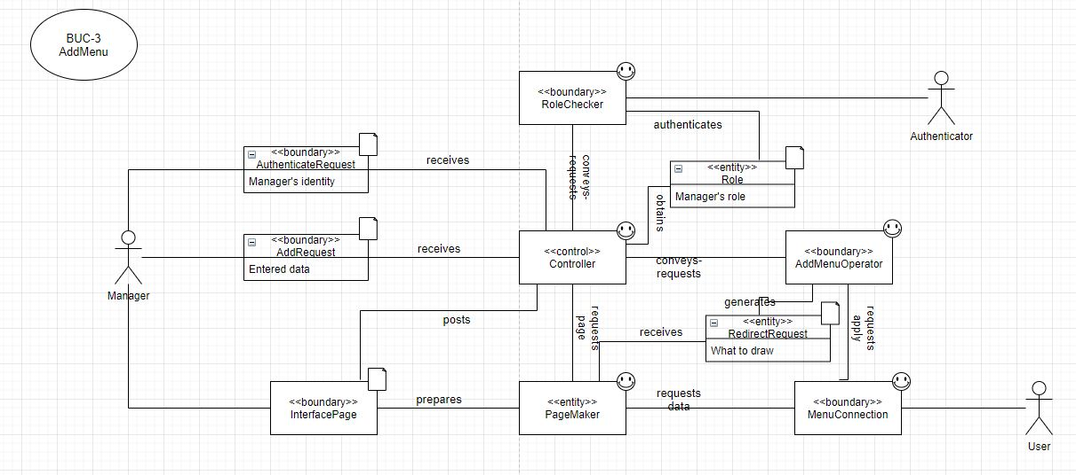

B-UC4:UpdateMenu

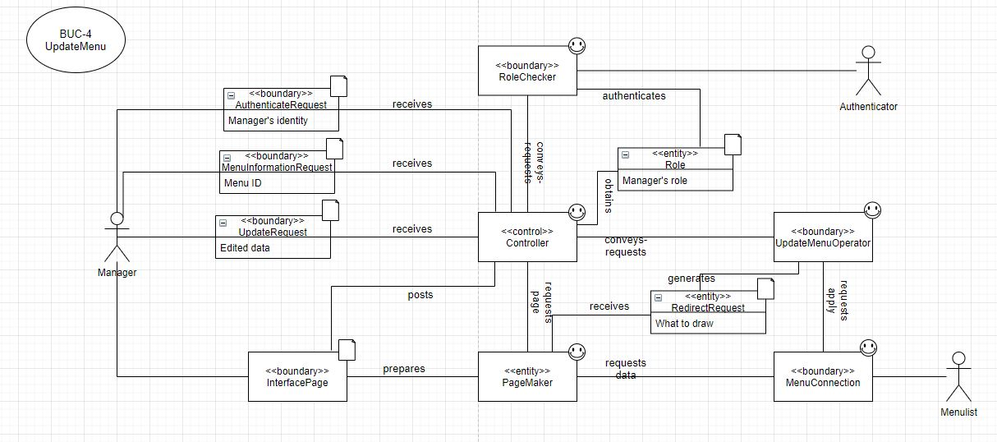

B-UC5:DeleteMenu

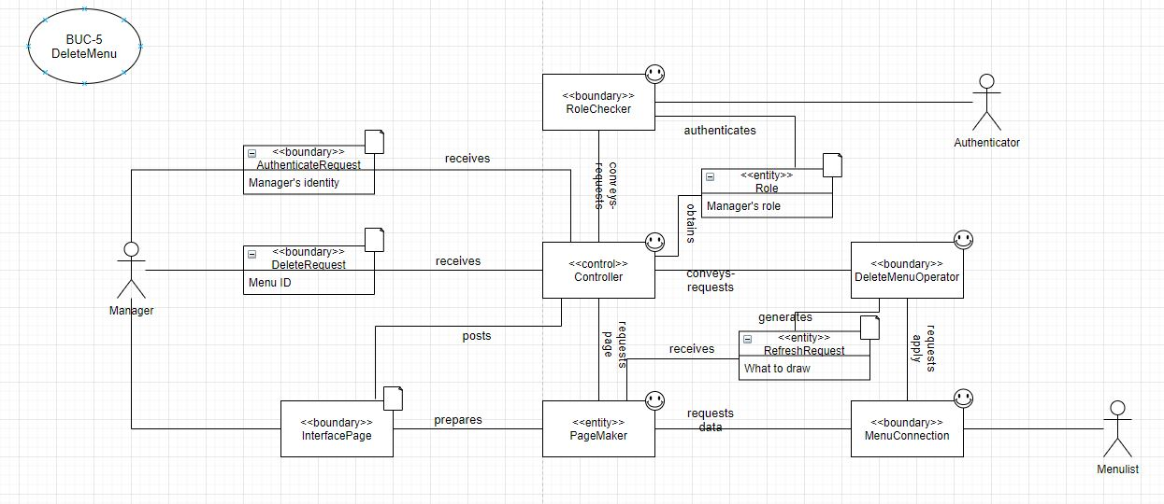

B-UC6:ManageUsers extends B-UC7~B-UC9 includes B-UC1

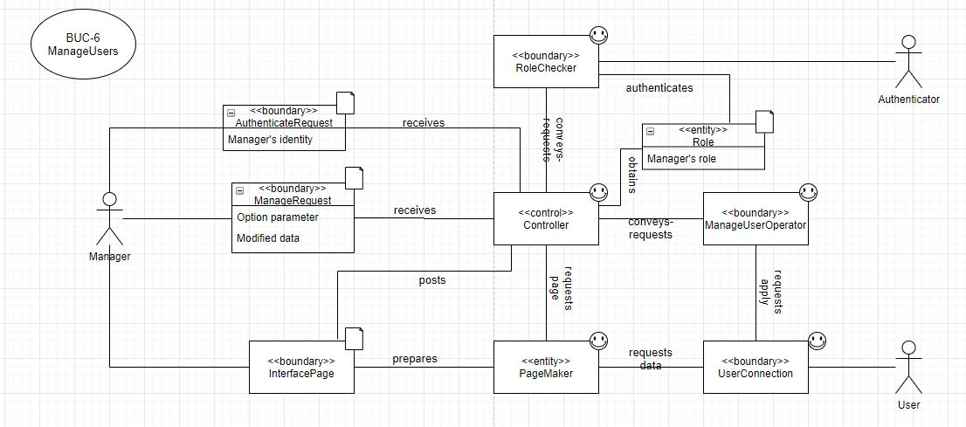

B-UC7:AddUser

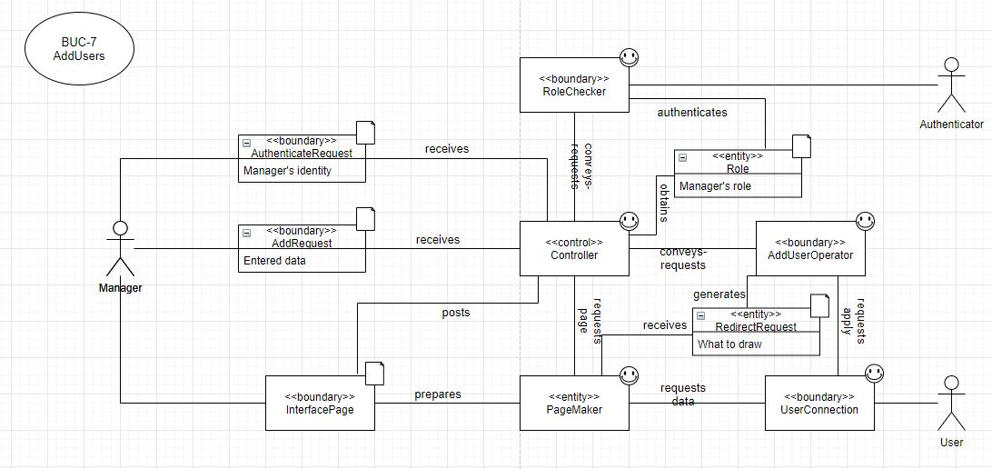

B-UC8:UpdateUser

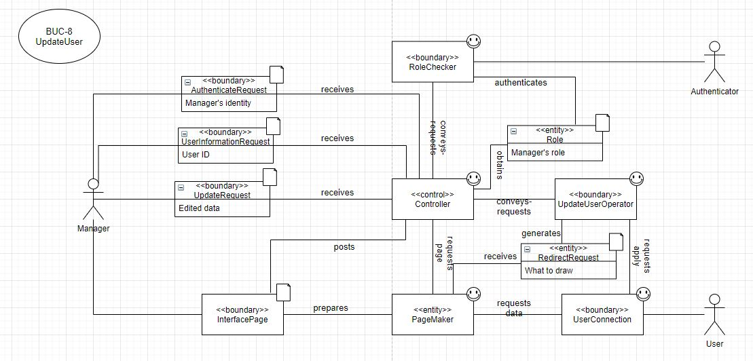

B-UC9:DeleteUser

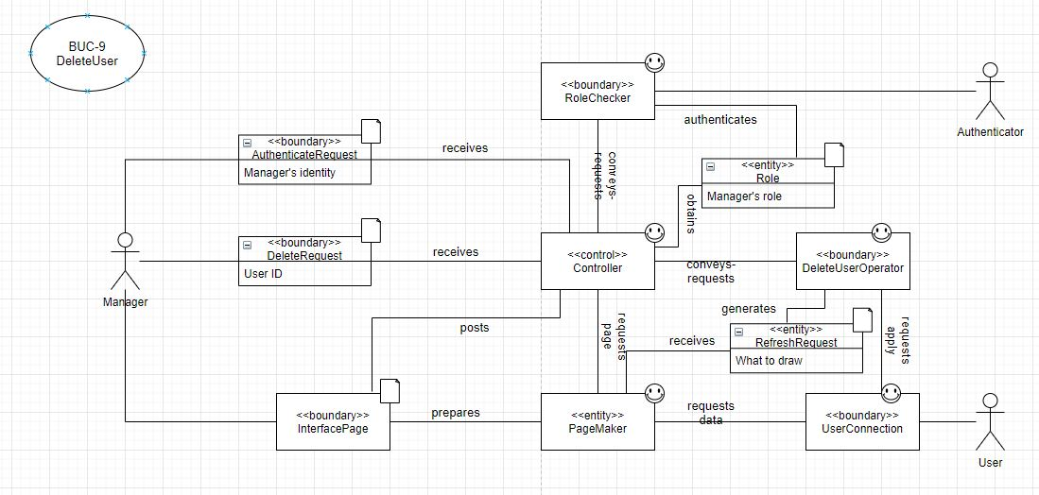

B-UC10:DisplaySales extends B-UC11~B-UC12 includes B-UC1

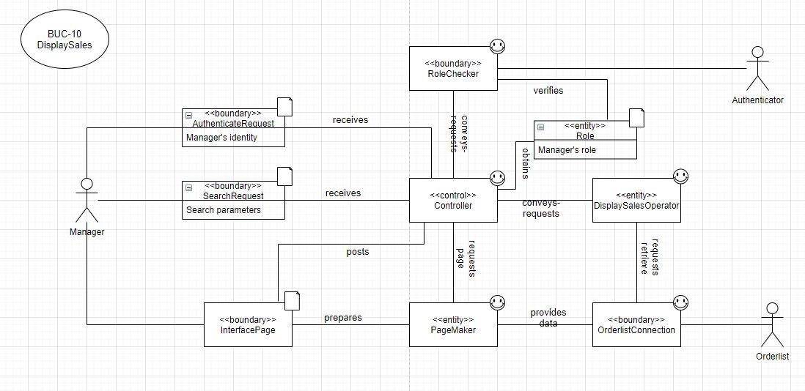

B-UC11: DisplayByPizza

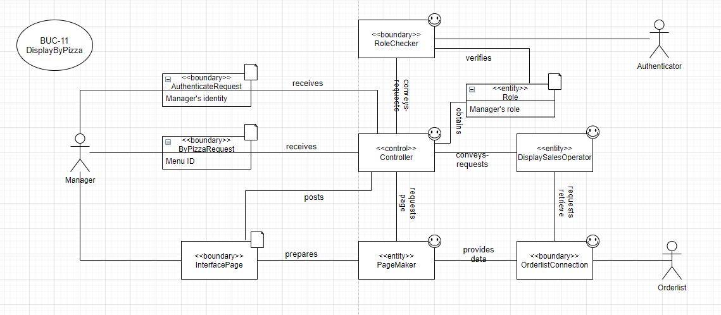

B-UC12: DisplayByPeriod

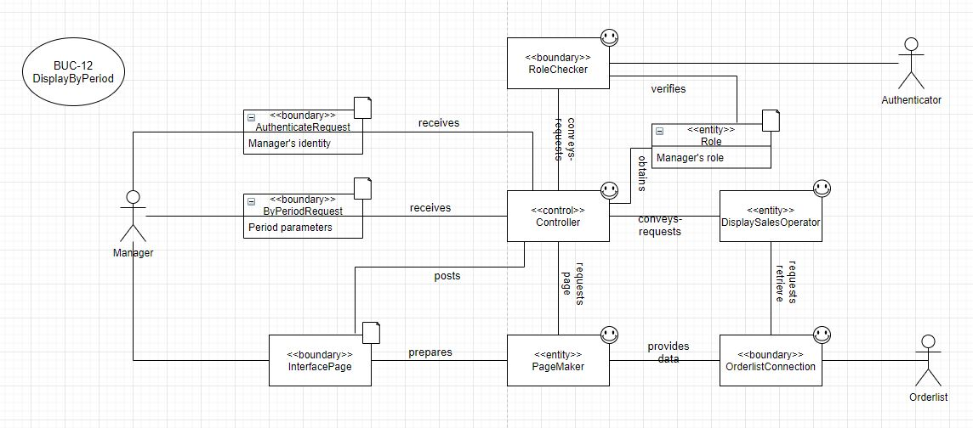

B-UC13: SwitchOpening includes B-UC1

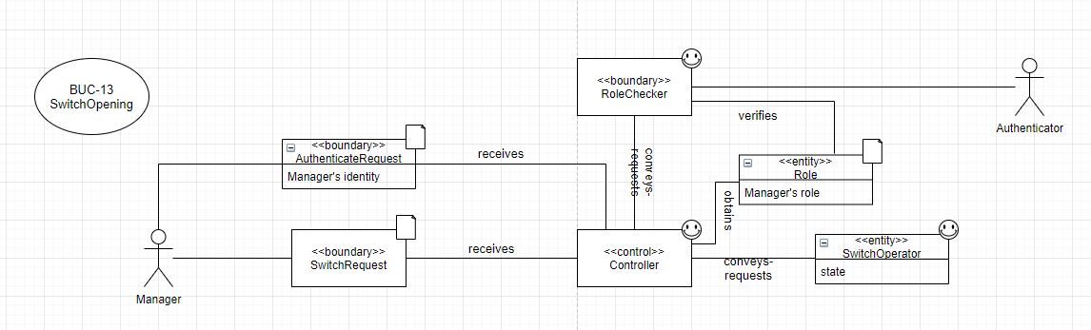

**2.3 SubgroupC(OrderStatus)**

C-UC1: Accept order

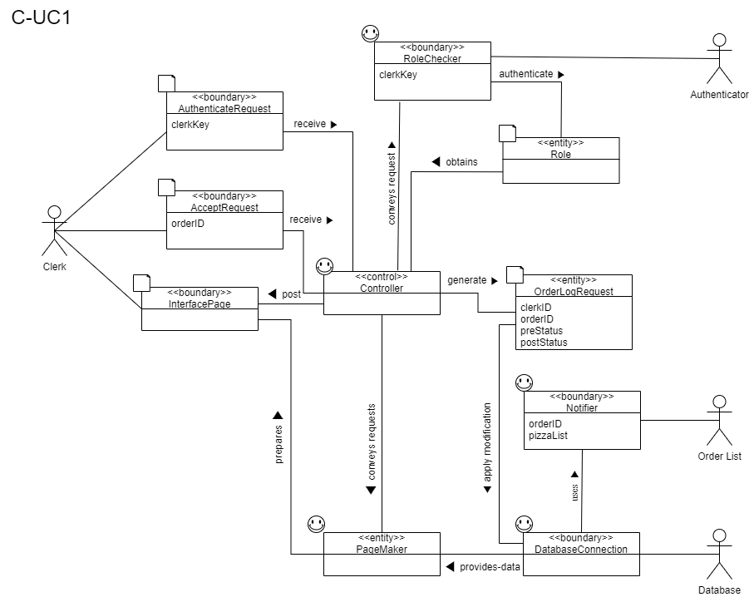

-UC2: Complete Cook

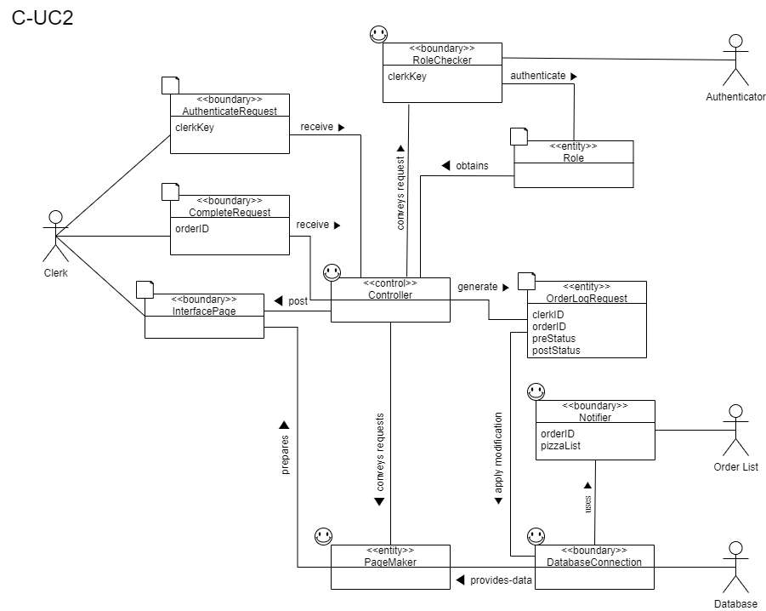

C-UC3: Handle emergency

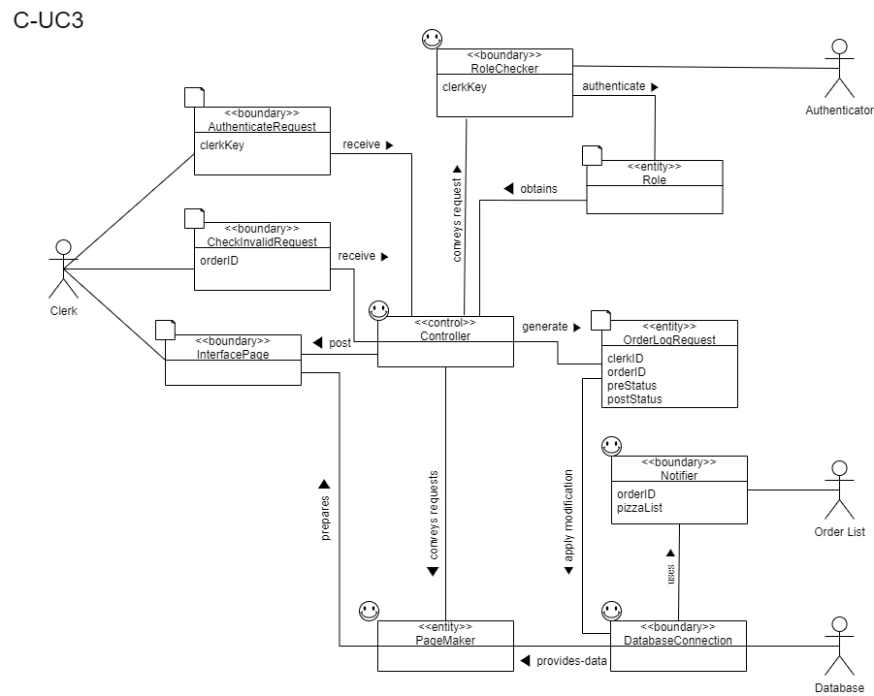

C-UC4: Start Delivery

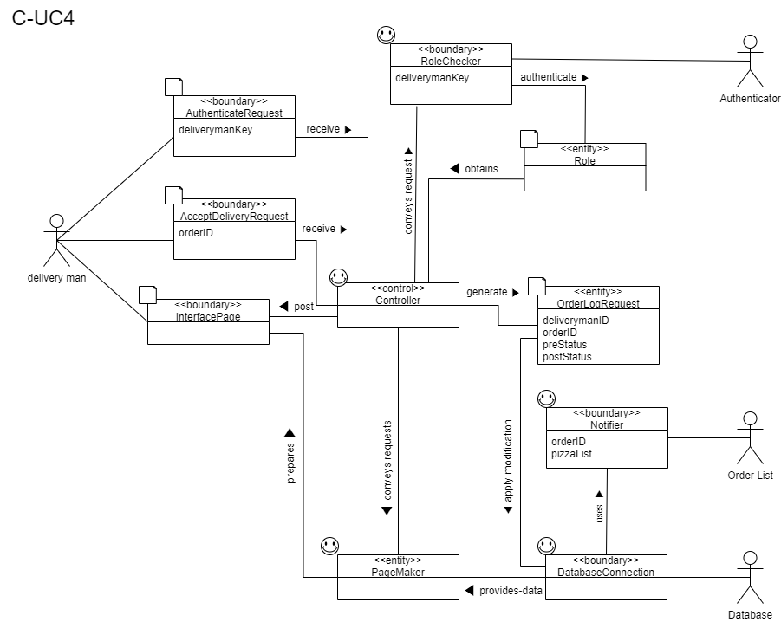

C-UC5: Complete Delivery

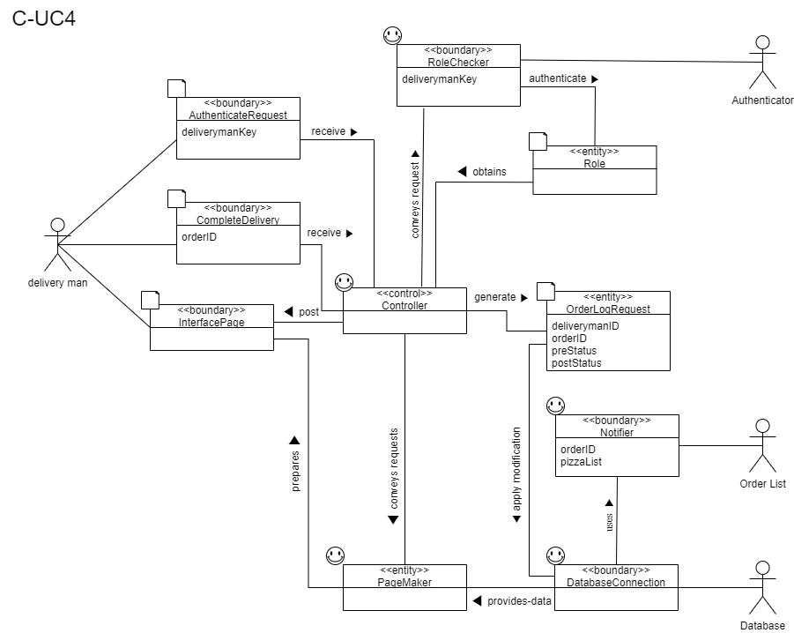

C-UC6: Track order

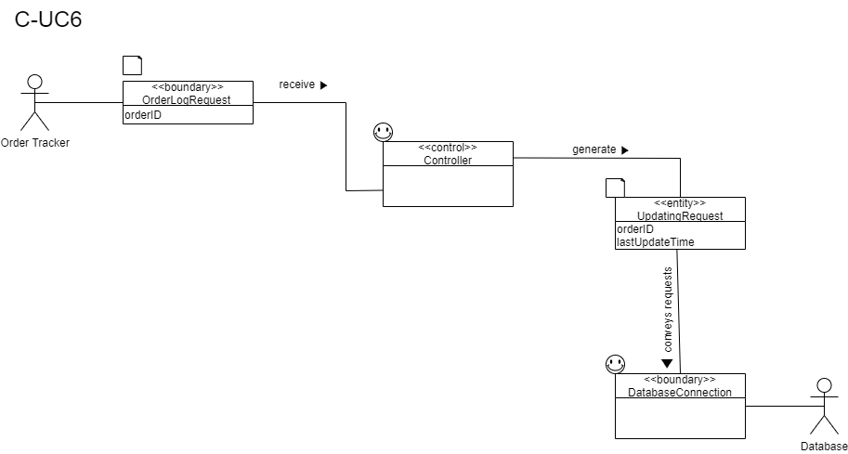

C-UC7: Logout

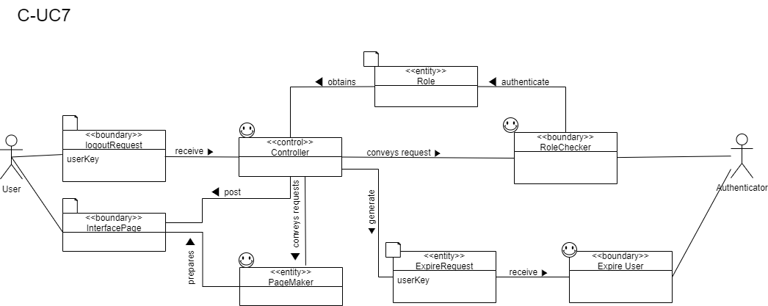

C-UC8: Sign up

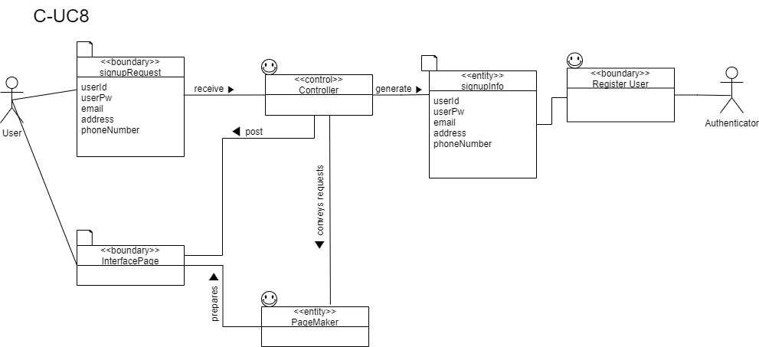

C-UC9: Display user's info page

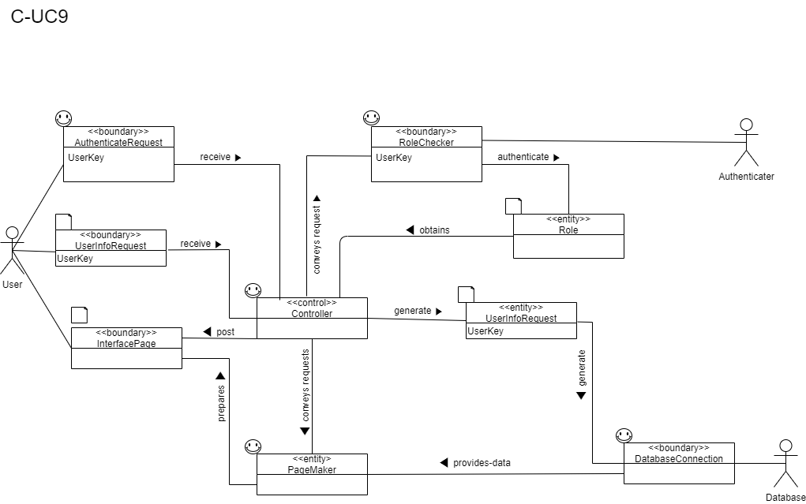

C-UC10: Display Orders

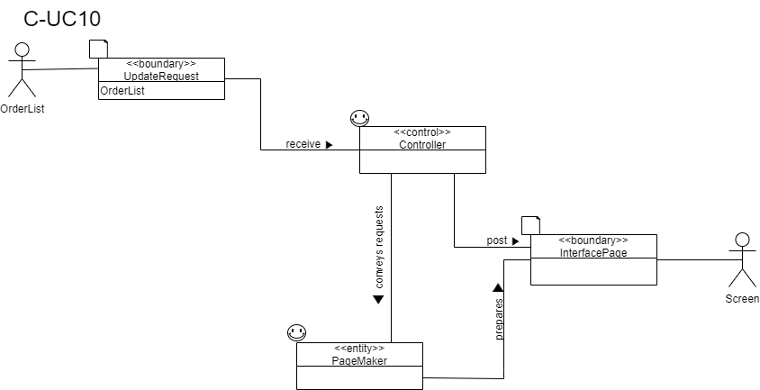

C-UC11: Login User

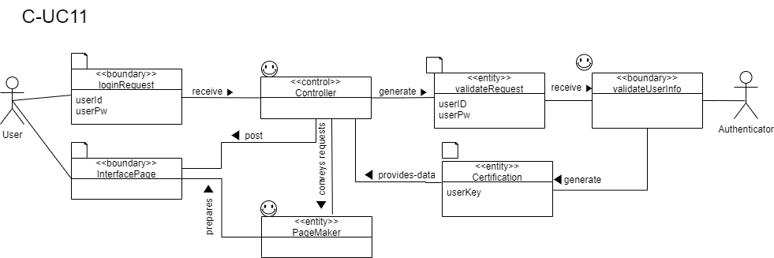

# Traceability Matrix

**3.1 SubgroupA(PizzaOrder)**

|  |  |  |  |  |  |  |  |  |  |  |  |  |  |  |  |  |  |  |  |  |  |  |  |  |
| --- | --- | --- | --- | --- | --- | --- | --- | --- | --- | --- | --- | --- | --- | --- | --- | --- | --- | --- | --- | --- | --- | --- | --- | --- |
|  | pw | GetAddressRequest | OrderRequest | LoginChecker | Orderer Information | UserInformationStorage | OrderOperator | GetOrderHistoryRequest | OrderDetailRequest | OrderHistoryStorage | AuthenticationRequest | CancleOrderRequest | CancleOrderOperator | Menu Storage | Cart Storage | Menu Operator | Cart Operator | Add to Cart Request | Modify Cart Item Quantity Request | Remove Cart Item Request | Page Request | Controller | Page Maker | Interface Page |
| A-UC1 | 21 |  |  | O |  |  |  |  |  |  |  |  |  | O | O | O | O | O |  |  | O | O | O | O |
| A-UC2 | 34 |  |  | O |  |  |  |  |  |  |  |  |  |  | O |  | O |  |  |  | O | O | O | O |
| A-UC3 | 5 |  |  | O |  |  |  |  |  |  |  |  |  |  | O |  | O |  | O |  | O | O | O | O |
| A-UC4 | 8 |  |  | O |  |  |  |  |  |  |  |  |  |  | O |  | O |  |  | O | O | O | O | O |
| A-UC5 | 44 | O | O | O | O | O | O |  |  |  |  |  |  |  |  |  |  |  |  |  | O | O | O | O |
| A-UC6 | 1 |  |  |  |  |  |  | O |  | O |  |  |  |  |  |  |  |  |  |  | O | O | O | O |
| A-UC7 | 1 |  |  | O | O |  |  |  | O | O | O |  |  |  |  |  |  |  |  |  | O | O | O | O |
| A-UC8 | 2 |  |  |  |  |  |  |  |  |  |  | O | O |  |  |  |  |  |  |  | O | O | O | O |
| Total PW | | 44 | 4 | 113 | 45 | 44 | 44 | 1 | 1 | 2 | 1 | 2 | 2 | 21 | 68 | 21 | 68 | 21 | 5 | 8 | 116 | 116 | 116 | 116 |

**3.2 SubgroupB(Management)**

|  |  |  |  |  |  |  |  |  |  |  |  |  |  |  |  |  |  |  |  |  |  |  |  |  |  |  |
| --- | --- | --- | --- | --- | --- | --- | --- | --- | --- | --- | --- | --- | --- | --- | --- | --- | --- | --- | --- | --- | --- | --- | --- | --- | --- | --- |
|  | pw | PageMaker | Controller | InterfacePage | AuthenticateRequest | ManageMeunuRequest | ManageUserRequest | MenuConnection | ManageMenuOperator | RoleChecker | Role | RedirectRequest | MenuInformationRequest | UserInformationRequest | RefreshRequest | UserConnection | ManageUserOperator | SearchRequuest | OrderlistConnection | DisplaySalesOperator | DisplayByPizzaOperator | DisplayByPeriodOperator | ByPizzaRequest | ByPeriodRequest | SwitchRequest | SwitchOperator |
| B-UC-1 | 11 |  | o |  | o |  |  |  |  | o | o |  |  |  |  |  |  |  |  |  |  |  |  |  |  |  |
| B-UC-2 | 10 | o | o | o | o | o |  | o | o | o | o |  |  |  |  |  |  |  |  |  |  |  |  |  |  |  |
| B-UC-3 | 3 | o | o | o | o | o |  | o | o | o | o | o |  |  |  |  |  |  |  |  |  |  |  |  |  |  |
| B-UC-4 | 3 | o | o | o | o | o |  | o | o | o | o | o | o |  |  |  |  |  |  |  |  |  |  |  |  |  |
| B-UC-5 | 3 | o | o | o | o | o |  | o | o | o | o |  |  |  | o |  |  |  |  |  |  |  |  |  |  |  |
| B-UC-6 | 8 | o | o | o | o |  | o |  |  | o | o |  |  |  |  | o | o |  |  |  |  |  |  |  |  |  |
| B-UC-7 | 3 | o | o | o | o |  | o |  |  | o | o | o |  |  |  | o | o |  |  |  |  |  |  |  |  |  |
| B-UC-8 | 3 | o | o | o | o |  | o |  |  | o | o | o |  | o |  | o | o |  |  |  |  |  |  |  |  |  |
| B-UC-9 | 3 | o | o | o | o |  | o |  |  | o | o |  |  |  | o | o | o |  |  |  |  |  |  |  |  |  |
| B-UC-10 | 9 | o | o | o | o |  |  |  |  | o | o |  |  |  |  |  |  | o | o | o |  |  |  |  |  |  |
| B-UC-11 | 4 | o | o | o | o |  |  |  |  | o | o |  |  |  |  |  |  |  | o |  | o |  | o |  |  |  |
| B-UC-12 | 4 | o | o | o | o |  |  |  |  | o | o |  |  |  |  |  |  |  | o |  |  | o |  | o |  |  |
| B-UC-13 | 10 |  | o |  | o |  |  |  |  | o | o |  |  |  |  |  |  |  |  |  |  |  |  |  | o | o |
| Total PW: 74 | | 53 | 74 | 53 | 74 | 19 | 17 | 19 | 19 | 74 | 74 | 12 | 3 | 3 | 6 | 17 | 17 | 9 | 17 | 9 | 4 | 4 | 4 | 4 | 10 | 10 |

**3.3 SubgroupC(OrderStatus)**

|  |  |  |  |  |  |  |  |  |  |  |  |  |  |  |  |  |  |  |
| --- | --- | --- | --- | --- | --- | --- | --- | --- | --- | --- | --- | --- | --- | --- | --- | --- | --- | --- |
|  | pw | AuthenticateRequest | OrderLogRequest | AcceptRequest | CompleteRequest | CheckInvalidRequest | AcceptDeliveryRequest | CompleteDeliveryRequest | UpdatingRequest | LogoutRequest | ExpireRequest | SignupRequest | SignupInfo | UpdateRequest | Certification | ValidateRequest | LoginRequest | UserInfoRequest |
| C-UC-1 | 5 | o | o | o |  |  |  |  |  |  |  |  |  |  |  |  |  |  |
| C-UC-2 | 5 | o | o |  | o |  |  |  |  |  |  |  |  |  |  |  |  |  |
| C-UC-3 | 3 | o | o |  |  | o |  |  |  |  |  |  |  |  |  |  |  |  |
| C-UC-4 | 5 | o | o |  |  |  | o |  |  |  |  |  |  |  |  |  |  |  |
| C-UC-5 | 5 | o | o |  |  |  |  | o |  |  |  |  |  |  |  |  |  |  |
| C-UC-6 | 2 |  | o |  |  |  |  |  | o |  |  |  |  |  |  |  |  |  |
| C-UC-7 | 8 | o |  |  |  |  |  |  |  | o | o |  |  |  |  |  |  |  |
| C-UC-8 | 14 |  |  |  |  |  |  |  |  |  |  | o | o |  |  |  |  |  |
| C-UC-9 | 4 | o |  |  |  |  |  |  |  |  |  |  |  |  |  |  |  | o |
| C-  UC-10 | 2 |  |  |  |  |  |  |  |  |  |  |  |  | o |  |  |  |  |
| C-  UC-11 | 4 |  |  |  |  |  |  |  |  |  |  |  |  |  | o | o | o | o |
| Total PW | | 35 | 25 | 5 | 5 | 3 | 5 | 5 | 2 | 8 | 8 | 14 | 14 | 2 | 4 | 4 | 4 | 8 |