**Explanation Document**

**Software Requirements:**

* Python 3
* Anaconda (Jupyter Notebook)

**Processing Steps**

**Step #1: Data Collection**

* Machines initially learn from the data that we give to them.
* This is the utmost importance to collect reliable data so that your machine learning model can find the correct patterns.
* The quality of the data that you feed to the machine will determine how accurate our model is.
* Data Collection can be done from various sources like kaggle, UCI etc.,
* NSL-KDD dataset: <https://www.kaggle.com/datasets/hassan06/nslkdd>

**Step #2: Data Preprocessing:**

* Data preprocessing is a process of preparing the raw data and making it suitable for a machine learning model.
* It is the first and crucial step while creating a machine learning model.
* First, Importing the necessary libraries

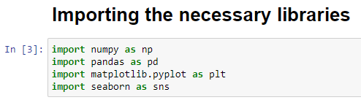

* Next, then Load the dataset as a DataFrame using the pandas library.

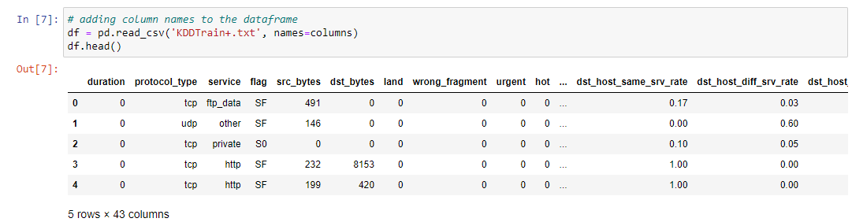

* We will leverage several Pandas features and properties to understand some basic information.
* ****.head()**** - This allow us to view an arbitrary number of rows (by default 5) from the beginning or end of the dataset.
* **.shape() -** This returns us a pair of numbers that represent the dimensionality(rows and columns) of our dataset.

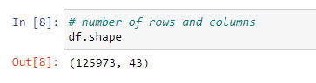

* ****.describe() -** This** provides statistical information about the dataset.

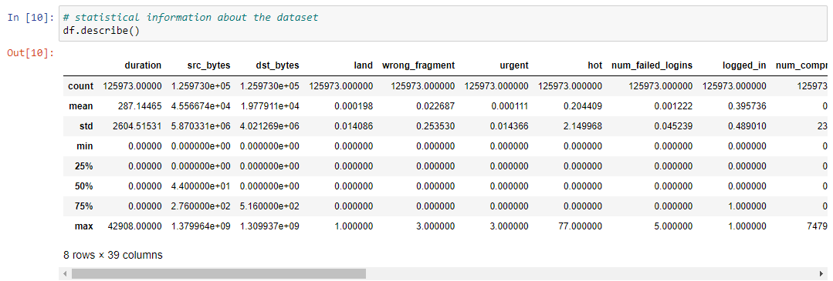

* ****.info()-** This gives** us information about the data type, non-null values and memory usage.

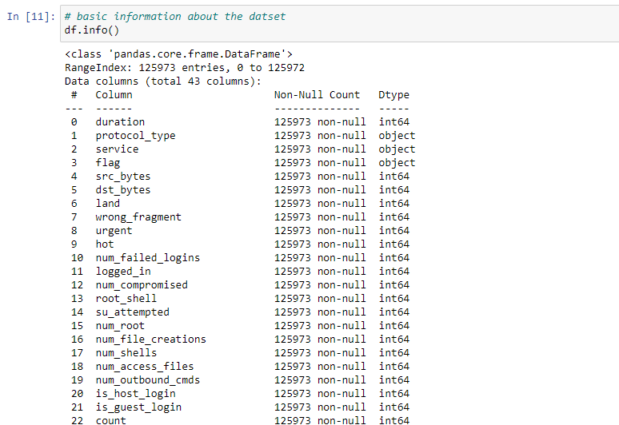

**Finding Missing Data**

The next step of data preprocessing is to handle missing data in the datasets. If our dataset contains some missing data, then it may create a huge problem for our machine learning model.

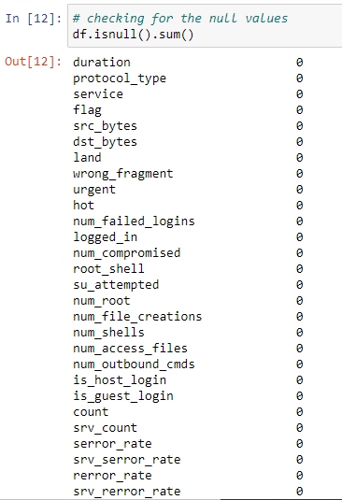

We don’t have null values in our dataset.

**Categorical Variables**

****.value_counts() -** This** is one of the most important functions to understand how many values of a given variable there are in our dataset.

Let’s do it with the target variable,

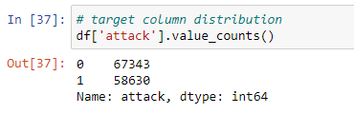

Visualizing the above one, with the help of countplot(),

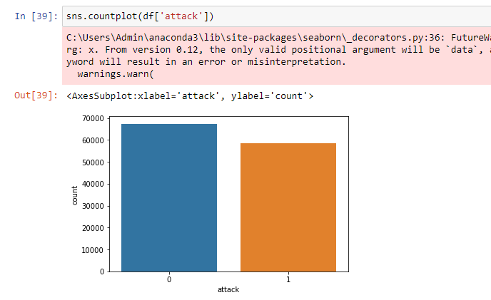

**Label Encoding**

* In machine learning, we usually deal with datasets that contain multiple labels in one or more than one columns.
* These labels can be in the form of words or numbers.
* **Label Encoding** refers to converting the labels into a numeric form so as to convert them into the machine-readable form.

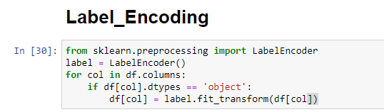

**Feature Selection**

* ****Feature selection**** is the process of reducing the number of input variables when developing a predictive model, to both reduce the computational cost of modeling and, in some cases, to improve the performance of the model.

**Feature Selection using Chi-Square Test**

* Chi-square test is used for categorical features in a dataset.
* We calculate Chi-square between each feature and the target and select the desired number of features with best Chi-square scores.

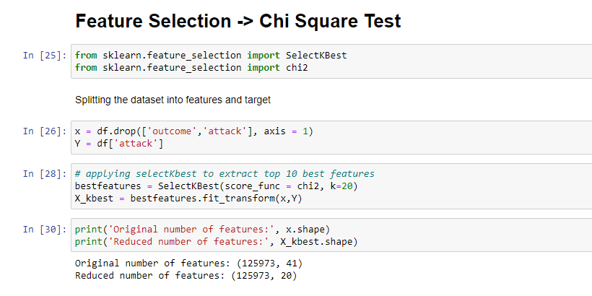

**Standard Scaling**

**StandardScaler** follows **Standard Normal Distribution (SND)**. Therefore, it makes *mean = 0* and scales the data to unit variance.

