**OPERATION OF NIRS BOX USING TRS**

*(Antonio Pifferi, 12/12/2017)*

**SOFTWARE:**

* TRS ≥ version 15.0 (Beta\Work\Programs\NirsBox)
* Using NIRS_DLL_v2.dll (included in TRS) – not necessary
* Standalone exe: NIRS-Box_v2 (Beta\Work\Programs\NirsBox) – not necessary

**START (ONLY AT THE BEGINNING OF THE DAY):**

* Open Window->NirsBox
* Press “NIRS Box” button (initially OFF)
* Wait for confirmation
* Set/Check Laser parameters on same window (Freq, Time, Lambda)
* Press “NIRS Laser” button (initially OFF)
* Wait for confirmation

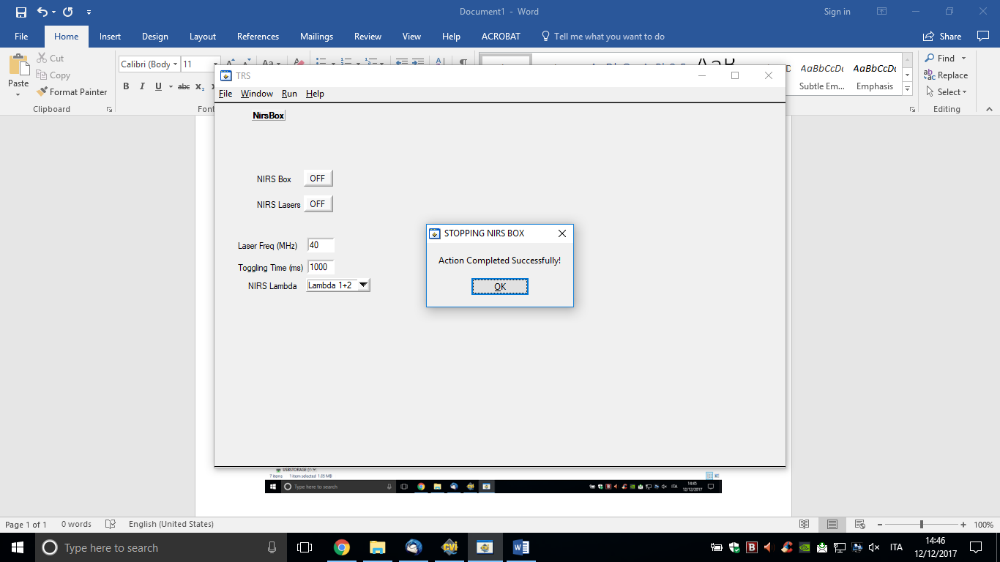

**MEASUREMENT/OSCILLOSCOPE:**

* Select Type=NIRS, Wait=SPC, ClearData=OFF, StopData=OFF
* In case you selected Lambda=LAMBDA 1+2, you have 2 curves on channels #1 (LAMBDA2) and #2 (LAMBDA1)
* You can change FREQ, LAMBDA under the NirsBox Window
* Time (Meas or Oscill) is the TOTAL time for the single or double lambda (i.e. 2 lambda =50% of the time each)
* Run Operation as usual

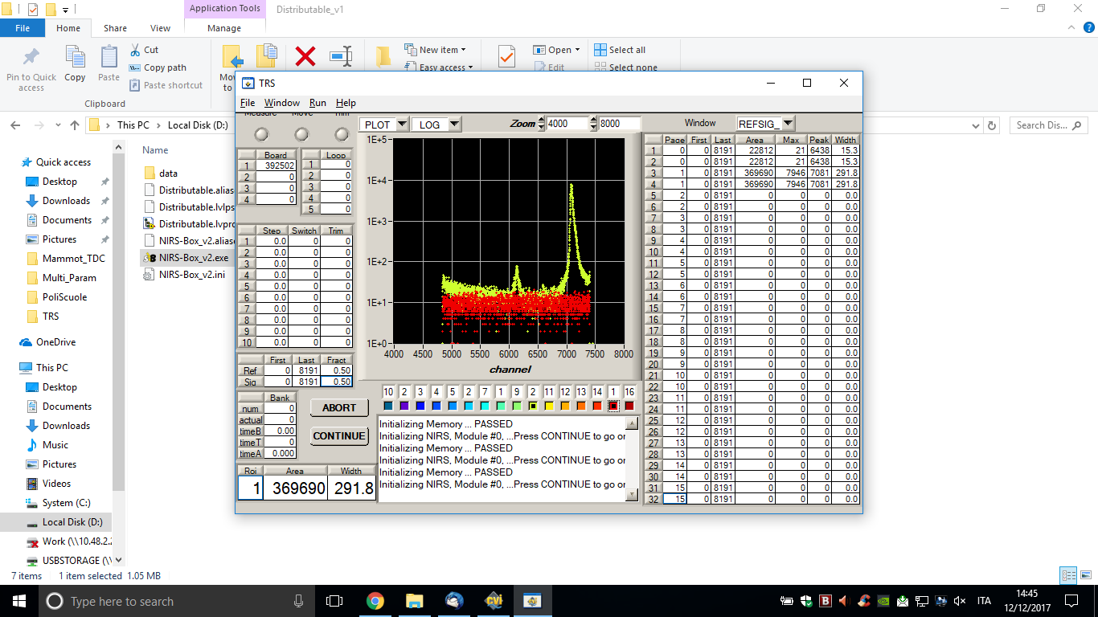

**STOP (ONLY AT THE END OF DAY):**

* Open Window->NirsBox
* Press “NIRS Laser” button (now in ON)
* Wait for confirmation
* Press “NIRS Box” button (now in ON)
* Wait for confirmation

**NOTES:**

* Minimum Acquisition Time = 0.5 s (total for 2 lambda)
* Calib (ps/ch) and Factor (ps/ch) automatically defined (9.77 ps/ch)
* Scale by now is not operative (could be implemented to bin in time and reduce #channels)
* Better not to START/STOP the Laser many times and at short intervals (1 min)
* Remember to STOP Laser and Board at the End (need for automatic control?, not straightforward)