Q1 Describe the Joux’s three-party Diffie-Hellman protocol

Q2 What is the (min) order of the following multiplicative groups defined by the chosen parameters p and g:
[hint: 593, 1187, 3559 primes, with 1187 = 2 x 593 + 1 and 3559=593 x 2 x 3+1 → with the exception of (2), no need to do any modular exponentiation! – NOTE: EXPLAIN YOUR ANSWER otherwise answer is not valid]

1) g^{x} mod p, with g=1186, p=1187
Order 2: 1186 is -1

2) g^{x} mod p, with g=7, p=1187
Must check 7^593 mod 1187 → -1 → g is generator of the full group, order 1186

3) g^{x} mod p, with g=9, p=1187
9 = 3^2 = 3^2 mod 1187, g is QR, order is (p-1)/2 = 593

4) g^{x} mod p, with g=64, p=3599
Just note that 64 is 2^6 → order is (p-1)/6 = 593

Q3 Describe the Pedersen Verifiable Secret sharing

Q4 Being e: GxG→Gt a bilinear map, and g a generator of G, simplify the expression:

e(gª g^{b}, g^{c} g^{d}) / e(g^{ac}, g^{bd})

E1. Consider the Elliptic curve y² = x³ - 2x - 3 defined over the modular integer field Z₅.
- find all the points EC(Z₅) and state what is the order of the corresponding group
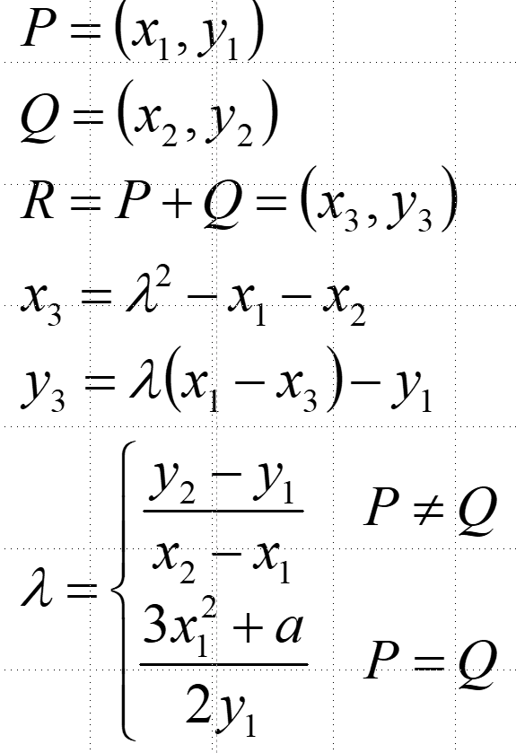

- Compute [4](1,1)
[HELP: possibly useful mnemonic hints reported here on the right;
MUST-DO: show step-by-step detailed computations; try to minimize the number of EC additions]

points: 0, (1,1), (1,4), (2,1), (2,4)
order: 5
[4](1,1) = [2] ((1,1)+(1,1)) = [2] (2,1) = (2,1)+(2,1) = (1,4)

E2 – Secret Sharing and Threshold RSA. A group of four parties forms a (3,4) secret sharing scheme. Using ordinary arithmetic (no moduli) parties P_{i}={1,2,3,4} are dealt with shares σ_{i} of a key SK, which is the private key of an RSA scheme with modulus n=91 and public key PK=5.

A. Using shares σ₁=34, σ₂=41, σ₄=61, reconstruct the secret key SK and verify that it is the correct one for the considered RSA public key PK;

Lambda1=8/3, lambda2=-2, lambda4=1/3;
8/3*34-2*41+1/3*61 = 29 → OK because 29 = PowerMod[5,-1,72] being 72 = EulerPhi[91]

B. If the attacker only knows shares σ₁ and σ₄, and does not yet know share σ₂, what’s his/her advantage in terms of chances to guess the secret key versus a pure random guess?

Double chance to guess, as the secret key must be odd: being x the unknown value of the share,
8/3*34-2*x+1/3*61=111-2x hence sk must be odd.[note: we are NOT accounting for the fact that sk is an RSA key so it also must be odd… i.e. strictly speaking in this very specific case there is no real advantage]

C. Using the Shoup construction, show step by step how the three parties P1, P2 and P4 can distributely compute a threshold RSA signature for the message m=15, and verify that the result is correct by directly computing the signature using the SK value computed before.
[NOTE: if you prefer, to simplify computation instead of using the full L! you can use the minimum value that permits to make all lambda coefficients integer] [HINT: 15⁻¹ mod 91 =85]

Since lambda denominators are at most 3, each party computes m^(3*lambda_i*sigma_i)] mod 91= {22,64,15}. Multiplying mod 91, m^(3d) = 8. But we also know that m^ed = m^(59d)=m=15.

Now we can apply the common modulus attack: ExtendedGCD[59,3] = {-1,20}. Hence
Msigned = 8^20*15^(-1) mod 91 = 64*85 mod 91 = 71 → check: PowerMod[15,29,91]=71 OK

