Q1. Determine whether the following statements are true or false or Not-applicable/meaningless (i.e. the sentence is badly formulated or refers to something impossible/wrong).

In ECDSA, for providing IND-CPA (semantic) security, the nonce used must be always fresh | V F N/A
In ECIES, for providing IND-CPA (semantic) security, the nonce used must be always fresh | V F N/A
In El Gamal, for providing IND-CPA security, the nonce used must be always fresh | V F N/A
ECDSA security relies on the hardness of the factorization problem over elliptic curves | V F N/A
The order of an elliptic curve group built on Zp with p prime is either p or a multiple of p | V F N/A
In a (4,4) secret sharing scheme using arithmetic modulo n, n must be a prime number | V F N/A
The Shamir secret sharing is unconditionally secure | V F N/A
A verifiable secret sharing using the Pedersen Commitment is unconditionally secure | V F N/A
The Pedersen Commitment is perfectly hiding | V F N/A
Unlike Shamir, a trivial secret sharing scheme cannot be ideal | V F N/A

Q2. Part 1: Describe the Boneh-Franklin’s Identity Based Encryption scheme
Part 2: Show how the user private key can be computed via a PKG system distributed among two
parties so that neither party is able, alone, to know the users’ private keys.
Q3. Let P be an EC point. What is the minimum number of EC sums/doubles necessary to compute [193]P?

193 in binary is: 1100.0001
Then, 7 doubles and 2 additions = 8.

Q4 Assume arithmetic modulus 100. A Linear secret sharing scheme involving 4 parties is described by the following access control matrix:
A: 1 1 0 0
B: 0 1 1 0
C: 0 0 1 1
D: 0 0 0 1
Assume that the following shares are revealed: A → 15, B → 27, C → 33, D→41
What is the secret?

A-B+C-D = 80.

Q5. Consider the Elliptic curve EC(Z₇): y² = x³ + x defined over the modular integer field Z₇.
- Verify that (0,0) is a point of the curve, and (without any computation) determine (0,0)+(0,0).
- find all the remaining points of the curve.

(0,0) + (0,0) = 0 (y=0 implies that the “intercept” is at infinity, hence no need to do any computation of course – besides, computation would anyway give 0/0…)
[COMMON MISTAKE: 0 is NOT (0,0) → (0,0) is a “normal” point in the curve… the point at infinitiy is a supplementary one!]

All points: (0,0), (1,3), (1,4), (3,3), (3,4), (5,2), (5,5), and 0

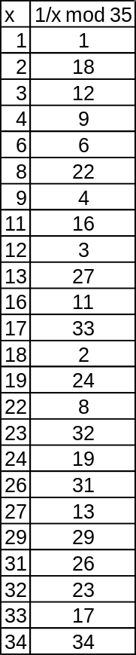
Q6. A Shamir Secret Sharing scheme uses a non-prime modulus p=35 (if you need modular inverses see table on the right). Of the 5 participating parties P₁,…,P₅, with respective x coordinates x_{i} = {1,2,3,4,5}, parties P1, P2 and P4 aim at reconstructing the secret.
a) compute the Lagrange Interpolation coefficients for parties 1, 2, 4.
b) Reconstruct the secret, assuming that the shares are:
P1 → 33
P2 → 4
P4 → 21
c) Does the knowledge of the two shares P1 and P2 leak information about the secret?

a) Lambda 1/2/4 = {26,33,12}

b) secret = 17

c) Unlike what we could expect, in this SPECIFIC CASE we are still ok! Indeed, if share 4 is not known (call it D), then the secret is given by the expression

S = 33 x 26 + 4 x 33 + D x 12 mod 35 = 10 + 12 D mod 35

But since 12 is (luckily) still coprime with 35, for any value of D in the range (0,34) we have a different value of S!
(you can also see this via brute force:
Mod[10+12 Range[0,34] → {10,22,34,11,23,0,12,24,1,13,25,2,14,26,3,15,27,4,16,28,5,17,29,6,18,30,7,19,31,8,20,32,9,21,33}

Q7 An RSA system has the following parameters: modulo n=253, public key e=3. Assume we are NOT able neither to factorize n nor gather or compute the corresponding private key d. Despite this, we wish to compute the RSA signature 19^{d} mod n for message m=19.
1) Show how this is possible if we know that 19^{5d} = 10 mod n, and
2) numerically compute the signature.
[here a few modular inverses with might (might not) be useful: {3, 5, 10, 19, 100}⁻¹ mod n → {169,152,76,40,210}]

Remember Shoup’s lecture and just apply Common modulus attack using (all what follows is mod n)
M₁ → 19^{5d} = 10
M₂ → 19^{ed} = 19^{3d} = 19
Since ExtendedGCD[5,3] = {-1,2} we just need to compute
19^{d} = M₁⁻¹ x M₂² = 76 x 108 = 112
You can check that this is correct by explicitly computing the signature using d=147

