Q1. Determine whether the following statements are true or false or Not-applicable/meaningless (i.e. the sentence is badly formulated or refers to something impossible/wrong).

In ECDSA, for providing IND-CPA (semantic) security, the nonce used must be always fresh | V F N/A
In ECIES, for providing IND-CPA (semantic) security, the nonce used must be always fresh | V F N/A
In El Gamal, for providing IND-CPA security, the nonce used must be always fresh | V F N/A
ECDSA security relies on the hardness of the factorization problem over elliptic curves | V F N/A
The order of an elliptic curve group built on Zp with p prime is either p or a multiple of p | V F N/A
In a (4,4) secret sharing scheme using arithmetic modulo n, n must be a prime number | V F N/A
The Shamir secret sharing is unconditionally secure | V F N/A
A verifiable secret sharing using the Pedersen Commitment is unconditionally secure | V F N/A
The Pedersen Commitment is perfectly hiding | V F N/A
Unlike Shamir, a trivial secret sharing scheme cannot be ideal | V F N/A

Q2. Part 1: Describe the Boneh-Franklin’s Identity Based Encryption scheme
Part 2: Show how the user private key can be computed via a PKG system distributed among two
parties so that neither party is able, alone, to know the users’ private keys.
Q3. Let P be an EC point. What is the minimum number of EC sums/doubles necessary to compute [193]P?

Q4 Assume arithmetic modulus 100. A Linear secret sharing scheme involving 4 parties is described by the following access control matrix:
A: 1 1 0 0
B: 0 1 1 0
C: 0 0 1 1
D: 0 0 0 1
Assume that the following shares are revealed: A → 15, B → 27, C → 33, D→41
What is the secret?

Q5. Consider the Elliptic curve EC(Z₇): y² = x³ + x defined over the modular integer field Z₇.
- Verify that (0,0) is a point of the curve, and (without any computation) determine (0,0)+(0,0).
- find all the remaining points of the curve.

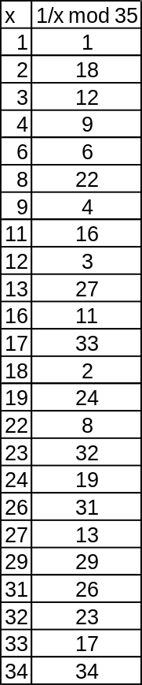
Q6. A Shamir Secret Sharing scheme uses a non-prime modulus p=35 (if you need modular inverses see table on the right). Of the 5 participating parties P₁,…,P₅, with respective x coordinates x_{i} = {1,2,3,4,5}, parties P1, P2 and P4 aim at reconstructing the secret.
a) compute the Lagrange Interpolation coefficients for parties 1, 2, 4.
b) Reconstruct the secret, assuming that the shares are:
P1 → 33
P2 → 4
P4 → 21
c) Does the knowledge of the two shares P1 and P2 leak information about the secret?

Q7 An RSA system has the following parameters: modulo n=253, public key e=3. Assume we are NOT able neither to factorize n nor gather or compute the corresponding private key d. Despite this, we wish to compute the RSA signature 19^{d} mod n for message m=19.
1) Show how this is possible if we know that 19^{5d} = 10 mod n, and
2) numerically compute the signature.
[here a few modular inverses with might (might not) be useful: {3, 5, 10, 19, 100}⁻¹ mod n → {169,152,76,40,210}]

