Exploring the Intricate Relationship between Artificial Intelligence and Healthcare Organizations
Lorella Cannavacciuolo¹[0000-0001-7740-7595], Paolo Mancuso²[0000-0003-2249-2766] and Alessandro Scarpa²[0009-0003-3507-9257]
¹ Dept of Industrial Engineering, University of Naples Federico
Piazzale Tecchio,80 – corresponding author: lorella.cannavacciuolo@unina.it
² Dept of Enterprise Engineering, University of Rome "Tor Vergata"
Via del Politecnico, 1
Abstract. This paper explores the role of Artificial Intelligence (AI) in the healthcare industry through a literature review based on Latent Dirichlet Allocation (LDA) topic modelling. While previous reviews have employed narrative or systematic approaches grounded in keyword co-occurrence, citation networks, or predefined topic categories, this study adopts an unsupervised learning technique capable of identifying latent themes within large volumes of unstructured data. This methodological shift allows for a more nuanced and dynamic understanding of emerging trends in AI applications across diverse healthcare domains. The literature review, conducted in the ISI Web of Science Core Collection, initially identified 36,113 documents. Applying exclusion criteria (English-language, Q1 peer-reviewed journals, ≥5 citations, complete metadata) reduced the dataset to 1,962 papers. The findings reveal three overarching themes that underpin the integration of AI in healthcare: data, algorithms, and decision support systems. These elements are tightly interlinked and collectively essential to successful AI implementation. This study contributes to the growing body of research by identifying the key thematic areas that guide AI integration in healthcare and by highlighting the importance of a holistic approach. It offers valuable insights for researchers, practitioners, and policymakers seeking to understand the evolution of AI in healthcare and to promote more effective, ethical, and robust implementations.
Keywords: Artificial Intelligence in Healthcare, Topic analysis, Latent Dirichlet Allocation (LDA).
- Introduction
Artificial Intelligence’s (AI) integration in healthcare is reshaping medical practice by enhancing diagnostics, predicting patient deterioration, personalizing treatments, and optimizing administrative tasks [1], improving both clinical outcomes and system efficiency.
Recent literature reviews highlight the need to explore how AI is transforming healthcare organizations. [2] recognize AI’s key role in enhancing clinical decision-making in six domains: data analytics, diagnostic modelling, personalized medicine, telehealth, administrative efficiency, and decision support. [3] emphasize AI applications in imaging, virtual care, research, patient engagement, rehabilitation, and administration. [4] identify four key roles: diagnostics, system efficiency, telemedicine, and drug development. Studies also address AI's challenges, such as data integration, privacy, legal issues, and safety [3,5], which involve technologies like machine learning (ML), natural language processing (NLP), and robotics [6].
These technological advancements have profoundly shaped AI’s roles in healthcare, with applications closely tied to the specific needs and challenges of the sector, which in turn guide their implementation in clinical settings.
Against this backdrop, this study investigates how AI is transforming healthcare by identifying the key themes driving this process. The research question is:
What overarching themes guide healthcare transformation through AI?
Addressing this question allows us to capture the multiple perspectives of AI integration and to provide a comprehensive view of its impact on healthcare delivery.
- Methodology
The literature review is based on Latent Dirichlet Allocation (LDA) topic modelling [7]. Unlike previous reviews, the use of LDA, an unsupervised ML approach, allows for the uncovering of latent themes in a large corpus of unstructured data, identifying emerging trends in AI applications across healthcare domains.
LDA assigns topics fractionally, assuming that documents consist of multiple themes, each represented by a probability distribution. This reduces subjective errors in topic classification compared with discrete assignment methods. In line with this advantage, LDA has been applied in various AI-related research [6,8]. Finally, a standard NLP procedure (see Section 3) ensures results’ consistency and reliability, determining the optimal number of topics, which is a critical step.

2.2 Data selection
We performed a literature search in the ISI Web of Science (WoS) Core Collection using the query: ((AI AND health) OR (artificial intelligence AND health) OR (AI AND hospital*) OR (artificial intelligence AND hospital*) OR (AI AND healthcare*) OR (artificial intelligence AND healthcare*)) NOT (aortic AND insufficiency). This approach provided broad coverage while excluding unrelated topics (e.g., “aortic insufficiency”), aligning with [6] on avoiding topic drift in LDA-based bibliometric analyses.
The search initially retrieved 36,113 documents. Limiting results to English-language journal articles and excluding book chapters, conference abstracts, and posters reduced the set to 22,733 records. After restricting the dataset to Q1-ranked journals in the SCImago Journal Rank (SJR), 13,202 articles remained. Subsequently, excluding articles with fewer than five citations [9] and incomplete metadata, the final dataset comprised 1,962 articles.
- Results

LDA revealed key themes in the expanding AI-healthcare literature, clarifying how AI integrates across domains. It highlighted dominant and emerging topics, guiding future research and applications. To select the optimal number of topics and ensure coherence, we applied two topic coherence metrics [10,11], identifying three as most suitable (see Figure 1). We then manually validated the results, assessing the topic’s internal consistency, distinctiveness, and relevance.
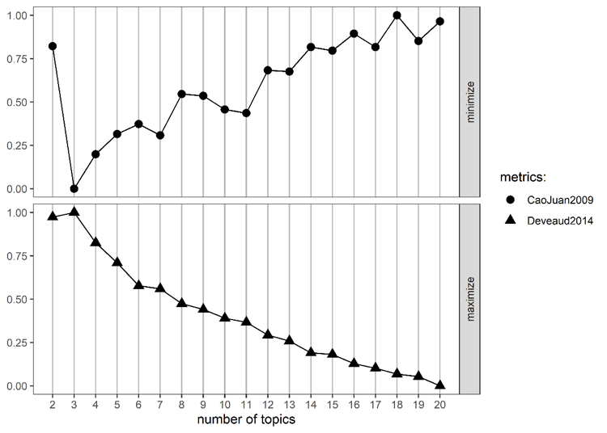
Fig. 1. Coherence measures for topics range from 2 to 20.
In what follows, we will describe the topics through two graphical analyses: the word cloud and the bigram network.

A word cloud shows word frequencies for a topic, but does not capture relationships between words. In contrast, bigram modelling analyzes the frequency (node size) and co-occurrence of word pairs (edges between nodes, whose size indicates how often the words appear together), revealing their associations. A word’s size in a bigram network may differ from that in a word cloud, as the former reflects raw frequency, while the latter reflects the likelihood of occurrence within a topic.

3.1 Topic 1 description: data
Figure 2 shows the word cloud (panel a) and bigram network (panel b) for Topic 1. This topic examines the role of clinical data in improving health diagnosis, particularly in cancer detection using deep learning (DL) models.

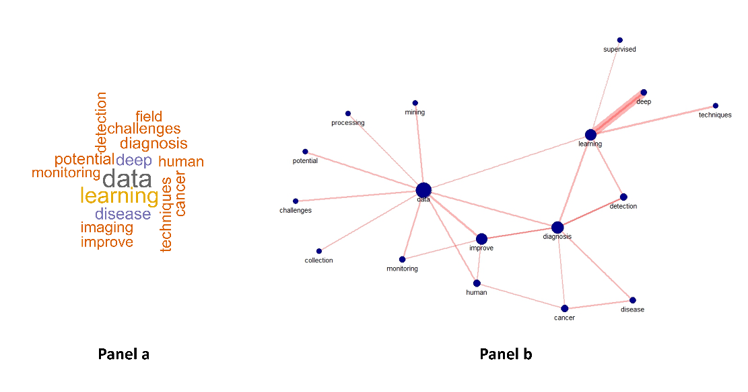
Fig. 2. Word cloud –panel a)- and network bigram –panel b)- for the topic 1 related to data.
DL is a subset of ML that utilizes neural networks to process complex medical data, including imaging, genomics, and electronic health records (EHRs) [12]. DL models play a crucial role in cancer diagnostics due to their ability to handle complex and high-volume data, such as images [13]. They also support precision medicine through tools like DeepVariant [14] and enhance early detection via transformer models analyzing EHRs [15].
Despite these advances, DL models face significant challenges. They are data-intensive, requiring large amounts of labeled data to train effectively [16], which is rarely available at individual institutions [17]. Moreover, they suffer from imbalance and unequal representation in training datasets, which can affect the outputs and impair their generalizability [18,19].

3.2 Topic 2 description: algorithms
Figure 3 presents the word cloud (panel a) and bigram network (panel b) for Topic 2, highlighting its focus on algorithms.

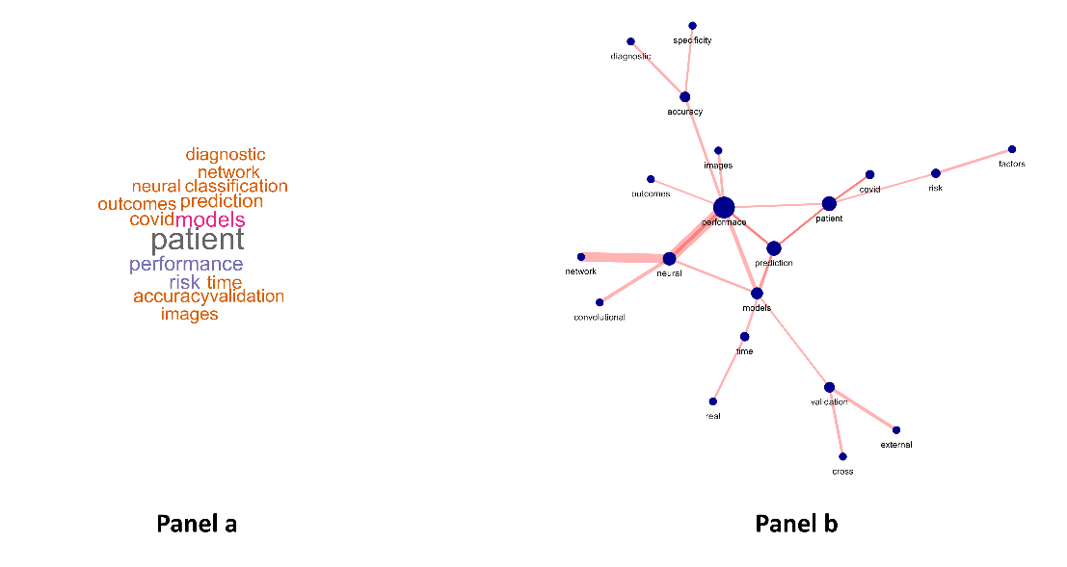

Fig. 3. Word cloud –panel a)- and network bigram –panel b)- for the topic 2 related to algorithms.

It focuses specifically on neural networks, particularly convolutional neural networks (CNNs), now dominant in image analysis [19]. These models optimize predictions from clinical data but often act as black boxes, prompting a shift toward explainable AI (XAI) using attention mechanisms and surrogate models to improve interpretability [20,21,22]. Moreover, the effectiveness of these algorithms in enhancing patient outcomes depends on high-quality training data. Poor or biased data can lead to biased output from biased algorithms [23,24].

3.3 Topic 3 description: decision support systems
Figure 4 shows the word cloud (panel a) and bigram network (panel b) for Topic 3, highlighting its focus on decision support systems (DSS), which integrate AI to enhance knowledge use and clinical decision-making across different areas [25]. In this context, Knowledge Management (KM) emerges as a foundational domain, enhancing communication and value extraction from medical knowledge through the use of AI [26].
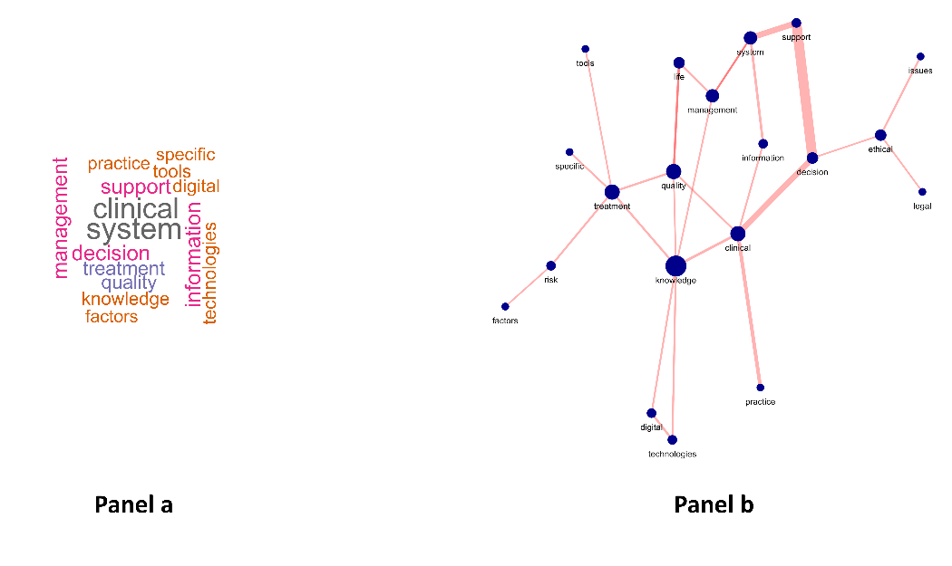

Figure 4: Word cloud –panel a)- and network bigram –panel b)- for the topic 3 related to DSS
AI technologies span virtual and physical systems, such as mobile sensors, robotics, and digital phenotyping, supporting interventions from monitoring to mental health care [27,28]. Effective adoption depends not only on technology but also on user readiness and contextual integration. [29] note a shift from standalone AI systems focused on accuracy in the 1980s to integrated, socio-technical AI tools within clinical workflows today. This calls for clinical DSS that balance accuracy, usability, and ethics. AI also enhances patient engagement through virtual assistants and chatbots, improving care and adherence [3,4]. However, their deployment demands robust governance to safeguard privacy and build trust [3,5].
- Discussion
The LDA approach highlights AI's multifaceted role in healthcare, revealing three interconnected themes: data, algorithms, and organizational integration. At the forefront are clinical DSS solutions, which restructure clinical workflows by enabling real-time monitoring [30], patient engagement, and personalized treatment [27,28]. While these technologies act as knowledge brokers [29], they raise challenges around professional roles and ethics [3,25].
Underlying algorithms, including ML and DL models, show high predictive performance in cancer diagnosis, risk stratification, and anomaly detection [19,31]. Their effectiveness, however, depends on data quality, highlighting concerns about explainability in clinical settings [21]. Data often represents the weakest link: quality, bias, and representativeness issues limit performance and risk patient safety [17,24].
Effective AI deployment requires a holistic approach that simultaneously addresses organizational adaptation, algorithmic transparency, and data governance. Focusing on only one aspect risks fragmented, unsustainable, or harmful outcomes.
- Conclusion

This paper addresses a research question on the overarching themes of healthcare transformation. Topic modeling of the literature shows how AI intersects with healthcare, offering insights to enhance services, patient care, and outcomes. Despite its promise, AI adoption entails challenges beyond organizational change. A comprehensive approach is required to manage these complexities, ensuring both long-term sustainability and ethical practice in healthcare.

Ethics declaration
Ethical clearance was not required for the research.

AI declaration
AI tools were not used to create the paper.

References
- Kumar, P., Chauhan, S., Awasthi, L.K.: Artificial Intelligence in Healthcare: Review, Ethics, Trust Challenges & Future Research Directions. Engineering Applications of Artificial Intelligence, Elsevier Ltd, 120 120, 105894 (2023).
- Khalifa, M., Albadawy, M., Iqbal, U.: Advancing clinical decision support: The role of artificial intelligence across six domains. Computer Methods and Programs in Biomedicine Update, 5, 100142 (2024).
- Al Kuwaiti, A., Nazer, K., Al-Reedy, A., Al-Shehri, S., Al-Muhanna, A., Subbarayalu, A.V., Al Muhanna, D., et al.: A Review of the Role of Artificial Intelligence in Healthcare. Journal of Personalized Medicine, 13(6), 951 (2023).
- Gupta, S., Kumar, V., Gupta, P.: Role of artificial intelligence in health sector”, Challenges. In Information, Communication and Computing Technology, pp. 690–695, CRC Press, London (2024).
- Ali, O., Abdelbaki, W., Shrestha, A., Elbasi, E., Alryalat, M.A.A., Dwivedi, Y.K.: A systematic literature review of artificial intelligence in the healthcare sector: Benefits, challenges, methodologies, and functionalities. Journal of Innovation and Knowledge, 8 (1), 100333 (2023).
- Yu, D., Xiang, B.: Discovering topics and trends in the field of Artificial Intelligence: Using LDA topic modeling. Expert Systems with Applications, 225, 120114 (2023).
- Blei, D.M., Ng, A.Y., Jordan, M.I.: Latent Dirichlet Allocation. Journal of Machine Learning Research, 3, 993–1022 (2003).
- Chen, X., Chen, J., Cheng, G., Gong, T.: Topics and trends in artificial intelligence assisted human brain research. PLoS ONE, 15(4), 0231192 (2020).
- Mullins, C.H., Boyd, C.J., Lindeman, B.: Factors Associated With the Highest and Lowest Cited Research Articles in General Surgery Journals. Journal of Surgical Research, 250, 39–44 (2020).
- Cao, J., Xia, T., Li, J., Zhang, Y., Tang, S. A density-based method for adaptive LDA model selection. Neurocomputing, 72(7–9), 1775–1781 (2009).
- Deveaud, R., SanJuan, E., Bellot, P.: Accurate and effective Latent Concept Modeling for ad hoc information retrieval. Document Numerique, 17(1), 61-84 (2014).
- Deo, R.C.: Machine learning in medicine. Circulation, Lippincott Williams and Wilkins, 132(20), 1920–1930 (2015).
- Jiang, F., Jiang, Y., Zhi, H., Dong, Y., Li, H., Ma, S., Wang, Y., et al.: Artificial intelligence in healthcare: Past, present and future. Stroke and Vascular Neurology, 2(4), (2017).
- Poplin, R., Chang, P.-C., Alexander, D., Schwartz, S., Colthurst, T., Ku, A., Newburger, D., et al.: A universal SNP and small-indel variant caller using deep neural networks. Nature Biotechnology, 36(10), pp. 983–987 (2018)..
- Khan, S. and Yairi, T.: A review on the application of deep learning in system health management. Mechanical Systems and Signal Processing, 107, 241-265(2018)
- Tran, K.A., Kondrashova, O., Bradley, A., Williams, E.D., Pearson, J. V. and Waddell, N.: Deep learning in cancer diagnosis, prognosis and treatment selection. Genome Medicine, 13(1), 152 (2021).
- Mahajan, A., Vaidya, T., Gupta, A., Rane, S. and Gupta, S.: Artificial intelligence in healthcare in developing nations: The beginning of a transformative journey. Cancer Research, Statistics, and Treatment, 2(2), 182-189 (2019).
- Haibe-Kains, B., Adam, G.A., Hosny, A., Khodakarami, F., Shraddha, T., Kusko, R., Sansone, S.-A., et al.: Transparency and reproducibility in artificial intelligence. Nature, 586 (7829), E14–E16 (2020).
- Rendleman, M.C., Buatti, J.M., Braun, T.A., Smith, B.J., Nwakama, C., Beichel, R.R., Brown, B., et al.: Machine learning with the TCGA-HNSC dataset: Improving usability by addressing inconsistency, sparsity, and high-dimensionality. BMC Bioinformatics, 20(1), 339 (2019).
- Dayhoff, J., Deleo, J.: Artificial neural network-Opening the black box. Cancer, 91, 1615–1635 (2001).
- Shao, Y., Cheng, Y., Shah, R.U., Weir, C.R., Bray, B.E., Zeng-Treitler, Q.: Shedding Light on the Black Box: Explaining Deep Neural Network Prediction of Clinical Outcomes. Journal of Medical Systems, 45(1), 5 (2021).
- Srinivasu, P.N., Sandhya, N., Jhaveri, R.H., Raut, R.: From Blackbox to Explainable AI in Healthcare: Existing Tools and Case Studies. Mobile Information Systems, 2022(1), 8167821 (2022).
- Gianfrancesco, M.A., Tamang, S., Yazdany, J., Schmajuk, G.: Potential Biases in Machine Learning Algorithms Using Electronic Health Record Data. JAMA Internal Medicine, American Medical Association, 178(11), 1544-1547 (2018).
- Norori, N., Hu, Q., Aellen, F.M., Faraci, F.D., Tzovara, A.: Addressing bias in big data and AI for health care: A call for open science, Patterns, 2(10), (2021)
- Hamet, P., Tremblay, J.: Artificial intelligence in medicine, Metabolism - Clinical and Experimental, 69, S36–S40 (2017).
- Sibte, S., Abidi, R.: Knowledge Management in Healthcare: Towards “knowledge-Driven” Decision-Support Services. International Journal of Medical Informatics, 63(1-2), 5-18. (2001)
- Burns, M.N., Begale, M., Duffecy, J., Gergle, D., Karr, C.J., Giangrande, E., Mohr, D.C.: Harnessing Context Sensing to Develop a Mobile Intervention for Depression. Journal of Medical Internet Research, 13(3), e55 (2011).
- Torous, J., Bucci, S., Bell, I.H., Kessing, L. V., Faurholt-Jepsen, M., Whelan, P., Carvalho, A.F., et al.. The growing field of digital psychiatry: current evidence and the future of apps, social media, chatbots, and virtual reality. World Psychiatry, 20(3), 318–335 (2021).
- Patel, V.L., Shortliffe, E.H., Stefanelli, M., Szolovits, P., Berthold, M.R., Bellazzi, R., Abu-Hanna, A.: The coming of age of artificial intelligence in medicine. Artificial Intelligence in Medicine, 46(1), 5–17 (2009).
- Hee Lee, D., Yoon, S.N.: Application of artificial intelligence-based technologies in the healthcare industry: Opportunities and challenges. International Journal of Environmental Research and Public Health, 18 (1), 1–18 (2021).
- Wang, L., Yin, Y., Glampson, B., Peach, R., Barahona, M., Delaney, B.C., Mayer, E.K.: Transformer-based deep learning model for the diagnosis of suspected lung cancer in primary care based on electronic health record data, EBioMedicine, 110, 105442 (2024).

