# User-Role Import Script - High-level Design

The purpose of this document is to describe the overall design for a script to handle importing User and Role data into the Kenna Platform. The source of this information could be from Active Directory, or any other Identity Management source system.

### Ruby Environment Requirements:

Kenna Sample Scripts can be run from any standard Ruby environment. For most customers this can be accomplished using a Windows or Linux VM within their existing VMWare/Hypervisor environment.

* **OS:** Windows/Linux
* **Memory:** No specific RAM requirements
* **Disk:** No specific Disk Space Requirements
* **Ruby:** Latest version of Ruby installed from <https://www.ruby-lang.org/en/>
* **Ruby GEMS:** these are normally dependent on which are required by the specific script but the following are the most common. Instructions on how to install gems can be found here (<https://guides.rubygems.org/rubygems-basics/>)
  + rest-client
  + json
  + csv
* **HTTPS access to the Kenna API:** at <https://api.kennasecurity.com/>
* **Scheduler:** for running script at specific times
  + This can normally be handled through the built-in schedulers on the specific OS (Windows: Scheduled Tasks; Linux: cron)

### Running Scripts:

Kenna Sample Scripts are run from the command line and typically follow the same pattern for being called:

**ruby <api token> <script-specific list of parameters>**

Parameters for the ***User-Role-Sync.rb*** script are shown below

| **Parameter** | **Description** |
| --- | --- |
| **api token** | User specific token to access the Kenna API. |
| **CSV File** | File that contains the User/Role data |
| **Email Column** | Column in ‘CSV File’ that contains the EMAIL from the user. |
| **First Name Column** | Column in ‘CSV File’ that contains the FIRSTNAME from the user. |
| **Last Name Column** | Column in ‘CSV File’ that contains the LASTNAME from the user. |
| **Role Column** | Column in ‘CSV File’ that contains the ROLE from the user. |
| **Proxy Address** | (Optional) Proxy Parameter. |

**Note:** Storage and management of keys to be determined by customer’s internal teams.

### Overall Data Flow:

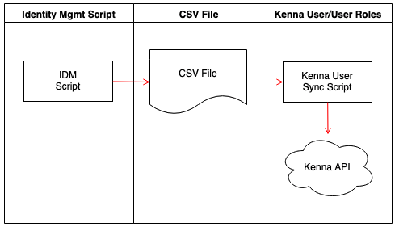

### Identity Management Script:

In most cases a script or other automated process would need to be developed internally to produce the input file for this script. The specific requirements of this script is completely up to the specific customer.

### CSV File

This CSV file will be the data exchange between the GWL AD Script and the Kenna User Sync Script. The CSV file will have the following format.

| EmailAddress | FirstName | LastName | ADGroup |
| --- | --- | --- | --- |
| user1@example.com | User1 | FirstLast | ADGroup1 |
| user2@example.com | User2 | SecondLast | ADGroup1 |
| user3@example.com | User3 | ThirdLast | ADGroup2 |
| user4@example.com | User4 | FourthLast | ADGroup2 |

### Kenna User Sync Script

This script will be responsible for adding synchronizing the users between Kenna and the CSV file provided by the customers Identity Mgmt system.

**Assumptions:**

* If the ADGroup does not exist as a role within the customer’s Kenna instance, a new read-only role will be created within Kenna that will have no Asset Groups. The customer will be responsible for making the needed adjustments to the new group.
* User Roles within Kenna will be named to match the ADGroup Names

**Script Logic:**

Below is the logic that the script will perform in bringing the users and roles into Kenna.