**In association with Dr Pi and MB limited**

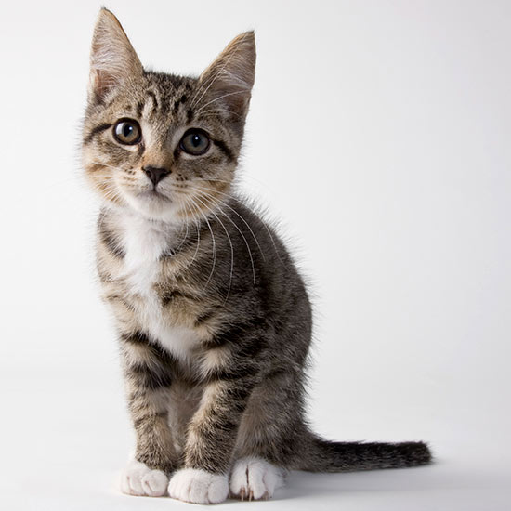

6 trimester

(Year 2019-20)

**Name:**

**Company: 12.1(2)**

**Teacher: York**

**Total: 12.1/100**