# The Principles of Coaching

1. **Why embark into a coaching process ?**

The goal of a coaching programme is to support a personal change within the framework of a professional project.

Coaching is an empowering type of support, based on active listening and questioning, whose ultimate goal is to improve the coachee’s autonomy and to facilitate his decision making process.

« The lonely man is always in bad company » said Gide.

The coach helps the coachee to recreate his choices of action to succeed in a new task, or to develop a competence in order to tackle new situation.

The coach opens new perspectives on reality, allowing the coachee to put into practice new solutions to his challenges.

The coach provokes a new consciousness in the coachee’s way of being and way of doing, favoring a learning process towards an increased autonomy.

Coaching is neither advise, nor mentoring, nor tutoring, nor training.

The support is particularly effective for individuals engaged into a reflection on how to change their professional universe. It is oriented towards the achievement of the coachee’s professional goals, supporting him in finding his own optimal solution. Initially the coachee puts his objectives into focus, then he strives to realize them as a next step.

Coaching’s key benefits involve :

* Better self-knowledge
* Becoming aware of one’s potential to change
* Defining objectives in the short, medium, and long term
* Elaborate personalized and dedicated action plans
* Access the necessary resources to achieve concrete objectives

**b) What can you expect from your coach ? What kind of relationship will you have ?**

Your coach could be...

|  |  |
| --- | --- |
| A thinking cap | * *He will help you process your solution.* |
| A guide dog | * *He will always walk one step beside you, never in front of you* |
| A mirror or a deforming mirror | * *He will show you back your true self, or exaggerate when appropriate to help you relativize* |
| A compass | * *He will help you find and keep your route* |
| A copilot | * *He will tackle a difficult journey with you and act as sparring partner* |
| A bridge | * *He will allow you to span gaps and to move to the other side* |
| A mechanical climber | * *He will make it easier to climb to the top* |
| A lamp and an optician | *He will help you gain clarity and change the lenses through which you see reality* |
| A choreographer and gym teacher | * *Helping you rise up and gain in confidence and smoothness in your behaviors* |
| A gardner and an electrician | * *He will help you sow to reap the fruits, and re-establish contact with others* |

Your coach will adapt to you needs, and can play more than one role to best support you in your goals.

Your coach **will not be**

|  |  |
| --- | --- |
| A guru | * *You remain free and independent !* |
| a chef | * *You decide what you want !* |
| A judge | * *You have every right to make mistakes without being judged !!* |
| A prompter | * *You have your answers !* |
| A seer | * *You make and shape your future !!* |

© Luc TEYSSIER

# 

# 2 The spirit of Coaching

**a) How will we succeed together?**

A Coaching program is by definition a personal venture : as such, it cannot be supported by the company’s processes and/or organization.

The relationship between Coachee and Coach rests on simple and indispensable principles:

* Sincerity : of the Coachee in questioning himself, of the Coach in engaging in an authentic and honest confrontation.
* Clarity: of expectations, contract terms and relationship.
* Confidentiality: at the base of mutual trust and sincerity, is essential for making the relationship work.

**b) What are our mutual commitments?**

* The Coachee commits to a personal change in order to achieve the desired objectives. A contract binds him to the Coach for a set timeframe and precise and clear working methods.
* The Coach commits over time to be available for the Coachee. He is responsible for the optimal execution of the contract, while the Coachee maintains responsibility for every operative decision he makes.

**c) What is our approach to coaching?**

Our approach is pragmatic and is aimed to provide the Coachee with a « toolbox » from which he can draw the best one to fix his weaknesses.

We work to obtain lasting and visible changes in behaviors, inspired by the approaches of Max Landsberg, William Miller and Stephen Rolnick.

Our main « tools » are the « Attitude/Aptitude © » and the « Conviction/Confidence » matrices.

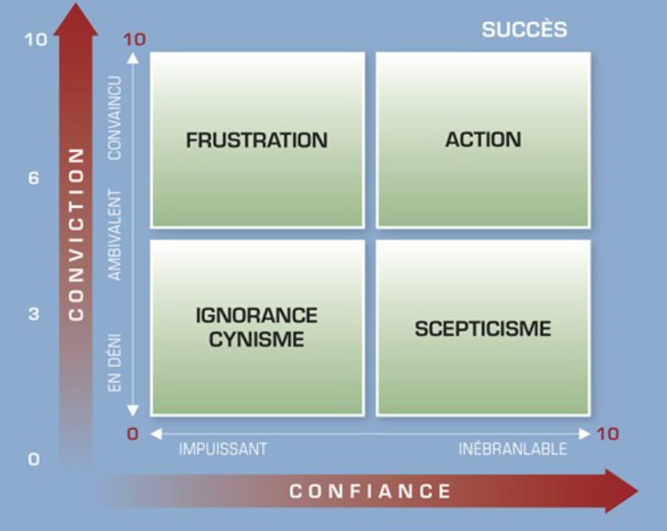

# 3 The Coaching Process

**How will we work together?**

A preliminary meeting is set up between both parties to have a first exchange on the potential type of support : if an agreement is reached, then the coaching process can begin.

During the first session, the Coach and Coachee agree on the objective to be achieved through the coaching process.

The Coach has then the obligation to guide his Coachee towards the set objectives : he does so adapting his interventions and techniques according to the development stages reached by the Coachee.

The Coachee remains the owner of every decision made during the process, as well as of the achievement of his own objectives.

**a) The Coaching intervention is within a limited timeframe**

Like every change process, and in order to make the intervention meaningful, the Coaching processes are defined by a specific beginning and a specific end.

The dates and deadlines are agreed by both parties, and the number of sessions can be defined and adapted according to the emerging priorities.

The nature of the sessions, either face-to-face or remote, is to be determined according to the evolution of the relationship and of the changes in the Coachee.

**b) The intervention facilitates acting and practicing**

Acting is a crucial factor in shaping personal transformations : this is why the Coaching program takes place over several months, typically with one session per month. This gives the Coachee the possibility to evolve by his own experimentation, and the possibility to act in between each session, sharing afterwards his experience and results of these actions with the Coach.

The success of the program lies in the achievement of concrete results, based on the definition of clear objectives in the beginning. .

# 4) The phases

* Set-up : exchange between Coach and Coachee in order to formalize the objectives, the KPIs, the duration, the rhythm, the logistics and nature of the sessions, the investment, and the cancellation policies… The final outcome of this phase is the formalization and signature of a Coaching contract.
* Support : the Coach organizes and animates each Coaching session. The Coachee drafts a progress report, summarizing the key developments in between each session. The report also includes an action plan and an analysis of the means to be put in place.
* Evaluation: the Coachee finalizes a written report in the format he prefers after a verbal exchange with his Coach and based on a self-assessment questionnaire.