PERSONAL INFORMATION | Vittoria LAPOMARDA
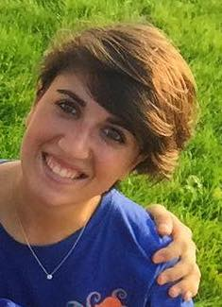 |   Via Papa Pio XII, 1 – 70020 – Bitritto (BA) - ITALY
 |  +39 3405465958

vittoria.lapomarda@aiesec.net
 | Date of birth 07/01/1994 | Nationality Italian

WORK EXPERIENCE

Jan. 2016 – Dec. 2016  Jan. 2015 – Dec. 2015 | President of AIESEC Bari  - Strategy and Local Committee management  - Building and leading Executive Board Team  - Leading Middle Management Team  - Internal and External Accountability and Legality  - External Representation  - Member of National Leadership Body
Jan. 2016 – Dec. 2016  Jan. 2015 – Dec. 2015 | Vice President Finance of AIESEC Bari  - Financial and legal management  - Financial analysis and forecasting  - Accounting and bookkeeping  - Financial cuture creation

EDUCATION AND TRAINING

Sept. 2013 – Dec. 2016  Sept. 2007 – June 2012 | Bachelor Degree in Economics - Università degli studi di Bari “Aldo Moro”  - Business law  - Organizational development  - Business administration  - Statistics  - Accounting  Scientific High School – Liceo scientifico “Salvemini” (Bari)

PERSONAL SKILLS

Mother tongue | Italian
Other language(s) | UNDERSTANDING |  | SPEAKING |  | WRITING
Other language(s) | Listening | Reading | Spoken interaction | Spoken production
English | C1 | B2 | B2 | B2 | B2
French | A2 | A2 | A1 | A1 | A1
Levels: A1/A2: Basic user - B1/B2: Independent user - C1/C2 Proficient user
Common European Framework of Reference for Languages

Presentation Skills [Intermediate]
Job-related skills
Internet User Skills [Beginner]
Pc and Mac User Skills [Intermediate]
Leadership Skills [Intermediate]
Microsoft Office [Intermediate]
Google Drive [Intermediate]
Public Speaking [Intermediate]
Team Management [Intermediate]
Project Management [Intermediate]

Volunteering Experiences  30/06/2014 – 10/08/2014 | “Colors of Bahrain” – AIESEC Manama  - Study the traditions and culture of the country  - Capture and collect videos/photos across the country  - Go through photography classes and Arabic lessons  - Work on press releases/projects website/social media  - Empower the community through filling cultural and educational gaps through activities such as cultural sharing, leadership skills, carreer development, soft skills and personal development

