https://github.com/ShellingFord221/My-implementation-of-What-Uncertainties-Do-We-Need-in-Bayesian-Deep-Learning-for-Computer-Vision
https://github.com/pmorerio/dl-uncertainty
https://github.com/pmorerio/dl-uncertainty
https://paperswithcode.com/paper/what-uncertainties-do-we-need-in-bayesian

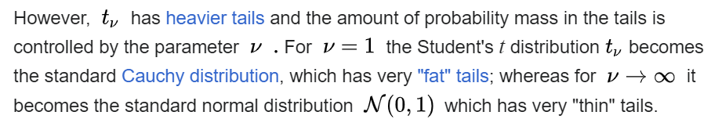

We must find a way to insert the parameter v in the loss, following the criteria expressed in the Learned Loss Attenuation (it explains why the loss is working).

AUSE and AUCE
AUSE: Area Under the Sparsification Error

https://github.com/lmb-freiburg/robustmvd/blob/627dffe74132670c115a3a249682e6a3f079f20f/rmvd/eval/multi_view_depth_evaluation.py#L566
https://github.com/mattpoggi/mono-uncertainty/blob/543772b4a5165820e94acd3e6ae2349785f763ff/evaluate.py#L108
https://torch-uncertainty.github.io/generated/torch_uncertainty.metrics.AUSE.html#torch_uncertainty.metrics.AUSE

Confusionario ma forse ha tutto:
https://github.com/fregu856/evaluating_bdl/blob/3d16421a8c46673eba14126f6785932a0834d762/depthCompletion/ensembling_eval_ause_virtual.py#L293

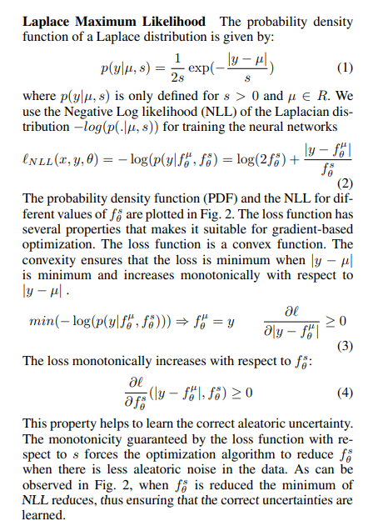
Laplacian distribution:
- In this paper is explained the formula of the loss: https://arxiv.org/pdf/2202.03870.pdf (Maximum Likelihood Uncertainty Estimation: Robustness to Outliers)
- In this GitHub there is also the code: https://github.com/deebuls/uncertainty-robustness-deep-regression-benchmark

Epoch: 002/003, Iter: 479/1875, Loss: -9559.586914
Epoch: 002/003, Iter: 480/1875, Loss: -9539.534180
Epoch: 002/003, Iter: 481/1875, Loss: nan
C:\Users\alessandro.lombardin\AppData\Local\Programs\Python\Python311\Lib\site-packages\torch\utils\tensorboard\summary.py:574: RuntimeWarning: invalid value encountered in cast
tensor = (tensor * scale_factor).clip(0, 255).astype(np.uint8)
Epoch: 002/003, Iter: 482/1875, Loss: nan
Epoch: 002/003, Iter: 483/1875, Loss: nan
Epoch: 002/003, Iter: 484/1875, Loss: nan

Encoder – Decoder model
- An encoder module, in the context of neural networks, particularly convolutional neural networks (CNNs) or autoencoders, is a component responsible for transforming input data into a lower-dimensional representation or feature space. This lower-dimensional representation typically captures essential features or patterns present in the input data.
- In the context of CNNs, encoder modules are often found in the early layers of the network and are responsible for extracting features from the input data. These features become increasingly abstract and high-level as information is propagated through deeper layers of the network.
- In the context of autoencoders, an encoder module is a component of the network that compresses the input data into a latent representation. This compressed representation ideally captures the most important features of the input data in a lower-dimensional space. Autoencoders consist of an encoder module and a decoder module, with the encoder responsible for compression and the decoder responsible for reconstructing the input data from the compressed representation.
- Overall, an encoder module plays a crucial role in capturing and representing relevant information from the input data, which can be further utilized for tasks such as classification, object detection, or generation.

https://torch-uncertainty.github.io/_modules/torch_uncertainty/metrics/sparsification.html#AUSE

