NOW — Territory MVP: Technical, Functional & AWS Architecture Specification
Oct 12, 2026 · Alessandro Heringer Milagres

1. Executive summary
The NOW Territory MVP has one job: prove one authorized, confirmed, measurable local commercial action in a single concentrated territory, with 20–50 pilot merchants and one or two categories. Everything in this specification serves that proof; everything that does not is explicitly deferred.
NOW is a real-time local-intent product. A consumer says what they want to do, where and when; NOW interprets the request, matches it to actionable local supply, shows how trustworthy each option is, and directs the consumer to one truthful next action. The MVP proves the smallest credible version of that loop:
Ask → Understand → Match → Verify → Recommend → Act → Record outcome → Learn

1.1 Document control
Item | Value
Document | Consolidated Technical, Functional and AWS Architecture Specification
Version | V3 (consolidates Functional Spec V2, AWS Architecture V2 and the detailed D2 diagram)
Status | MVP baseline — for review
Language | English
Scope | Territory MVP (P0). Not the long-term NOW platform.
Primary stack | Flutter (consumer) · React + TypeScript (web) · Node.js + TypeScript on AWS (backend)
Source basis | NOW Source Evidence Ledger

1.2 Key decisions at a glance
Decision | What we chose | Why
Consumer client | Keep the existing Flutter iOS/Android app | Only implementation with physical-iPhone validation of voice, map and navigation flows. A React Native rewrite is out of scope.
Web clients | React + TypeScript for Business, Operations, Support, Admin | Fast delivery of internal and merchant tools without touching the mobile stack.
Backend shape | Modular monolith (Node.js + TypeScript) on ECS Fargate | One deployable, strict module boundaries; avoids a premature microservice estate.
Source of truth | Aurora PostgreSQL Serverless v2 + PostGIS | Transactional, geospatial and append-only ledger data in one place.
Search | PostGIS first, OpenSearch only on measured need | Avoids running a derived index before query volume justifies it.
Identity | Amazon Cognito User Pools | OIDC/OAuth, JWT, MFA for privileged roles.
Integrations | ProviderAdapter and MapProviderAdapter contracts | Core domain stays independent of any booking, inventory or map vendor.
Trust model | Explicit trust states on every assertion | A candidate is never a confirmed booking without provider or merchant evidence.

1.3 What success looks like
The MVP is successful when, in the pilot territory, a consumer completes an action that is authorized (contracted provider or direct merchant), confirmed (provider or merchant reference as evidence), and measurable (traceable by correlation ID from intent to outcome, with exactly one rule-versioned, append-only attribution entry). Demo, simulated, unverified, expired or conflicted data is never presented as a confirmed booking.

2. Product boundary and MVP configuration
The MVP does not attempt to prove a universal super-app, a global inventory network, a payment wallet or 30 revenue engines. It proves the core loop in one territory and makes every launch parameter a configuration value that can change without a mobile release.

2.1 In scope vs. out of scope
In scope (P0) | Out of scope (deferred)
One territory polygon, one hero + one adjacent category | Global or multi-city rollout, broad category expansion
20–50 pilot merchants or an equivalent authorized supply cohort | Advanced POS/PMS portfolio, many simultaneous providers
Exactly one primary action path | Multi-provider Journey Commerce with coordinated rollback
Source-backed, expiring availability with visible trust state | Sponsored ranking, ad auctions, outcome advertising
Append-only, rule-versioned attribution ledger | Owned payments, wallet, settlement, crypto, financial products
Private media upload with moderation | Photo Rewards at scale, advanced video pipeline
Foreground, consented location with manual fallback | Background location and geofencing

2.2 Configuration decisions required before build
Management sets these values before implementation. Each is stored as configuration and versioned, so a change does not require an app release.
Configuration key | MVP rule | Owner | Decision gate
territory | One approved polygon, timezone, supported language(s) and operating owner | CEO / COO / Product | Gate A
categories | One hero category and one adjacent category; no broad multi-vertical launch | Product / COO | Gate A
map_provider | Selected after cross-platform, commercial, privacy, coverage and cost assessment | Chief Technology Architect | Gate A
primary_action | Exactly one: external handoff, direct merchant booking request, or provider-confirmed booking | CEO / COO / Product | Gate B
source_policy | Source authority, freshness window, conflict precedence and action-eligibility rules | COO / Product | Gate C
pilot_merchants | 20–50 merchants or an equivalent authorized provider/direct-supply cohort | COO | Gate C
release_cohort | Internal alpha → invited consumer/merchant pilot → evidence-based public beta | CEO / Founder | Gate D

2.3 Primary action options
Only one of these is activated for P0. The choice drives what "confirmed" can mean and which lifecycle states are reachable.
Option | What the consumer gets | Highest truthful state | NOW responsibility
External handoff | Allow-listed deep link or redirect to the provider | started (unless the provider returns an outcome) | Track initiation; never claim confirmation without evidence
Direct merchant booking request | Request sent to the merchant via NOW for Business | confirmed when the merchant accepts | Request routing, merchant SLA, outcome capture
Provider-confirmed booking | Booking made through an authorized provider adapter | confirmed with provider reference | Adapter, idempotency, outcome reconciliation; cancellation/refund only if contracted

3. Actors, roles and permissions
Seven actors use NOW in P0. Cognito groups carry broad roles only; organization, venue and territory authorization is always enforced in the backend, never trusted from the client.

3.1 Actor catalogue
Actor | Client | P0 responsibility | Access boundary | MFA
Consumer | Flutter iOS/Android app | Discover, inspect, act, save, report a quality issue, manage profile and consent | Own account, preferences, saved items and actions only | Optional
Merchant administrator | NOW for Business (React) | Claim and manage venue, availability, offers, staff, initial reporting | Own organization and authorized venues | Required
Merchant staff | NOW for Business (React) | Update assigned venue availability and offers | Assigned venue only | Recommended
Territory operator | Operations console (React) | Onboard merchants, resolve data and supply issues, review action problems | Assigned territory; every privileged action audited | Required
Support agent | Support console (React) | Handle account and action incidents | Masked, minimum-necessary data; every access audited | Required
Partner / provider | Adapter / API | Exchange supply, availability and action/booking outcomes | OAuth or signed-webhook scope for one authorized integration contract | n/a (machine)
Platform administrator | Admin web app | Manage roles, territories, policies and feature flags | Least privilege, full audit trail | Required

3.2 Permission matrix
C = create, R = read, U = update, D = decide/approve, — = no access. "Own" means scoped to the actor's own account, organization, venue or territory.
Resource | Consumer | Merchant admin | Merchant staff | Operator | Support | Platform admin
Own profile, consent, favorites | C R U | — | — | — | R (masked) | —
Intents and candidates | C R (own) | — | — | R (territory) | R (masked) | —
Venue profile | R (published) | C R U (own org) | R (assigned) | C R U (territory) | R | R
Availability assertions and offers | R (published) | C R U (own org) | C R U (assigned) | C R U (territory) | R | R
Merchant claims | — | C R (own) | — | R D (territory) | R | R
Staff memberships | — | C R U (own org) | — | R U (territory) | R | C R U
Actions and provider outcomes | C R (own) | R (own org, summary) | — | R (territory) | R (masked) | R
Commission ledger | — | R (own org, summary) | — | R (territory) | — | R
Operational cases and queues | C (quality report) | — | — | C R U D (territory) | C R U | R
Territory, roles, policy, feature flags | — | — | — | R | — | C R U D
Audit events | — | — | — | R (own actions) | — | R (restricted)

3.3 Authorization rules
- Every protected request is validated twice: JWT signature and audience at API Gateway, then tenant, venue and territory membership in the backend.
- Role or tenant claims sent by a client are never authoritative.
- Merchant staff revocation takes effect on the next request and writes an audit_event.
- Support reads personal data in masked form by default; unmasking is a separate, audited, reason-coded action.
- Reporter identity on quality reports is never exposed to the merchant.

4. Functional scope
P0 covers four surfaces: the Flutter consumer app, NOW for Business, the Operations/Support consoles, and one authorized partner integration. Each capability below has an ID for traceability to tests, tickets and release gates.

4.1 Consumer app (Flutter)
ID | Capability | P0 functional behavior | Acceptance criteria
CON-01 | Onboarding and sign-in | Sign in, restore a session, choose language, grant or deny contextual permissions | A protected session is established; denied location falls back to manual location selection
CON-02 | Voice and typed intent | Speak or type a local request; set When, What, Where | Transcription/review state is shown before submit; the request becomes a canonical intent with timezone, language and context
CON-03 | Map/list discovery | Candidates shown as cards and markers; filters for category, time and configured radius | List and map always show the same result set; state refreshes after any valid filter change
CON-04 | Trust visibility | Each option shows demo, simulated, unverified, recently updated, partner verified, expired or conflicted | "Confirmed" or "booked" wording cannot render unless evidence meets the source policy
CON-05 | Detail view | Venue/event/offer info, source and freshness, action path, basic media, report control | Status and action eligibility are re-checked server-side before the action starts
CON-06 | Action | Start the one approved action path | action_id is created before handoff; result is an explicit lifecycle state (confirmed, unknown, failed, …)
CON-07 | Favorites and profile | Save and revisit items; manage profile, preferences, consent, privacy settings | Save is idempotent; profile data honors consent and authorization
CON-08 | Quality feedback | Report wrong availability, unsafe/stale content or irrelevant result | Report is rate-limited, enters the operations queue with evidence, and hides reporter identity from the merchant
Key consumer journey (happy path)
- Consumer opens the app; session restores; location permission is requested just in time (or manual area chosen).
- Consumer says "dinner for two near me tonight"; transcript is shown for review.
- Backend creates an intent, normalizes time/place/category/party size, and returns ranked candidates with trust states.
- Consumer opens a partner_verified venue; detail view re-checks eligibility.
- Consumer taps the action; backend creates action_id + idempotency key, then hands off or calls the provider.
- Provider outcome arrives (sync or signed webhook); action moves to confirmed with a provider reference.
- Attribution creates exactly one ledger entry; analytics records the full intent → outcome trace.

4.2 NOW for Business (React + TypeScript)
ID | Capability | P0 functional behavior | Acceptance criteria
BIZ-01 | Merchant claim | Identify a venue and submit verification evidence | Operator approve / reject / request-more-information is audited
BIZ-02 | Venue profile | Manage name, category, location, hours, contact, attributes, approved images | Every edit is tenant-scoped, versioned, and published only after validation
BIZ-03 | Availability | Set availability, price or offer assertion with a validity window | Expiry automatically downgrades status; discovery reflects the update within the freshness target (60 s)
BIZ-04 | Offers | Create, pause or expire a simple offer | Offer carries eligibility, start/end time, source and policy state
BIZ-05 | Staff access | Invite or revoke staff for selected venues | Revocation blocks future access immediately and writes an audit event
BIZ-06 | Pilot reporting | See own action and outcome summary | Confirmed outcomes are visually distinct from initiated or unknown actions

4.3 Operations and support (React + TypeScript)
ID | Capability | P0 functional behavior | Acceptance criteria
OPS-01 | Merchant onboarding | Review claims and activate approved merchants | No merchant gains control without a verified relationship or an explicit, recorded policy exception
OPS-02 | Supply quality | Create, edit, merge or suppress venues; resolve stale or conflicting assertions | Before/after state, actor, reason and timestamp are retained
OPS-03 | State governance | Apply and inspect demo, simulated, unverified, verified, expired, conflicted states | Demo/simulated data can never appear in commercial reporting or as a confirmed action
OPS-04 | Action investigation | Trace intent → candidate → action → provider outcome | Correlation ID and masked data are available under role policy
OPS-05 | Queues and alerts | Receive claims, reports, stale supply, webhook/DLQ and provider-health work | Every item has territory, severity, owner, status and resolution record

4.4 Partner and provider integration
ID | Capability | P0 functional behavior | Acceptance criteria
INT-01 | Authorized source onboarding | One provider or direct-merchant workflow with contract, credentials, source policy and monitoring | No live connector is activated without written authorization and a named owner
INT-02 | Availability ingestion | Receive a manual update, approved import, polling response or signed webhook | Payload is validated, normalized, provenance-tagged, idempotent and expiry-aware
INT-03 | Action / outcome | Adapter creates or receives the action reference and outcome | Redirects are allow-listed; duplicate callbacks never duplicate action or commission state
INT-04 | Attribution | Link each action to one rule-versioned attribution entry | Overlapping revenue logic cannot count the same action twice

5. Functional business rules
The rules below are the product's truth guarantees. They are enforced in the backend domain modules and covered by automated tests; the clients only render their result.

5.1 Intent rules
An intent is the structured form of a user request. At minimum it captures:
Field | Source | Required
Raw text or reviewed voice transcript | Client | Yes
Selected or derived category | Client selection or classifier | Yes
Time horizon and timezone | When control + territory timezone | Yes
Location (point, accuracy, source) | Consented foreground GPS or manual selection | Yes (one of the two)
Language | Profile or device | Yes
Party size, budget, preferences, accessibility, mobility | Client or classifier | Optional
Territory ID | Server, from location | Yes
Correlation ID and policy version | Server | Yes
Generative AI boundary. A model may classify, normalize or summarize the request. It can never create availability, price, opening-hour or booking-confirmation facts. Every factual attribute shown to a consumer comes from a stored, source-tagged assertion.

5.2 Candidate eligibility and ranking
A venue becomes a candidate only if all of the following hold:
- it is inside the territory polygon and an enabled category;
- it fits the requested time window;
- it is not blocked or suppressed by operations;
- its source data is sufficient for the trust state it will display.
Eligible candidates are ranked with a transparent additive score, stored with the candidate as score_explanation:
\text{final\_score} = \text{relevance} + \text{time\_fit} + \text{distance\_fit} + \text{freshness} + \text{availability\_confidence} + \text{preference\_fit} + \text{quality} - \text{policy\_penalties}
Signal | What it measures
relevance | Match between the normalized intent and the venue/offer category and attributes
time_fit | Overlap between requested time and opening hours / availability window
distance_fit | Distance or travel time from the consumer location, within the configured radius
freshness | How recently the assertion was observed relative to its validity window
availability_confidence | Weight of the trust state (partner_verified > recently_updated > unverified)
preference_fit | Fit with saved preferences, party size, budget and accessibility needs
quality | Content completeness and the absence of open quality reports
policy_penalties | Deductions for conflicts, near-expiry, or operator flags
Sponsored ranking is not in P0. No commercial placement may ever override safety, legality, trust or action eligibility.

5.3 Trust states and display rules
State | Meaning | Display and action rule | Commercial metrics
demo | Controlled, non-commercial demonstration data | Visibly labeled "Demo"; no live action | Excluded
simulated | Artificial scenario data or outcome | Visibly labeled; never described as provider-confirmed | Excluded
unverified | Place exists but current actionability is not confirmed | Discoverable with qualification; no "confirmed" CTA | Included as discovery only
recently_updated | Merchant/operator update within the freshness policy | Timestamp and source shown; action depends on contract | Included
partner_verified | Authorized provider/merchant confirmed state within validity window | Eligible for provider action; timestamp and source shown | Included
expired | Assertion validity has ended | Removed or downgraded; never promoted as active | Excluded from availability
conflicted | Sources disagree or a quality report was received | Suppressed or qualified until resolved by operator or policy | Flagged

5.4 Action and commercial rules
- Every action begins with an immutable action_id and an idempotency key, created before any handoff.
- A provider or direct-merchant reference is mandatory for any state beyond started, wherever the workflow supports it.
- A deep-link or redirect click is an initiated action, never a booking confirmation.
- confirmed requires permitted source evidence (provider reference or merchant acceptance).
- Cancellation, refund and chargeback responsibilities apply only if the commercial contract assigns NOW that role.
- A commission is created only from a single rule version and a qualifying action/outcome. Corrections append new ledger entries; nothing is overwritten.

5.5 Consent, location and privacy rules
- Location is requested just in time, in the foreground, only when it improves the current task; manual location is always offered.
- No background location tracking in P0.
- For each optional processing purpose, store notice version, purpose, scope, grant/revocation time and legal basis.
- Privileged users access the minimum necessary data; every sensitive read or action is auditable.
- Account deletion, data export and the privacy-rights workflow must exist before public-scale launch (LGPD/GDPR-ready).

6. AWS architecture
The architecture protects the validated Flutter consumer app, runs one Node.js modular monolith on ECS Fargate behind a protected AWS edge, and keeps every vendor behind an adapter. The source materials show a real Flutter iPhone app with physical-device voice, map and navigation flows; they do not show a production-ready booking, provider, payment or global platform. Engineering effort therefore goes to the decisive proof point, not to breadth.
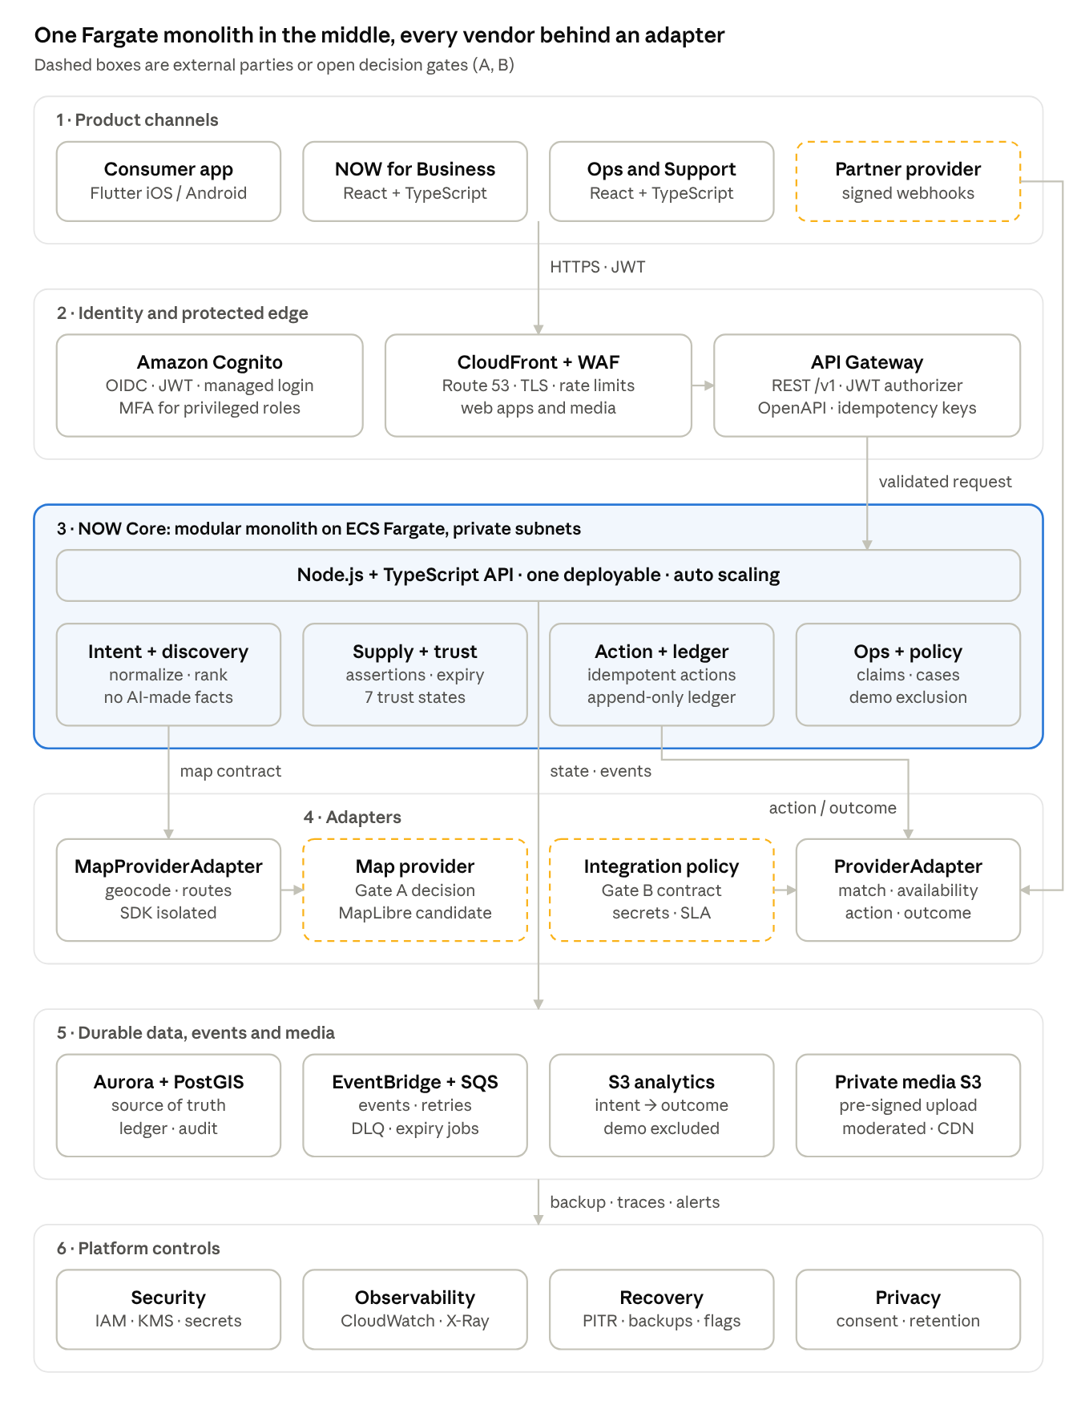
NOW Territory MVP on AWS · six layers
Requests flow down from the clients through Cognito, CloudFront/WAF and API Gateway into one Fargate service; the core writes all state to Aurora and events to EventBridge/SQS, and reaches maps and partners only through the two adapters.

6.1 Architecture principles
# | Principle | What it means in practice
1 | Protect the validated consumer foundation | Restore point and regression suite before any Flutter change; no React Native rewrite in MVP.
2 | One backend deployable first | Modular monolith with strict module boundaries; split services only when load or team topology demands it.
3 | Trustworthy availability and outcomes | Persist source, observed time, expiry, status and outcome evidence; a candidate is never a booking.
4 | Integrations are adapters | Core domain is independent of the chosen booking, inventory or map provider.
5 | Durable attribution | The same action cannot be monetized twice across overlapping revenue concepts.
6 | Demo is not commerce | demo, simulated, unverified, recently_updated, partner_verified, expired, action_started, confirmed, failed, unknown are explicit states.
7 | Scale by evidence | OpenSearch, Redis, video, more providers, Journey Commerce, Wallet, ads and public API activate only after the territory loop proves demand, freshness, action and economics.

6.2 Reference topology
Layer | AWS / technology | Purpose
Consumer client | Flutter (iOS + Android) | Voice and typed intent, When/What/Where, map/list, favorites, bookings, profile, Journey UI foundations
Business and ops clients | React + TypeScript (S3 + CloudFront hosting) | Merchant supply, availability, offers, onboarding, support, operations, pilot reporting
Identity | Amazon Cognito User Pools | OIDC/OAuth, managed login, JWTs, MFA for privileged roles, optional federation
Protected edge | Route 53, CloudFront, AWS WAF, API Gateway | TLS, web/media delivery, managed rules, rate limits, JWT authorizer, versioned REST API; WebSockets only when justified
Core application | Node.js + TypeScript on ECS Fargate (private subnets, Auto Scaling) | Intent, supply, availability, action, attribution, policy, operations, integration orchestration
Source of truth | Aurora PostgreSQL Serverless v2 + PostGIS | Territory geometry, venues, tenants, availability, actions, outcomes, attribution, audit
Async work | EventBridge, SQS + DLQ, Lambda or Fargate workers | Webhooks, polling, retries, freshness expiry, notifications, moderation, analytics delivery
Analytics | Restricted S3 event store | Intent → candidate → action → outcome funnel; demo/simulated excluded
Media | Private S3 (raw + processed), KMS, pre-signed uploads, CloudFront | Approved imagery with private ingestion and protected delivery
Maps | MapProviderAdapter + selected provider | Rendering, geocoding, routes isolated from NOW core data; Amazon Location + MapLibre is a candidate, not a fixed decision
Security and operations | CloudWatch, OpenTelemetry/X-Ray, CloudTrail, Config, GuardDuty, Security Hub, Secrets Manager, AWS Backup | Traceability, least privilege, alerting, configuration control, recovery

6.3 Request path (authenticated API call)
- Client obtains tokens from Cognito (managed login, PKCE).
- Request reaches CloudFront + WAF (TLS, managed rules, rate limiting, bot protection).
- API Gateway validates the JWT, applies quotas, assigns request_id, and enforces the OpenAPI contract and idempotency-key header on mutations.
- The Fargate service (via private integration / VPC link) resolves tenant, venue and territory authorization, then executes the domain module.
- Writes go to Aurora inside one transaction together with an outbox record; the domain event is published to EventBridge.
- Workers consume via SQS with retries; unrecoverable messages land in the DLQ and raise an operations alert.
- Traces, logs and metrics carry the same correlation ID end to end.

7. Clients and core domain modules

7.1 Flutter consumer application
The Flutter app remains the production candidate because it is the only supplied implementation with physical-iPhone validation. P0 keeps:
- voice and typed local-intent input with transcript review;
- When, What, Where context controls;
- map/list exploration, category, radius and time filters, map markers;
- venue/event detail, favorites, profile, bookings and Journey navigation;
- language selection and consented foreground location;
- clear states for unavailable, stale, simulated and provider-confirmed information.
Change protocol. The existing UI is a product asset. Before any change: create a restore point, run a current regression suite (historic test counts are not accepted for a changed codebase), and require named approval for every physical-device pilot build. Backend contracts are added incrementally behind feature flags.

7.2 React + TypeScript web applications
Web surface | Users | P0 responsibility
NOW for Business | Merchant admins and staff | Authentication, venue profile, hours, availability, prices/offers, staff access, initial action reporting
Operations | Territory operators | Merchant onboarding, listing review, freshness exceptions, action failures, demo/simulated-data control, provider-health review
Support | Support agents | Account and action incidents with masked data and audited access
Administration | Platform admins | Territory configuration, role assignments, feature flags, source policy, restricted audit access
These may ship as separate apps or role-gated modules of one app; either way they share a component library, the Cognito auth flow, the generated OpenAPI client and accessibility patterns.

7.3 Core domain modules (modular monolith)
The core runs as one Fargate service. Modules share a canonical schema but each has its own internal interface, authorization checks, ownership and test boundary; cross-module calls go through those interfaces, never direct table access.
Module | Responsibilities | Must never
Identity and access | Cognito claims, tenant membership, role policy, MFA enforcement, API authorization | Trust client-side role or tenant data
Intent and discovery | Store the request; normalize time, place, language, category, party, budget, constraints; generate and rank candidates | Claim factual availability from an LLM response
Supply and availability | Merchants, venues, schedules, offers, assertions, provenance, freshness, conflicts, expiry | Silently upgrade unverified data to confirmed
Action and booking adapter | Start handoff, booking request or provider operation; idempotency, confirmation, unknown outcome, cancellation/refund status | Treat a deep-link click as a confirmed booking
Attribution and commission ledger | Link intent, impression, action, outcome, merchant, partner and one rule version; append-only entries | Double-count across revenue engines or rewrite an attributed record
Trust and operations policy | Display state, source policy, demo labels, moderation, incident controls, escalation | Allow simulated investor data into commercial reporting
Partner adapter | Signed-webhook validation, normalization, credential isolation, provenance, domain events | Leak provider schema or credentials into the core or clients
Module interactions: Discovery sends qualified candidates to Supply for eligibility; Supply hands eligible actions to Action; Operations applies policy to Supply; Action reports failures and exceptions back to Operations.

8. Canonical state models
Three state machines carry the product's truth: the availability assertion, the action lifecycle and the attribution/commission lifecycle. Transitions are server-side only and each one emits a domain event.

8.1 Availability assertion
Every availability, price or offer assertion carries:
Field | Requirement
source_type | merchant, authorized_provider, operator, demo or simulated
source_reference | Source record or provider identifier, where applicable
observed_at | When NOW observed or received the state
valid_until | Mandatory expiry for every non-static availability or price claim
trust_state | demo, simulated, unverified, recently_updated, partner_verified, expired or conflicted
display_policy | Whether the item may be shown, promoted, made actionable, or must be suppressed
actor_id | Merchant, operator, provider or worker responsible
evidence | Minimal source/payload evidence for audit, without secrets
Freshness worker. A scheduled worker moves any assertion past valid_until to expired and emits availability.expired; no manual step is needed. A new assertion from a different source that disagrees with a live one moves both to conflicted and opens an operations case.

8.2 Action lifecycle
created → started → pending_provider → confirmed | failed | cancelled | refunded | unknown
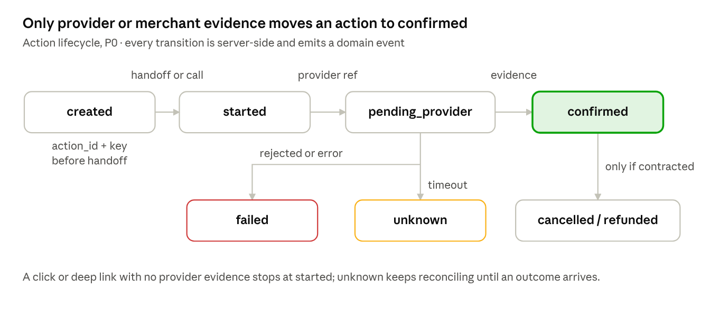
Action lifecycle · 7 states
From | To | Trigger | Evidence required
— | created | POST /v1/actions with idempotency key | Eligible candidate at request time
created | started | Handoff opened or provider call issued | Client/adapter acknowledgement
started | pending_provider | Provider accepted the request | Provider or merchant reference
pending_provider | confirmed | Provider/merchant confirms | Provider reference or merchant acceptance
pending_provider | failed | Provider rejects or errors terminally | Error code, stored
pending_provider | unknown | Timeout with no reconcilable outcome | Timeout record; reconciliation job keeps polling
confirmed | cancelled / refunded | Contracted cancellation or refund | Provider reference; only if NOW holds that role
A click or deep-link handoff may be counted as started; it can never be labeled confirmed without evidence.

8.3 Attribution and commission lifecycle
eligible → attributed → pending_confirmation → earned | reversed | disputed | corrected
- A ledger entry references exactly one action_id and one attribution_rule_version.
- Corrections append a new entry linked by correction_of; prior entries are never updated or deleted.
- A unique constraint on (action_id, active rule type) prevents double-counting across overlapping revenue concepts.
- Demo and simulated actions can never reach attributed.

9. Data model, API and events

9.1 Logical data model
Aurora PostgreSQL + PostGIS is the single source of truth. Ledger and audit tables are append-only (no UPDATE/DELETE grants for the application role).
Domain | Entity | Core fields
Territory | territory | id, polygon (PostGIS), timezone, languages, category_policy, map_provider_config_version, status
Identity | user, consumer_profile, consent | Cognito sub, preferences, notice version, purpose, scope, granted/revoked at
Merchant | organization, membership, venue | venue: id, organization_id?, name, category, point, address, publish_state
Supply | availability_assertion | id, venue_id, source_type, observed_at, valid_until, trust_state, evidence_ref, actor_id
Supply | offer, price_assertion | id, venue_id, title, eligibility, starts_at, ends_at, state, source_id
Discovery | intent | id, user_id?, raw_input, structured_intent, territory_id, time_context, location_source, correlation_id
Discovery | candidate, impression | intent_id, venue_id, rank, score_explanation, trust_state_at_display, source_id
Action | action | id, intent_id, venue_id, action_type, status, provider_reference, idempotency_key, correlation_id
Action | provider_outcome | id, action_id, status, provider_reference, received_at, evidence_ref
Ledger | attribution_rule_version | id, rule_type, effective_at, partner_id?, terms_reference, status
Ledger | commission_ledger_entry | id, action_id, rule_version_id, state, amount/currency?, correction_of?, created_at
Integration | source, integration_connection, webhook_receipt | Provenance, credential reference (Secrets Manager ARN), schema version, idempotency, delivery history
Media | media_asset, moderation_decision | Owner, raw/derivative keys, policy decision, publish state
Governance | audit_event | id, actor_id, action, resource_type, resource_id, before_after_ref, occurred_at
Governance | operational_case | Type, territory, severity, owner, status, resolution
Key relationships: territory 1—N venue; organization 1—N venue; venue 1—N availability_assertion and offer; intent 1—N candidate; intent 1—N action; action 1—N provider_outcome; action 1—N commission_ledger_entry (only one active per rule type); every privileged change → audit_event.
Search strategy. P0 uses PostGIS (GiST indexes on polygon and point) for territory, radius, category and time queries. OpenSearch Serverless is added in P1 only after measured query volume, ranking complexity or semantic-retrieval need justifies a derived index.

9.2 API contract groups (REST, /v1)
Group | Endpoints | Callers
Identity / profile | GET /v1/me · PATCH /v1/me/preferences · POST /v1/me/consents · POST /v1/me/privacy-requests | Consumer
Intent / discovery | POST /v1/intents · GET /v1/intents/{id}/candidates · GET /v1/venues/{id} · POST /v1/candidates/{id}/feedback | Consumer
Actions | POST /v1/actions · GET /v1/actions/{id} · POST /v1/actions/{id}/provider-outcome | Consumer, adapter
Merchant | POST /v1/merchant/claims · GET/PATCH /v1/merchant/venues/{id} · POST /v1/merchant/venues/{id}/availability-assertions · POST /v1/merchant/offers | Merchant admin/staff
Operations | GET /v1/ops/queues · POST /v1/ops/claims/{id}/decision · PATCH /v1/ops/venues/{id} · POST /v1/ops/cases/{id}/resolution | Operator, support
Integration | POST /v1/integrations/{provider}/webhooks · POST /v1/integrations/{provider}/imports · GET /v1/integrations/{provider}/health | Provider, operator
Media | POST /v1/media/upload-authorizations · POST /v1/media/{id}/publish | Merchant, operator
API conventions
- Contract-first: OpenAPI 3 spec is the source; clients are generated for Flutter and React.
- Every mutation requires an Idempotency-Key header; replays return the original response.
- Every response carries request_id; every request carries or receives a correlation_id.
- Errors follow one envelope (code, message, request_id); sensitive details never reach the client.
- Breaking changes require a new major path version (/v2); additive changes are allowed within /v1.
- Webhooks are verified by HMAC signature and timestamp, deduplicated via webhook_receipt.

9.3 Event catalog
All events carry event_id, event_type, schema_version, occurred_at, correlation_id, territory_id, actor context where policy allows, and the minimum necessary payload.
Domain | Events
Intent | intent.created · intent.normalized · candidate.generated · candidate.displayed
Supply | availability.asserted · availability.expired · availability.conflicted
Action | action.created · action.started · provider.outcome_received · action.confirmed · action.failed
Ledger | commission.attributed · commission.reversed
Merchant | merchant.claim_submitted · merchant.claim_decided
Trust and ops | quality.issue_reported · media.moderated · incident.opened
Privacy | consent.updated

10. Integration design
Every external dependency sits behind a bounded adapter contract, so the core domain never sees a vendor schema, SDK or credential, and a provider can be swapped without changing domain logic.

10.1 ProviderAdapter contract
Operation | Purpose | Notes
searchOrMatch(intent, territory) | Find matching provider supply for a normalized intent | Read-only; cached within the freshness window
getAvailability(venueOrProduct, timeContext) | Current availability, price or slot | Result stored as an availability_assertion with valid_until
startAction(actionRequest) | Create a booking, request or handoff | Requires action_id + idempotency key
getOutcome(actionReference) or signed webhook | Obtain the final outcome | Webhook preferred; polling as reconciliation
cancelOrRefund(actionReference) | Cancel or refund | Only when NOW is contractually responsible
health() | Operational status | Feeds provider-health dashboard and alerts
Every call carries a correlation ID, an idempotency key where mutable, the source/policy version and the partner trace reference. The adapter normalizes external payloads into canonical NOW entities and stores the original payload as evidence in a restricted location.
Resilience pattern per call: timeout → retry with exponential backoff and jitter → circuit breaker → SQS/DLQ for async work → source downgrade (e.g. partner_verified → unverified) → operator alert. An external failure must never produce a false confirmation.

10.2 Provider onboarding checklist (Gate B)
- ☐ Written authorization and commercial contract signed
- ☐ Named technical and support owner on both sides
- ☐ Credentials stored in Secrets Manager; rotation defined
- ☐ Action/outcome contract agreed (sync, webhook, polling)
- ☐ Freshness SLA and source precedence defined
- ☐ Cancellation/refund ownership decided
- ☐ Privacy and legal review complete
- ☐ Test environment and sandbox credentials available
- ☐ Health monitoring and alerts configured

10.3 MapProviderAdapter contract
The UI screenshots show Apple Maps attribution, while the earlier architecture proposed Amazon Location. Neither fact alone should lock the cross-platform design, so Flutter consumes a map adapter:
Function | Owner of the data
Map style / configuration retrieval | Provider (config version stored in territory)
Renderer initialization | Provider SDK, behind the adapter
Geocoding / reverse geocoding | Provider, where approved
Place search | Provider, where approved
Route / ETA | Provider, where approved
Marker and viewport rendering | NOW core supplies geometry and trust state
Privacy-aware location handling | NOW client policy
The NOW backend owns territory, venue, marker geometry, trust status and action policy. Tiles, styles, native renderer and provider credentials stay behind the adapter.

10.4 Map provider selection criteria (Gate A)
Criterion | Amazon Location + MapLibre | Platform provider (e.g. Apple/Google)
iOS + Android parity | To validate | Varies by provider
Coverage in the pilot territory | To validate | To validate
Commercial terms and cost at pilot volume | To assess | To assess
Data residency and privacy | AWS-region controlled | Provider terms
Attribution requirements | To confirm | To confirm
Offline needs | To confirm | To confirm
Operational control | High (same AWS account) | Lower
The decision is recorded at Gate A with the comparison filled in from real tests in the pilot territory.

11. Security, privacy, reliability and non-functional requirements

11.1 Security controls
Area | Control
Identity | Cognito User Pools issue JWTs; MFA required for merchant admins, operators, support and admins
Authorization | API Gateway JWT authorizer + backend tenant/venue/territory checks on every protected request
Secrets | Provider and API credentials only in Secrets Manager; no privileged key in Flutter or React bundles
Network | Core and data workloads in private subnets; VPC endpoints for AWS services; no public database endpoint
Encryption | TLS in transit; KMS at rest for Aurora, S3, SQS and backups
IAM | Least-privilege task roles per workload; routine access reviews
Detection | CloudTrail, AWS Config, GuardDuty, Security Hub
Edge | AWS WAF managed rules, rate limits, bot and API-abuse protection

11.2 Privacy
- Foreground precise location requested only when it improves the current task; manual place/area always offered; no background location in MVP.
- Consent stores purpose, scope, notice version, granted/revoked time and processing basis.
- Account deletion, export and rights-request workflow implemented before public scale.
- Support sees masked data by default; unmasking is audited.

11.3 Media pipeline
- Client requests an upload authorization; backend validates tenant, file type, size and quota.
- Backend returns a short-lived, single-object pre-signed URL to the private raw S3 bucket (Block Public Access, SSE-KMS).
- Upload triggers validation and moderation; a moderation_decision is recorded.
- Approved derivatives are written to the processed bucket and delivered only through protected CloudFront.
- Photo Rewards (rights, fraud, funding, redemption) is P1 validation scope only.

11.4 Reliability and operations
Concern | MVP requirement
Availability | Stateless Fargate service with health checks and horizontal auto scaling; Aurora resilience matched to production tier
Provider resilience | Timeout, retry/backoff, circuit breaker, idempotency, SQS/DLQ, source downgrade, operator alert
Freshness | Expiry worker downgrades stale availability without manual intervention
Observability | One correlation ID links client request, API, domain event, worker, outcome and ledger entry
Recovery | Aurora PITR, AWS Backup policy, pre-pilot restore drill, feature-flag rollback, named release approver
Operational queues | Merchant claims, stale supply, data conflicts, media decisions, action failures, support cases
Pilot reporting | Restricted dashboard: intent-to-action, confirmation rate, freshness, merchant activation, action failure, attribution exceptions, repeat use

11.5 Non-functional requirements
ID | Area | P0 requirement | How it is verified
NFR-01 | Security | No cross-tenant access; no public raw-media bucket; secrets only in Secrets Manager; least-privilege IAM | Negative role/tenant tests; S3 access test; IAM review
NFR-02 | Performance | P95 discovery API < 1.5 s in the configured territory, excluding external provider time | Load test at pilot volume; CloudWatch P95 alarm
NFR-03 | Freshness | Direct merchant update visible or state-changed within 60 s | Synthetic update probe
NFR-04 | Reliability | External failures never create false confirmation; safe retries; unrecoverable to DLQ | Fault-injection tests on adapter
NFR-05 | Observability | All P0 flows traceable by correlation ID across client, API, worker, provider event and database | Trace sampling review
NFR-06 | Privacy | Consent stored and enforced; no background location; manual fallback | Privacy test cases; permission audit
NFR-07 | Accessibility | Scalable text, accessible labels, focus order and a non-map fallback on critical Flutter and React paths | Accessibility checklist (WCAG 2.1 AA target)
NFR-08 | Recovery | PITR, restore drill, rollback runbook, feature flags, release approval before pilot | Restore drill record
NFR-09 | Data quality | Every displayed candidate has source, observed/freshness time and trust-state semantics | Contract test on candidate payload

12. Governance, gates and rollout
Nothing is built before Gates A–D are signed, and nothing opens to the public before Gate E records one authorized, confirmed, measurable action.
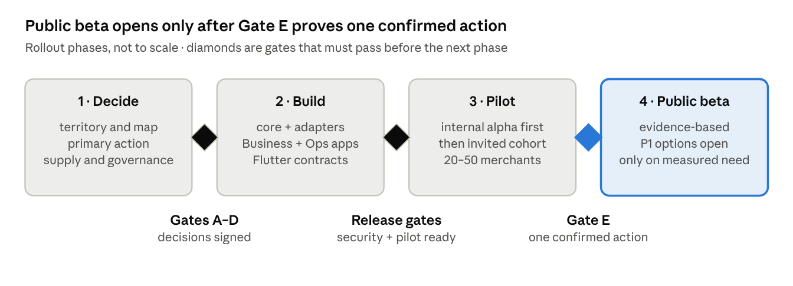
Rollout · 4 phases, 3 gate points

12.1 Decision gates before implementation
Gate | Required decision | Accountable roles
A — Territory and map | Territory polygon, timezone, categories, map provider and adapter contract | CEO, COO, Product, Chief Technology Architect
B — Action | One provider/direct-merchant flow; handoff vs booking request vs confirmed booking; cancellation/refund ownership | CEO, COO, Product, Chief Technology Architect
C — Supply | Merchant operating process, freshness SLA, source precedence, 20–50 pilot merchant plan | COO, Product
D — Governance | RACI, release approval, physical-device build policy, restore point, regression evidence, incident escalation | CEO/Founder, Chief Technology Architect
E — Commercial proof | Definition of an authorized, confirmed, measurable transaction and a rule-versioned attribution entry | CEO, COO, Finance, Chief Technology Architect

12.2 Release gates (evidence required)
Gate | Evidence required
Baseline preservation | Current restore artifact; Flutter regression results for validated voice and map flows
Territory readiness | Approved polygon, category policy, map-provider choice, merchant/supply list, operating owner
Provider readiness | Authorization, credentials, terms, action/outcome contract, privacy/legal review, test environment, support contact
Security readiness | Role/tenant negative tests, S3 access test, secrets review, audit logging, MFA policy, privacy workflow
Pilot readiness | Merchant onboarding, freshness queue, action/outcome traceability, alerting, runbooks, support ownership
Commercial proof | One authorized, confirmed action with provider/direct-merchant evidence and one append-only attribution entry

12.3 Pilot KPIs
Targets for each KPI are set at Gate E; the definitions are fixed now so the dashboard can be built from day one. Demo and simulated records are excluded from every KPI.
KPI | Definition
Intent-to-action rate | Actions started ÷ intents created
Confirmation rate | Actions confirmed ÷ actions started
Unknown-outcome rate | Actions ending unknown ÷ actions started
Supply freshness | Share of displayed candidates with a non-expired assertion at display time
Merchant activation | Pilot merchants with at least one valid availability assertion in the last 7 days
Action failure rate | Actions failed ÷ actions started, by cause
Attribution exceptions | Ledger entries in disputed or corrected state
Repeat use | Consumers with a second intent within 30 days
Discovery latency | P95 of GET /v1/intents/{id}/candidates

12.4 Key risks and mitigations
Risk | Impact | Mitigation
No authorized provider signed in time | Commercial proof cannot be reached | Use the direct-merchant booking-request path as fallback for Gate B
Merchants stop updating availability | Stale supply, low trust | Freshness queue, automatic expiry, operator outreach, simple mobile-friendly Business UI
Flutter regressions while adding contracts | Loss of the validated consumer asset | Restore point, regression suite, feature flags, named build approval
Demo data leaks into commercial metrics | False investor and business signals | source_type and trust_state filters enforced in analytics; OPS-03 tests
Provider outage or slow responses | False confirmations or poor UX | Adapter resilience pattern; unknown state with reconciliation
Map provider lock-in or terms conflict | Costly rework | MapProviderAdapter; Gate A comparison before build
Double-counted commissions | Financial and partner disputes | One rule version per entry; unique constraint; append-only ledger

12.5 Explicit non-goals (P0)
Excluded from the P0 release: consumer React Native rewrite; payment ownership, wallet, stored value, settlement, crypto/stablecoins or other financial products; broad multi-provider Journey Commerce; sponsored-intent auctions and outcome ads; broad affiliate portfolio and data products; public API and white-label; global or multi-city rollout; broad category expansion; advanced POS/PMS integrations; background location and geofencing; scalable Photo Rewards; full video pipeline.

12.6 Glossary
Term | Meaning
Intent | Structured form of a consumer's request (what, where, when, constraints)
Candidate | A venue/offer eligible to answer an intent, with rank and trust state
Assertion | A source-tagged, expiring claim about availability, price or offer
Trust state | Visible label for how reliable an assertion is (demo … partner_verified)
Action | A consumer's commercial step (handoff, request or booking) with its own lifecycle
Provider outcome | The external or merchant result of an action, with reference
Attribution rule version | Versioned rule that decides which party earns what for an action
Correlation ID | Identifier that ties one user flow together across all systems
P0 / P1 | MVP scope / first post-proof expansion

12.7 References
- NOW Source Evidence Ledger (internal)
- NOW Technical and Functional Specification V2 (superseded by this document)
- NOW Revised AWS Architecture V2 and detailed D2 diagram (superseded by this document)
- Amazon Cognito User Pools
- Amazon Location Service Maps
- Expo Authentication Guidance
This design preserves future scale options, but it intentionally avoids treating strategic proposals, demonstrations or simulated flows as commercial production capabilities.

