Fiber photometry data analysis - Pipeline
Alain Marchand – V17b – 14 nov. 2025

Summary

BEFORE RECORDING 2
1. Synchronization pulses (TTL) 2
2. Naming files 2
AFTER RECORDING – PREPARING DATA ANALYSIS 3
3. Pre-processing behavioral files 3
4. Pooling photometry and behavioral files 4
5. Create database from photometry & behavioral files 5
6. Parameters in phautom_parameters.json 5
7. Synchronization options 6
8. Calculation options 7
9. Databases 7
10. Visualization 10
11. Extracting signals for events of interest 11
12. Database files 11
13. Analysis parameter file 11

BEFORE RECORDING

Synchronization pulses (TTL)

Synchronization of the photometry recording with the behavioural recording relies on TTL pulses sent by the behavioural program. It exploits the variability of times between events to identify and match events from both types of recordings.

Under Whand → TTL.txt this file must be placed in the folder Scripts (Whand/Scripts)
→ controls a TTL cable adaptator plugged into LED1 (L1) connector
(It requires connection file “scripts/connections.txt”)
→ defines pulses for tagging events of interest during the session, typically:
Single short pulse (300ms) when P1 is pressed
Double short pulses (300ms) separated by 300ms when P2 is pressed
Triple short pulses (300ms) separated by 300ms each when P3 is pressed
Delayed long pulse (600ms) when a reward was delivered
Under POLY → Exercise with TTL included (on TTL dedicated cable)
There is a refractory period of 2500 ms for the TTL pulse code, so a new pulse is only emitted at the beginning of next press.
Pulse parameters in phautom program are specified in parameter 'Synchro_codes'.

Naming files

Both files must receive the same name!
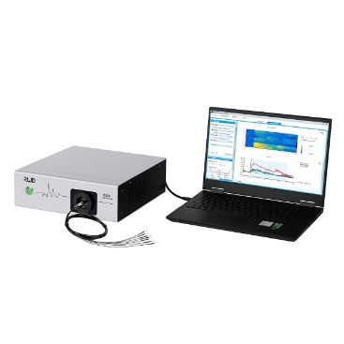

Photometryfile_name : date_manip_rat_session
ex: 220511_bandit_rat29BAZ_S14
WHAND
Behaviorfile_name : date_manip_rat_session
ex: 220511_bandit_rat29BAZ_S14_1_

AFTER RECORDING – PREPARING DATA ANALYSIS


Data
Database
Events
Folders and programs
poolphot.py
phanal.py
phautom.py

analysis.txt
Logs


Pre-processing behavioral files

Behavioral files must be preprocessed under Excel® with Sk_traite macro, using 'group file', 'historique' and 'modele' to obtain an .xlsx file containing a list of trials with columns identifying various events of interest. At least a column named “temps” must be present (see also Align_on, line 74).
Alternatively, a pre-processing program may be developed to create a text (.xls) or Excel® file with a similar format:
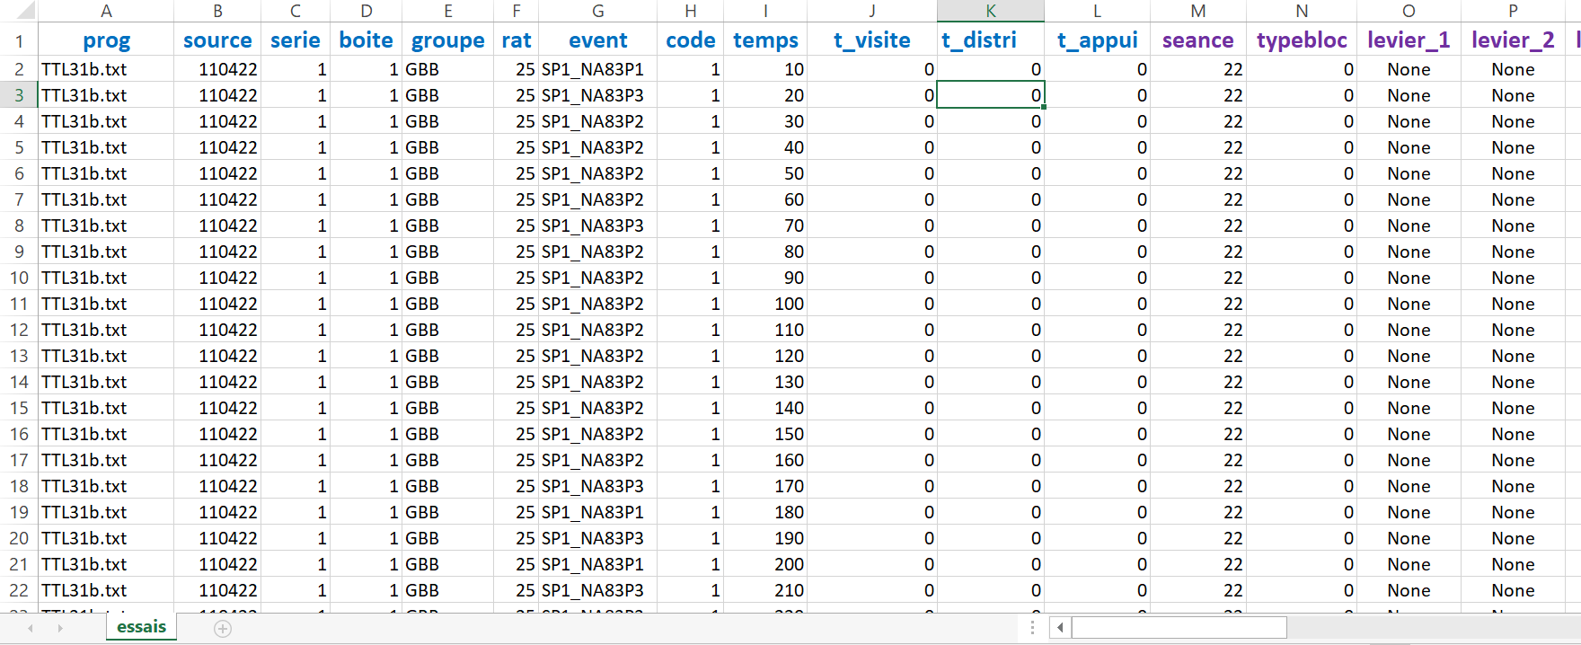
Excel® file by trial with columns identifying various events of interest.

Pooling photometry and behavioral files

poolphot.py → Renames files (photometry = .csv + behaviour = .xlsx) to have the same name by recording session and extract these files from their original folders and put them all together in an empty folder Data (which must be created beforehand).
Poolphot is an open source Python program.
(This step can be skipped if all files are named similarly)
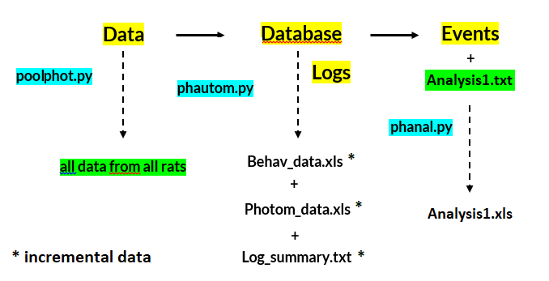

Diagram of the pipeline process.

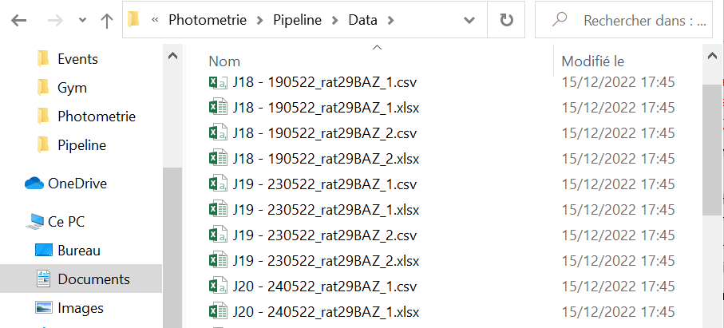

Example of data files after poolphot.

Create database from photometry & behavioral files

In order to run analysis, Pandas and other modules must be installed, or Anaconda with the Spyder notebook.
To install Pandas separately, search and start 'cmd' in command bar then type 'pip install pandas' (or other module name) in the black command window.

phautom.py (currently version 15)
→ Phautom program combines behavioral and photometry data to extract deltaF/F for all available trials. It creates two incremental databases with all recordings of all rats. Only trials with photometry recordings are processed. Batch processing of multiple files is supported. Processing each file takes several seconds but needs only be done once.
Phautom takes data from subdirectory 'Data' from where phautom.py is located. It is allowed to replace actual data files with shortcuts to data files.
Phautom writes data into subdirectory 'Database' from where phautom.py is located. Subdirectory 'Database' will be created if it does not exist. It contains a sub-subdirectory named 'Logs' to store detailed information about trial alignment.
Phautom synchronizes behavioral and photometry recordings by automatically aligning time intervals between specific events with the synchronization pulses (TTL –1.) triggered by these events.
Phautom is an open source Python program.

Parameters in phautom_parameters.json
The following parameters are stored in file phautom_parameters.json and can be changed on a panel at runtime.
"Regions": 2,
"Behav_time": 100,
"Minus_window": -5000,
"Plus_ window": 8000,
"Min_offset": -4000,
"Max_offset": 1000,
"Photom_interval": 50,
"Approximation": 50,
"Ignore_first_seconds": 5,
"Photom_marker": "*0",
"TTL_on": "t_appui",
"Align_on": "t_appui",
"Synchro_codes": "{'P1': [0], 'P2': [0, 600], 'P3': [0, 600, 1200], 'D1': [1800], 'A1': [1800]}",
"Add_reward": "True",
"Globalize_z_score": "False",
"Linear_regression": "True",
"Divide_by_mean": "False",
"Keep_DC_level": "False"
"Detrend": "False",
"Visualize": "False"

Regions may be 1 or 2 depending on the number of fibers implanted. Results will be accordingly tagged as 1 or 2.
Visualize: set to "True" to visualize processing steps, set to “False” for normal function (blind).
Ignore_first_seconds will discard the beginning of the photometry record where most of the bleaching occurs. It has no effect on synchronization.

Synchronization options

Settings in the photometry setup
Option Photom_marker and Photom_interval correspond to settings in the photometry setup.

Photom_marker is used to identify lines in the .csv file containing a TTL pulse marker. set to "*0;" or to "*0" to detect TTL events, depending on details of the .csv format.
Behav_time (in ms) is normally 100, but can be adjusted if clock rates do not quite match (after V17b). With the Doric system, a value of 100.00574 may be appropriate.
Photom_interval (in ms) is the sampling period (including both signal and isosbectic).

Search limits limit the range of explored offsets for alignment (in milliseconds). The range should be set according to the sequence of recording in the experiment. If the photometry recording starts before the behavior recording, the offset will be positive. If the photometry starts after the behavior, the offset will be negative. Setting a narrow time range may prevent alignment of some recordings. Setting a large time range may slow down processing.
min_offset=-1200_000 # behavior file may start up to 20 min before photometry
max_offset=120_000 # behavior file may not start more than 120 s after photometry
Approximation (in ms) was found to give good results for synchronization in the range 0.6 to 1.5 times the sampling interval. Low values should be at least half the sampling interval, and large enough to accommodate the accuracy of the behavioural system.

Pulse parameters
TTL_on (not to be confused with Align_on) is generally a lever press ("t_appui"). This parameter must not be empty. It indicates the position (latency) of the TTL event in the trial (not counting artificial delays of the TTL pulse). Trial time usually refers to lever presentation. In the absence of lever presses (e.g. Pavlovian experiments), reward delivery ("t_reward") may be used for synchronization. The names "t_appui", "t_reward" must correspond to column titles in the .xlsx file, and originate from Excel® sheet names defined in the processing historique.

Synchro_codes={"P1":[0], "P2":[0,600], "P3":[0,600,1200], "D1":[1800] , "A1":[1800]}
Both codes "D1" and "DA1" (reduced to "A1" here) are accepted for rewards. More events may be added if they give TTL pulses. Here, reward pulses are artificially delayed by 1800 ms, and there are 1, 2 or 3 TTL pulses depending on the lever pressed, with the second or third pulse being artificially delayed by 600 or 1200 ms. Must be in agreement with the TTL from the behavioral program.
Add_reward=True means to expect a reward TTL pulse on trials where the "reward" column is 1. The corresponding time will be added to the behavioural list of events. Must be in agreement with the TTL from the behavioral program.

Calculation options

Calculation options affect the results only marginally and should be fixed once and for all.
Align_on must not be confused with TTL_on. If Align_on is empty, data will be aligned with the start of the trial (typically presentation of the levers).
Minus_window and Max_window determine the range of data recorded in the database. A negative Minus_window refers to data preceding the Align_on event. A positive Max-window refers to data following the Align_on event. Beware of overlapping between trials!
If option linear regression is False, the isobectic is simply subtracted from the fluorescence channel.
Divide_by_mean=False # if True, compute deltaF/Ftrial_mean instead of deltaF/Finstant
Globalize_z_score=False # if True, compute mean and stdev over whole session
Keep_DC_level=False # if True, center isosbectic on zero to detect variations in DC level
Detrend=False # (V17 and above) if True, removes global linear trend from deltaF/F
A linear trend could result in baseline changes from session start to end

Databases
Database integrity: it is allowed to delete columns from databases or to add columns containing new formulas (under Excel®), but rows must not be changed.
Each time Phautom is run, new rows get added to the databases. Do not run the same data twice or you will get duplicate trials and ruin the statistics. You may delete the databases and the Log_summary file to start again.
When recording from two regions, set option Regions=1 to Regions=2.
Databases are in 'text separator tabulation' format with an '.xls' extension so they can be automatically loaded by Excel®.
One database named 'Behav_data.xls' contains trial behavioral information taken from all .xlsx processed files. Session info is retrieved from file name. With two regions names become 'Behav_data1.xls' and 'Behav_data2xls'.
The other database named 'Photom_data.xls' contains trial-by-trial deltaF/F together with mean and standard deviation, so that z-score may be easily computed. With two regions names become 'Photom_data1.xls' and 'Photom_data2xls'.

Trials from both databases are in the same order and their random number code must match (column 'check').
A log file named 'Log_summary.txt' recapitulates the alignment quality of each file. Sub-subdirectory 'Logs' stores detailed information about trial alignment, for information only. Alignment scores below 80% should be examined with caution (e.g. wrong file).
A bad alignment may be due to excluded events (e.g. early lever presses). If criteria to exclude events differ between the exercise controlling the experiment and the analysis historique, you may get widely variable timing or missing events.
Another possibility is a discrepancy in clock rates between behavior and photometry, as evidenced by a gradual drift of synchronization errors. A slight change in Behav_time parameter (e.g. 100.00574 with the Doric system) may correct this problem.

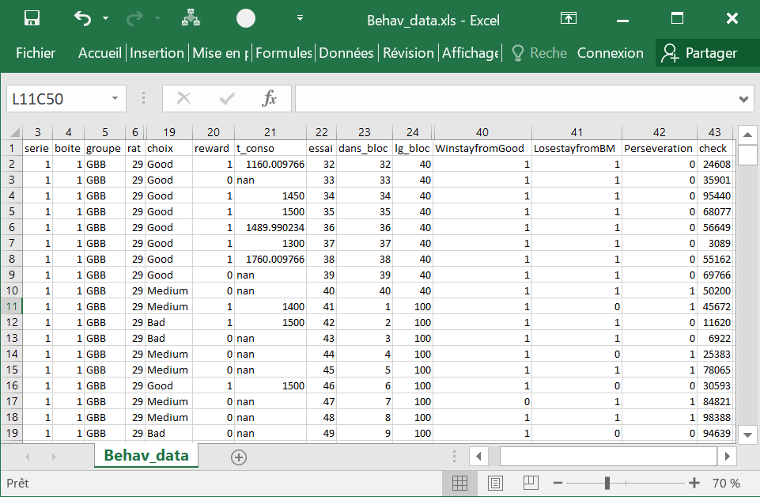

A sample from Behav_data.xls database.

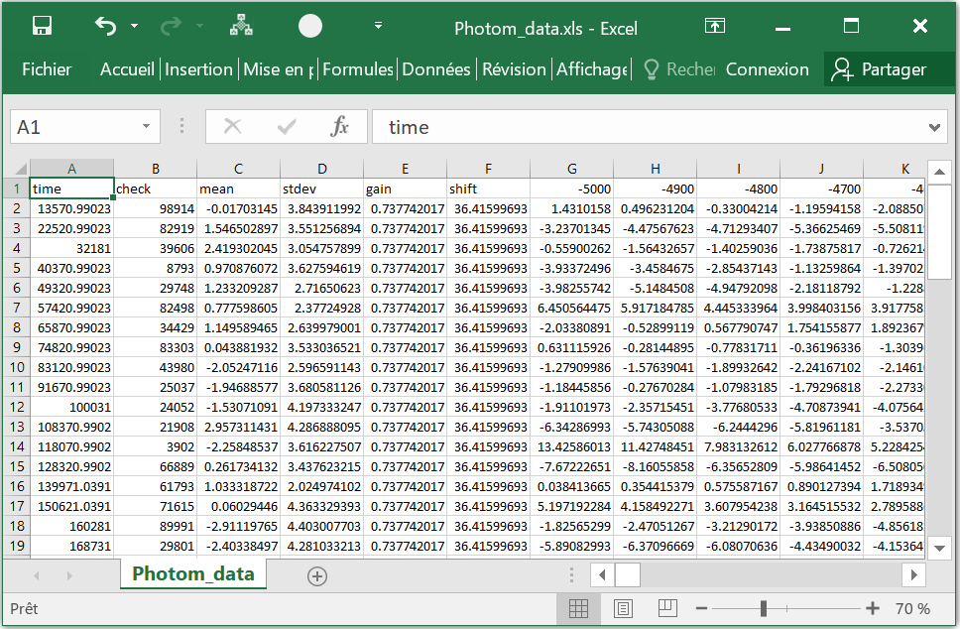

A sample from Photom_data.xls database.

Visualization
It is now possible to visualize the raw photometry signals and the first stages of data processing, including filtering and linear fit (not trial-by-trial). Select Visualize: True in the parameter panel.
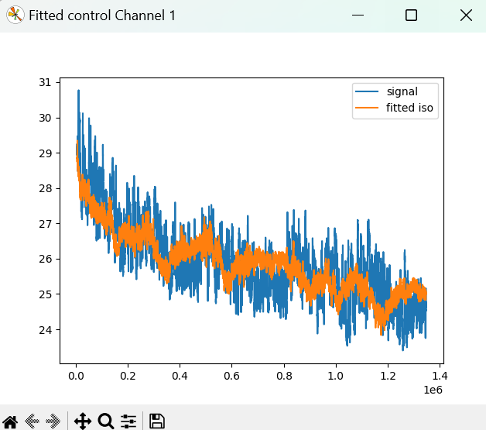
The above visualization tools enable you to zoom and scroll the data for inspection. After closing the window, the next graph will appear after a pause of several seconds.
You can stop visualization at any time during pauses between displays by pressing Ctrl-C.

Warning: while Visualize mode is activated, data will not be fully processed and database will not be updated.

To view the photometry data, you may need to install matplotlib, if it’s not already done.
To do this, the command [Windows window key]R should open a small command window.
enter: cmd to open a larger black command window.
enter: pip install matplotlib
If all goes well and there is no error message, you are done.

Extracting signals for events of interest

phanal.py

→ Phanal program extracts deltaF/F or z-scores from selected trials in selected bins. It retrieves data from databases with all recordings of all rats. Only trials matching parameters specified in a parameter file are stored.
Once the database has been created it can be used with phanal.py for multiple analyses.
Phanal takes data from subdirectory 'Database' from where phanal.py is located. Results are stored in Subdirectory 'Events' which must exist beforehand and contain a text file with parameters (extension '.txt').
Results are stored in a text file with the same name as the parameter file, in 'text separator tabulation' format with an '.xls' extension. They can be automatically loaded by Excel® or another software for further analysis (graphics, pivot tables, statistics).
The result file contains behavioral data about events of interest, as in the original '.xlsx' file, except that times are all in milliseconds, and additional columns for signal/PSTH, on a trial-by-trial basis.
Phanal is an open source Python program.

Database files

There is now one version of Phanal.py. It automatically detects the number of regions to analyze from the names of the database files.
'Photom_data.xls' + 'Behav_data.xls' (1 region) or
'Photom_data1.xls' + 'Behav_data1.xls' (1 or 2 regions) or
'Photom_data2.xls' + 'Behav_data2.xls' (2 regions)

Analysis parameter file

A parameter file contains various lines specifying parameters for extracting and processing trial data. They may be in any order. Blank lines and spaces are ignored. Comments may be added after '#'.
An “analysis.txt” file must be created and placed in the folder “Events”.
Processing options:
Z-score: If a line starts with 'z-score' and not with 'z-score=false', data will be processed as z-scores. Z-score is (delta-mean)/std where delta is deltaF/F₀ , mean and std are mean(delta) and standard deviation (delta) over 15 s around lever press.
DeltaF/F: Alternatively, data represent deltaF/F₀, = (F- F₀)/F₀ where F₀ is the instantaneous fluorescence of the isosbectic channel. This is OK as long as there are no artefacts in the isosbectic channel.
Peak, Trough, Area below the curve: If a line starts with 'max' and not with 'max=false', data in each bin will be processed as the maximum value (peak) in each bin. Other keywords 'tmax', 'min', 'tmin' will yield respectively the time of the peak (max), the minimum value (trough) and the trough time. Keyword 'area' will yield the area below the curve for each bin, using a trapeze integration algorithm, as in Guppy.
Only one of the options 'max', 'tmax', 'min', 'tmin', 'area' is allowed in a given analysis.
Mean or individual values: If none of the previous options is selected, data in each bin will be processed as a mean value. If bin size is equal to sampling rate (100 ms), every deltaF/F or Z-score value will be copied. This may be used to plot the detailed profile of the response.

To sum up:
- to compute deltaF/ F₀ → do not write anything in the analysis.txt file
or to compute z-score → write “z-score” in the analysis.txt file
- to compute mean → do not write anything in the analysis.txt file
or to compute area → write “area” in the analysis.txt file
or to compute peak → write “max” in the analysis.txt file
or to compute peak time → write “tmax” in the analysis.txt file
or to compute trough → write “min” in the analysis.txt file
or to compute trough time → write “tmin” in the analysis.txt file
Trial selection (example):
essai= 1:100 # take only the trials from 1 to 100
rat= 29:33
rat= 40 # this means either rat 40 or rats 29, 30,31, 32, 33
choix= medium # case is ignored
choix= Good # this means either Medium or Good

The first part of each line, e.g. 'essai' must be one of the column titles of the original '.xlsx' file, e.g. 'reward', 'W-shift', etc. The second part may be a string (case is ignored), a number or an interval (separator ':').
A range is defined by the presence of a colon ‘:’ in the line. Integer values or decimal values such as 2.5 are allowed in a range (e.g. latencies).
All lines referring to the same column name are treated as a logical 'OR'.
All lines referring to different column names are treated as a logical 'AND'.
In the example above, conditions on 'essai', 'rat' and 'choix' must all be met on each trial.

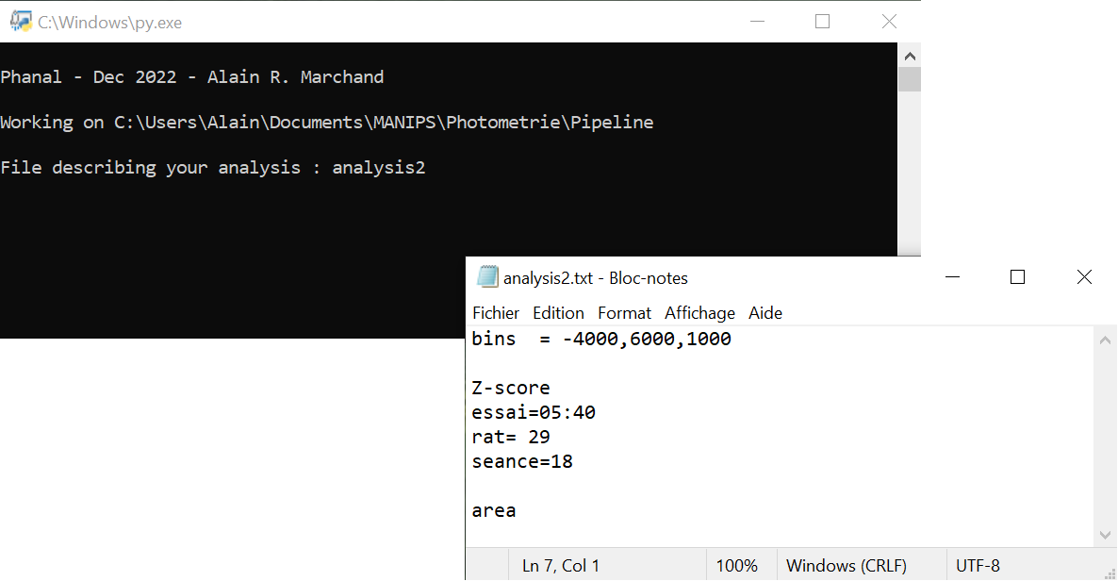

Running an analysis file.

Bin selection (example):
bins=1000,2000,1000 # start,stop,step
bins=1000,2000,500
bins = -4000,5000 # bin size by default is 100 ms (sampling rate)
The first part of each line must be 'bins'. The second part is start, end, bin size in milliseconds.
Each line may be used to define one bin or a range of bins.
Here, 'bins=1000,2000,1000' defines a single bin containing the mean value or area between start and end, with name indicating 1500.
'bins=1000,2000,500' defines two bins containing the mean value or area between 1000 and 1500, and between 1500 and 2000. Their names indicate 1250 and 1750.
'bins=-4000,5000' just copies each value in a different bin without averaging because bin size is equal to sampling rate (100 ms). Names indicate -3950…4950.

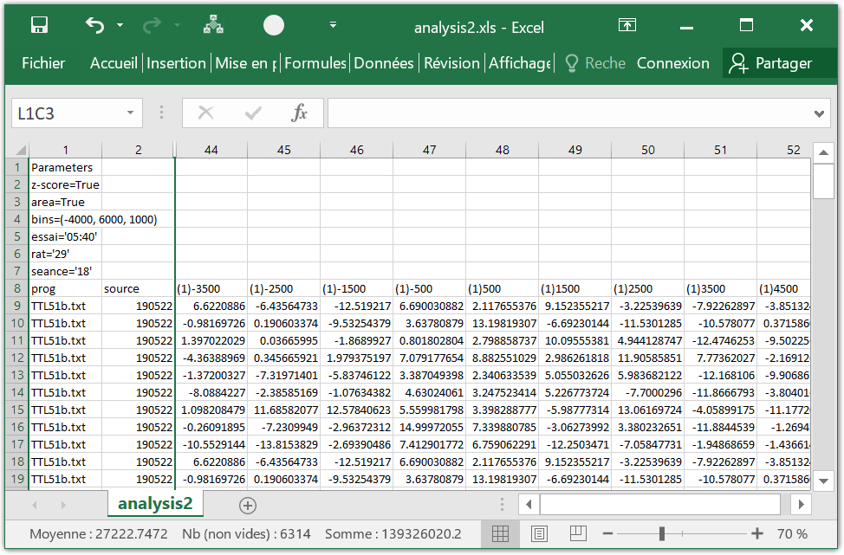
A sample from result file analysis2.xls.

