Lab4 – Building Microservices for your Smart Space
Group name: Boar
Members
Alessandro Querzé | Andrei Radu | Enrico Giannini | Mirko Tonelli
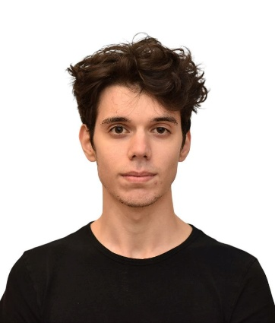 |  |  | 

Link to YouTube video

Project Description
Material:
- Sensor DHT11 for both temperature and humidity
- Servo motor for the window
- Motor 2N2222 for the fan

Distribution of Effort
Andrei:
- DDL build
- MQTT middleware setup
Mirko:
- Services organization
Enrico:
- Vibe coder
Alessandro:
- Sensors and actuators setup
- Test code

