Lab1 – Virtual Smart Space (VSS) – 2026
Group name: Boar
VSS name: BoarNET
Members
Alessandro Querzé | Andrei Radu | Enrico Giannini | Mirko Tonelli
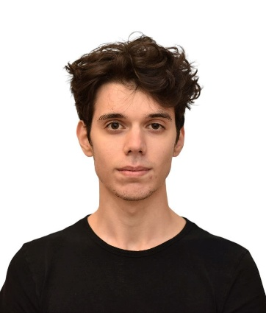 |  | 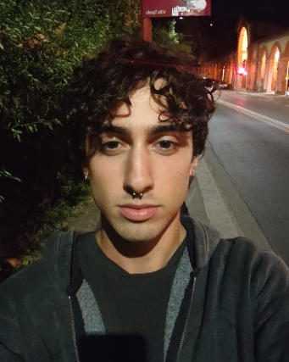 | 

Link to YouTube video

Project Description
In this project we configured the Virtual Smart Space (VSS) using a laptop, a wi-fi router and a Raspberry Pi 4B to form the Cloud, Edge and IoT Things layers. To demonstrate that the VSS works, we created a circuit that lights an LED according to a photoresistor connected to the Raspberry. To determine the intensity of the LED we used the PWM method.
We developed a python script that reads the value given by a photoresistor to a Raspberry’s input pin and converts it to the output pin that gives the LED a brighter intensity when the photoresistor detects more light and a dimmer intensity in the opposite scenario. To convert the analog value of the photoresistor in digital, we used an A/D Converter (MCP3008). We used a red LED to have a visual indication of the sensor’s readings, giving it a variable intensity thanks to the PWM method, that changes at a very high speed the tension on and off, obtaining the average voltage in output.

Distribution of Effort
Everyone interacted in all areas and was important to overcome the difficulties that this first boot gave us. Alessandro and Enrico were mainly invested in video and code development, while Mirko and Andrei wrote a significant part of the report. For the setup of the VSS and electrical circuit we shared the workload equally.

Relative % of Effort
- Alessandro: 25%
- Andrei: 25%
- Enrico: 25%
- Mirko: 25%

