Alessio Amorelli 40176996

Bosighur Shishani 40170574

**Development Environment:**

Tomcat v10.1

jdk-17.0.3.1

Eclipse 2023-09

**Instructions:**

D

**UML Diagram:**

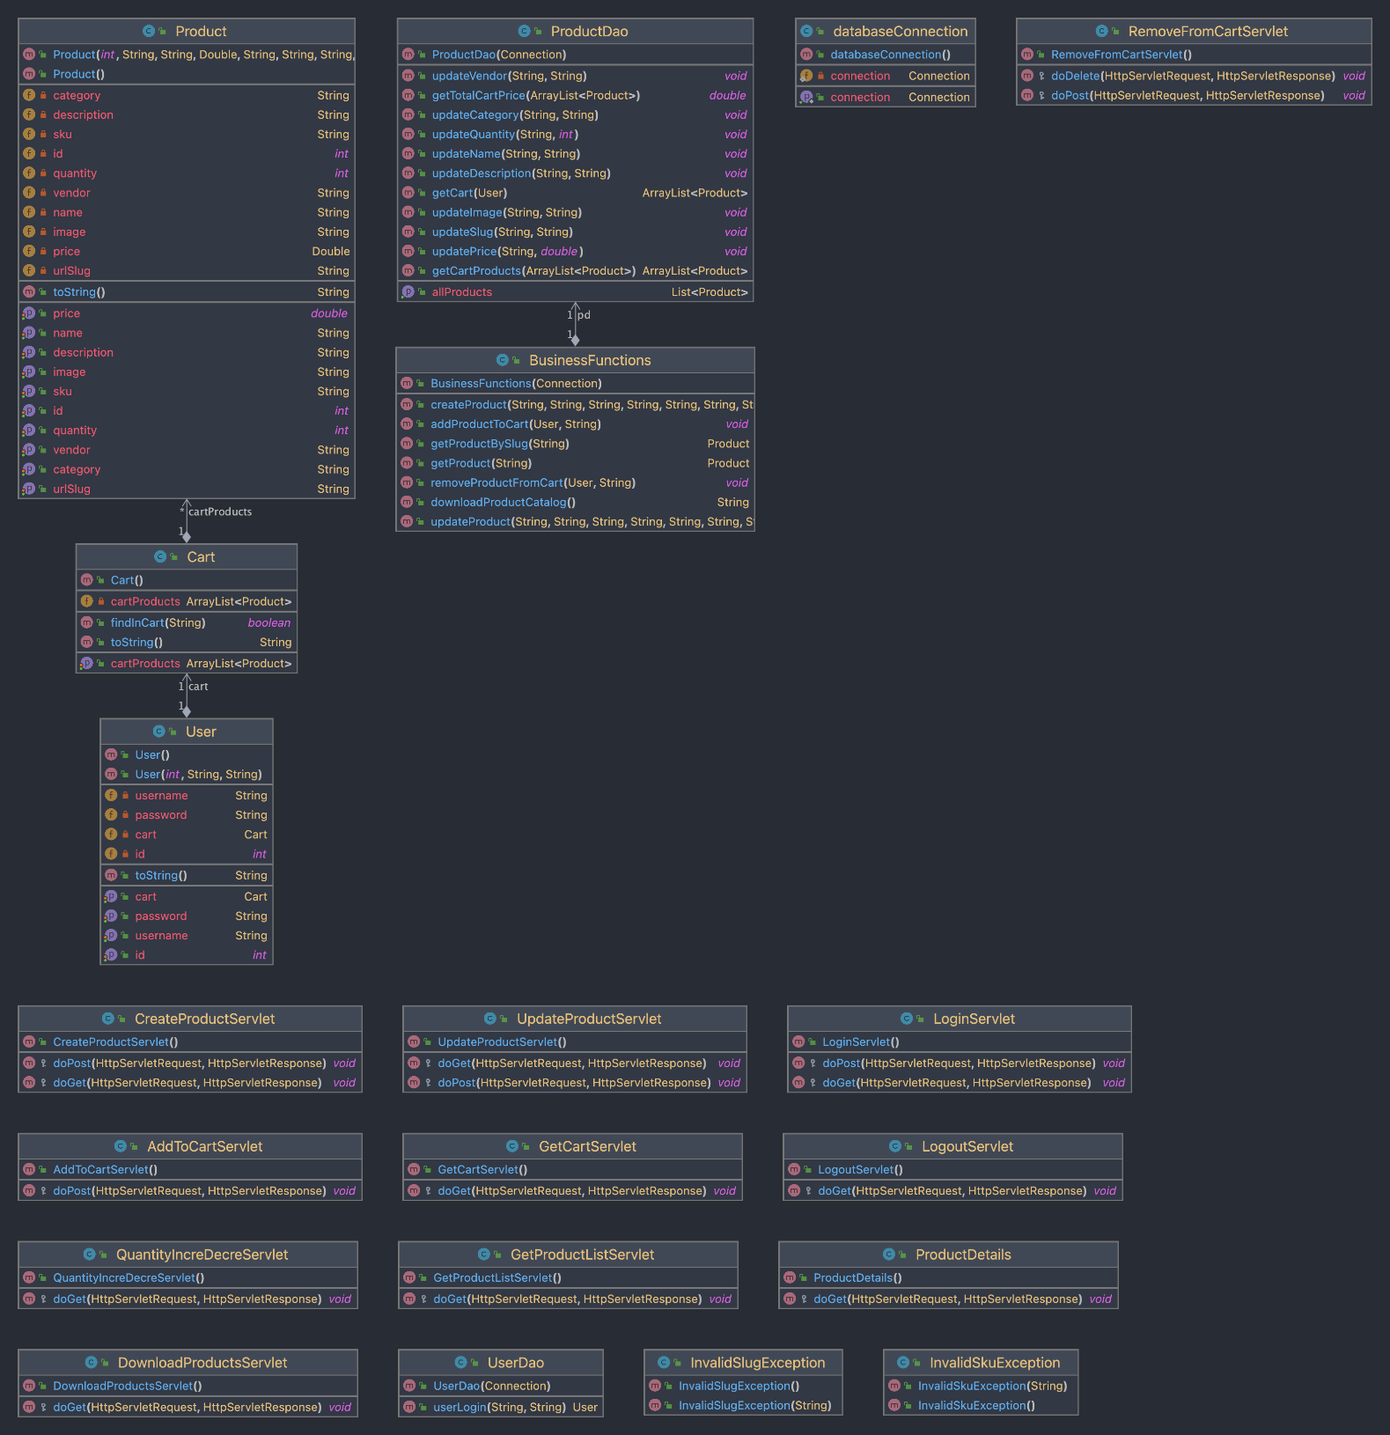

**Bonus Marks:**

d