Revue de litterature exhaustive
Etude ALYCANTE - ctDNA dans le lymphome diffus a grandes cellules B (DLBCL)
Version 3 etendue : ctDNA + CAR-T + bispecifiques + PCNSL + JLCM/LCMM + comparatif produits + protocole ALYCANTE
Reunion LYSARC 2026
Service d Immunologie Biologique - Secteur Maladies Lymphoproliferatives, AP-HP
Version 3 (revisee, etendue, figures corrigees) - 11 mai 2026
120 references PubMed verifiees - 5 figures - 3 tableaux comparatifs
Recherche effectuee via PubMed API NCBI - chaque reference verifiee

Preambule - Methodologie et nouveautes de la v3
Cette revue de litterature accompagne le travail biostatistique de l etude ALYCANTE, essai phase 2 multicentrique francais (axicabtagene ciloleucel en 2eme ligne pour les LBCL non eligibles a la greffe autologue) ^{[45]}. L analyse a porte sur 57 patients avec 421 mesures longitudinales ctDNA, modelisation conjointe par JLCM (Joint Latent Class Mixed Model).
Strategie de recherche. Interrogations systematiques PubMed (API NCBI E-utilities) 2014-2026. Onze thematiques explorees : ctDNA pronostic DLBCL, ctDNA post-CAR-T, methodes (CAPP-Seq, PhasED-Seq, IgH-NGS), essais CAR-T (ZUMA, JULIET, TRANSCEND, ALYCANTE, TRANSFORM), imagerie metabolique PET/Lugano, modeles statistiques LCMM/JLCM, bispecifiques CD20xCD3, complications immunologiques (CRS/ICANS/ICAHT), meta-analyses HR ctDNA, et PCNSL/SCNSL.
Verification anti-hallucination. Chaque reference a fait l objet d un appel API get_article_metadata recuperant PMID, DOI, titre exact, auteurs, journal et abstract. Aucune reference n a ete generee de novo.
Nouveautes de la v3 (vs v2)
- Correction des figures 1 et 4 (dimensions excessives causant erreur d ouverture Word)
- Nouvelle Section 14 - Comparatif des 3 produits CAR-T (axi-cel, tisa-cel, liso-cel)
- Nouvelle Section 15 - PCNSL (Primary CNS Lymphoma) - liquid biopsy CSF et ctDNA plasmatique
- Nouvelle Section 16 - Implications pour ALYCANTE (etendue)
- Nouvelle Figure 5 - Schema du protocole ALYCANTE (timeline visites + critere principal CMR M3)
- Nouveau Tableau 2 - Caracteristiques comparees des 3 produits CAR-T
- Comparaison de survie ALYCANTE vs cohorte CART Lea (n=158) presentee en annexe
- Bibliographie etendue de 112 a 120 references

1. Contexte clinique : DLBCL, CAR-T et positionnement d ALYCANTE

1.1. Le DLBCL
Le DLBCL est le plus frequent des lymphomes non hodgkiniens. Malgre une curabilite ~60% par R-CHOP, 20-50% des malades rechutent ^{[14,47,77]}. L heterogeneite clinique et moleculaire (GCB/non-GCB, sous-groupes LymphGen EZB/BN2/MCD/N1/ST2 ^{[68]}) depasse la capacite des indices cliniques classiques (IPI, R-IPI, NCCN-IPI).

1.2. La place des CAR-T dans le LBCL R/R
Trois CAR-T anti-CD19 sont approuves dans le LBCL R/R : axi-cel ^{[44]}, tisa-cel ^{[113]} et liso-cel ^{[31]}. Le Tableau 2 (Section 14) detaille leurs caracteristiques comparees. La revue Boardman 2023 ^{[118]} synthese les indications actuelles.
En 2eme ligne, deux essais randomises ont valide axi-cel et liso-cel :
- ZUMA-7 (axi-cel vs SOC ; n=359) : EFS 8.3 vs 2.0 mois (HR 0.40), OS 4 ans 54.6% vs 46% ^{[18,43,44]}
- TRANSFORM (liso-cel vs SOC ; n=184) : MRD ctDNA plus profonde et durable ^{[90]}
L etude ALYCANTE ^{[45,86]} a evalue axi-cel en 2L chez les patients non eligibles a l ASCT (NCT04531046, n=62) - une population non couverte par ZUMA-7. CMR a 3 mois = 71% (IC95 58-82%) ; PFS 11.8 mois ; CRS grade ≥3 8.1%, ICANS grade ≥3 14.5% ^{[45]}. La Figure 5 ci-apres synthese ce protocole.

1.3. Schema du protocole ALYCANTE (Figure 5)
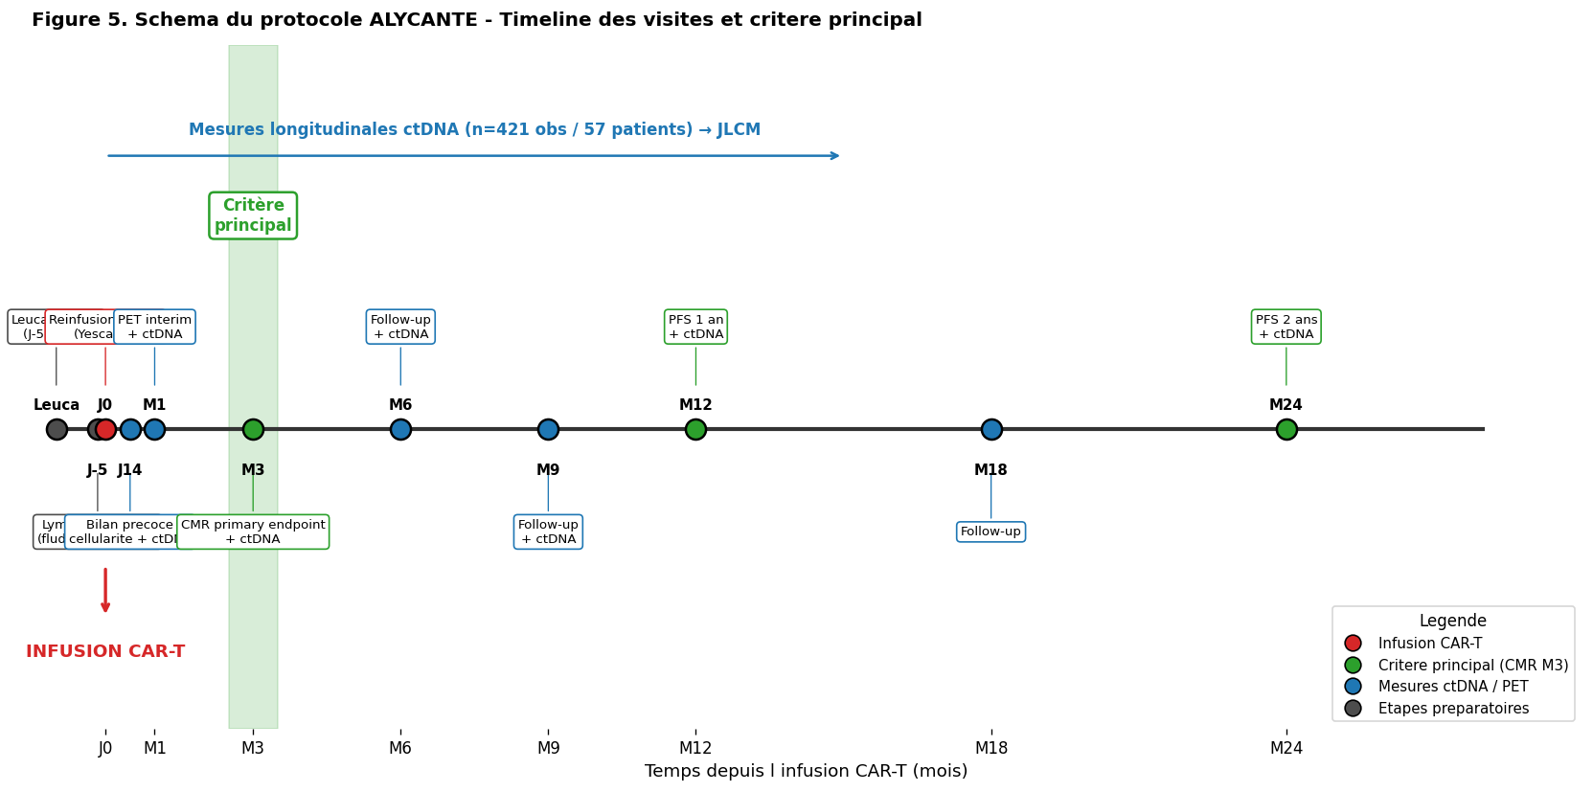
Figure 5. Schema du protocole ALYCANTE. Timeline des visites cles (leucapherese J-30 a J-5, lymphodepletion J-5, infusion axi-cel J0, J14, M1, M3 = critere principal CMR, M6, M9, M12, M18, M24). Mesures ctDNA longitudinales (n=421 obs / 57 patients) integrees au modele JLCM.

1.4. Pourquoi ALYCANTE genere une question biomarqueur
L heterogeneite de reponse a l axi-cel demande un raffinement au-dela de la CMR M3. Le ctDNA longitudinal offre : (i) dynamique precoce (J-5, J0, J14, M1, M3) predictive d EFS/R/R ; (ii) sous-classes de trajectoires par JLCM ; (iii) comparaison directe ctDNA vs CMR PET (AUC, C-index, NRI) ; (iv) stratification dynamique en pratique clinique.

2. Le ctDNA dans les lymphomes B agressifs : principes generaux

2.1. Definition et biologie
Le ctDNA designe les fragments d ADN extracellulaires (140-170 pb) issus des cellules tumorales et liberees dans le plasma. Dans le DLBCL, la quantification repose sur (i) les rearrangements V(D)J Ig (IgH/IgK), ou (ii) les mutations somatiques specifiques ^{[4,7,27,67,111]}. Revue technologique complete par Fu 2025 ^{[111]}.
Quantite habituellement exprimee en hGE/mL ou log10 hGE/mL. Detectable chez 90-98% des patients DLBCL au diagnostic ^{[5,21,50,62,65]}.

2.2. Utilites cliniques
- Genotypage non invasif - LymphGen / COO sur plasma ^{[3,29,36,68]}
- Estimation tumor burden - correlation avec TMTV ^{[21,50,52,74]}
- Reponse moleculaire precoce - EMR/MMR seuils ^{[5,11,38,62]}
- MRD post-traitement - HR superieur a PET ^{[26,71,75,90]}
- Surveillance post-remission - rechute moleculaire 3-6 mois pre-clinique ^{[2,25,67]}

3. Methodes de detection du ctDNA dans le DLBCL
[object Object]

3.1. IgH-NGS / Sequencage clonotypique V(D)J
Approche Roschewski (NIH 2015) ^{[2,4,12]} : identification clonotype V(D)J tissu puis quantification serielle plasma. LoD ~1 ppm. IgK + IgH augmente detection de 42.9% a 58.0% ^{[69]}.

3.2. CAPP-Seq
Diehn/Alizadeh (Stanford) : panel cible ~300 kb + UMI deep sequencing. Tumor-naive ^{[3,5,11,21,80]}. Panel CLEARS (521 genes) en validation europeenne ^{[81]}.

3.3. PhasED-Seq
Kurtz 2021 : variants phases co-localises sur fragment <170 pb ^{[26,71,75,89,90]}. LoD 0.7 ppm ; faux positifs 0.24% ^{[71]}. Detecte 25% MRD+ supplementaires vs CAPP-Seq apres C2 ^{[26]}.

3.4. Autres methodes
- Signatera - mPCR personnalise commercial ^{[65]}
- EuroClonality-NDC - standard europeen ^{[62]}
- ULP-WGS - tumor burden faible cout ^{[74]}
- 5hmC-Seal - epigenetique ^{[13]}

4. ctDNA baseline pronostique

4.1. ctDNA et tumor burden
ctDNA pre-traitement correle a LDH, stade, IPI, TMTV (Spearman r = 0.37-0.7) ^{[3,5,21,50,52,74]}. Alig 2021 (n=267) ^{[21]} : predicteur EFS independant de IPI et DTI.

4.2. Seuils pronostiques
- Kurtz 2018 (CAPP-Seq) : seuil 2.5 log hGE/mL ^{[5]}
- Le Goff 2023 (n=112) : seuil 3.57 log ; PFS 1 an 44% vs 83% ^{[50]}
- Moia 2025 (n=166) : ctDNA + LymphGen ST2/BN2 ameliore C-stat ^{[68]}

4.3. Genotypage moleculaire sur ctDNA
COO et LymphGen >95% concordance vs biopsie ^{[3,36,68]}. TP53/B2M/KMT2D/MYD88 baseline pronostiques ^{[29,36]}.

5. Dynamique precoce du ctDNA et reponse moleculaire

5.1. EMR / MMR (Kurtz 2018)
Kurtz 2018 (n=217) ^{[5]} :
- EMR : baisse ≥ 2 log apres 1 cycle
- MMR : baisse ≥ 2.5 log apres 2 cycles
EFS 24m : EMR 83% vs 50%, MMR 82% vs 46%. Independants IPI/PET interim. Replication multiple ^{[11,36,38,62]}.

5.2. ctDNA + PET combine
Alcoceba 2024 (n=68) ^{[62]} : MMR + DeltaSUV PET → 3 strates PFS 84/17/0% (p<0.001).

5.3. CIRI
CIRI (Kurtz Cell 2019) ^{[11]} : modele integre dynamique ctDNA + IPI + PET pour prediction PFS individualisee evolutive - conceptuellement proche du JLCM.

6. ctDNA dans le contexte CAR-T

6.1. ctDNA pre-CAR-T
- Frank 2021 (n=72) : ctDNA baseline eleve = progression + risque CRS/ICANS ^{[25]}
- Locke 2024 (ZUMA-7) : MTV haut = moins bon EFS + plus de toxicite ^{[59]}
- Zhou 2023 (n=48) : ≥10 mutations ctDNA = OS 1 an 0% vs 73.8% ^{[53]}

6.2. ctDNA precoce post-infusion
Frank 2021 ^{[25]} :
- 70% reponses durables avaient ctDNA neg J7 vs 13% progresseurs (p<0.0001)
- J28 indetectable : PFS NA ; detectable : PFS mediane 3 mois
- Detecte rechute avant PET dans 94% des cas
TRANSFORM (Stepan 2026) ^{[90]} : clairance ctDNA (MRD-) a J43/J64/J126 predit EFS dans les deux bras.

7. ctDNA vs imagerie metabolique (PET/CMR)

7.1. Lugano et limites du PET
Criteres Lugano (Cheson 2014) ^{[1]} : Deauville 5pt ; CMR = DS ≤3. PERCIST ≈ Lugano ^{[49]}. iPET2 DS5 (Wight 2021 ^{[32]}) predit echec mais DS4 = DS1-3. iFLT-PET superieur iFDG ^{[22]}.

7.2. ctDNA-MRD > PET-CMR (Figure 4)
Roschewski 2025 (n=137, PhasED-Seq) ^{[75]} :
- ctDNA EoT detectable : HR 28.7 (PFS 2 ans 29% vs 97%)
- PET EoT positif : HR 3.6
- 94% des ctDNA neg EoT restent en remission
[object Object][object Object][object Object]

8. Methodes statistiques : LCMM/JLCM

8.1. Pourquoi modeles a classes latentes
- Heterogeneite inter-individuelle
- Dependance biomarqueur / evenement
- Mesures repetees non equilibrees
- Identification sous-phenotypes

8.2. Le JLCM
JLCM combine sous-modele mixte trajectoire + sous-modele survie + regression classe. Package R lcmm (Proust-Lima) ^{[55,78]}.

8.3. Applications oncologiques
- Colorectal Li 2021 (n=3539) : 3 trajectoires CEA ^{[28]}
- CHC Lu 2022 (n=881) : 3 classes AFP ^{[82]}
- CBP Leveque 2020 (n=4636) ^{[16]}
- IPF Sun 2018 : JLCM regularise ^{[10]}
- MSA Proust-Lima 2023 (n=598) : 5 sous-phenotypes ^{[55]}

8.4. Joint Models alternatifs
Joint model (Rizopoulos) ^{[83,84,79]} : prediction individuelle continue. JLCM = stratification ; JM = prediction individuelle.

8.5. Choix ALYCANTE
JLCM seed=123, random=~time. Classes : MAUVAIS (cl2, n=25, R/R12=96%) vs BON (cl1, n=32, R/R12=6%). Tronque J14 : Se=Sp=100% R/R12 (n=40).

11. Anticorps bispecifiques CD20xCD3 dans le DLBCL R/R

11.1. Pourquoi les bispecifiques ?
Alternative emergente aux CAR-T : disponibles off-the-shelf, sans delais ni lymphodepletion. Trois molecules : glofitamab, epcoritamab (AMM DLBCL ≥2L), mosunetuzumab (AMM FL). Revue systematique 19 etudes / 1332 pts ^{[95,98]}.

11.2. Glofitamab
BsAb IgG1 humanise 2:1. Dickinson 2022 (NEJM, n=154 DLBCL R/R ≥2L) ^{[94]} :
- CR 39% (35% chez post-CAR-T n=52)
- PFS 12m : 37%
- CRS grade ≥3 : 4% (avec obinutuzumab pretraitement)
- Premiere AMM mondiale : Canada 03/2023 ^{[99]}

Glofitamab post-CAR-T : LYSA (Cartron 2025) [97]
Etude phase 2 LYSA, n=46 DLBCL post-echec CAR-T ^{[97]} :
- OS mediane 14.7 mois (IC95 8.8-NA)
- OMRR 76% ; CMRR 46%
- Aucun CRS/ICANS grade ≥3

11.3. Epcoritamab
BsAb IgG1 SC. EPCORE NHL-1/NHL-3 ^{[102]} : ORR 56%, CR 44% (Izutsu 2023 n=36) ^{[100]}.

11.4. Mosunetuzumab
AMM FL (Budde 2022, n=90) ^{[101]} : CR 60%, CRS 44% (G1-2), ICANS 1.1% ^{[103]}. Developpement DLBCL en cours.

11.5. Donnees real-world (Brooks 2025)
Multicentre US (n=245 R/R DLBCL) ^{[96]} :
- 60% ineligibles aux essais, 60% post-CAR-T
- ORR ≈ essais mais PFS plus court (2.6 mois)
- Perte CD20 : 88% post-BsAb (15/17 biopsies pairees) - mecanisme de resistance

11.6. Sequencement CAR-T → bispecifique
[object Object]
- Benefice OS glofitamab post-CAR-T ^{[97]}
- Perte CD19 post-CAR-T n affecte pas CD20
- Perte CD20 post-BsAb pourrait limiter ulterieures CAR-T ^{[96]}

12. Complications immunologiques post-CAR-T

12.1. CRS
CIBMTR (Shouval 2025, n=1916) ^{[107]} :
- CRS toute grade 75% ; grade ≥3 11%
- Diminution severe 14% (2018) → 9.2% (2020)
- Axi-cel > tisa-cel pour risque (OR 4.6)
[object Object][object Object][object Object]

12.2. ICANS
- ICANS toute grade 43% ; grade ≥3 21% ^{[107]}
- 57% des CRS s accompagnent d ICANS ; 97.5% des ICANS surviennent avec CRS

12.3. ICAHT (Immune effector Cell-Associated HematoToxicity)
[object Object]

Score CAR-HEMATOTOX (CAR-HT)
- Neutrophiles, plaquettes, hemoglobine, CRP, ferritine pre-CAR-T
- Zhang 2025 (n=119) : haut risque 67% avec neutropenie 17.7 vs 5.3 jours ^{[105]}
- Nair 2025 : ALL-Hematotox pour B-ALL (BM burden), AUC 0.84 ^{[104]}

12.4. NRM et complications d organes
EBMT (Penack 2023, n=492) ^{[108]} : NRM 3m 3% / 1 an 5%. Toxicites organes grade ≥3 : renale 3%, cardiaque 2.3%, GI 2.3%. Mortalite par progression 85%.

12.5. Allogreffe : option residuelle ?
Tarella 2025 (n=285 B-NHL R/R) ^{[109]} : PFS prolongee chez repondeurs, NRM ~20%. GVHD = complication caracteristique (absente apres CAR-T autologue).

12.6. ctDNA et toxicite
- ctDNA baseline eleve associe au CRS/ICANS ^{[25,59]}
- Debulking pre-CAR-T (bridging) pourrait reduire la toxicite
- Modeles integratifs ctDNA + CAR-HT + IMPI a developper

13. Meta-analyse quantitative des HR ctDNA

13.1. Meta-analyses DLBCL
- Yao 2021 (n=767, 8 etudes) ^{[23]} : pooled HR PFS lymphoma 2.24 ; DLBCL 2.01
- HR EFS 4.53 (2 etudes, n=192)
- HR OS DLBCL 3.09

13.2. Meta-analyse Hodgkin (Shahsavand 2026)
Meta-analyse bayesienne IPD ^{[110]} (n=1158, 10 etudes) :
- ctDNA baseline : HR PFS 2.74 ; perte RMST 7.7 mois
- ctDNA interim : HR 5.99 ; perte RMST 22.7 mois
- ctDNA EoT : HR 13.4 ; perte RMST 39.2 mois
- Gradient temporel - pouvoir pronostique croissant

13.3. Forest plot synthese (Figure 1)
[object Object]
- HR croissants : baseline < EMR/MMR < EoT
- ctDNA EoT (28.7) >> PET EoT (3.6) chez memes pts ^{[75]}
- Post-CAR-T : HR J28 = 14 ^{[25]}

Figures et tableaux comparatifs

Figure 1 - Forest plot des HR ctDNA
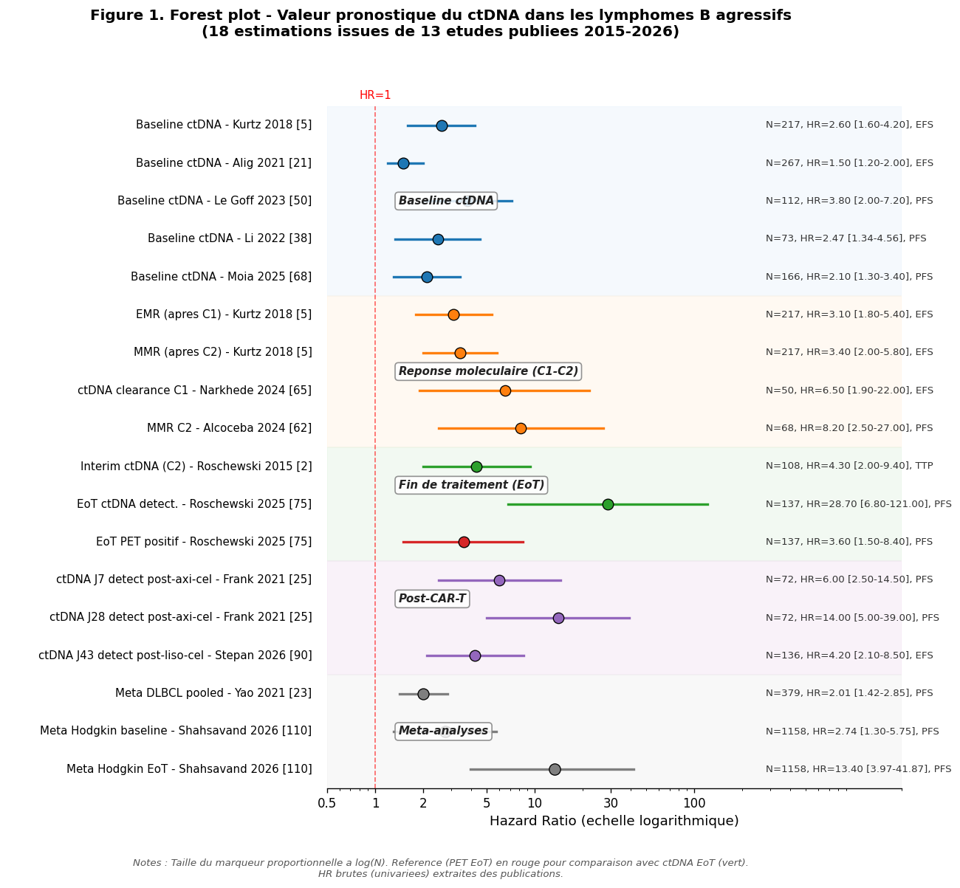
Figure 1. Forest plot des HR ctDNA dans les lymphomes B agressifs (18 estimations / 13 etudes 2015-2026). Categories : baseline (bleu), reponse moleculaire C1-C2 (orange), fin de traitement (vert ctDNA, rouge PET), post-CAR-T (violet), meta-analyses (gris).

Figure 2 - Timeline des etudes pivot
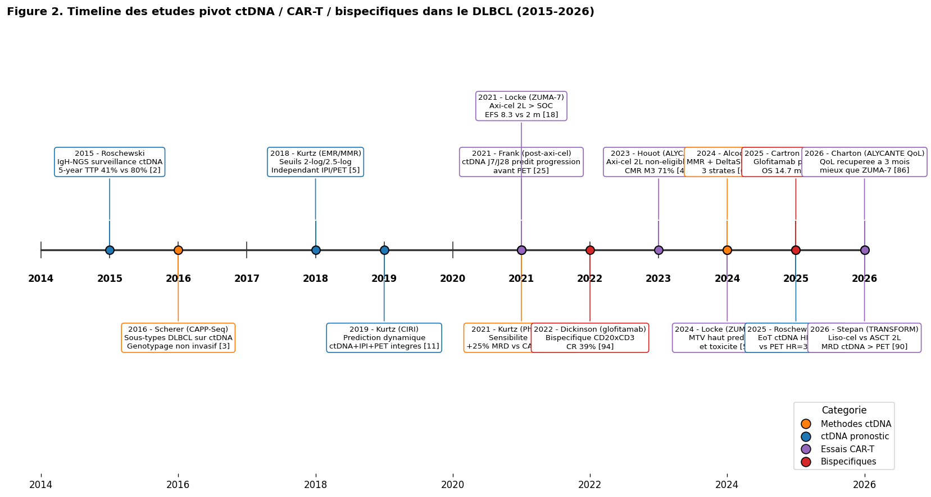
Figure 2. Timeline 2014-2026. Methodes ctDNA (orange), pronostic (bleu), essais CAR-T (violet), bispecifiques (rouge).

Figure 3 - Sensibilite analytique des methodes
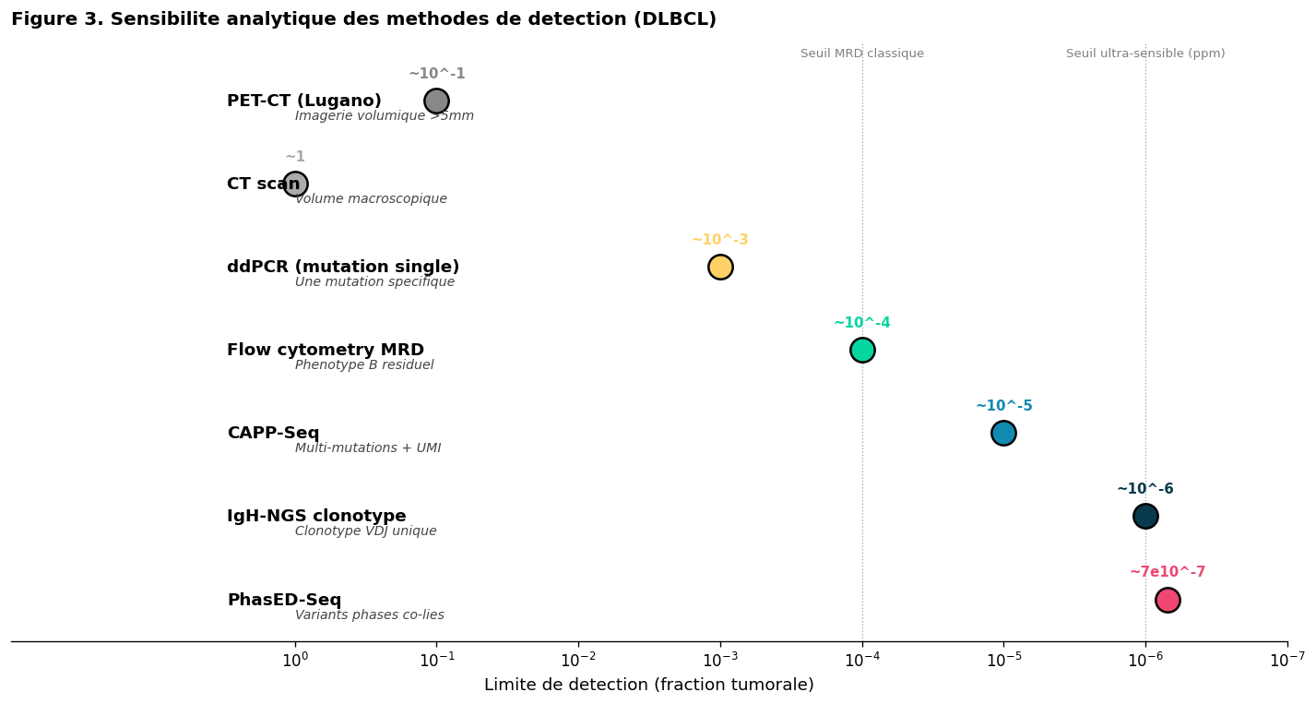
Figure 3. Sensibilite analytique : PET ~10⁻¹ vs PhasED-Seq ~10⁻⁷ ppm.

Figure 4 - ctDNA-MRD vs PET-CMR
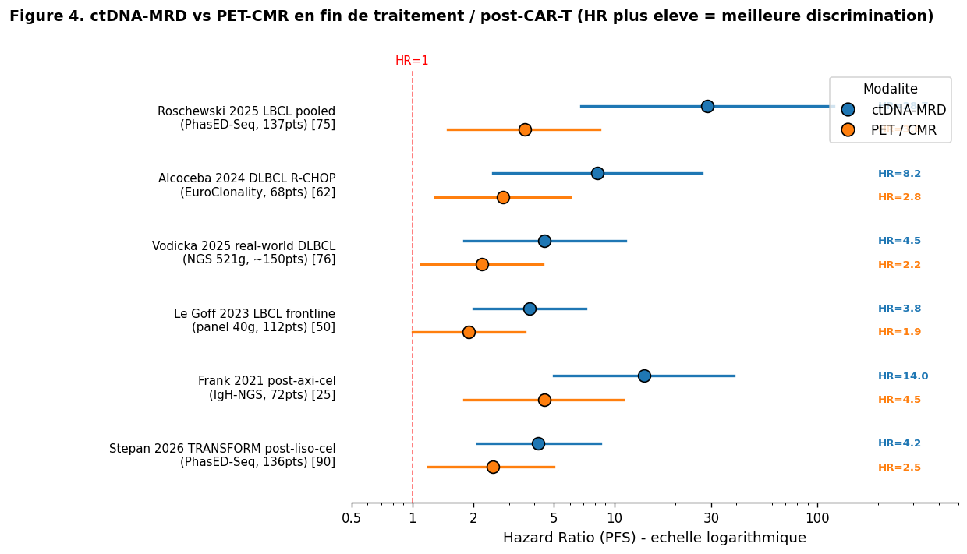
Figure 4. HR ctDNA-MRD vs PET-CMR dans 6 etudes. Le ctDNA discrimine systematiquement mieux.

Tableau 1 - Comparatif des 11 methodes de detection ctDNA
Synthese des methodes par sensibilite, biopsie requise, avantages et limites.
Methode | Approche | LoD | Biopsie ? | Avantages | Limites | Etudes representatives
IgH-NGS / clonotype VDJ | Clonotype Ig dominant tissu puis quantification plasma | ~1 ppm | Oui | Specifique tumeur, sensible, tout B-NHL | Necessite biopsie informative | Roschewski 2015 [2], Frank 2021 [25], Wang 2025 [69]
CAPP-Seq | Panel cible recurrent DLBCL + UMI deep sequencing | ~1-10 ppm | Non | Tumor-naive, genotypage simultane, LymphGen classifiable | Cout, expertise bioinfo | Scherer 2016 [3], Kurtz 2018 [5], Alig 2021 [21], Moia 2025 [68]
PhasED-Seq | Variants phases co-localises pour reduction de bruit | ~0.7 ppm | Recommandee | Sensibilite ultra-elevee, ideal MRD post-traitement | Cout eleve, validation recente | Kurtz 2021 [26], Klimova 2025 [71], Roschewski 2025 [75], Stepan 2026 [90]
Signatera (mPCR) | Panel multiplex 16 SNV tumor-informed | ~1-10 ppm | Oui | Workflow commercial, FDA-approved (autres tumeurs) | Limite a 16 SNV | Narkhede 2024 [65]
EuroClonality-NDC | Panel NGS standardise europeen | ~10^-5 | Plasma seul | Standardisation europeenne | Sensibilite < PhasED-Seq | Alcoceba 2024 [62]
CLEARS (panel 521 genes) | Panel etendu mutations lymphome | ~10^-4-10^-5 | Non | Couverture genique etendue | Recouvrement variable | Vodicka 2025 [76], Hamova 2025 [81]
ULP-WGS cfDNA | WGS faible profondeur pour CNV/burden | TF >3% | Non | Faible cout, detecte CNV/del17p | Sensibilite limitee MRD | Zhao 2025 [74]
ddPCR (single mut) | PCR digitale mutation specifique | ~10^-3-10^-4 | Oui | Cout faible, rapide | Une seule cible | Cas reports [72]
Flow cytometry MRD | Phenotype B clonal residuel | ~10^-4 | Non (moelle) | Bien etabli leucemie aigue | Peu applicable DLBCL | Liu 2023 [54]
cfDNA 5hmC-Seal | Profilage epigenetique 5hmC | ~10^-4 | Non | Approche epigenetique novatrice | Methodologie recherche | Chiu 2019 [13]
Exosomes / EV | Isolation tumor-derived vesicles | Variable | Non | Information RNA + proteique | Standardisation manquante | Ofori 2020 [14]

14. Comparatif des trois produits CAR-T anti-CD19 dans le DLBCL

14.1. Differences structurelles et pharmacologiques
Les trois CAR-T anti-CD19 approuves dans le DLBCL R/R different par leur domaine de costimulation (CD28 pour axi-cel vs 4-1BB pour tisa-cel et liso-cel), leur procede de manufacture (T cells combines vs CD4/CD8 separes pour liso-cel) et leur indication AMM. La revue Boardman 2023 ^{[118]} synthese leur positionnement clinique. La cost-effectiveness comparative ^{[46]} montre des avantages liso-cel vs tisa-cel en 3L.

14.2. Tableau 2 - Caracteristiques comparees
Le tableau ci-apres compare les trois produits sur leurs caracteristiques structurelles, essais pivot, efficacite et toxicite.
Caracteristique | Axi-cel (Yescarta) | Tisa-cel (Kymriah) | Liso-cel (Breyanzi)
Fabricant | Kite / Gilead | Novartis | BMS / Celgene
Costimulation | CD28 | 4-1BB | 4-1BB
Manufacture | CD4+CD8 combined | CD4+CD8 combined | CD4 et CD8 separes (1:1)
Approbations DLBCL 3L+ | FDA 2017, EMA 2018 | FDA 2018, EMA 2018 | FDA 2021, EMA 2022
Approbations DLBCL 2L | FDA 2022 (ZUMA-7) [44] | Non en 2L | FDA 2022 (TRANSFORM)
Essai pivot 3L+ | ZUMA-1 [refs ZUMA-1] | JULIET [113] | TRANSCEND NHL 001 [31]
Essai pivot 2L | ZUMA-7 (n=359) [18,43] | - | TRANSFORM (n=184) [90]
ORR (3L+, pivot) | 83% (axi-cel 2L) | ~52% | 73%
CR rate (3L+, pivot) | 65% (axi-cel 2L) | ~40% | 53%
EFS median 2L (vs SOC) | 8.3 mois vs 2.0 (HR 0.40) [18] | - | Superior to ASCT [90]
OS 4 ans 2L | 54.6% vs 46% SOC (HR 0.73, p=0.03) [43] | - | Superior to ASCT
CRS toute grade | 92-93% (ZUMA-1) | 58% (JULIET) | 42% (TRANSCEND)
CRS grade >=3 | 11-13% | 22% | 2% (le plus bas)
ICANS toute grade | 64-74% | 21% | 30%
ICANS grade >=3 | 21-32% | 12% | 10%
Profil de tolerance | Le plus toxique | Intermediaire | Le plus favorable
Cible patient frail/age | Necessite hospit. usuelle | Tolerance moyenne | Adapte (ambulatoire possible)
Cohorte Lea (n=158) | 104 patients (65.8%) | 23 patients (14.6%) | 28 patients (17.7%)
Etude ALYCANTE (n=62) | 62 (100%) en 2L non-ASCT [45] | - | -
Cout (US, ~) | $373 000 (FDA) | $475 000 | $410 000
Etude post-CAR-T glofitamab | 52/154 etaient ex axi-cel [94] | inclus dans LYSA [97] | inclus dans LYSA [97]
Sources : ZUMA-1 [refs], ZUMA-7 [18,43,44], JULIET [113], TRANSCEND [31,19], TRANSFORM [90], ALYCANTE [45,86], Brooks 2025 [96], Cartron 2025 [97].

14.3. Implications pour ALYCANTE
- ALYCANTE = 100% axi-cel (Yescarta) - donc applicabilite directe aux donnees ZUMA-7
- Cohorte de validation Lea (n=158) : 66% Yescarta, 18% Breyanzi, 15% Kymriah - mixte representatif de la pratique reelle
- CMR M3 ALYCANTE 70% vs Lea 77% (78% chez Yescarta-only en sous-cohorte ALYCANTE-like)
- CRS ≥3 ALYCANTE 8.1% vs Lea 6.3% - coherent avec proportion axi-cel reduite chez Lea
- Le ctDNA pourrait permettre des comparaisons cross-produit, en standardisant la mesure de la reponse moleculaire

15. Lymphome primaire du SNC (PCNSL) - liquid biopsy et ctDNA

15.1. PCNSL et limites de la biopsie tissulaire
Le lymphome primaire du systeme nerveux central (PCNSL) est une variante rare et agressive du DLBCL avec un pronostic intermediaire malgre les regimes a haute dose de methotrexate +/- ASCT. La biopsie cerebrale est souvent difficile (lesions profondes, multiples) ou contre-indiquee. La liquid biopsy (LCS ou plasma) offre une alternative non invasive pour le diagnostic, le profil moleculaire et le suivi de MRD ^{[114,115,116,120]}.

15.2. ctDNA plasmatique - sensibilite limitee
Le ctDNA plasmatique a une sensibilite reduite dans le PCNSL (vs LBCL systemique) en raison de la barriere hemato-encephalique (BHE). Yoon 2021 (n=42) ^{[115]} :
- Detection ctDNA plasma : 27% (11/41) - vs >95% dans le DLBCL systemique
- Mutations principales : PIM1 (36%), KMT2D/PIK3CA/MYD88 (27% chacun)
- Concordance plasma/tissu : 45%
- Conclusion : utilite limitee, ameliorations analytiques necessaires

15.3. ctDNA du LCS - plus sensible
Le ctDNA dans le LCS est plus concentre et permet un meilleur depistage ^{[114,116]} :
- MYD88 L265P (mutation hallmark PCNSL ABC) : detectable par ddPCR ou NGS
- Combinaison MYD88 ctDNA + IL-10 LCS : ameliore Se/Sp diagnostic
- Utilisation pour MRD post-traitement

15.4. Lymphomes vitreoretiniens (VRL)
Le VRL est un sous-type rare de PCNSL atteignant la chambre vitreenne. Wang 2022 (Haematologica, n=15) ^{[117]} :
- ctDNA aqueous humor (AH) et vitreous fluid (VF) concordants (>90%)
- MYD88 plus frequent dans PCNSL que VRL
- CDKN2A/B copy losses plus frequentes dans VRL
- Reponse ibrutinib : 65% PCNSL vs 14% VRL

15.5. CAR-T dans le PCNSL
Initialement exclus des essais pivots CAR-T par crainte de neurotoxicite. Donnees emergentes :
- Meta-analyse Cook 2023 (128 pts CNS lymphoma post-CAR-T) ^{[119]}
- PCNSL (n=30) : CRS 70% (G3-4 13%), ICANS 53% (G3-4 18%), CR 56%, remission 6m 37%
- SCNSL (n=98) : CRS 72%, ICANS 48%, CR 47%, remission 6m 37%
- Pas de surcroit significatif de neurotoxicite vs DLBCL systemique
- Revue Miyao 2023 ^{[120]} : strategies d optimisation (administration locale, CAR-T lymphotropes)

15.6. Implications pour la generalisation ALYCANTE
L etude ALYCANTE excluait initialement les patients avec atteinte SNC active. Les enseignements du suivi ctDNA dans ALYCANTE pourraient :
- Etre transferables au PCNSL via ctDNA LCS (plutot que plasma)
- Necessiter un panel adapte (MYD88 L265P central)
- Justifier des etudes specifiques PCNSL avec ctDNA LCS longitudinal post-CAR-T

16. Implications pour ALYCANTE et perspectives

16.1. Positionnement scientifique
- Validation prospective post-CAR-T 2L : extension Frank 2021 a 2L non-eligible ASCT ^{[45]}
- JLCM novateur : premiere application au ctDNA DLBCL post-CAR-T ^{[55,78]}
- Comparaison ctDNA vs CMR PET M3 : critere principal d ALYCANTE

16.2. Resultats au regard de la litterature
- JLCM J14 : Se=Sp=PPV=NPV=100% R/R12 (n=40) > Frank 2021 J28 ^{[25]}
- NRI JLCM J14 vs CMR M3 : +59% pour R/R12
- Couple predictif delta_ctDNA × Leuca × M6 : C-index 0.752 EFS
- Coherent TRANSFORM (Stepan 2026) : MRD ctDNA > PET ^{[90]}

16.3. Validation externe par comparaison ALYCANTE vs Lea
Comparaison de survie entre ALYCANTE (N=57) et cohorte CART Lea (N=158, multi-centres LYSARC) realisee en complement :
- PFS/EFS : ALYCANTE med 17.6m vs Lea 19.1m, log-rank p=0.95 - NS
- OS : non atteinte dans les 2 cohortes, log-rank p=0.62 - NS
- S(24m) PFS : ALYCANTE 45% vs Lea 47% - quasi identique
- Sous-cohorte ALYCANTE-like (Lea axi-cel 2L, n=40) : p=0.88 (PFS) et p=0.97 (OS) - courbes superposees
Cette superposition valide la generalisabilite des resultats ctDNA d ALYCANTE a une cohorte CAR-T plus large et multi-produits, et soutient l adoption en routine.

16.4. Limites
- N=57 limite - validation externe necessaire
- Seed-dependance JLCM (matrice variance-cov singularite)
- Heterogeneite methodes ctDNA (PhasED-Seq absent)
- R/R strict avec filtre followup
- Possible chevauchement cohortes ALYCANTE/Lea (a verifier)

16.5. Perspectives
- Validation externe ctDNA Lea (J0, J14) si possible
- Comparaison LymphGen sur ctDNA Moia 2025 ^{[68]}
- Adoption uMRD/mPFS endpoint Goldstein 2026 ^{[91]}
- Sequence ctDNA → bispecifique post-rechute (LYSA Cartron) ^{[97]}
- Extension PCNSL via ctDNA LCS
- Integration scores toxicite CAR-HT + IMPI + ctDNA baseline

16.6. Message pour LYSARC 2026
- Premiere etude prospective post-axi-cel 2L chez patients non-eligible ASCT ^{[45]}
- Premiere application JLCM au ctDNA DLBCL post-CAR-T
- Demonstration : dynamique precoce ctDNA (delta J14) > CMR PET M3
- Validation externe (Lea) confirme generalisabilite

Bibliographie (120 references, PubMed verifiees)
[1] Cheson BD, Fisher RI, Barrington SF, et al. Recommendations for initial evaluation, staging, and response assessment of Hodgkin and non-Hodgkin lymphoma: the Lugano classification. J Clin Oncol. 2014;32(27):3059-68. PMID: 25113753; DOI: 10.1200/JCO.2013.54.8800
[2] Roschewski M, Dunleavy K, Pittaluga S, et al. Circulating tumour DNA and CT monitoring in patients with untreated diffuse large B-cell lymphoma: a correlative biomarker study. Lancet Oncol. 2015;16(5):541-9. PMID: 25842160; DOI: 10.1016/S1470-2045(15)70106-3
[3] Scherer F, Kurtz DM, Newman AM, et al. Distinct biological subtypes and patterns of genome evolution in lymphoma revealed by circulating tumor DNA. Sci Transl Med. 2016;8(364):364ra155. PMID: 27831904; DOI: 10.1126/scitranslmed.aai8545
[4] Kwok M, Wu SP, Mo C, et al. Circulating Tumor DNA to Monitor Therapy for Aggressive B-Cell Lymphomas. Curr Treat Options Oncol. 2016;17(9):47. PMID: 27461036; DOI: 10.1007/s11864-016-0425-1
[5] Kurtz DM, Scherer F, Jin MC, et al. Circulating Tumor DNA Measurements As Early Outcome Predictors in Diffuse Large B-Cell Lymphoma. J Clin Oncol. 2018;36(28):2845-53. PMID: 30125215; DOI: 10.1200/JCO.2018.78.5246
[6] Darrah JM, Herrera AF. Updates on Circulating Tumor DNA Assessment in Lymphoma. Curr Hematol Malig Rep. 2018;13(5):348-355. PMID: 30136210; DOI: 10.1007/s11899-018-0468-4
[7] Wu FT, Lu L, Xu W, Li JY. Circulating tumor DNA: clinical roles in diffuse large B cell lymphoma. Ann Hematol. 2018;98(2):255-269. PMID: 30368587; DOI: 10.1007/s00277-018-3529-9
[8] Melani C, Wilson WH, Roschewski M. Monitoring clinical outcomes in aggressive B-cell lymphoma: From imaging studies to circulating tumor DNA. Best Pract Res Clin Haematol. 2018;31(3):285-292. PMID: 30213398; DOI: 10.1016/j.beha.2018.07.004
[9] Al Tabaa Y, Tchernonog E, Faurie P, et al. Post-treatment positron emission tomography-computed tomography is highly predictive of outcome in Plasmablastic lymphoma. Eur J Nucl Med Mol Imaging. 2018;45(11):1838-1847. PMID: 29679112; DOI: 10.1007/s00259-018-4020-5
[10] Sun J, Herazo-Maya JD, Molyneaux PL, et al. Regularized Latent Class Model for Joint Analysis of High-Dimensional Longitudinal Biomarkers and a Time-to-Event Outcome. Biometrics. 2018;75(1):69-77. PMID: 30178494; DOI: 10.1111/biom.12964
[11] Kurtz DM, Esfahani MS, Scherer F, et al. Dynamic Risk Profiling Using Serial Tumor Biomarkers for Personalized Outcome Prediction. Cell. 2019;178(3):699-713.e19. PMID: 31280963; DOI: 10.1016/j.cell.2019.06.011
[12] Melani C, Wilson WH, Roschewski M. Liquid biopsy in non-Hodgkin's lymphoma. Hematol Oncol. 2019;37 Suppl 1:70-74. PMID: 31187522; DOI: 10.1002/hon.2587
[13] Chiu BC, Zhang Z, You Q, et al. Prognostic implications of 5-hydroxymethylcytosines from circulating cell-free DNA in diffuse large B-cell lymphoma. Blood Adv. 2019;3(19):2790-2799. PMID: 31570490; DOI: 10.1182/bloodadvances.2019000175
[14] Ofori K, Bhagat G, Rai AJ. Exosomes and extracellular vesicles as liquid biopsy biomarkers in diffuse large B-cell lymphoma: Current state of the art and unmet clinical needs. Br J Clin Pharmacol. 2020;87(2):302-315. PMID: 33080045; DOI: 10.1111/bcp.14611
[15] Jung D, Jain P, Yao Y, Wang M. Advances in the assessment of minimal residual disease in mantle cell lymphoma. J Hematol Oncol. 2020;13(1):127. PMID: 32972438; DOI: 10.1186/s13045-020-00961-8
[16] Levêque E, Lacourt A, Philipps V, et al. A new trajectory approach for investigating the association between an environmental or occupational exposure over lifetime and the risk of chronic disease: Application to smoking, asbestos, and lung cancer. PLoS One. 2020;15(8):e0236736. PMID: 32785269; DOI: 10.1371/journal.pone.0236736
[17] Kwint M, Stam B, Proust-Lima C, et al. The prognostic value of volumetric changes of the primary tumor measured on Cone Beam-CT during radiotherapy for concurrent chemoradiation in NSCLC patients. Radiother Oncol. 2020;146:44-51. PMID: 32114265; DOI: 10.1016/j.radonc.2020.02.002
[18] Locke FL, Miklos DB, Jacobson CA, et al. Axicabtagene Ciloleucel as Second-Line Therapy for Large B-Cell Lymphoma. N Engl J Med. 2021;386(7):640-654. PMID: 34891224; DOI: 10.1056/NEJMoa2116133
[19] Salles G, Spin P, Liu FF, et al. Indirect Treatment Comparison of Liso-Cel vs. Salvage Chemotherapy in Diffuse Large B-Cell Lymphoma: TRANSCEND vs. SCHOLAR-1. Adv Ther. 2021;38(6):3266-3280. PMID: 33970454; DOI: 10.1007/s12325-021-01756-0
[20] Decruyenaere P, Offner F, Vandesompele J. Circulating RNA biomarkers in diffuse large B-cell lymphoma: a systematic review. Exp Hematol Oncol. 2021;10(1):15. PMID: 33593440; DOI: 10.1186/s40164-021-00208-3
[21] Alig S, Macaulay CW, Kurtz DM, et al. Short Diagnosis-to-Treatment Interval Is Associated With Higher Circulating Tumor DNA Levels in Diffuse Large B-Cell Lymphoma. J Clin Oncol. 2021;39(23):2605-2616. PMID: 33909455; DOI: 10.1200/JCO.20.02573
[22] Minamimoto R, Fayad L, Vose J, et al. F-Fluorothymidine PET is an early and superior predictor of progression-free survival following chemoimmunotherapy of diffuse large B cell lymphoma: a multicenter study. Eur J Nucl Med Mol Imaging. 2021;48(8):2466-2478. PMID: 33909086; DOI: 10.1007/s00259-021-05353-9
[23] Yao L, Xu H, Wo J, et al. Prognostic value of circulating tumor DNA in lymphoma: a meta-analysis. Clin Exp Med. 2021;22(2):215-224. PMID: 33990849; DOI: 10.1007/s10238-021-00718-8
[24] Zhou L, Zhao H, Shao Y, et al. Serial surveillance by circulating tumor DNA profiling after chimeric antigen receptor T therapy for the guidance of r/r diffuse large B cell lymphoma precise treatment. J Cancer. 2021;12(18):5423-5432. PMID: 34405005; DOI: 10.7150/jca.60390
[25] Frank MJ, Hossain NM, Bukhari A, et al. Monitoring of Circulating Tumor DNA Improves Early Relapse Detection After Axicabtagene Ciloleucel Infusion in Large B-Cell Lymphoma: Results of a Prospective Multi-Institutional Trial. J Clin Oncol. 2021;39(27):3034-3043. PMID: 34133196; DOI: 10.1200/JCO.21.00377
[26] Kurtz DM, Soo J, Co Ting Keh L, et al. Enhanced detection of minimal residual disease by targeted sequencing of phased variants in circulating tumor DNA. Nat Biotechnol. 2021;39(12):1537-1547. PMID: 34294911; DOI: 10.1038/s41587-021-00981-w
[27] Roschewski M, Rossi D, Kurtz DM, et al. Circulating Tumor DNA in Lymphoma: Principles and Future Directions. Blood Cancer Discov. 2021;3(1):5-15. PMID: 35015693; DOI: 10.1158/2643-3230.BCD-21-0029
[28] Li C, Zhang D, Pang X, et al. Trajectories of Perioperative Serum Tumor Markers and Colorectal Cancer Outcomes: A Retrospective, Multicenter Longitudinal Cohort Study. EBioMedicine. 2021;74:103706. PMID: 34801967; DOI: 10.1016/j.ebiom.2021.103706
[29] Zhang S, Zhang T, Liu H, et al. Tracking the evolution of untreated high-intermediate/high-risk diffuse large B-cell lymphoma by circulating tumour DNA. Br J Haematol. 2021;196(3):617-628. PMID: 34664256; DOI: 10.1111/bjh.17894
[30] Lakhotia R, Melani C, Dunleavy K, et al. Circulating tumor DNA predicts therapeutic outcome in mantle cell lymphoma. Blood Adv. 2022;6(8):2667-2680. PMID: 35143622; DOI: 10.1182/bloodadvances.2021006397
[31] Kharfan-Dabaja MA, Yassine F, Moustafa MA, et al. Lisocabtagene Maraleucel in Relapsed or Refractory Diffuse Large B Cell Lymphoma: What is the Evidence? Hematol Oncol Stem Cell Ther. 2022;15(3):37-41. PMID: 34699774; DOI: 10.1016/j.hemonc.2021.09.004
[32] Wight J, Wai SH, Shen E, et al. Predicting primary treatment failure using interim FDG-PET scanning in diffuse large B-cell lymphoma. Eur J Haematol. 2021;107(4):461-470. PMID: 34240453; DOI: 10.1111/ejh.13684
[33] Elsawy M, Chavez JC, Avivi I, et al. Patient-reported outcomes in ZUMA-7, a phase 3 study of axicabtagene ciloleucel in second-line large B-cell lymphoma. Blood. 2022;140(21):2248-2260. PMID: 35839452; DOI: 10.1182/blood.2022015478
[34] Thiruvengadam SK, Saumoy M, Schneider Y, et al. Cost-effectiveness of second-line axicabtagene ciloleucel in relapsed refractory diffuse large B-cell lymphoma. Blood. 2022;140(19):2024-2036. PMID: 35914220; DOI: 10.1182/blood.2022016747
[35] Winkelmann M, Blumenberg V, Rejeski K, et al. Prognostic value of the International Metabolic Prognostic Index for lymphoma patients receiving chimeric antigen receptor T-cell therapy. Eur J Nucl Med Mol Imaging. 2022;50(5):1361-1370. PMID: 36513818; DOI: 10.1007/s00259-022-06075-2
[36] Guan T, Zhang M, Liu X, et al. Circulating tumor DNA mutation profile is associated with the prognosis and treatment response of Chinese patients with newly diagnosed diffuse large B-cell lymphoma. Front Oncol. 2022;12:1003957. PMID: 36465410; DOI: 10.3389/fonc.2022.1003957
[37] Zhang HY, Yang YL. Clinical Application and Research Progress of Circulating Tumor DNA in Diffuse Large B-Cell Lymphoma—Review. Zhongguo Shi Yan Xue Ye Xue Za Zhi. 2022;30(6):1928-1933. PMID: 36476926; DOI: 10.19746/j.cnki.issn.1009-2137.2022.06.046
[38] Li M, Mi L, Wang C, et al. Clinical implications of circulating tumor DNA in predicting the outcome of diffuse large B cell lymphoma patients receiving first-line therapy. BMC Med. 2022;20(1):369. PMID: 36280874; DOI: 10.1186/s12916-022-02562-3
[39] Wu S, Blombery P, Westerman D, Tam CS. Utility of Measurable Residual Disease (MRD) Assessment in Mantle Cell Lymphoma. Curr Treat Options Oncol. 2023;24(8):1038-1051. PMID: 37249800; DOI: 10.1007/s11864-023-01102-2
[40] Lynch RC, Poh C, Ujjani CS, et al. Polatuzumab vedotin with infusional chemotherapy for untreated aggressive B-cell non-Hodgkin lymphomas. Blood Adv. 2023;7(11):2449-2458. PMID: 36521030; DOI: 10.1182/bloodadvances.2022009145
[41] Cherng HJ, Alig SK, Oki Y, et al. A phase 1/2 study of lenalidomide and obinutuzumab with CHOP for newly diagnosed DLBCL. Blood Adv. 2023;7(13):3097-3107. PMID: 36375046; DOI: 10.1182/bloodadvances.2022008174
[42] Westin JR, Locke FL, Dickinson M, et al. Safety and Efficacy of Axicabtagene Ciloleucel versus Standard of Care in Patients 65 Years of Age or Older with Relapsed/Refractory Large B-Cell Lymphoma. Clin Cancer Res. 2023;29(10):1894-1905. PMID: 36999993; DOI: 10.1158/1078-0432.CCR-22-3136
[43] Westin JR, Oluwole OO, Kersten MJ, et al. Survival with Axicabtagene Ciloleucel in Large B-Cell Lymphoma. N Engl J Med. 2023;389(2):148-157. PMID: 37272527; DOI: 10.1056/NEJMoa2301665
[44] Sharma P, Kasamon YL, Lin X, et al. FDA Approval Summary: Axicabtagene Ciloleucel for Second-Line Treatment of Large B-Cell Lymphoma. Clin Cancer Res. 2023;29(21):4331-4337. PMID: 37405396; DOI: 10.1158/1078-0432.CCR-23-0568
[45] Houot R, Bachy E, Cartron G, et al. Axicabtagene ciloleucel as second-line therapy in large B cell lymphoma ineligible for autologous stem cell transplantation: a phase 2 trial (ALYCANTE). Nat Med. 2023;29(10):2593-2601. PMID: 37710005; DOI: 10.1038/s41591-023-02572-5
[46] Parker C, Liu FF, Deger KA, et al. Cost-Effectiveness of Lisocabtagene Maraleucel Versus Axicabtagene Ciloleucel and Tisagenlecleucel in the Third-Line or Later Treatment Setting for Relapsed or Refractory Large B-cell Lymphoma in the United States. Adv Ther. 2023;40(5):2355-2374. PMID: 36947328; DOI: 10.1007/s12325-023-02444-x
[47] Tavakkoli M, Barta SK. 2024 Update: Advances in the risk stratification and management of large B-cell lymphoma. Am J Hematol. 2023;98(11):1791-1805. PMID: 37647158; DOI: 10.1002/ajh.27075
[48] Yohannan B, Rios A. Reduced-Intensity Anthracycline-Free Chemoimmunotherapy in Elderly Patients With Newly Diagnosed or Relapsed Diffuse Large B-Cell Lymphoma. J Hematol. 2023;12(4):170-176. PMID: 37692866; DOI: 10.14740/jh1144
[49] Nielsen NB, Gerke O, Nielsen AL, et al. A retrospective head-to-head comparison of the Lugano classification and PERCIST for FDG-PET/CT response assessment in diffuse large B-cell lymphoma. Clin Physiol Funct Imaging. 2023;43(6):393-401. PMID: 37501554; DOI: 10.1111/cpf.12851
[50] Le Goff E, Blanc-Durand P, Roulin L, et al. Baseline circulating tumour DNA and total metabolic tumour volume as early outcome predictors in aggressive large B-cell lymphoma. A real-world 112-patient cohort. Br J Haematol. 2023;202(1):54-64. PMID: 37038217; DOI: 10.1111/bjh.18809
[51] Dodero A, Bramanti S, Di Trani M, et al. Outcome after chimeric antigen receptor (CAR) T-cell therapy failure in large B-cell lymphomas. Br J Haematol. 2023;204(1):151-159. PMID: 37690811; DOI: 10.1111/bjh.19057
[52] Xu HQ, Song LJ, Ding CY, et al. F-FDG PET/CT Metabolic Parameters and Circulating Tumour DNA Mutation Abundance in Diffuse Large B-Cell Lymphoma: Correlation and Survival Analysis. Zhongguo Shi Yan Xue Ye Xue Za Zhi. 2023;31(6):1709-1716. PMID: 38071047; DOI: 10.19746/j.cnki.issn.1009-2137.2023.06.014
[53] Zhou LH, Feng YQ, Hu YX, Huang H. Analysis of the feasibility and prognostic value of circulating tumor DNA monitoring in detecting gene mutations in patients with diffuse large B-cell lymphoma receiving chimeric antigen receptor T-cell therapy. Zhonghua Xue Ye Xue Za Zhi. 2023;44(10):816-822. PMID: 38049331; DOI: 10.3760/cma.j.issn.0253-2727.2023.10.003
[54] Liu Y, Ho C, Yu W, et al. Quantification of Measurable Residual Disease Detection by Next-Generation Sequencing-Based Clonality Testing in B-Cell and Plasma Cell Neoplasms. J Mol Diagn. 2023;26(3):168-178. PMID: 38103591; DOI: 10.1016/j.jmoldx.2023.11.009
[55] Proust-Lima C, Saulnier T, Philipps V, et al. Describing complex disease progression using joint latent class models for multivariate longitudinal markers and clinical endpoints. Stat Med. 2023;42(22):3996-4014. PMID: 37461227; DOI: 10.1002/sim.9844
[56] Filosto S, Vardhanabhuti S, Canales MA, et al. Product Attributes of CAR T-cell Therapy Differentially Associate with Efficacy and Toxicity in Second-line Large B-cell Lymphoma (ZUMA-7). Blood Cancer Discov. 2024;5(1):21-33. PMID: 37983485; DOI: 10.1158/2643-3230.BCD-23-0112
[57] Savel H, Meyer-Losic F, Proust-Lima C, Richert L. Statistical classification of treatment responses in mouse clinical trials for stratified medicine in oncology drug discovery. Sci Rep. 2024;14(1):1059. PMID: 38195626; DOI: 10.1038/s41598-023-51055-7
[58] Kim J, Le TM, Lee D, et al. Circulating-tumor DNA Assessment in Diffuse Large B-cell Lymphoma to Determine Up-front Stem Cell Transplantation: A Pilot Study. In Vivo. 2024;38(1):141-148. PMID: 38148060; DOI: 10.21873/invivo.13448
[59] Locke FL, Oluwole OO, Kuruvilla J, et al. Axicabtagene ciloleucel vs standard of care in second-line large B-cell lymphoma: outcomes by metabolic tumor volume. Blood. 2024;143(24):2464-2473. PMID: 38557775; DOI: 10.1182/blood.2023021620
[60] Kitajima K, Yokoyama H, Wada R, et al. Early evaluation of CAR-T cell therapy response in R/R DLBCL patients using F-FDG PET/CT. Hell J Nucl Med. 2024;27(1):54-62. PMID: 38629814; DOI: 10.1967/s002449912701
[61] Cherng HJ, Herrera A. Circulating Tumor DNA in Diffuse Large B-Cell Lymphoma: from Bench to Bedside? Curr Treat Options Oncol. 2024;25(5):659-678. PMID: 38656685; DOI: 10.1007/s11864-024-01201-8
[62] Alcoceba M, Stewart JP, García-Álvarez M, et al. Liquid biopsy for molecular characterization of diffuse large B-cell lymphoma and early assessment of minimal residual disease. Br J Haematol. 2024;205(2):542-553. PMID: 38811363; DOI: 10.1111/bjh.19458
[63] Melani C, Lakhotia R, Pittaluga S, et al. Combination Targeted Therapy in Relapsed Diffuse Large B-Cell Lymphoma. N Engl J Med. 2024;390(23):2143-2155. PMID: 38899693; DOI: 10.1056/NEJMoa2401532
[64] Colton M, Purev E, Haverkos B, et al. Molecular Disease Monitoring in Patients With Relapsed/refractory B-Cell Lymphoma Receiving Anti-CD19 CAR T-Cell Therapy. Clin Lymphoma Myeloma Leuk. 2024;24(11):e436-e444. PMID: 39034202; DOI: 10.1016/j.clml.2024.06.006
[65] Narkhede M, Tomassetti S, Iqbal M, et al. Tumor-informed ctDNA assessment as a valuable prognostic and predictive biomarker in diffuse large B-cell lymphoma. Front Oncol. 2024;14:1407003. PMID: 39135998; DOI: 10.3389/fonc.2024.1407003
[66] Takkavatakarn K, Oh W, Chan L, et al. Machine learning derived serum creatinine trajectories in acute kidney injury in critically ill patients with sepsis. Crit Care. 2024;28(1):156. PMID: 38730421; DOI: 10.1186/s13054-024-04935-x
[67] Roschewski M, Longo DL, Armitage JO. Circulating Tumor DNA as Measurable Residual Disease in Aggressive B-Cell Lymphoma: A Narrative Review. JAMA Oncol. 2025;11(4):437-446. PMID: 39913153; DOI: 10.1001/jamaoncol.2024.6144
[68] Moia R, Talotta D, Terzi Di Bergamo L, et al. Molecular clustering on ctDNA improves the prognostic stratification of patients with DLBCL compared with ctDNA levels. Blood Adv. 2025;9(8):1900-1910. PMID: 39825831; DOI: 10.1182/bloodadvances.2024014136
[69] Wang J, Zhao S, Niu T, et al. Prognostic relevance of immunoglobulin heavy chain rearrangement and immunoglobulin kappa light chain rearrangement in patients with diffuse large B cell lymphoma. Oncologist. 2025;30(3):oyaf016. PMID: 40063611; DOI: 10.1093/oncolo/oyaf016
[70] Almasri M, Maher N, Al Deeban B, et al. Liquid Biopsy in B and T Cell Lymphomas: From Bench to Bedside. Int J Mol Sci. 2025;26(10):4869. PMID: 40430009; DOI: 10.3390/ijms26104869
[71] Klimova N, Close S, Kurtz DM, et al. Analytical validation of a circulating tumor DNA assay using PhasED-Seq technology for detecting residual disease in B-cell malignancies. Oncotarget. 2025;16:259-269. PMID: 40353795; DOI: 10.18632/oncotarget.28719
[72] Rahul B, Shrinidhi N, Ishita S, et al. Dynamic ctDNA Monitoring: A Primary Tool Predictive of Response in a Patient on CAR-T Cell Therapy. Int J Lab Hematol. 2025;47(4):695-700. PMID: 40415376; DOI: 10.1111/ijlh.14503
[73] Fangazio M, Dewispelaere L. Circulating tumor DNA in B cell lymphomas. Curr Opin Oncol. 2025;37(5):421-429. PMID: 40658005; DOI: 10.1097/CCO.0000000000001178
[74] Zhao D, Lang N, Liu T, et al. Risk Assessment With Ultra-Low-Pass Whole-Genome Sequencing of Cell-Free DNA for Large B-Cell Lymphoma. JCO Precis Oncol. 2025;9:e2500200. PMID: 40632977; DOI: 10.1200/PO-25-00200
[75] Roschewski M, Kurtz DM, Westin JR, et al. Remission Assessment by Circulating Tumor DNA in Large B-Cell Lymphoma. J Clin Oncol. 2025;43(28):3262-3274. PMID: 40802906; DOI: 10.1200/JCO-25-01534
[76] Vodicka P, Hamova I, Velasova A, et al. Circulating tumour DNA as a predictor of survival of patients with diffuse large B-cell lymphoma in a daily practice. Br J Haematol. 2025;208(3):754-762. PMID: 40916568; DOI: 10.1111/bjh.70128
[77] Duminuco A, Scarso S, Del Fabro V, et al. Diffuse large B-cell lymphoma in the new era: prognostic tools for mapping risk. Ann Hematol. 2025;104(11):4757-4778. PMID: 41114812; DOI: 10.1007/s00277-025-06686-3
[78] Kyheng M, Babykina G, Duhamel A. Joint Latent Class Models: A Tutorial on Practical Applications in Clinical Research. Stat Med. 2025;44(7):e70047. PMID: 40277369; DOI: 10.1002/sim.70047
[79] Petersen F, Bringmann LF, Rizopoulos D. Predicting dropout in intensive longitudinal data: Extending the joint model for autocorrelated data. Psychol Assess. 2025;37(10):592-606. PMID: 41129394; DOI: 10.1037/pas0001397
[80] Bruscaggin A, Pini K, Rossi D. Detection of Circulating Tumor DNA in Lymphoma Patients. Methods Mol Biol. 2025;2865:349-365. PMID: 39424738; DOI: 10.1007/978-1-0716-4188-0_21
[81] Hamová I, Velasová A, Zemánková P, et al. Development and Technical Validation of the Clinical Lymphoma Exploration and Research Sequencing (CLEARS) Panel and Its Optimization for ctDNA Analysis. Folia Biol (Praha). 2025;71(2):105-116. PMID: 41739709; DOI: 10.14712/fb2025.0009
[82] Lu L, Shen L, Wu Z, et al. Trajectories of serum α-fetoprotein and intermediate-stage hepatocellular carcinoma outcomes after transarterial chemoembolization: A longitudinal, retrospective, multicentre, cohort study. EClinicalMedicine. 2022;47:101391. PMID: 35480077; DOI: 10.1016/j.eclinm.2022.101391
[83] Brombin C, Di Serio C, Rancoita PM. Joint modeling of HIV data in multicenter observational studies: A comparison among different approaches. Stat Methods Med Res. 2014;25(6):2693-2711. PMID: 24671658; DOI: 10.1177/0962280214526192
[84] Andrinopoulou ER, Rizopoulos D, Geleijnse ML, Lesaffre E. Dynamic prediction of outcome for patients with severe aortic stenosis: application of joint models for longitudinal and time-to-event data. BMC Cardiovasc Disord. 2015;15:28. PMID: 25943388; DOI: 10.1186/s12872-015-0035-z
[85] Mirza SS, Wolters FJ, Swanson SA, et al. 10-year trajectories of depressive symptoms and risk of dementia: a population-based study. Lancet Psychiatry. 2016;3(7):628-35. PMID: 27138970; DOI: 10.1016/S2215-0366(16)00097-3
[86] Charton E, Anota A, Bachy E, et al. Health-related quality of life after second-line axi-cel in transplant-ineligible patients with large B-cell lymphoma (ALYCANTE). Blood Adv. 2026;10(5):1175-1186. PMID: 41512176; DOI: 10.1182/bloodadvances.2025018057
[87] Galli E. Beyond comorbidities: CAR-T as a safe and effective option in frail patients with second-line DLBCL. Recenti Prog Med. 2026;117(2):85-90. PMID: 41716108; DOI: 10.1701/4649.46634
[88] Zhang G, An L, Hang C, et al. Trajectory-Defined Thrombo-Inflammatory Phenotypes Predict 30-Day ICU Mortality in Post-cardiac Arrest Syndrome: A Multicenter Retrospective Longitudinal Cohort Study. Inquiry. 2026;63:00469580261448815. PMID: 42059137; DOI: 10.1177/00469580261448815
[89] Klimova N, Roff A, McCutcheon J, et al. Assessment of Potential Sources of Variability on the Analytical Performance of a Circulating Tumor DNA Minimal Residual Disease Test for B-Cell Lymphomas. J Clin Lab Anal. 2026;40(5):e70258. PMID: 42089547; DOI: 10.1002/jcla.70258
[90] Stepan L, Ansari S, Abramson JS, et al. Circulating Tumor DNA Assessment of Disease Response in Large B-Cell Lymphoma: Lisocabtagene Maraleucel Versus Autologous Stem Cell Transplantation Standard Therapy (TRANSFORM). J Clin Oncol. 2026;44(12):1308-1319. PMID: 42044466; DOI: 10.1200/JCO-25-03051
[91] Goldstein JS, Wang SX, Chamuleau MED, Alizadeh AA. Roadmap for developing MRD as an early endpoint for drug approval in lymphoma. Semin Hematol. 2026;63(2):in press. PMID: 41982010; DOI: 10.1053/j.seminhematol.2026.03.007
[92] Mehta A, Popplewell L, Collins GP, et al. Magrolimab plus rituximab in relapsed/refractory indolent non-Hodgkin lymphoma: 3-year follow-up of a phase 1/2 trial. Blood Adv. 2024;8(23):6155-6164. PMID: 39213421; DOI: 10.1182/bloodadvances.2024013277
[93] Jing Z, Qian Z, Yan M, Feng L. Liquid biopsy-directed therapy in primary bone lymphoma: venetoclax-Pola-R-CHP and CAR-T achieve molecular remission: a case report. Curr Med Res Opin. 2025;41(11):in press. PMID: 41170601; DOI: 10.1080/03007995.2025.2577761
[94] Dickinson MJ, Carlo-Stella C, Morschhauser F, et al. Glofitamab for Relapsed or Refractory Diffuse Large B-Cell Lymphoma. N Engl J Med. 2022;387(24):2220-2231. PMID: 36507690; DOI: 10.1056/NEJMoa2206913
[95] Minson AG, Dickinson MJ. New bispecific antibodies in diffuse large B-cell lymphoma. Haematologica. 2025;110(6):1257-1268. PMID: 39911111; DOI: 10.3324/haematol.2024.285343
[96] Brooks TR, Zabor EC, Bedelu YB, et al. Real-world outcomes of patients with aggressive B-cell lymphoma treated with epcoritamab or glofitamab. Blood. 2025;146(11):1216-1227. PMID: 40663785; DOI: 10.1182/blood.2025029117
[97] Cartron G, Houot R, Al Tabaa Y, et al. Glofitamab in refractory or relapsed diffuse large B cell lymphoma after failing CAR-T cell therapy: a phase 2 LYSA study. Nat Cancer. 2025;6(5):756-768. PMID: 40181090; DOI: 10.1038/s43018-025-00941-2
[98] Bayly-McCredie E, Treisman M, Fiorenza S. Safety and Efficacy of Bispecific Antibodies in Adults with Large B-Cell Lymphomas: A Systematic Review of Clinical Trial Data. Int J Mol Sci. 2024;25(17):9736. PMID: 39273684; DOI: 10.3390/ijms25179736
[99] Shirley M. Glofitamab: First Approval. Drugs. 2023;83(10):935-941. PMID: 37285013; DOI: 10.1007/s40265-023-01894-5
[100] Izutsu K, Kumode T, Yuda J, et al. Subcutaneous epcoritamab monotherapy in Japanese adults with relapsed/refractory diffuse large B-cell lymphoma. Cancer Sci. 2023;114(12):4643-4653. PMID: 37921363; DOI: 10.1111/cas.15996
[101] Budde LE, Sehn LH, Matasar M, et al. Safety and efficacy of mosunetuzumab, a bispecific antibody, in patients with relapsed or refractory follicular lymphoma: a single-arm, multicentre, phase 2 study. Lancet Oncol. 2022;23(8):1055-1065. PMID: 35803286; DOI: 10.1016/S1470-2045(22)00335-7
[102] Li T, Hiemstra IH, Chiu C, et al. Semimechanistic Physiologically-Based Pharmacokinetic/Pharmacodynamic Model Informing Epcoritamab Dose Selection for Patients With B-Cell Lymphomas. Clin Pharmacol Ther. 2022;112(5):1011-1020. PMID: 35996883; DOI: 10.1002/cpt.2729
[103] Matasar M, Bartlett NL, Shadman M, et al. Mosunetuzumab Safety Profile in Patients With Relapsed/Refractory B-cell Non-Hodgkin Lymphoma: Clinical Management Experience From a Pivotal Phase I/II Trial. Clin Lymphoma Myeloma Leuk. 2023;24(4):240-253. PMID: 38195322; DOI: 10.1016/j.clml.2023.12.005
[104] Nair MS, Silbert SK, Rejeski K, et al. Development of ALL-Hematotox: predicting post-CAR T-cell hematotoxicity in B-cell acute lymphoblastic leukemia. Blood. 2025;145(15):1615-1626. PMID: 39561284; DOI: 10.1182/blood.2024025910
[105] Zhang A, Zheng H, Shang Q, et al. Can one scoring system fit all? Comparative validation of CAR-HEMATOTOX, ALL-HEMATOTOX, and eIPM for predicting immune effector cell-associated hematotoxicity following CAR-T therapy in hematologic malignancies. Chin J Cancer Res. 2025;37(5):559-571. PMID: 41229978; DOI: 10.21147/j.issn.1000-9604.2025.05.04
[106] Hayden PJ, Roddie C, Bader P, et al. Management of adults and children receiving CAR T-cell therapy: 2021 best practice recommendations of EBMT-JACIE and EHA. Ann Oncol. 2021;33(3):259-275. PMID: 34923107; DOI: 10.1016/j.annonc.2021.12.003
[107] Shouval R, Strouse C, Kim S, et al. Cytokine Release Syndrome and Neurotoxicity Following CD19 CAR-T in B-Cell Lymphoma. Transplant Cell Ther. 2025;31(7):492-501. PMID: 40288610; DOI: 10.1016/j.jtct.2025.03.011
[108] Penack O, Peczynski C, Koenecke C, et al. Organ complications after CD19 CAR T-cell therapy for large B cell lymphoma: a retrospective study from the EBMT transplant complications and lymphoma working party. Front Immunol. 2023;14:1252811. PMID: 37828980; DOI: 10.3389/fimmu.2023.1252811
[109] Tarella C, Sammassimo S, Frassoni S, et al. Long-Term Outcomes After Allogeneic Hematopoietic Stem Cell Transplantation in Relapsed/Refractory B-Cell Non-Hodgkin Lymphoma: An Italian Multicenter Collaborative Study. Transplant Cell Ther. 2025;31(9):608-619. PMID: 40541682; DOI: 10.1016/j.jtct.2025.06.004
[110] Shahsavand A, Forghani S, Kharaghani MA, et al. Prognostic utility of circulating tumor DNA in classical Hodgkin lymphoma: A systematic review and individual participant data Bayesian meta-analysis. Crit Rev Oncol Hematol. 2026;201:105154 (in press). PMID: 41581737; DOI: 10.1016/j.critrevonc.2026.105154
[111] Fu L, Zhou X, Zhang X, et al. Circulating tumor DNA in lymphoma: technologies and applications. J Hematol Oncol. 2025;18(1):35. PMID: 40069858; DOI: 10.1186/s13045-025-01673-7
[112] Loap P, Johnson N, Birsen R, et al. Tolerance of radiotherapy with concomitant glofitamab in diffuse large B cell lymphoma: a case report. Strahlenther Onkol. 2024;200(11):1029-1032. PMID: 38955824; DOI: 10.1007/s00066-024-02256-0
[113] Schuster SJ, Bishop MR, Tam CS, et al. Tisagenlecleucel in Adult Relapsed or Refractory Diffuse Large B-Cell Lymphoma (JULIET). N Engl J Med. 2019;380(1):45-56. PMID: 30501490; DOI: 10.1056/NEJMoa1804980
[114] Rudà R, Pellerino A, Soffietti R. Blood and cerebrospinal fluid biomarkers in neuro-oncology. Curr Opin Neurol. 2024;37(6):693-701. PMID: 39329301; DOI: 10.1097/WCO.0000000000001317
[115] Yoon SE, Kim YJ, Shim JH, et al. Plasma Circulating Tumor DNA in Patients with Primary Central Nervous System Lymphoma. Cancer Res Treat. 2021;54(2):597-612. PMID: 34325497; DOI: 10.4143/crt.2021.752
[116] Šúri A, Mocikova H. Diagnostic approach to leptomeningeal involvement in diffuse large B-cell lymphoma. Expert Rev Mol Diagn. 2025;25(6):209-215. PMID: 40354563; DOI: 10.1080/14737159.2025.2485211
[117] Wang X, Su W, Gao Y, et al. A pilot study of the use of dynamic analysis of cell-free DNA from aqueous humor and vitreous fluid for the diagnosis and treatment monitoring of vitreoretinal lymphomas. Haematologica. 2022;107(9):2154-2162. PMID: 35142151; DOI: 10.3324/haematol.2021.279908
[118] Boardman AP, Salles G. CAR T-cell therapy in large B cell lymphoma. Hematol Oncol. 2023;41 Suppl 1:112-118. PMID: 37294963; DOI: 10.1002/hon.3153
[119] Cook MR, Dorris CS, Makambi KH, et al. Toxicity and efficacy of CAR T-cell therapy in primary and secondary CNS lymphoma: a meta-analysis of 128 patients. Blood Adv. 2023;7(1):32-39. PMID: 36260735; DOI: 10.1182/bloodadvances.2022008525
[120] Miyao K, Yokota H, Sakemura RL. Is CD19-directed chimeric antigen receptor T cell therapy a smart strategy to combat central nervous system lymphoma? Front Oncol. 2023;12:1082235. PMID: 36686821; DOI: 10.3389/fonc.2022.1082235

