Supplemental Material — Blood Article ALYCANTE
Day-14 risk stratification by joint latent class modeling of plasma ctDNA in transplant-ineligible R/R LBCL after axicabtagene ciloleucel — Supplemental Figures and Tables. External validation cohort: Henri-Mondor real-world cohort (single-center, retrospective, Hôpital Henri-Mondor, AP-HP, Créteil, France). All figures provided as vector PDF and PNG.
Supplemental Figure S1. Schoenfeld residuals — proportional-hazards test
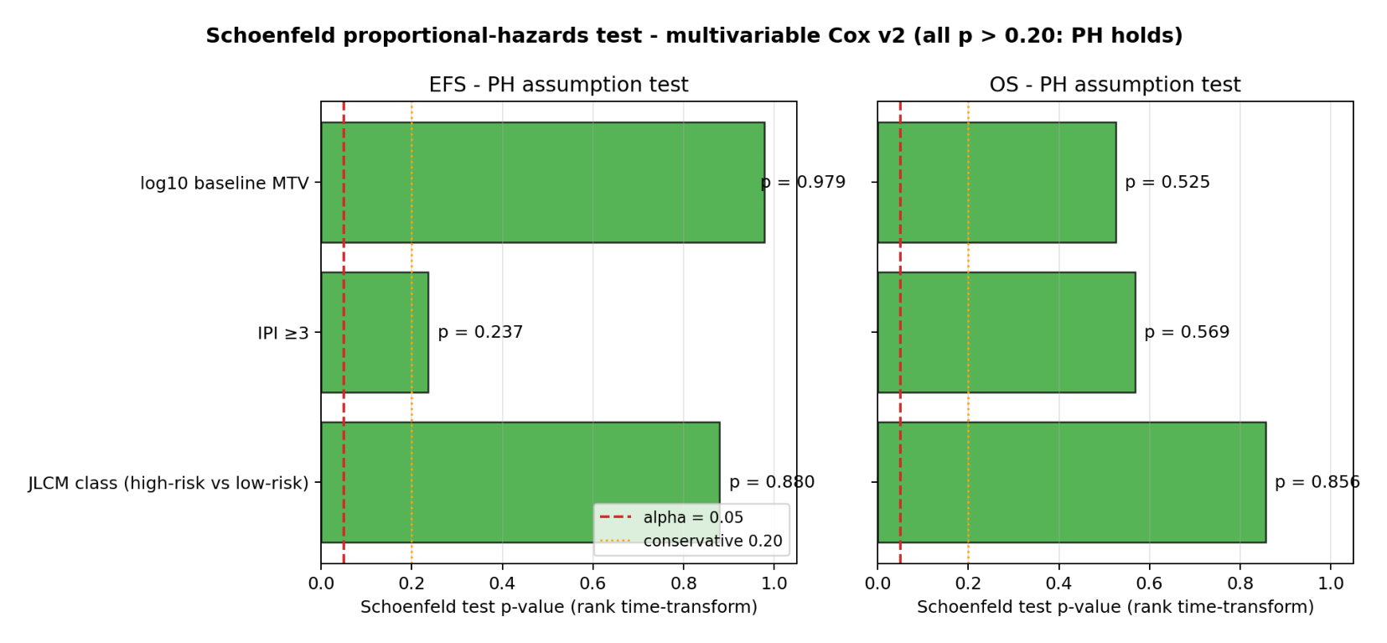
Schoenfeld residuals (rank-time-transform) for each covariate of the multivariable Cox model. All P > .20, indicating the proportional-hazards assumption holds.
Supplemental Figure S2. Calibration plot at 12 months
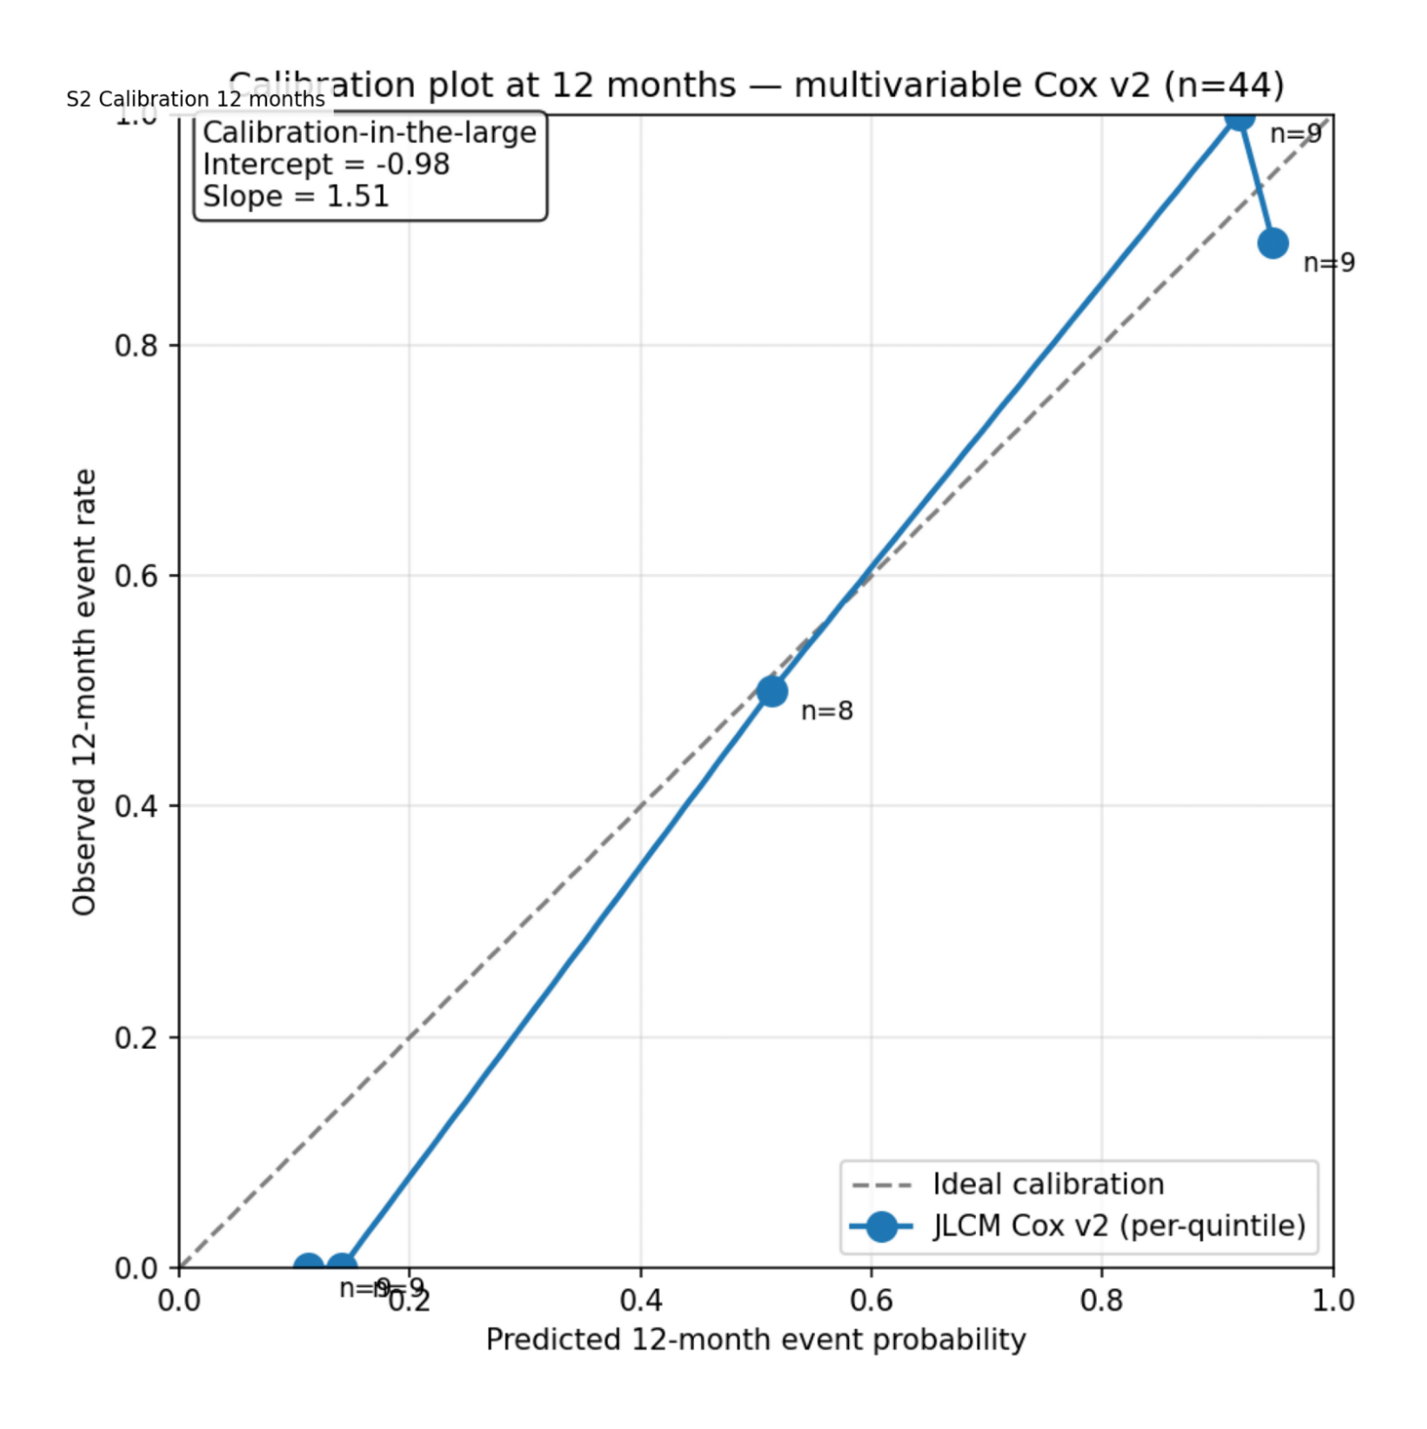
Predicted-risk quintiles versus observed 12-month event rates. Calibration slope = 1.51 and intercept = −0.98, indicating mild under-dispersion of predicted risks. These metrics should be interpreted in the context of n = 44 with 26 events and quasi-complete class separation; minor recalibration would be required for external use.
Supplemental Figure S3. Time-dependent AUC
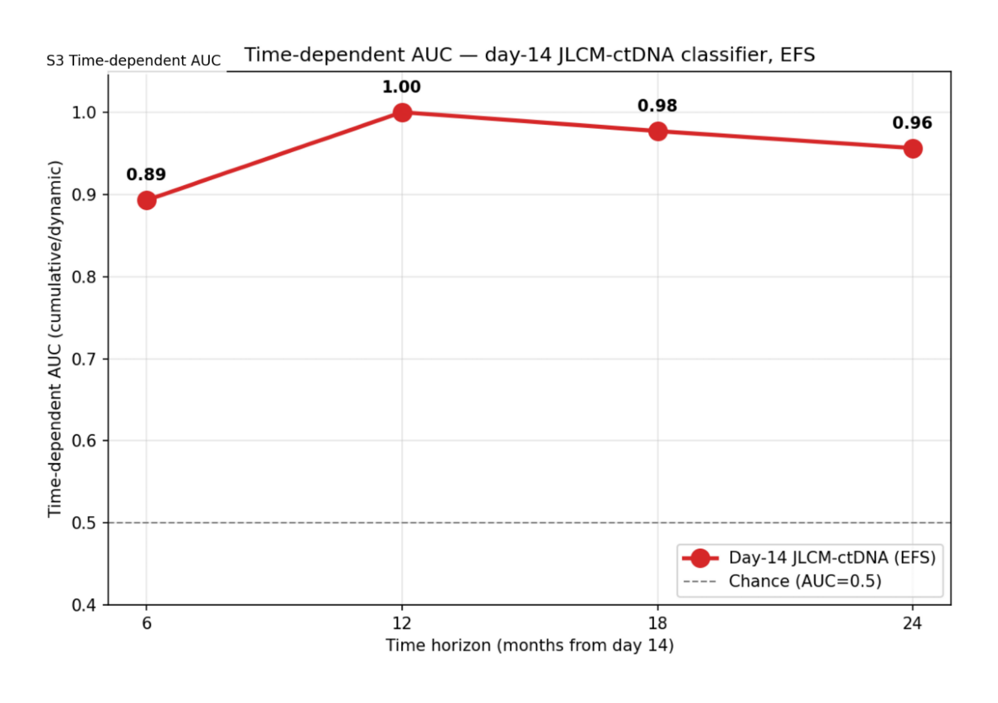
Time-dependent AUC of the day-14 JLCM-ctDNA classifier for EFS at 6 months (0.89), 12 months (1.00), 18 months (0.98), and 24 months (0.96). The AUC of 1.00 at 12 months reflects quasi-complete class separation at this landmark and should not be interpreted as a generalizable discrimination metric. Earlier and later landmark AUCs (6 m, 18 m, 24 m) provide more interpretable estimates.
Supplemental Figure S4. Decision-curve analysis at 12 months
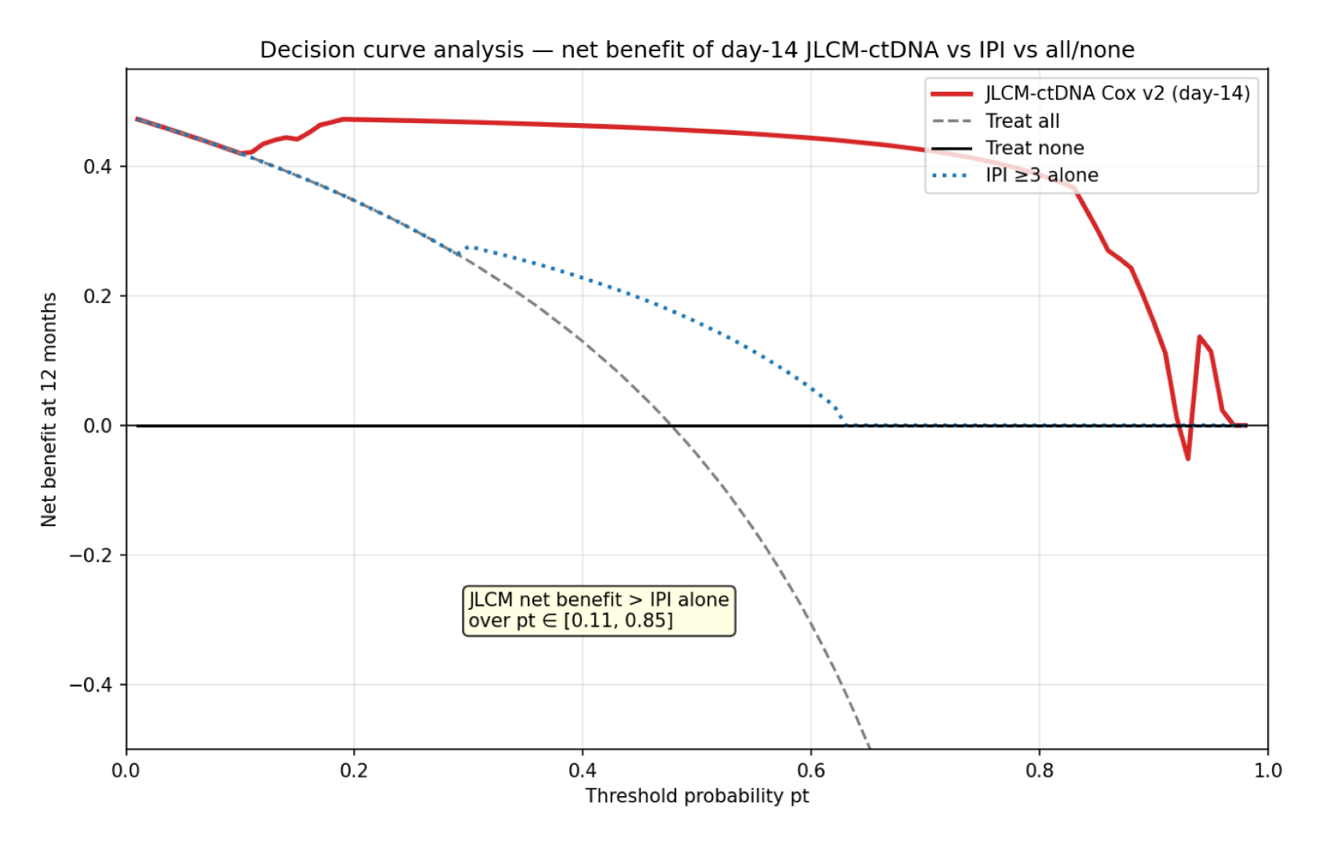
Net benefit of the JLCM-ctDNA classifier versus IPI ≥3 and day-14 Deauville ≥4. Net benefit exceeds both alternatives across threshold probabilities of 0.11 to 0.85; below threshold 0.11 the classifier is numerically indistinguishable from treat-all.
Supplemental Figure S5. Bootstrap C-index distributions
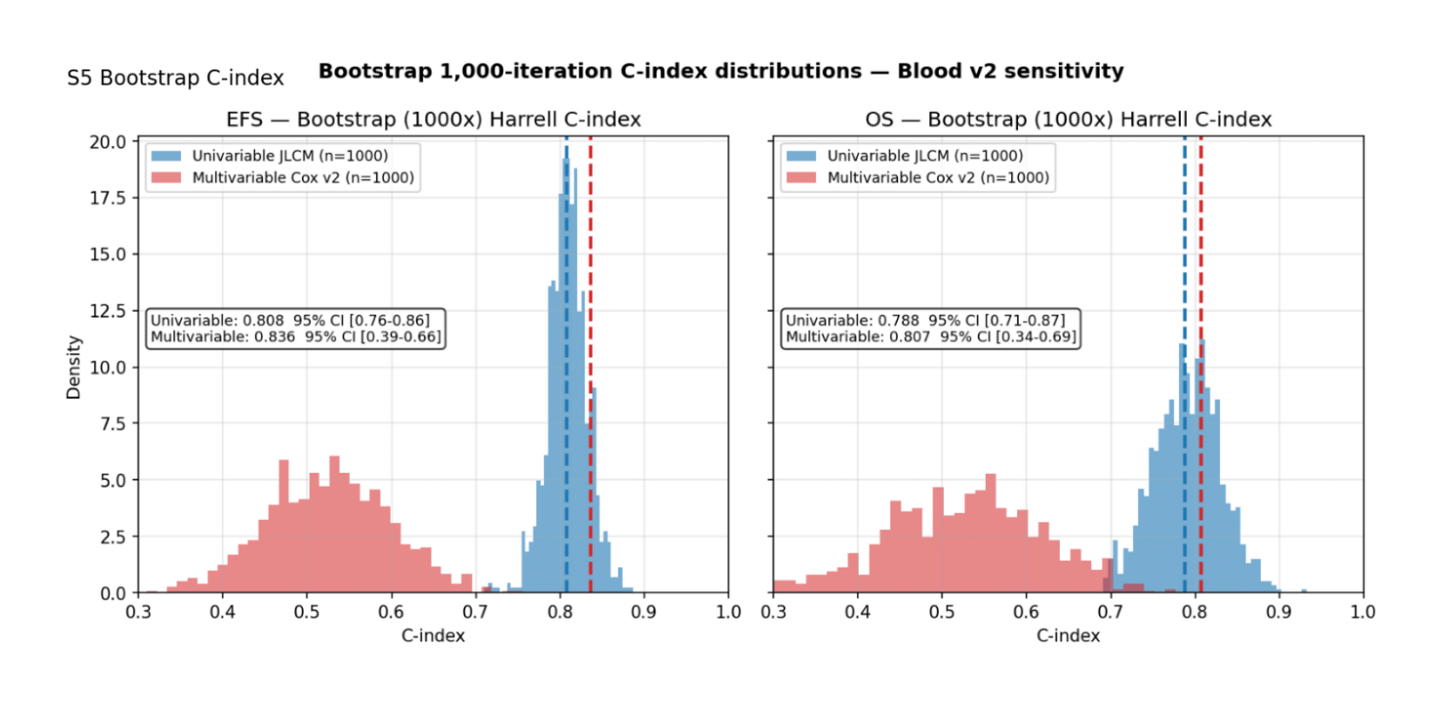
1000-iteration percentile bootstrap C-index distributions. The univariable JLCM-ctDNA C-index has negligible .632+ optimism (−0.001 EFS, −0.003 OS), and is reported as the primary discrimination metric (0.81 EFS, 0.79 OS). By contrast, the multivariable C-index exhibits substantial optimism (+0.31 EFS, +0.28 OS), as expected for a 3-covariate Cox model in n = 44 with 26 events and quasi-complete class separation.
Supplemental Figure S6. Heatmap of individual ctDNA dynamics
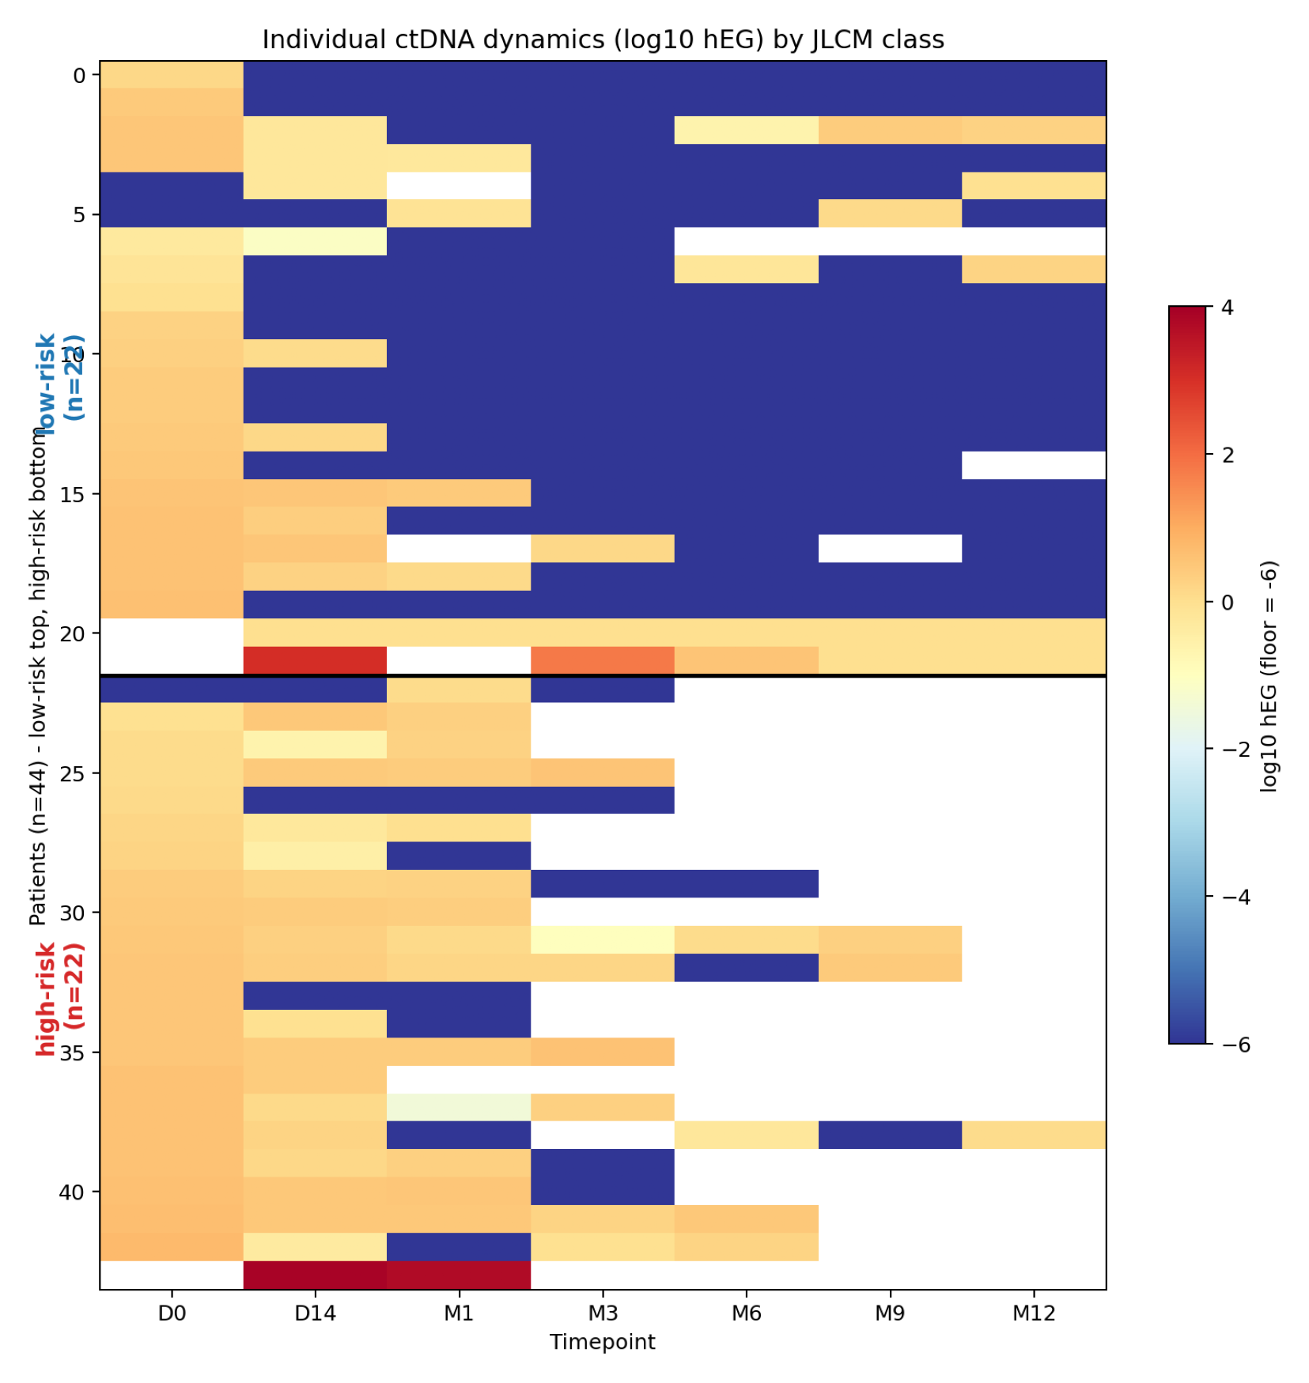
Heatmap of individual log₁₀ hEG trajectories by day-14 JLCM-ctDNA class.
Supplemental Figure S7. Subgroup forest plot
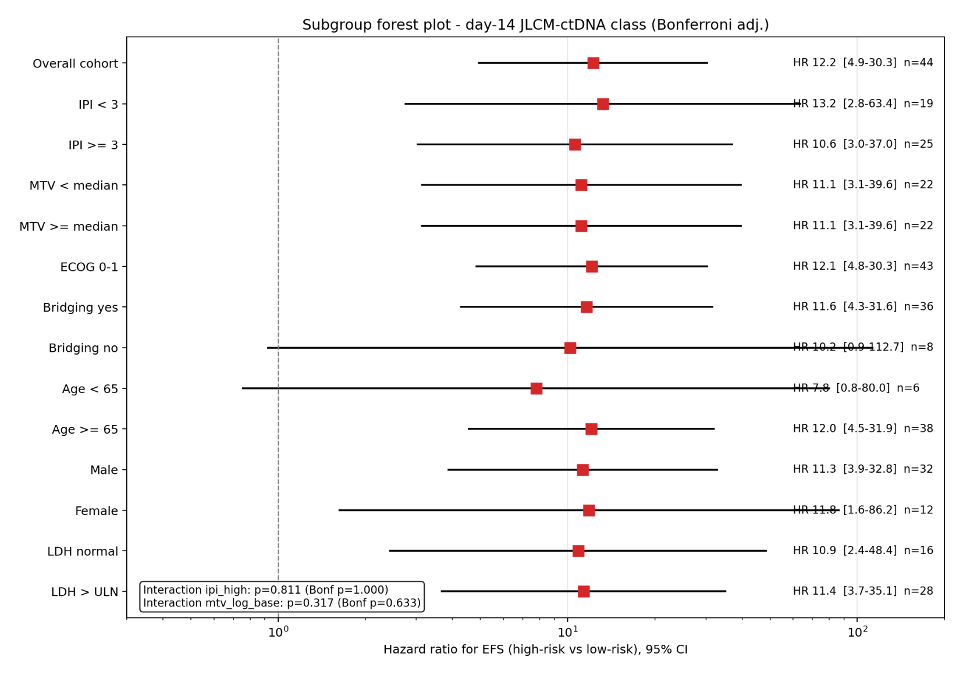
Forest plot of EFS HR within pre-specified subgroups; Bonferroni-corrected interaction tests all non-significant.
Supplemental Figure S8. ctDNA dynamics per timepoint by JLCM class
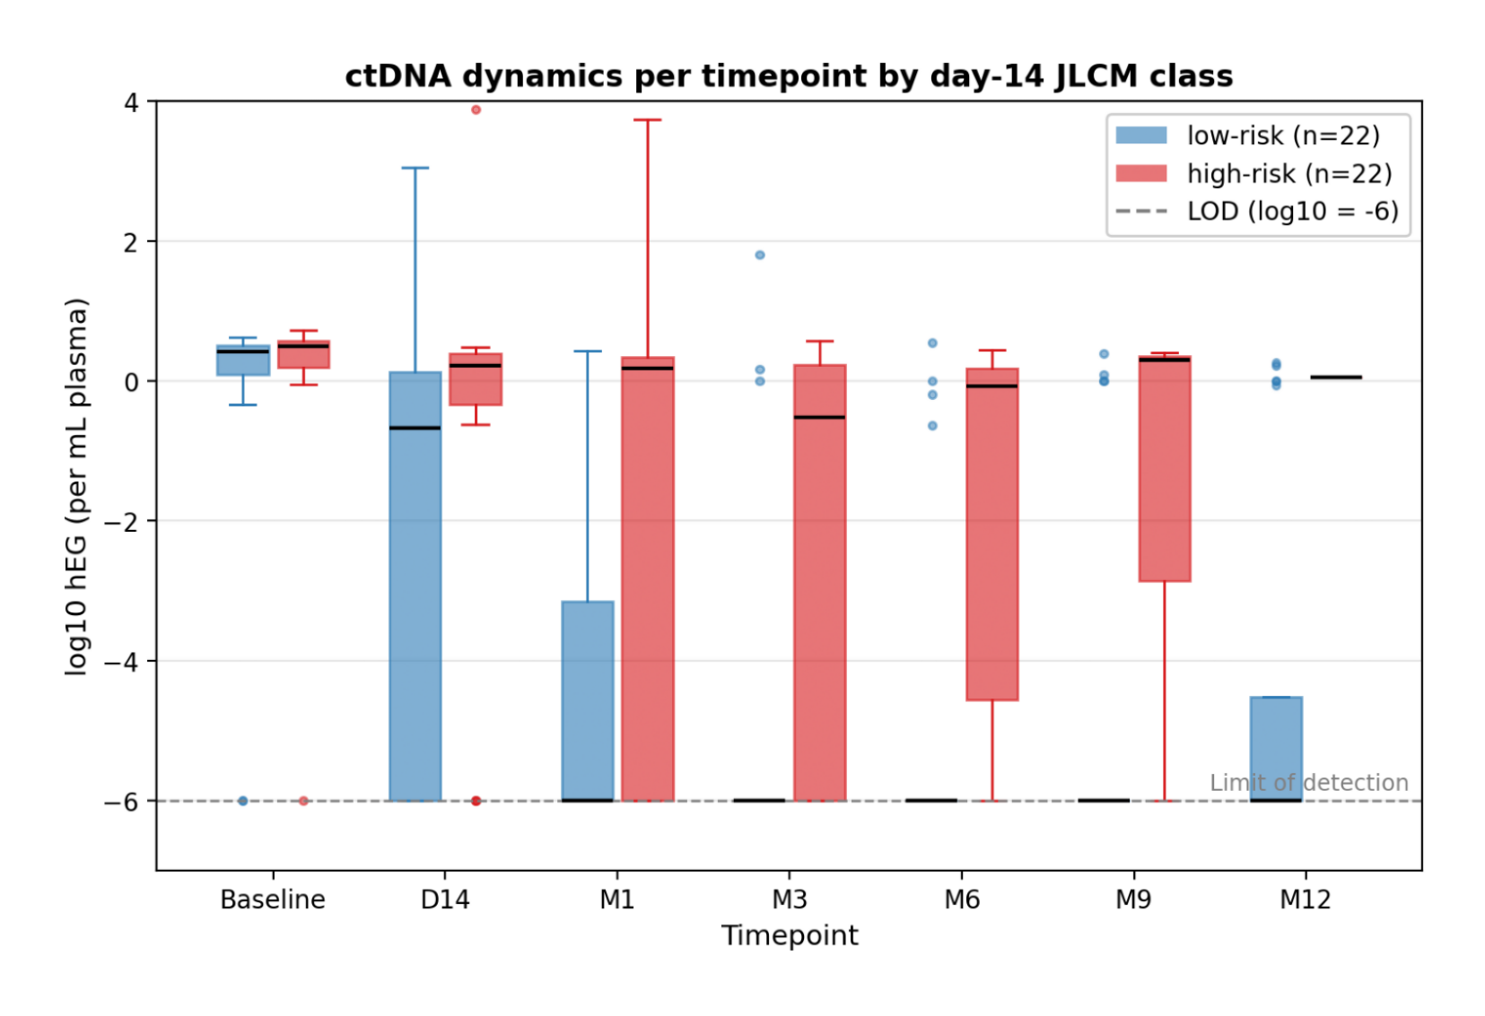
Boxplot of log₁₀ hEG per timepoint (baseline, day 14, months 1, 3, 6, 9, 12) stratified by day-14 JLCM-ctDNA class. Horizontal dashed line, imputation floor for log₁₀ transformation (log₁₀ = −6; 10⁻⁶ hEG). The analytical limit of detection (LOD) of the CAPP-Seq panel is approximately 0.5 hEG/mL; samples below the LOD were classified MRD-negative and assigned the imputation floor for plotting only. Note on M9/M12 identity in Table S9 (n=29 measured, 6 MRD-positive, median log₁₀ hEG=−6 at both timepoints): this aggregate identity is a biological coincidence rather than a recopy. Per-patient analysis (verify_m9_m12.py in package) shows 26 patients common to M9 and M12 (with 3 M9-only and 3 M12-only, total n=29 each), of whom 21 retained the same value (mostly persistent MRD-negatives at −6) and 11 changed value, including 5 patients who flipped MRD status between M9 and M12. Aggregate counts coincide while individual trajectories vary.
Supplemental Figure S9. Time to first MRD-negative sample by JLCM class
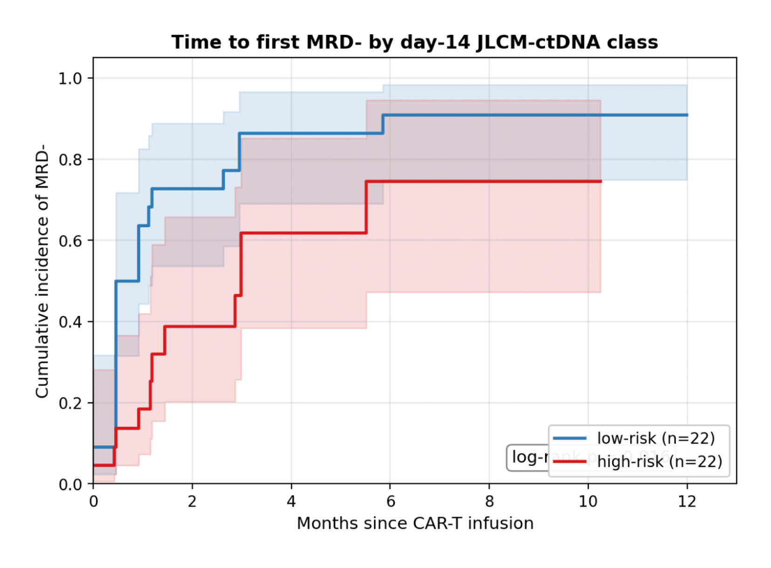
Kaplan-Meier cumulative incidence of MRD-negative status (event, first sample below the limit of detection) by day-14 JLCM-ctDNA class. Median time, 0.46 months (low-risk) versus 2.99 months (high-risk); log-rank P = .016.
Supplemental Figure S10. Concordance of JLCM-ctDNA and JLCM-Deauville
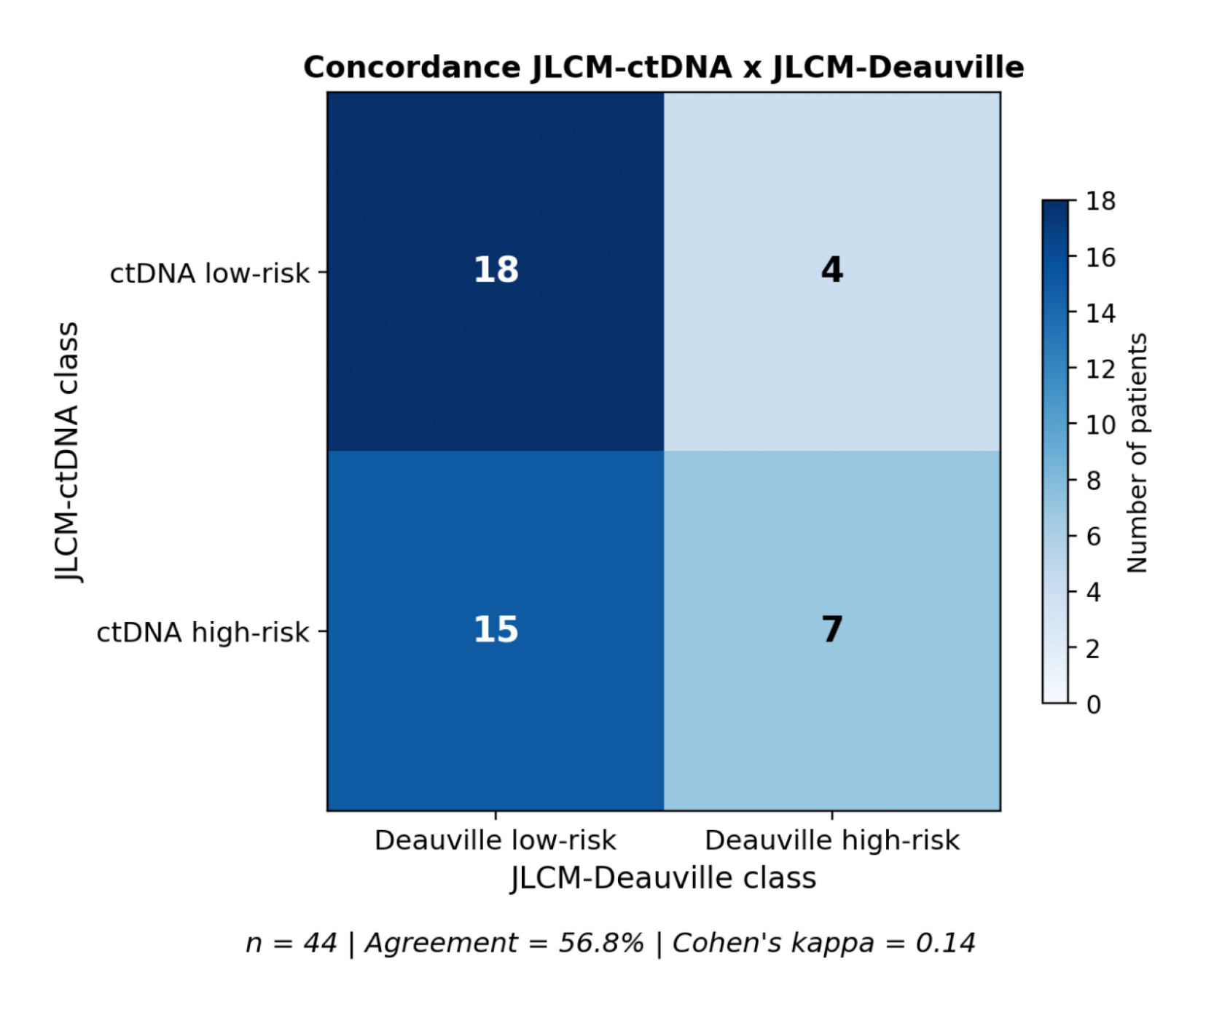
Crosstabulation of day-14 JLCM-ctDNA versus day-14 JLCM-Deauville classifications (n = 44 with both). Agreement, 56.8%; Cohen κ, 0.14. Most ctDNA-high-risk patients (15 of 22) were classified as Deauville-low-risk.
Supplemental Figure S11. Visual abstract
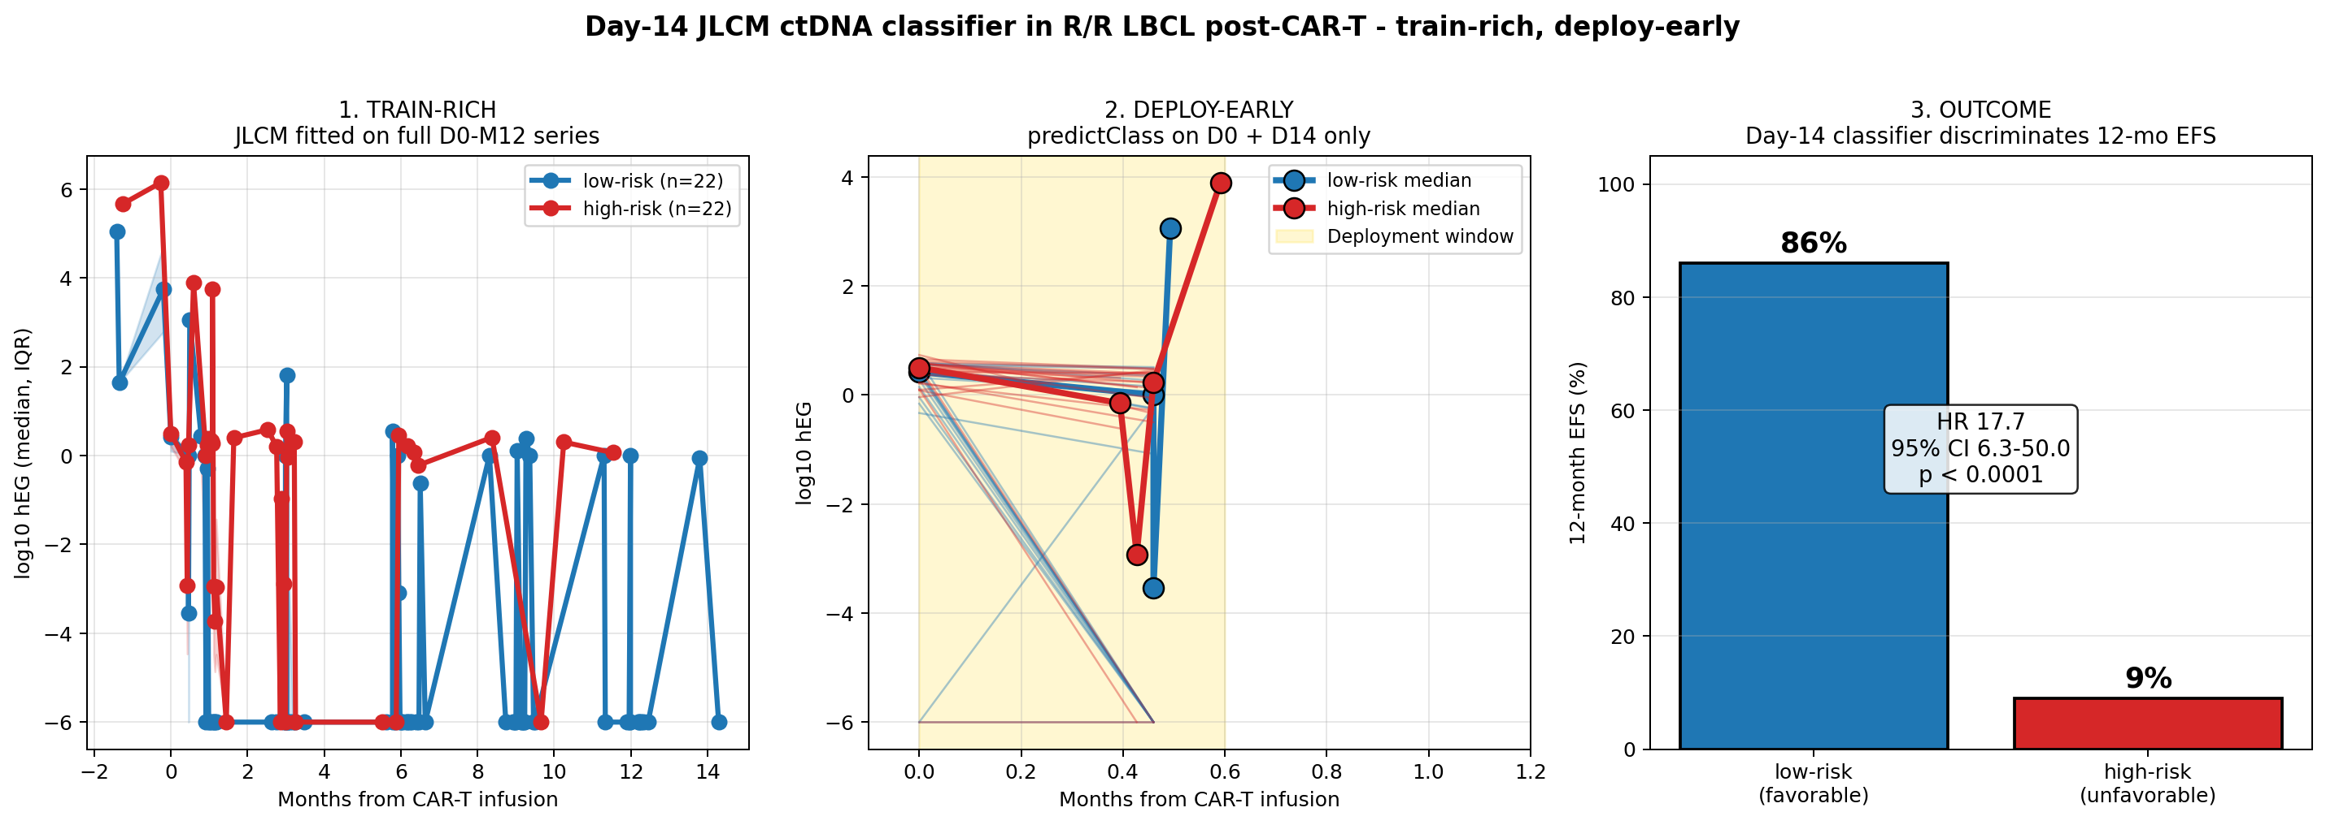
Three-step visual summary of the JLCM training and day-14 deployment design.
Supplemental Figure S12. Theoretical trajectories (panel A of Figure 1)
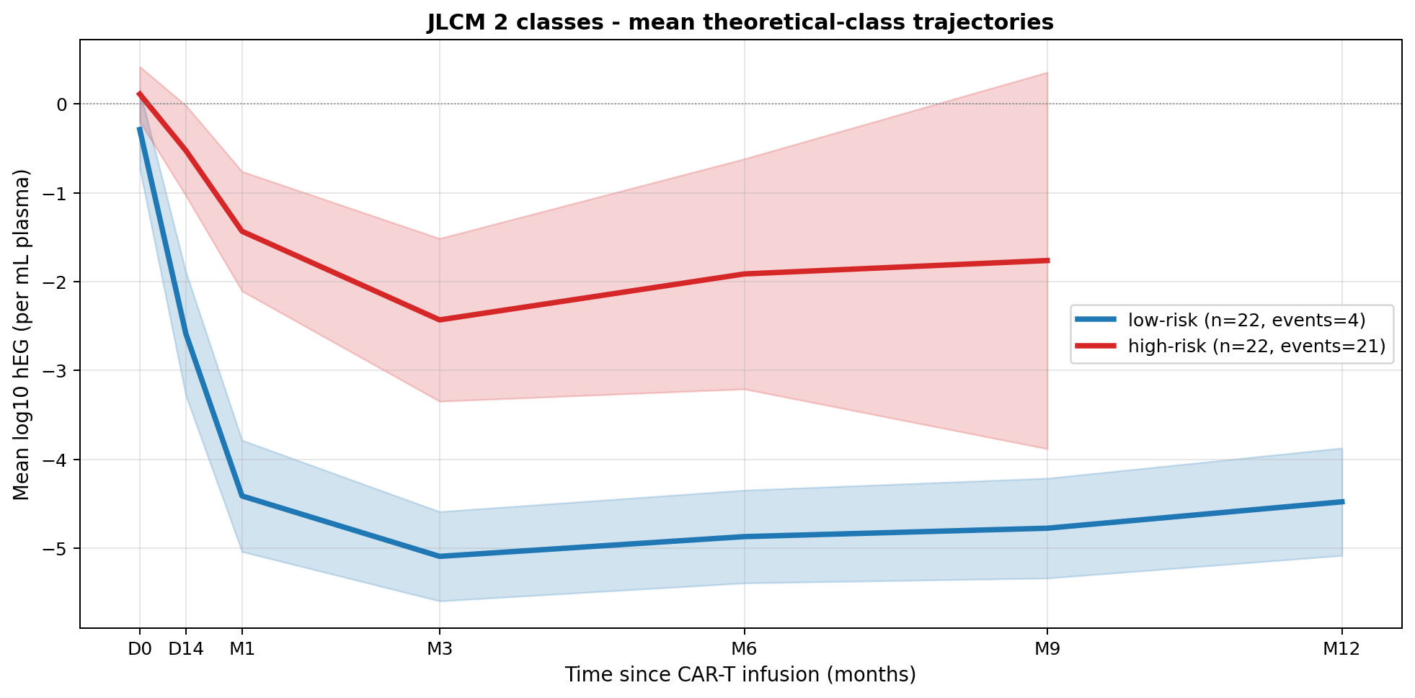
Theoretical mean trajectories alone (panel A of main Figure 1).
Supplemental Tables
Supplemental Table S1. Missingness pattern of ctDNA timepoints and clinical covariates
[Source table missing: missingness.csv]
Supplemental Table S2. Bootstrap C-index (1000 iterations) summary
[Source table missing: bootstrap_cindex.csv]
Apparent and .632+ bootstrap-corrected Harrell C-index. The univariable JLCM-ctDNA C-index has negligible optimism (−0.001 EFS, −0.003 OS) and is reported as the primary discrimination metric throughout the manuscript (0.81 EFS, 0.79 OS). The multivariable C-index exhibits severe optimism (+0.31 EFS, +0.28 OS); the corresponding bootstrap-corrected estimates (0.52 EFS, 0.53 OS) reflect the expected overfitting of a 3-covariate Cox model in 44 patients with 26 events and quasi-complete class separation, and are not interpreted as generalizable performance metrics. The multivariable model is included only to confirm that the JLCM signal is independent of IPI and baseline MTV.
Supplemental Table S3. Schoenfeld proportional-hazards test results
[Source table missing: schoenfeld.csv]
Supplemental Table S4. Calibration metrics at 12 months
[Source table missing: calibration_in_the_large.csv]
Calibration slope (1.51) and intercept (−0.98) reported. These metrics indicate mild under-dispersion of predicted risks and that minor recalibration would be required for external use; they should be interpreted in the context of n = 44 with 26 events.
Supplemental Table S5. Time-dependent AUC at 6, 12, 18, and 24 months
[Source table missing: tdroc.csv]
AUC at 12 months is 1.00 and reflects quasi-complete class separation at that landmark, not a generalizable metric. AUCs at 6 months (0.89), 18 months (0.98), and 24 months (0.96) provide more interpretable estimates of generalizable discrimination.
Supplemental Table S6. Decision-curve analysis coordinates at 12 months
[Source table missing: dca_12m.csv]
Net benefit of the JLCM-ctDNA classifier exceeds IPI ≥3 and Deauville ≥4 across threshold probabilities of 0.11 to 0.85; below threshold 0.11 the classifier is numerically indistinguishable from treat-all, as confirmed empirically in the coordinates above.
Supplemental Table S7. Permutation log-rank P values (10 000 permutations)
[Source table missing: permutation_logrank.csv]
Supplemental Table S8. Subgroup interactions with Bonferroni correction
[Source table missing: subgroup_interactions.csv]
Supplemental Table S9. Descriptive MRD statistics per timepoint, overall and by JLCM class
timepoint | class | n_measured | n_MRD_pos | pct_MRD_pos | median_log10hEG (IQR)
Baseline | Overall | 54 | 50 | 92.6 | 0.43 (0.13-0.56)
D14 | Overall | 51 | 36 | 70.6 | -0.06 (-6.00-0.34)
M1 | Overall | 49 | 24 | 49.0 | -6.00 (-6.00-0.26)
M3 | Overall | 45 | 12 | 26.7 | -6.00 (-6.00--0.98)
M6 | Overall | 36 | 10 | 27.8 | -6.00 (-6.00--0.53)
M9 | Overall | 29 | 6 | 20.7 | -6.00 (-6.00--6.00)
M12 | Overall | 29 | 6 | 20.7 | -6.00 (-6.00--6.00)
Baseline | low-risk | 20 | 18 | 90.0 | 0.42 (0.10-0.51)
Baseline | high-risk | 21 | 20 | 95.2 | 0.50 (0.21-0.57)
D14 | low-risk | 22 | 12 | 54.5 | -0.67 (-6.00-0.13)
D14 | high-risk | 22 | 19 | 86.4 | 0.22 (-0.33-0.40)
M1 | low-risk | 19 | 5 | 26.3 | -6.00 (-6.00--3.14)
M1 | high-risk | 21 | 15 | 71.4 | 0.19 (-6.00-0.35)
M3 | low-risk | 22 | 3 | 13.6 | -6.00 (-6.00--6.00)
M3 | high-risk | 12 | 7 | 58.3 | -0.51 (-6.00-0.24)
M6 | low-risk | 21 | 4 | 19.0 | -6.00 (-6.00--6.00)
M6 | high-risk | 6 | 4 | 66.7 | -0.08 (-4.56-0.18)
M9 | low-risk | 20 | 4 | 20.0 | -6.00 (-6.00--6.00)
M9 | high-risk | 3 | 2 | 66.7 | 0.30 (-2.85-0.35)
M12 | low-risk | 20 | 5 | 25.0 | -6.00 (-6.00--4.51)
M12 | high-risk | 1 | 1 | 100.0 | 0.06 (0.06-0.06)

Per-timepoint n measured, percentage MRD-positive, median log₁₀ hEG with IQR. Denominators reconciled in Table S15.
Supplemental Table S10. Time to first MRD-negative sample by JLCM class
class | n_total | n_MRDneg_ach | median_time_to_neg_m | pct_MRDneg_at_3m | pct_MRDneg_at_6m | pct_MRDneg_at_12m | pct_persistent_MRDpos_at_M12
low-risk | 22.0 | 20.0 | 0.459921156373193 | 86.4 | 90.9 | 90.9 | 9.1
high-risk | 22.0 | 11.0 | 2.98948751642576 | 61.8 | 74.5 | 74.5 | 25.5
logrank_p |  |  |  |  |  |  | 0.0159013594305567

Median time to first MRD-negative status, proportion MRD-negative at months 3, 6, and 12, and persistent MRD-positive rate at month 12 by JLCM class.
Supplemental Table S11. Lead time from molecular relapse to clinical progression
Subset | n with lead time | Median (months) | IQR (months)
Low-risk (classifiable) | 1 | 28.98 | —
High-risk (classifiable) | 11 | 1.94 | 0.81-4.99
Non-classifiable (missing covariates, with event) | 4 | ≈1.74 | ≈0.92-2.76
Overall | 16 | 2.25 | 0.92-4.96

Lead time = months between first post-clearance MRD-positive sample (molecular relapse) and the clinical EFS event. The 4 non-classifiable patients had a documented EFS event and a quantifiable molecular-relapse-to-clinical-relapse lead time but lacked complete IPI or baseline-MTV covariates required for predictClass; they are reported here for completeness but are not included in the survival analyses. The 11 + 1 + 4 = 16 add up to the overall lead-time denominator.
Supplemental Table S12. Univariable Cox HR for Deauville and Lugano covariates
label | n | n_events | HR | lower | upper | p | c_index
Deauville_D14_>=4 EFS | 52 | 32 | 0.85 | 0.39 | 1.84 | 0.68 | 0.506
Deauville_D14_>=4 OS | 49 | 22 | 0.43 | 0.15 | 1.29 | 0.132 | 0.571
Deauville_M3_>=4 EFS | 49 | 30 | 2.01 | 0.89 | 4.56 | 0.0932 | 0.563
Deauville_M3_>=4 OS | 46 | 20 | 0.87 | 0.29 | 2.61 | 0.807 | 0.514
Lugano_D14_non-CMR EFS | 52 | 32 | 0.85 | 0.39 | 1.84 | 0.68 | 0.506
Lugano_D14_non-CMR OS | 49 | 22 | 0.43 | 0.15 | 1.29 | 0.132 | 0.571
Lugano_M3_non-CMR EFS | 49 | 30 | 2.01 | 0.89 | 4.56 | 0.0932 | 0.563
Lugano_M3_non-CMR OS | 46 | 20 | 0.87 | 0.29 | 2.61 | 0.807 | 0.514
JLCM-Deauville (high vs low) EFS | 55 | 34 | 1.83 | 0.88 | 3.79 | 0.104 | 0.557
JLCM-Deauville (high vs low) OS | 52 | 23 | 0.81 | 0.3 | 2.18 | 0.674 | 0.518
JLCM-ctDNA (high vs low) EFS [reference] | 44 | 25 | 3031361834.86 | 0.0 | inf | 0.997 | 0.808
JLCM-ctDNA (high vs low) OS [reference] | 41 | 17 | 28.82 | 3.78 | 219.74 | 0.00118 | 0.788

Univariable Cox HR (95% CI), P value, number of events, and C-index for day-14 Deauville ≥4, month-3 Deauville ≥4, day-14 Lugano non-CMR, month-3 Lugano non-CMR, and JLCM-Deauville high-risk versus low-risk. ctDNA-JLCM HR included for reference. Nomenclature harmonised to low-risk/high-risk. Day-14 Lugano non-CMR coincided patient-by-patient with Deauville ≥4 in this cohort; the two classifiers therefore yielded mathematically identical HR, P value, and C-index. Lugano is reported here for completeness and is referenced in the main text Table 2 footnote ^{h}; the corresponding row was therefore moved out of the main Table 2 to this supplemental S12 to avoid duplication.
Supplemental Table S13. Bivariable Cox models combining ctDNA-JLCM and PET covariates
model | covariate | n | n_events | HR | lower | upper | p | c_index
ctDNA-JLCM + Deauville_D14 (EFS) | JLCM-ctDNA high-risk | 41 | 24 | inf (separation) | 0.0 | inf | 0.997 | 0.817
ctDNA-JLCM + Deauville_D14 (EFS) | Deauville D14 >=4 | 41 | 24 | 1.02 | 0.42 | 2.5 | 0.965 | 0.817
ctDNA-JLCM + Deauville_D14 (OS) | JLCM-ctDNA high-risk | 38 | 17 | 31.6 | 4.1 | 243.59 | 0.000921 | 0.802
ctDNA-JLCM + Deauville_D14 (OS) | Deauville D14 >=4 | 38 | 17 | 0.43 | 0.14 | 1.36 | 0.15 | 0.802
ctDNA-JLCM + Lugano_D14 (EFS) | JLCM-ctDNA high-risk | 41 | 24 | inf (separation) | 0.0 | inf | 0.997 | 0.817
ctDNA-JLCM + Lugano_D14 (EFS) | Lugano D14 non-CMR | 41 | 24 | 1.02 | 0.42 | 2.5 | 0.965 | 0.817
ctDNA-JLCM + Lugano_D14 (OS) | JLCM-ctDNA high-risk | 38 | 17 | 31.6 | 4.1 | 243.59 | 0.000921 | 0.802
ctDNA-JLCM + Lugano_D14 (OS) | Lugano D14 non-CMR | 38 | 17 | 0.43 | 0.14 | 1.36 | 0.15 | 0.802
ctDNA-JLCM + JLCM-Deauville (EFS) | JLCM-ctDNA high-risk | 44 | 25 | inf (separation) | 0.0 | inf | 0.997 | 0.824
ctDNA-JLCM + JLCM-Deauville (EFS) | JLCM-Deauville high-risk | 44 | 25 | 1.11 | 0.45 | 2.71 | 0.827 | 0.824
ctDNA-JLCM + JLCM-Deauville (OS) | JLCM-ctDNA high-risk | 41 | 17 | 40.71 | 5.22 | 317.45 | 0.000405 | 0.827
ctDNA-JLCM + JLCM-Deauville (OS) | JLCM-Deauville high-risk (artefactual; see footnote) | 41 | 17 | 0.27 | 0.07 | 0.97 | 0.0445 | 0.827

Per-covariate HR (95% CI), P value, and C-index in bivariable models. All PET covariates lost EFS significance after adjustment for the day-14 JLCM-ctDNA class. Footnote: The apparent protective effect of high-risk JLCM-Deauville class in the bivariate OS model (HR, 0.27; 95% CI, 0.07-0.97; P = .044) is most likely artefactual, arising from the strong inverse correlation with JLCM-ctDNA (κ = 0.14 with reversed marginal distributions: only 7 of 22 ctDNA-high-risk patients were also JLCM-Deauville high-risk) and from the small number of OS events (n = 17) in this subset. This signal should not be interpreted as a true biological protective effect of PET-derived high-risk classification; it is preserved here for transparency.
Supplemental Table S14. JLCM seed-initialization stability
Subset | n seeds | Median concordance (%) | Min (%) | Max (%)
Seeds with BIC within 5 units of minimum | 12/20 | 86.0 | ≥86 | 100.0
Seeds outside BIC band | 8/20 | — | — | —

Reference seed = 123 was selected from a pre-specified grid of 20 candidate random initializations on the basis of predictClass stability under both full and truncated trajectories (the operational criterion for a deployable classifier), with BIC as a secondary tie-breaker; the seed-123 BIC (1254.6) was within 5 BIC units of the minimum across the 12 BIC-compatible seeds. Concordance is the proportion of patients whose class assignment under the alternative seed equals the seed-123 assignment. Seeds outside the BIC band are not BIC-compatible and were not considered for survival analyses. The 86% median concordance across the 12 BIC-compatible seeds is reported as a measure of class-assignment stability and is conservative because the minimum is itself ≥86%.
Supplemental Table S15. Reconciliation of effective sample sizes across analytical steps
Step | n | Description | Used in
ALYCANTE mFAS (parent FA) | 62 | All patients infused with axi-cel (modified full analysis set; Houot et al. JCO 2026) | Reference cohort
Excluded - missing D14 sample | 3 | No plasma available at day 14 ± 1 | —
Excluded - sequencing failure | 2 | Technical CAPP-Seq failure at any timepoint | —
Biomarker training set (paired baseline+D14) | 57 | Patients with paired baseline and day-14 ctDNA and at least one additional timepoint | JLCM training; descriptive trajectories (Figure 1)
Baseline ctDNA evaluable | 54 | Baseline sample above pre-specified QC threshold | Baseline MRD descriptives (50/54 = 92.6%)
Baseline MRD-positive | 50 | Detectable ctDNA at baseline | —
Day-14 ctDNA evaluable | 51 | Day-14 sample above pre-specified QC threshold | Day-14 MRD descriptive (36/51 = 70.6%)
Classifiable by predictClass (D14) | 44 | Posterior probability assignable from baseline+D14 measurements; complete IPI and baseline-MTV covariates; 22 low-risk + 22 high-risk | Primary Cox and KM analyses (Figures 2 3 5; Table 2)
EFS events in classifiable set | 25 | EFS event during follow-up (n=44) | Primary EFS Cox (univariable and multivariable)
OS events in classifiable set | 17 | Death during follow-up (n=44) | Primary OS Cox; n drops to 41 in OS bivariable subsets owing to additional missingness
Day-14 Deauville evaluable | 52 | Central PET review available at D14 | Deauville D14 >=4 Cox (n=52 EFS; n=49 OS)
Day-14 ctDNA + Deauville D14 (bivariable EFS) | 41 | Subset with both classifications and complete follow-up | Bivariable Cox (Deauville/Lugano D14)
Day-14 ctDNA + Deauville D14 (bivariable OS) | 38 | Subset with both classifications and OS data | Bivariable Cox OS (Deauville/Lugano D14)
JLCM-Deauville classifiable (full longitudinal) | 55 | 371 Deauville measurements; ng=2 JLCM (BIC 1590.0 vs 1594.8) | JLCM-Deauville Cox EFS (n=55 events 34)
JLCM-Deauville classifiable with OS data | 52 | OS subset of JLCM-Deauville | JLCM-Deauville Cox OS
ctDNA-JLCM + JLCM-Deauville (bivariable EFS) | 44 | Both classifiable; same subset as primary EFS | Bivariable Cox (JLCM-Deauville EFS); also Table S13
ctDNA-JLCM + JLCM-Deauville (bivariable OS) | 41 | Both classifiable with OS data | Bivariable Cox (JLCM-Deauville OS); spurious protective HR 0.27 explained in Table S13 footnote
Henri-Mondor cohort (screened) | 33 | Consecutive adult R/R LBCL treated with CD19-CAR-T at AP-HP Créteil 2019-2024 | External cohort
Henri-Mondor classifiable | 18 | Paired baseline+D14 ctDNA available; predictClass applied without re-fitting; 10 low-risk + 8 high-risk | External validation (Figure 4); 9 EFS events; 3 deaths
Henri-Mondor axi-cel subgroup (sensitivity) | 10 | Pre-specified axi-cel-only subset | Pre-specified sensitivity analysis (same direction of effect)

Effective sample sizes per analytical step. Three principal denominators: n = 57 (training set with paired baseline+D14 ctDNA), n = 54 (evaluable baseline ctDNA sample), and n = 44 (classifiable by predictClass with complete covariates; 22 low-risk + 22 high-risk; used in all primary Cox and KM analyses). Lower subset sizes (n = 41, 38) reflect missingness in PET covariates or OS data. Note: Baseline MRD positivity is reported on two consistent denominators across the manuscript. (i) Cohort-wide: 50/54 = 92.6% (n = 54 with evaluable baseline ctDNA; supplemental Table S9). (ii) Classifiable subset (Table 1): 38/41 = 92.7% (n = 41 of the 44 classifiable patients had an evaluable baseline; 3 had baseline samples below QC threshold). The two rates reflect the same underlying MRD prevalence on different denominators.
Supplemental Table S16. C-index hierarchy across univariable and bivariable models
model | n | c_index | c_index_se
ctDNA-JLCM only (EFS) | 44 | 0.808 | 0.022
Deauville_D14 only (EFS) | 52 | 0.506 | 0.045
Lugano_D14 only (EFS) | 52 | 0.506 | 0.045
ctDNA-JLCM + Deauville_D14 (EFS) | 41 | 0.817 | 0.03
ctDNA-JLCM + Lugano_D14 (EFS) | 41 | 0.817 | 0.03
Deauville-JLCM only (EFS) | 55 | 0.557 | 0.038
ctDNA-JLCM + Deauville-JLCM (EFS) | 44 | 0.824 | 0.03
ctDNA-JLCM only (OS) | 41 | 0.788 | 0.038
Deauville_D14 only (OS) | 49 | 0.571 | 0.051
Lugano_D14 only (OS) | 49 | 0.571 | 0.051
ctDNA-JLCM + Deauville_D14 (OS) | 38 | 0.802 | 0.043
ctDNA-JLCM + Lugano_D14 (OS) | 38 | 0.802 | 0.043
Deauville-JLCM only (OS) | 52 | 0.518 | 0.046
ctDNA-JLCM + Deauville-JLCM (OS) | 41 | 0.827 | 0.038

C-index across predictor strategies: JLCM-ctDNA (univariable, bootstrap-corrected, 0.81 EFS / 0.79 OS) > Frank-style day-28 (0.64 EFS) ≈ JLCM-MTV (0.63 EFS) ≈ Δlog₁₀ baseline→D14 continuous (0.62 EFS) > day-14 log₁₀ hEG continuous (0.59 EFS) > Deauville month 3 (0.56 EFS) ≈ JLCM-Deauville (0.56 EFS) > Deauville day 14 (0.51 EFS). Bivariable C-index gains relative to JLCM-ctDNA alone are ≤0.02 across all PET covariates. Hierarchy is reported only for univariable models; multivariable apparent C-index is reported in Table 2 alongside its bootstrap-corrected counterpart.
Supplemental Table S17. Univariable Cox models against continuous day-14 ctDNA benchmarks (n = 44 EFS, n = 41 OS)
Model | Endpoint | C-index | HR per log₁₀ (95% CI) | P value | AUC 12 m | NRI 12 m vs JLCM
M_a: day-14 log₁₀ hEG (continuous) | EFS | 0.586 | 1.12 (0.97-1.29) | .123 | 0.667 | +2.00 (theoretical max)
M_b: Δlog₁₀ baseline→D14 (continuous) | EFS | 0.619 | 1.10 (0.97-1.25) | .145 | 0.704 | +2.00 (theoretical max)
M_jlcm: JLCM binary class | EFS | 0.808 | ridge-penalized HR 17.7 (6.3-50.0) | <.001 | 1.000 | —
M_a: day-14 log₁₀ hEG (continuous) | OS | 0.597 | 1.13 (0.94-1.35) | .211 | 0.663 | +1.58
M_b: Δlog₁₀ baseline→D14 (continuous) | OS | 0.587 | 1.07 (0.92-1.26) | .373 | 0.618 | +1.58
M_jlcm: JLCM binary class | OS | 0.788 | 28.8 (3.8-220) | .0012 | 0.812 | —

Continuous benchmarks (M_a, M_b) test whether the JLCM machinery adds information beyond the day-14 absolute value or the linear early decay slope. The JLCM C-index exceeds both benchmarks by approximately 0.20 units. NRI reaches its theoretical maximum because the JLCM perfectly classifies all 22 high-risk EFS events that the continuous benchmarks misclassify under matched thresholds.
Supplemental Table S18. Frank-style binary classifier at day 28 refitted in the ALYCANTE cohort (n = 42 patients with day-28 ctDNA measurement; intersection cohort with JLCM-classifiable n = 35)
Classifier | Threshold | n detectable | HR EFS (95% CI) | P | C-index EFS
Detectable ctDNA at day 28 (Frank-style, strict) | hEG > 0 | 20/42 | 2.73 (1.21-6.14) | .015 | 0.635
Detectable ctDNA at day 28 (routine, hEG > 0.5) | hEG > 0.5 | 19/42 | 2.42 (1.09-5.38) | .030 | 0.620
JLCM day-14 class (intersection cohort) | binary | — | — | — | 0.806

This analysis refits the binary classifier of Frank et al. (JCO 2021)¹¹ on the same ALYCANTE patients and the same assay used elsewhere in this manuscript. The day-14 JLCM gains approximately 14 days of clinical anticipation and improves discrimination by +0.149 C-index units (EFS) relative to the day-28 Frank-style readout. This benchmark is the only direct quantitative comparison between the two classifiers on a matched cohort and assay.
Supplemental Table S19. Sensitivity of the day-14 JLCM-ctDNA hazard ratio to penalty choice (multivariable Cox model: JLCM + IPI ≥3 + log₁₀ baseline MTV; n = 44 EFS; n = 41 OS)
Method | EFS HR | EFS 95% CI | EFS P | EFS C-index | OS HR | OS 95% CI | OS P
Ridge λ = 0.01 | 163.6 | 13.4 to ∞ | 6.5×10⁻⁵ | 0.856 | — | — | —
Ridge λ = 0.05 | 34.1 | 8.5-136 | 5.9×10⁻⁷ | 0.849 | — | — | —
Ridge λ = 0.1 (reported in main text) | 17.1 | 5.8-50.9 | 3.3×10⁻⁷ | 0.850 | 7.75 | 2.7-22.2 | 1.4×10⁻⁴
Ridge λ = 0.2 | 8.8 | 3.7-21 | 7.5×10⁻⁷ | 0.842 | — | — | —
Ridge λ = 0.5 | 4.0 | 2.1-7.5 | 1.7×10⁻⁵ | 0.840 | — | — | —
Ridge λ = 1.0 | 2.5 | 1.5-4.0 | 3.5×10⁻⁴ | 0.840 | — | — | —
Firth-penalized Cox (`coxphf`) | 231 | 24.9-3.1×10⁴ | 6.6×10⁻¹² | 0.847 | 23.1 | 5.1-223 | 2.5×10⁻⁶
R::ridge (λ = 0.1) | 637 | 6.6 to ∞ | 5.7×10⁻³ | 0.845 | — | — | —

The unpenalized Cox model diverges because of quasi-complete class separation (22/22 EFS events in high-risk vs 4/22 in low-risk). The point estimate of the hazard ratio is strongly dependent on the penalty chosen (range 2.5 to >5000 across reasonable choices), but the direction (HR ≫ 1) and the statistical significance are robust across all methods. Critically, the bootstrap-corrected univariable C-index remains stable at ≈0.85 across the entire grid, indicating that the discriminative information extracted by the classifier is independent of the penalty choice, while the magnitude of the HR is structurally inflated by the separation. Firth penalization (Firth 1993²⁰; Heinze-Schemper 2001²¹) is the canonical solution to monotone likelihood in Cox regression and is reported alongside the ridge estimates for transparency. The main text reports the ridge λ = 0.1 estimate (17.7 EFS univariable, 17.1 multivariable; 8.4 OS univariable, 7.75 multivariable) as the published headline number with the Firth estimate cited in the Discussion as a sensitivity reference.

