**Examples of model initialization and output**

Please, use the files provided for testing the model against the case study of the San Fili – Uncino landslide, by considering the following rain series and activations:

* SFILI_rain_C.csv – *rains, for* ***calibration***;
* SFILI_activation_C_(Frega17).csv – *activation dates, for* ***calibration***;
* SFILI_rains.csv – *rains, for* ***validation***;
* SFILI_activations.csv – *activation dates, for* ***validation***.

As for initialization of model parameters, cf. masks below.

* ***Calibration***

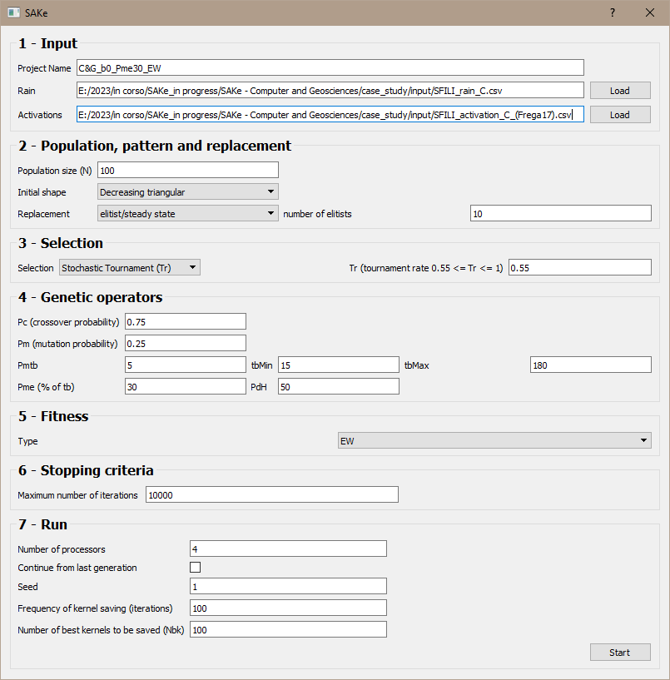

D309 [C&G_b0_Pme30_EW] - Initialization mask for calibration.

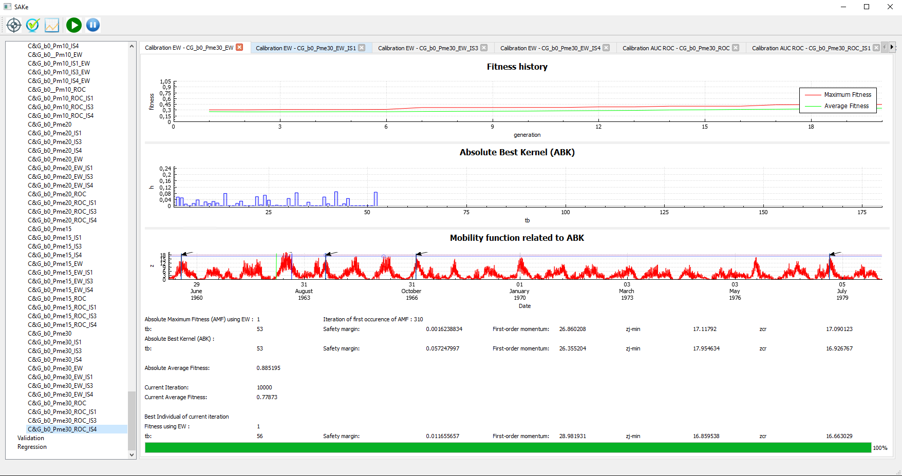

D309 [C&G_b0_Pme30_EW] – Calibration output (cf. also Table B-8 in Appendix B).

Note - In addition to the standard output files:

* currentGAiteration.csv
* fitnessHistory.csv
* kernels.csv

to be found in the MS-Windows folder C:\Users\*NAME*\Documents\workspace\calibration\C&G_b0_Pme30_EW

the “best” kernel related to the experiment D309 is also provided (cf. file: 7_D309_best.csv), as extracted from the file kernels.csv. This latter (with no headers) can be used for validation/regression purposes.

*NAME* is the name of the pc-user under MS-Windows (e.g. “iovine” in the example_file main.xml – cf. below).

*

* ***Validation***

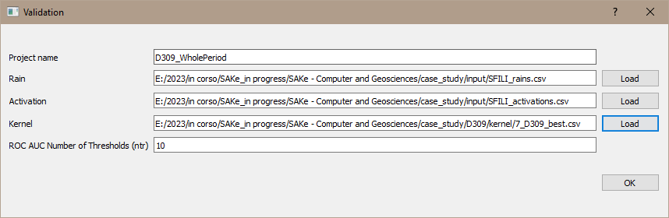

D309 [C&G_b0_Pme30_EW] - Initialization mask for validation (against all activations).

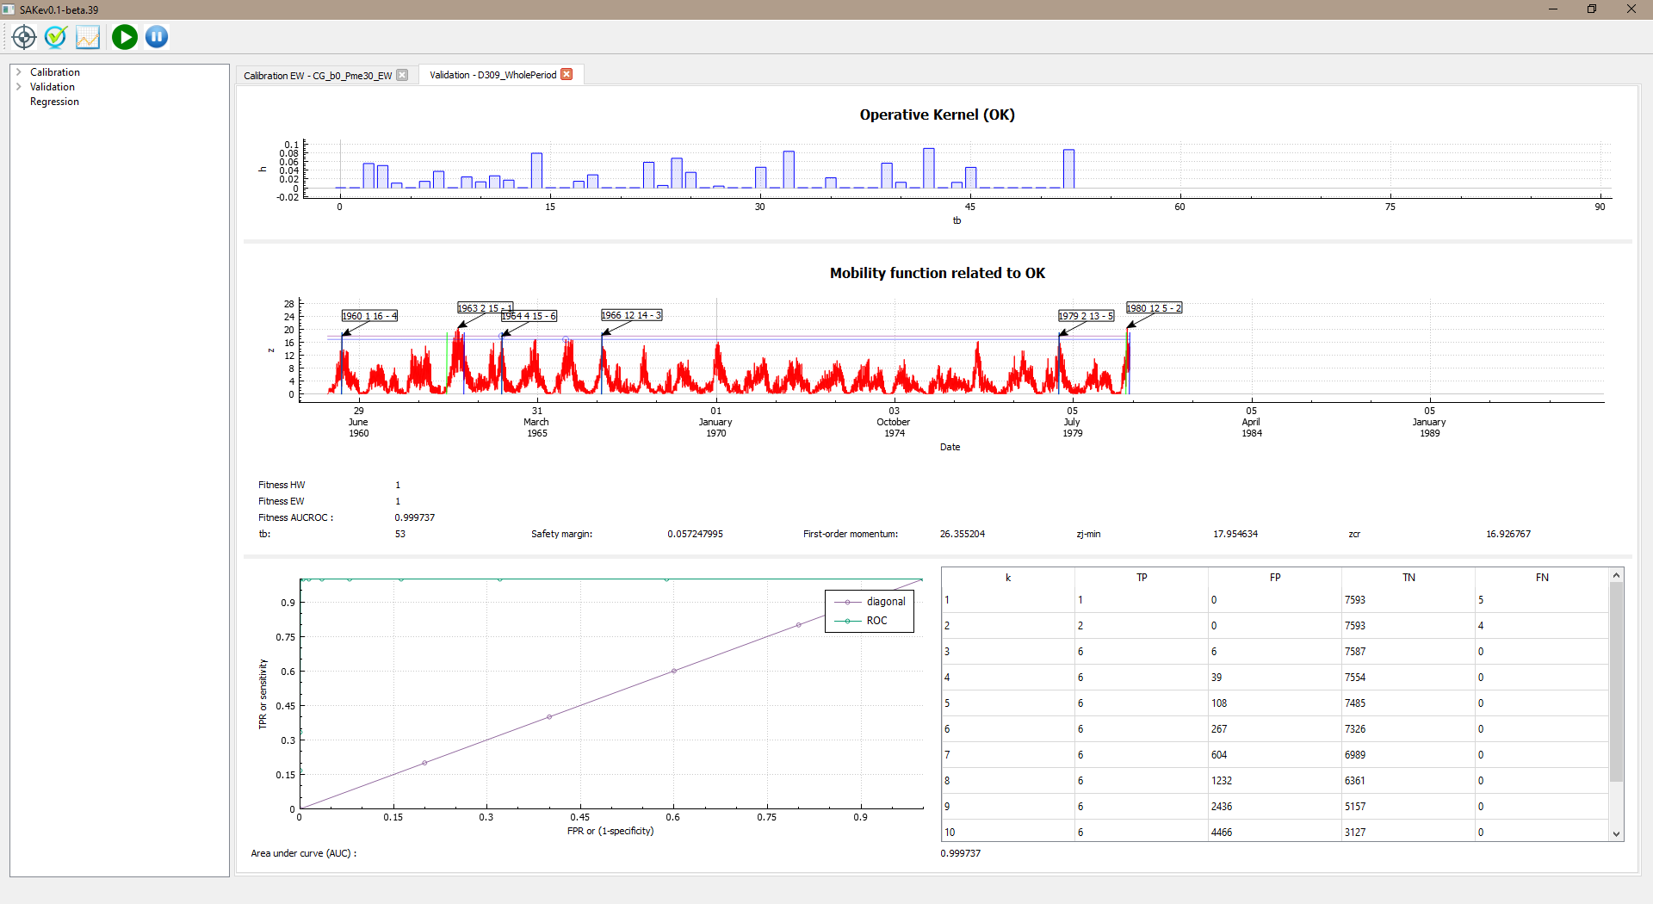

D309 [C&G_b0_Pme30_EW] – Validation output (cf. also Table B-9 in Appendix B).

Note - The standard output files:

* metrics.csv
* mobilityFunction.csv

to be found in the MS-Windows folder C:\Users\*NAME*\Documents\workspace\validation\D309_WholePeriod

are provided.

*

* ***Regression***

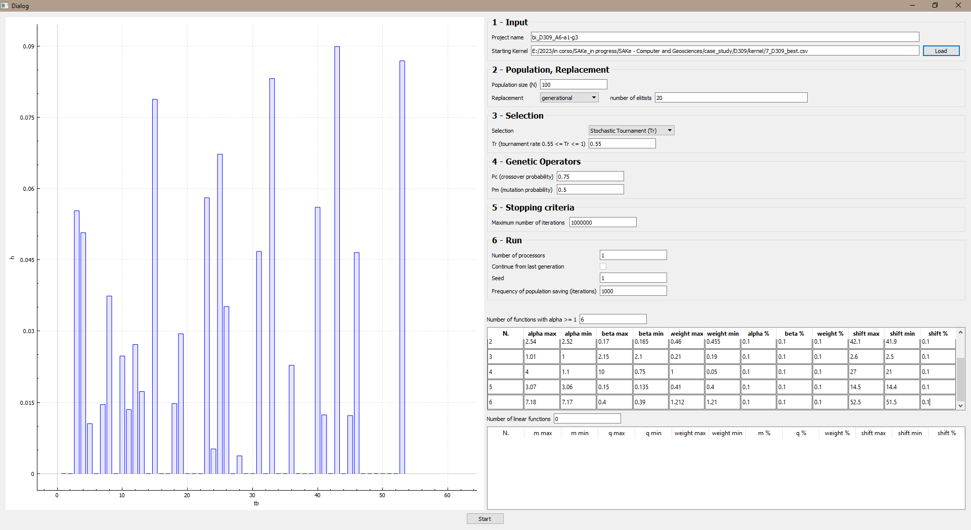

D309 [C&G_b0_Pme30_EW] - Initialization mask for regression (cf. also Table B-11 in Appendix B).

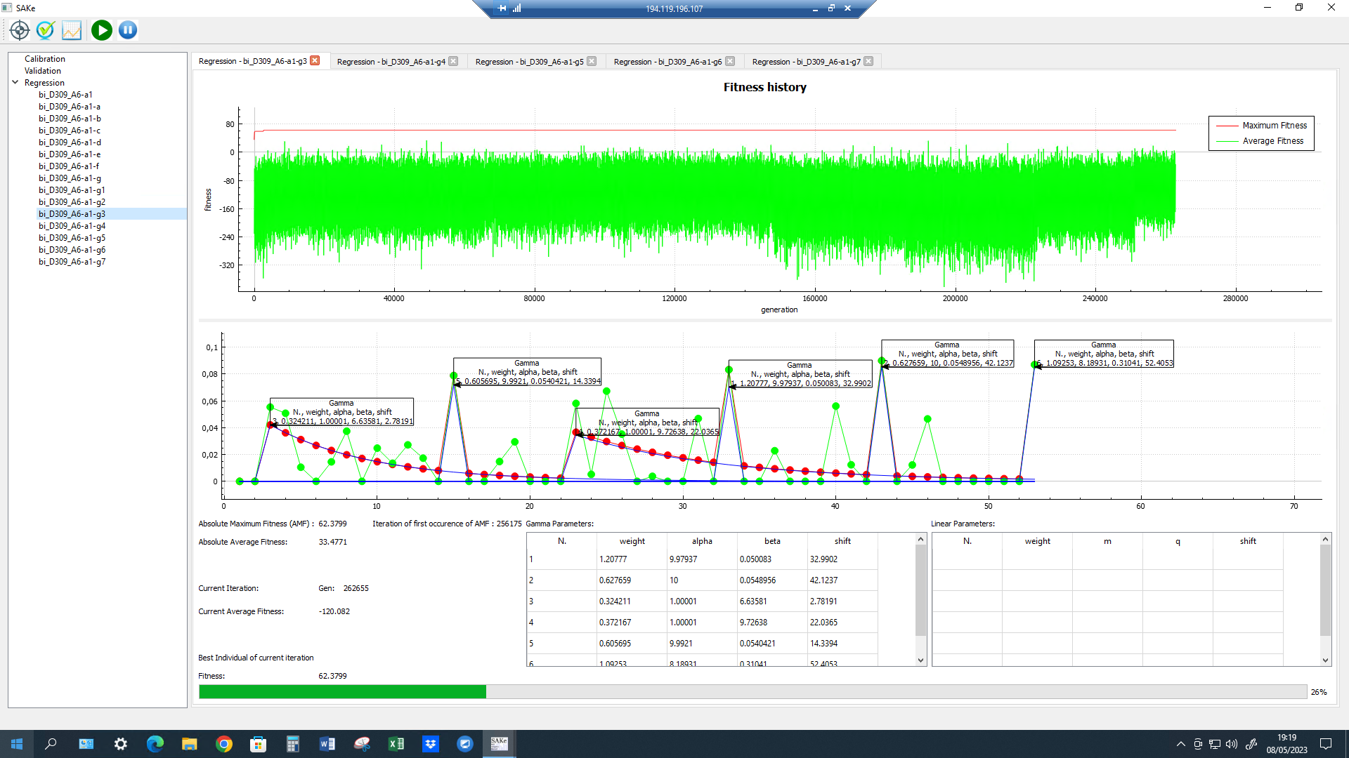

D309 [C&G_b0_Pme30_EW] – Regression output (cf. also Table B-12 in Appendix B).

Note - The standard output files:

* fitnessHistory.csv
* kernel.csv
* population.csv
* populationWithHeader.csv

to be found in the MS-Windows folder

C:\Users\*NAME*\Documents\workspace\regression\bi_D309_A6-a1-g3

are provided.

*

Finally, note that details on all the performed experiments of calibration, validation and regression are included in the “system file” main.xml, to be found in the folder

C:\Users\*NAME*\Documents\workspace