Procedimento

- Search in advanced mode in PDBe with the following query:

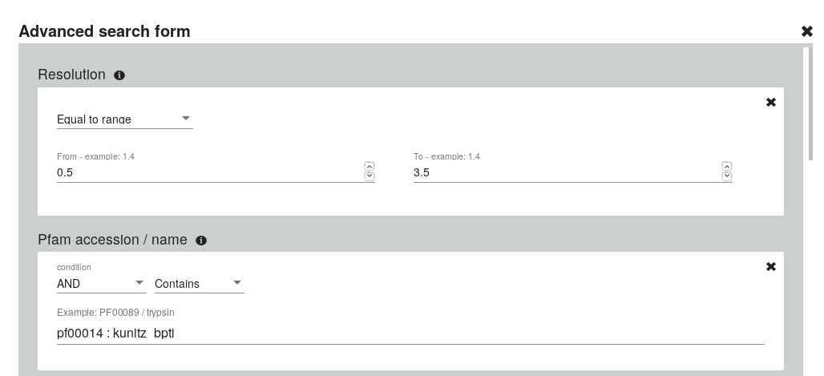
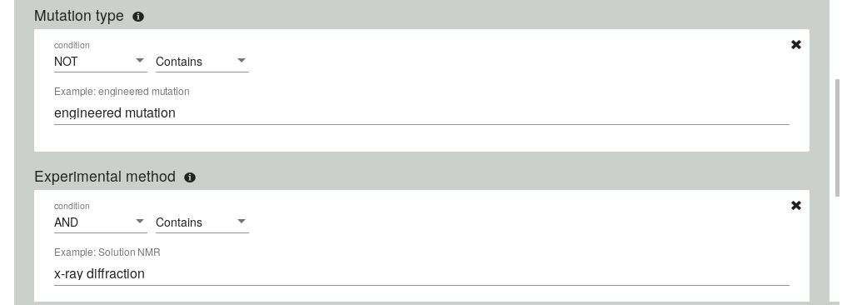
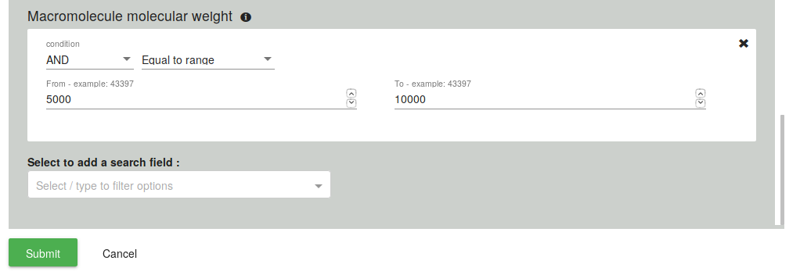
the number of protein obtained is 89. of witch 11 are not compexed to an other compound or protein.
Among the 11 the best for resolution and the two parameters (Model geometry
Fit model/data) and ramachandran outliers and clashcore and side chain outlier is:

9ptI (capital I) with a resolution of 1.22 A from bos tauros
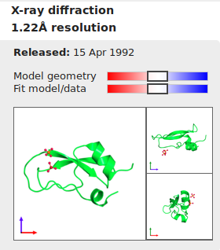
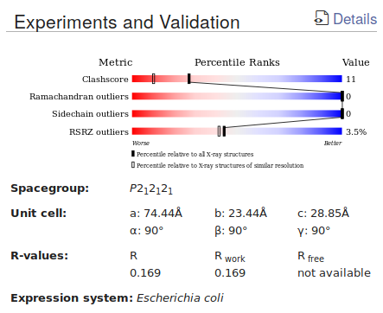

- To see the difference between structure crystallized with or without targets of the inibition is selected another protein with a target.

Among the other for the same parameters there is:

4y0y with a resolution of 1.22 A from bos tauros
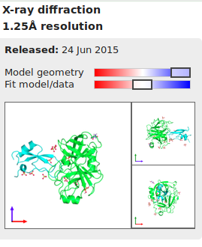
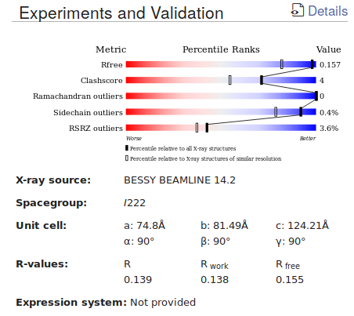

- For both chosen proteins we check if in the chains we are interested in ther are missing residues. Sometimes it happens.

Command to check if there are missing residues:

grep ‘^ATOM’ 4y0y.pdb | grep -w ‘CA’ |grep -w ‘I’ wc -l

both files have all the residues.

- Give both proteins specifing the chain we are considering to PDBefold. 9Pti : chain A, 4y0y : chain I. First search on pdbefold in a pairwise mode against the whole pdb archive.

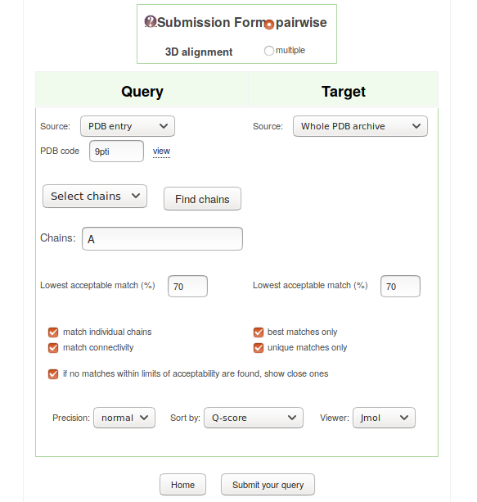
The retrieved chains are 569 of which the first is the chain itself of 9pti.
Same for 4y0y chain I. But the retrieved sequences are 484.

- Then the output of PDBefold are compared to see if there are differences (hope not). The retrieved ids are compared with the command:

to generate the list of chain ids from the output file of pdbefold

cat pdbefold_first_4y0y_retrieved.fasta | grep '^>' | cut -d " " -f 1 | cut -d ":" -f 2,3 > ids_retrieved_first_pdbefold_4y0y.txt
to sort the two files

sort ids_retrieved_first_pdbefold_4y0y.txt > sorted_ids_retrieved_first_pdbefold_4y0y.txt

to compare the ids files

comm -12 sorted_ids_retrieved_first_pdbefold_9pti.txt sorted_ids_retrieved_first_pdbefold_4y0y.txt | wc -l

this command counted how many ids are in common and the number is 439 on the 483 retrieved from PDBefold for 4y0y = 90,89 %.

- to see if in the rmsd ordered files all the best hits are the same other commands were used:

the file obtained from PDBefold are ordered from the lowest RMSD to highest, the first 50 non-sorted ids extracted from each file are compared with the common ids output of the previuos commands (439 ids). The commands:

create the common ids list:

comm -12 sorted_ids_retrieved_first_pdbefold_9pti.txt sorted_ids_retrieved_first_pdbefold_4y0y.txt > first_PDBefold_commonhits.txt

create the first 50 hits from the ids retrieved:

head -50 ids_retrieved_first_pdbefold_9pti.txt | sort > 50sorted_best_hits_9pti_pdbefold.txt

the two files are compared:

comm first_PDBefold_commonhits.txt 50sorted_best_hits_9pti_pdbefold.txt

there are no ids in the second column meaning that there are no ids present in 50sorted_best_hits_9pti_pdbefold.txt and not in commonhits.
So all 50 best hits for 9pti are present in the common one. Same for 4y0y.
This procedure is reapeted for the best 100. And the resuls are the same.
Same for 200 hits.

On pdb there are 168 x-ray structures with the pfam ids PF00014

- Compare this results with the pdb results. To do so the list of ids, chains, chain length and resolution is downloaded from PDB and compared with the one of PDBefold.

Command used to refine the format of the search:

sed 's/"//g' tabularResults.csv | sed 's/,/:/g' | cut -d ":" -f 1,2,3,5 > pdb_search.txt
cut -d ":" -f 1,2 pdb_search.txt | head -n -2 | sort > upper_ids.txt
tr '[:upper:]' '[:lower:]' < upper_ids.txt > ready_to_compare_pdb_ids.txt

Command used to compare the two outputs:

comm -12 ids_retrieved_first_pdbefold_9pti_lowercases.txt ready_to_compare_pdb_ids.txt

the total number of ids is 161 obtained from 4y0y that are the same from 9pti, we are going to work on this set to choose the seeds.

- Remove redundancy with blastclust. Try different percentages of coverage and sequence identity.

Commands to retrieve the sequence given the ids in lower cases:

awk -F ':' '{print $1 ":" toupper($2)}' common_redundant_ids_from_4y0y.txt

to retrieve the sequences:

for i in `cat common_redundant_ids_from_4y0y.txt`; do awk -v a=$i '$0~a {do {print $1; getline} while($0 !~ /^>/); exit}' pdbefold_first_4y0y_retrieved.fasta >> redundant_set.fasta ; done

now we launch blustclust with this command:

blastclust -i redundant_set.fasta -S 0.99 -L 0.97 > blastclust_out_99_97.txt

with (S 0.5 L 0.5) there are 3 clusters
with (S 0.8 L 0.8) there are 4 clusters
with (S 0.9 L 0.9) there are 8 clusters
with (S 0.95 L 0.95) there are 15 clusters
with (S 0.99 L 0.95) there are 15 clusters
with (S 0.99 L 0.97) there are 23 clusters < this is the one

now the identifiers have to be associated with they’re respective resolution with the commands:

done by hand

there are 22 ids of chains used for generating the seed.

- Doing a structural allignment from the ids of the seed using pdbefold

PDBefold as output gives the possibility to download a fasta.seq file with the sequence alignment after the structural one.

- Generating the model

commands:

hmmbuild hmm_model.hmm structural_allignment_of_seed.seq

- A uniprot search is executed to retrieve all the uniprot ids of kunitz reviewed proteins. There are 358 ids.
- To generate the positive set, from the aformentioned set, it is mandatory to remove the sequences that belong to the seed and the sequence that have a perfect match to the hmm model. Otherwise the next statistical tests would loose significance. PROBLEM: sequence in PDB and sequence in Swiss-prot DO NOT ALWAYS MATCH!!! One PDB ID can match multiple Swiss-Prot IDs. => I could get something that is not Kunitz BPTI (maybe something Kunitz related but not exactly what we are looking for), with blastall we are sure.

Commands used to retrieve the sequences of all the kunitz:

for i in `cat all_reviewed_kunitz_ids.txt`; do awk -v a=$i '$0~a {do {print $1; getline} while($0 !~ /^>/); exit}' uniprot_sprot.fasta >> all_reviewed_kunitz.fasta ; done

to use blastall:

formatdb -i all_reviewed_kunitz.fasta -p T

for i in `cat seeds_ids.txt`; do awk -v a=$i '$0~a {do {print $1; getline} while($0 !~ /^>/); exit}' before_hmmbuild/pdbefold_first_4y0y_retrieved.fasta>> seed.fasta; done

blastall -p blastp -i seed.fasta -d all_reviewed_kunitz.fasta -m 8 -o blastall_output.txt

blastall does a all versus all alignment, so for each sequence of the seed there is an alignment and a percentage of identity and a score (e-value) for each sequence of the all_kunitz.

to remove all the sequences that have an identity of 100%:

awk '{if ($3 == 100) print $0}' blastall_output.txt | awk -F '|' '{print $2}' | sort -u > ids_to_be_removed.txt

comm -3 <(sort all_reviewed_kunitz_ids.txt) ids_to_be_removed.txt > positive_set_ids.txt

for i in `cat positive_set_ids.txt`; do awk -v a=$i '$0~a {do {print $1; getline} while($0 !~ /^>/); exit}' all_reviewed_kunitz.fasta >> positive_set.fasta ; done

- download from uniprot the negative set in fasta format.

Query: NOT database:(type:pfam pf00014) length:[45 TO 5000] AND reviewed:yes

taking only half of them:

head -118294 > negative_set.fasta

this set has the first 250K sequence of the non-kunitz swiss-prot. But this is not enough in the hmmsearch part so it is used all the non-kunitz retrieved from the query on uniprot.

- Launching the hmmsearch against the model for positive and negative sets.

Commands:

hmmsearch --tblout table_positive.search --noali --max hmm_model.hmm positive_set.fasta

hmmsearch --tblout table_negative.search --noali --max -E 500.0 hmm_model.hmm whole_non_kunitz.fasta

the e-value has been increased to 500 to have a consistent amount of negative results for the confusion matrix to be worth it.

Commands to prepare it:
grep '^sp' table_positive.search | awk '{print $1 "\t" $8}' > evalue_ids_positive.txt

cat evalue_ids_positive_bestdomain.txt | awk '{print $0 "\t" "1"}' > ready_for_cm_positive.txt

the positive will be targeted as 1 and 0 for non-kunitz. And the e-values must be divided for the number of sequences in the file that was submitted to the hmmsearch.
340 sequences for the positive set and 548216 for the negative set. With 340 results for the positive set and 278 for the negative set, for a total of 618.

Dividing the e-values:

./divider_of_evalues.py ready_for_cm_positive.txt 340 > temp
./divider_of_evalues.py ready_for_cm_negative.txt 548216 >> temp

refine:

cat temp | sed 's/,//g' | sed 's/ \ [ //g' |sed 's/ \ ] //g' | sed "s/'//g" > input_for_cm.txt

- Compile the confusion matrix. Once is compiled based on one threshold value the procedure is repeated to generate the data necessary for the ROC curve, the list of intervals for the threshold is defined by all the e-values (618) obtained and ordered decreasing, so the range goes from the highest e-value to the smaller one.

TP FP

FN TN

The ROC curve has one the x axis the False Posite Rate ( FP / FP + TN ), and on the y axis the True Positive Rate ( TP / TP + FN ).

commands:

for i in `cat series_of_threshold_values.txt`; do ./threshold.py input_for_cm.txt $i >> data_for_ROC_curve.txt ; done

Maybe not

A
B

A

- Visualize the hmm model logo with skylign.

Citations

Serine proteinase inhibitors play important and diverse roles in biological processes such as coagulation, defense mechanisms, and immune responses.
Kong HJ1, Lee YJ, Park IS, Lee WW, Kim YO, Nam BH, Kim WJ, Jung H, Jeon YJ, An CM, Lee SJ. Fish Shellfish Immunol. 2013 Sep;35(3):1025-9. doi: 10.1016/j.fsi.2013.06.023. Epub 2013 Jun 27.

Among the canonical inhibitors of serine proteases, the BPTI-Kunitz family (PFAM PF00014) represents one of the most studied, particularly its prototypical member BPTI.
Kunitz M., Northrop J. H. (1936) Isolation from beef pancreas of crystalline trypsinogen, trypsin, a trypsin inhibitor, and an inhibitor-trypsin compound. J. Gen. Physiol. 19, 991–1007.
Ascenzi P., Bocedi A., Bolognesi M., Spallarossa A., Coletta M., De Cristofaro R., Menegatti E. (2003) The bovine basic pancreatic trypsin inhibitor (Kunitz inhibitor), a milestone protein. Curr. Protein Pept. Sci. 4, 231–251.
Krowarsch D., Cierpicki T., Jelen F., Otlewski J. (2003) Canonical protein inhibitors of serine proteases. Cell. Mol. Life Sci. 60, 2427–2444.

BPTI-Kunitz inhibitors usually contain a basic residue at the reactive site
Schechter I., Berger A. (1967) On the size of the active site in proteases. I. Papain. Biochem. Biophys. Res. Commun. 27, 157–162.

they strongly inhibit trypsin-like enzymes, but also chymotrypsin and HNE, with comparatively lower affinity.
Rossana García-Fernández,‡ Markus Perbandt,§¶ Dirk Rehders,‖ Patrick Ziegelmüller,§ Nicolas Piganeau,§ Ulrich Hahn,§ Christian Betzel,§ María de los Ángeles Chávez,‡ and Lars Redecke‖,1 J Biol Chem. 2015 May 29; 290(22): 14154–14165. Published 15 Apr 15. doi: 10.1074/jbc.M115.647586

The stability and experimental tractability of BPTI-Kunitz-type inhibitors have favored their exploration among canonical inhibitors as a scaffold for the development of protein therapeutics targeting different serine proteases.
Li W., Wang B. E., Moran P., Lipari T., Ganesan R., Corpuz R., Ludlam M. J., Gogineni A., Koeppen H., Bunting S., Gao W. Q., Kirchhofer D. (2009) Pegylated Kunitz domain inhibitor suppresses hepsin-mediated invasive tumor growth and metastasis. Cancer Res. 69, 8395–8402 [PubMed] [Google Scholar]
Ley A. C., Guterman S. K., Markland W., Kent R. B., Roberts B. L., Ladner R. C. (2003) ITI-D1 Kunitz domain mutants as HNE inhibitors. U. S. Patent 003/0175919 A1, pp. 1–55
Salameh M. A., Soares A. S., Hockla A., Radisky D. C., Radisky E. S. (2011) The P2′ residue is a key determinant of mesotrypsin specificity, engineering a high affinity inhibitor with anticancer activity. Biochem. J. 440, 95–105

it has a relatively broad inhibition profile, blocking serine proteases including chymotrypsin, plasmin, and trypsin, as well as metabolic intermediates and ion channels.25 BPTI is also of clinical importance as an antifibrinolytic agent used to reduce bleeding during cardiac surgery, although it was withdrawn from routine administration in 2008 due to increased risk of thrombotic events
Ascenzi P., Bocedi A., Bolognesi M., Spallarossa A., Colletta M., De Cristofaro R., Menegatticenzi E. Curr. Protein Pept. Sci. 2003;4:231.
Schneeweiss S., Seeger J. D., Landon J., Walker A. M. N. Engl. J. Med. 2008;358:771.

In solution, BPTI folds into a compact pear-shaped structure, comprising an antiparallel β-sheet and two helical regions, that is stabilized by three disulfide bonds (Cys5/55, Cys14/38, Cys30/51).
In particular, the P1–P3 segment forms an anti-parallel β-sheet with residues 214–216 of trypsin, the main chain nitrogen of Ser195 of the catalytic triad (including also His57 and Asp102) is H-bonded to the carbonyl oxygen of P1, but its side chain hydroxyl is not covalently bonded to the P1 carbonyl carbon at the P1–P1′ reaction site.
Shijie Ye, Bernhard Loll, Allison Ann Berger, Ulrike Mülow, Claudia Alings, Markus Christian Wahl, and Beate Koksch; Chem Sci. 2015 Sep 1; 6(9): 5246–5254. Published online 2015 Jun 12. doi: 10.1039/c4sc03227f

Mutational and structural studies of the side chain of Lys15/P1, fully solvent exposed in BPTI in solution, have demonstrated that it plays an important role in inhibitor binding to the protease.
Beckmann J., Mehlich A., Schröder W., Wenzel H. R., Tschesche H. Eur. J. Biochem. 1988;176:675.
Krowarsch D., Dadlez M., Buczek O., Krokoszynska I., Smalås A. O., Otlewski J. J. Mol. Biol. 1999;289:175.

Alzheimer's amyloid beta-protein precursor (APPI) and BPTI belong to the Kunitz family of inhibitors, which is characterized by a distinctive tertiary fold with three conserved disulfide bonds. At the specificity-determining site of these inhibitors (P1), residue 15(I)4 is an arginine in APPI and a lysine in BPTI, residue types that are counter to the chymotryptic hydrophobic specificity.
A. J. Scheidig, T. R. Hynes, L. A. Pelletier, J. A. Wells, and A. A. Kossiakoff; Protein Sci. 1997 Sep; 6(9): 1806–1824. doi: 10.1002/pro.5560060902.

These inhibitors contain about 58 amino acids and share a high degree of sequence homology.
Creighton TE, Charles IC. 1987. Biosynthesis, processing, and evolution of bovine pancreatic trypsin inhibitor. Cold Spring Harbor Symp Quanr Biol 52:511-519.

They form 1 : 1 complexes with their enzyme targets by providing an extended loop that fills the enzyme active site in a conformation mimicking a bound substrate through a series of independent subsite interactions.

Huber R. Kukla D, Bode W, Schwager P, Bartels K, Deisenhofer J, Steigemann W. 1974. Structure of the complex formed by bovine trypsin and bovine pancreatic trypsin inhibitor. J Mol Biol 8973-101.

