LHFM | FERTŐSZENTMIKLÓS, HUNGARY
Apt Elev 440’  N47°35’01’’ E016°50’42’’ | 2009-04-28 | FERTOSZENTMIKLOS
Fertoszentmiklos Airport  118.925 MHz | Budapest Info West  125.500 MHz

Visual Approach Chart

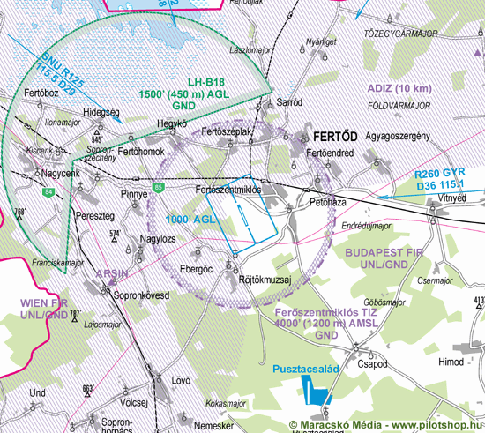

RWY | Dimension | Surface | TORA (m) | LDA (m) | Lights | Pattern
16/34 | 985x23 | asphalt | 985x23 | 985x23 | nil | LH/RH

NAV AID  nil | NVFR  nil | IFR  nil | ILS  nil

LHFM | FERTŐSZENTMIKLÓS, HUNGARY
Apt Elev 440’  N47°35’01’’ E016°50’42’’ | 2009-04-28 | FERTOSZENTMIKLOS
Fertoszentmiklos Airport  118.925 MHz | Budapest Info West  125.500 MHz

Ground Movement Chart
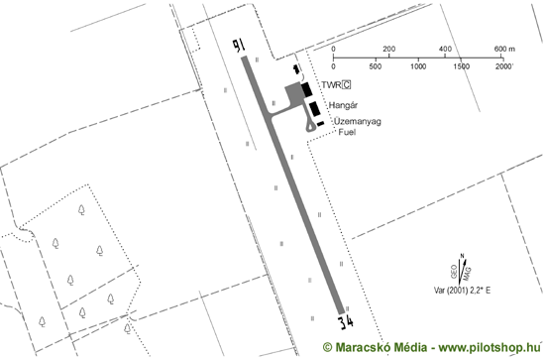

Remarks | 1. Only day VFR flight allowed  2. Flight Plan must be filed  3. TIZ R=5km 4000ft  4. Parachuting PPR  5. For international traffic report has to be made min. 1 hour before entering or departing respectively.  6. Flying out of opening hours: 2200 HUF/h
Warning | 1. THR 34 159°/1240m 158m/518ft high voltage line
Operator | Meidl Airport Kft. | OPS | +36-99-544020
Chief | Tóth Róbert | MET | PNR
Address | Pf. 20 | Weather info | Available
Zip City | H-9444 Fertõszentmiklós | Customs | 0900-1900 (LT) max. till SS, PNR min 1 day before ARR or DEP 1000 HUF /person (incl. crew); boarder opening PNR before 1 hour
Tel | +36-99-544020 | Customs
Fax | +36-99-381690 | Customs
GSM |  | Customs
Email | postmaster@meidlairport.t-online.hu | Fuel | AVGAS 100LL, JET A1, MOGAS98
Internet | www.lhfm.hu | Fuel | AVGAS 100LL, JET A1, MOGAS98
© 2010

