LHNK | NAGYKANIZSA, HUNGARY
Apt Elev 466’  N46°26’30’’ E016°57’05’’ | 2006-07-05 | NAGYKANIZSA
Nagykanizsa Info  135.7 MHz | Budapest Info West  125.500 MHz

Visual Approach Chart

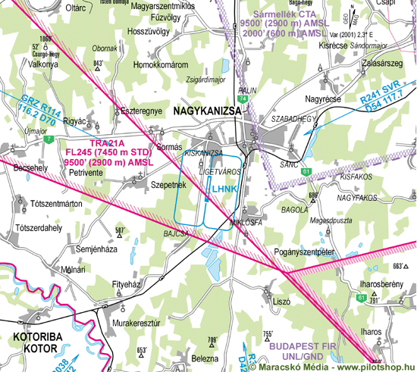

RWY | Dimension | Surface | TORA (m) | LDA (m) | Lights | Pattern
01/19 | 1000x100 | grass | 1000 x 100 | 1000 x 100 | nil | LH / RH

NAV AID  nil | NVFR  nil | IFR  nil | ILS  nil

LHNK | NAGYKANIZSA, HUNGARY
Apt Elev 466’  N46°26’30’’ E016°57’05’’ | 2006-07-05 | NAGYKANIZSA
Nagykanizsa Info  135.7 MHz | Budapest Info West  125.500 MHz

Ground Movement Chart
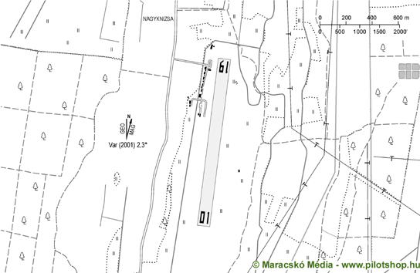

Remarks | 1. Only VFR flight allowed  2. Non public take-off and landing Ground  3. The airfield can only be used with the authorisation of the owner or operator except aircrafts in emergency.
Warning | 1. No countinous radio watch, only PNR  2. trees 400m 010°  3. electric wire 400m 190°
Operator | Magyar Repülõ Szövetség | OPS | +36-30-2683326
Chief | Ferinc Vince | PPR
Address | Pf. 49 | AIS
Zip City | H-8800 Nagykanizsa | MET
Tel |  | Weather info | nil
Fax |  | Customs | nil
GSM | +36-30-2683326, +36-20-7779050 | Customs Tel.
Email | ferinc@t-online.hu | Fuel | nil
Internet | www.nagykanizsa.hu/aeroclub

© 2010

