LHST | SZATYMAZ, HUNGARY
Apt Elev 265’  N46° 19’ 30’’ E20° 03’ 08’’ | 2011-07-31 | ANDRÁSHID
Szatymaz Unicom 123.200 MHz | Budapest Info East  133.000 MHz | Szeget Info  122.800 Mhz

Visual Approach Chart

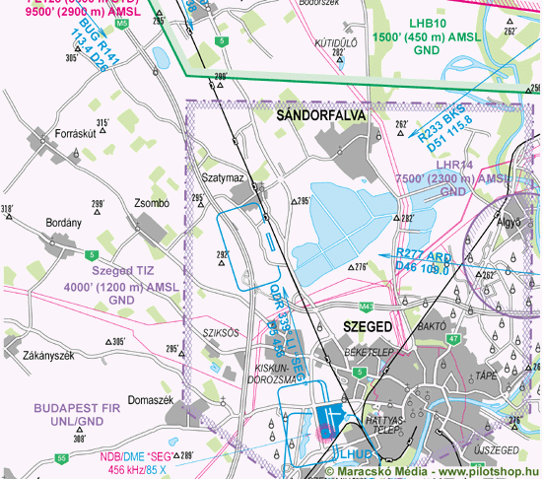

RWY | Dimension | Surface | TORA (m) | LDA (m) | Load | Lights | Pattern
16 | 800x50 | grass | 800 x 50 | 800 x 50 | 2 t | nil | RH
34 | 800x50 | grass | 800 x 50 | 800 x 50 | 2 t | nil | LH

NAV AID  nil | NVFR  nil | IFR  nil | ILS  nil

LHST | SZATYMAZ, HUNGARY
Apt Elev 265’  N46° 19’ 30’’ E20° 03’ 08’’ | 2011-07-31 | ANDRÁSHIDA
Szatymaz Unicom 123.200 MHz | Budapest Info East  133.000 MHz | Szeget Info  122.800 Mhz

Ground Movement Chart
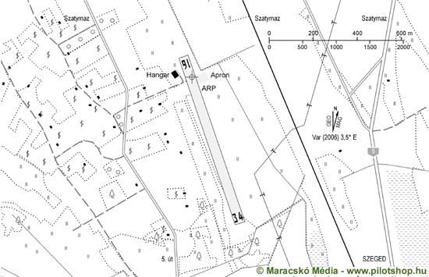

Remarks | 1. RWY lighting PNR
Warning | 1. Environment protection area east from AD, overflying the lake is prohibited below 1200ft.
Operator | SZEMP Air Kft | OPS
Chief | Molnár Gusztáv | PPR
Address | Reptér út 1. Szatymaz | AIS
Zip City | H-6763 | MET
Tel |  | Weather info | internet
Fax |  | Customs | PNR
GSM | +36-70-7014883 | Customs Tel.
Email | info@szempair.hu | Fuel | nil
Internet | www.szempair.hu

© 2019

