LHSY | SZOMBATHELY, HUNGARY
Apt Elev 732’  N47°17’00’’ E016°38’00’’ | 2009-07-16 | SZOMBATHELY
Szombathely Info  119.7 MHz | Budapest Info West  125.500 MHz

Visual Approach Chart

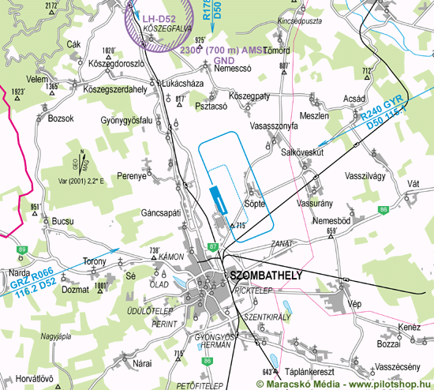

RWY | Dimension | Surface | TORA (m) | LDA (m) | Lights | Pattern
16 | 1150x80 | grass | 1150 x 40 | 1150 x 40 | nil | LH
34 | 1150x80 | grass | 1150 x 40 | 1150 x 40 | nil | RH

NAV AID  nil | NVFR  nil | IFR  nil | ILS  nil

LHSY | SZOMBATHELY, HUNGARY
Apt Elev 732’  N47°17’00’’ E016°38’00’’ | 2009-07-16 | SZOMBATHELY
Szombathely Info  119.7 MHz | Budapest Info West  125.500 MHz

Ground Movement Chart
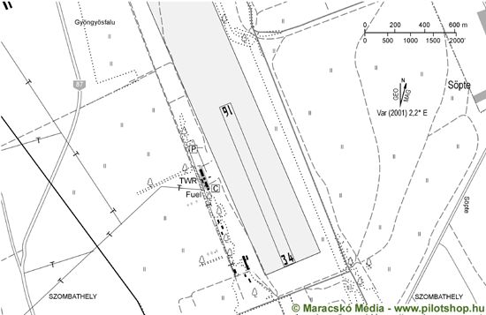

Remarks | 1. Only day VFR flight allowed  2. The airfield can only be used with the authorisation of the owner or operator except aircrafts in emergency.
Warning | 1. 13km/7nm E TSA-11, TSA-12, TSA-15
Operator | Szombathelyi Repülõklub | OPS | +36-30-4360007
Chief | Devecseri Péter | PPR
Address | Pf. 387 | AIS
Zip City | H-9701 Szombathely | MET
Tel | +36-94-329162 | Weather info | nil
Fax | +36-94-508663 | Customs | nil
GSM | +36-30-4360007 | Customs Tel.
Email | devep@freemail.hu | Fuel | nil
Internet | www.szrk.hu

© 2010

