LHUD | SZEGED, HUNGARY
Apt Elev 262’  N46° 15’ 03’’ E20° 05’ 21’’ | 2014-08-21 | ANDRÁSHID
Szeged Info  122.800 MHz | Budapest Info East  133.000 MHz

Visual Approach Chart

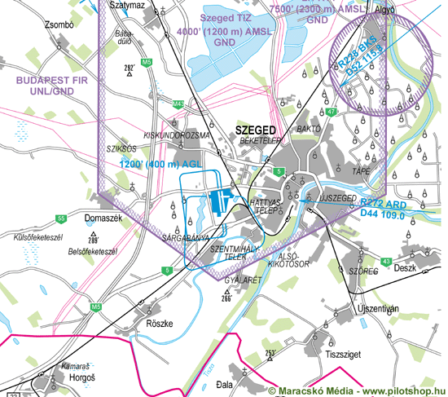

RWY | Dimension | Surface | TORA (m) | LDA (m) | Load | Lights | Pattern
16R | 1185x30 | asphalt | 1185x30 | 1185x30 | 3 t | REL/THR | RH
34L | 1185x30 | asphalt | 1185x30 | 1185x30 | 3 t | APP/THR/REL/PAPI | LH
16L/34R | 1177x50 | grass | 1177x50 | 1177x50 | 3 t | nil | 16 RH, 34 LH
09/27 | 610x50 | grass | 610x50 | 610x50 | --- | --- | 09 RH, 27 LH

NAV AID  nil | NVFR  nil | IFR  nil | ILS  nil

LHUD | SZEGED, HUNGARY
Apt Elev 262’  N46° 15’ 03’’ E20° 05’ 21’’ | 2014-08-21 | ANDRÁSHIDA
Szeget Info  122.800 Mhz | Budapest Info East  133.000 MHz

Ground Movement Chart
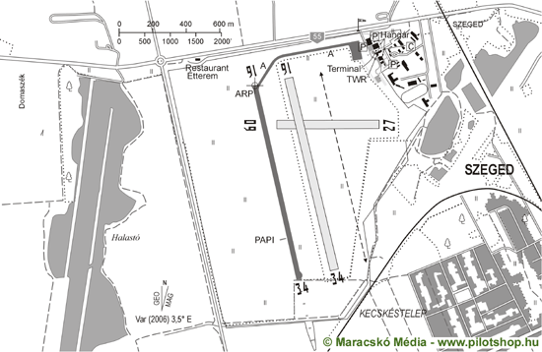

Remarks | 1. Day and night VFR flight allowed.  2. The use of airport beyond duty hours must be reported to AFIS until 1200(LT) the previous day.
Warning | 1. Glider and hang-gliding activity possible at east side of the airport with RH pattern.
Operator | Szegedi Közlekedési Kft. | OPS | +36-309677064 +36-62-553614
Chief | Harcsás Zoltán | PPR | +36-30-4175560
Address | Pf. 78., H-6701, Szeged 1 | AIS | +36-30-9677064
Zip City | Zrínyi u 4-8., H6720, Szeged | MET | OMSZ H24
Tel | +36-62-553614 | Weather info | Available
Fax | +36-62-541825 | Customs
GSM | +36-309677064 | Customs Tel.
Email | info@airportszeged.hu | Fuel | AVGAS 100LL
Internet

© 2019

