LHZA | ZALAEGERSZEG, HUNGARY
Apt Elev 643’  N46° 53’ 03’’ E16° 47’ 21’’ | 2010-06-09 | ANDRÁSHIDA
Zalaegerszeg Airport 133.425 MHz | Budapest Info West  125.500 MHz

Visual Approach Chart

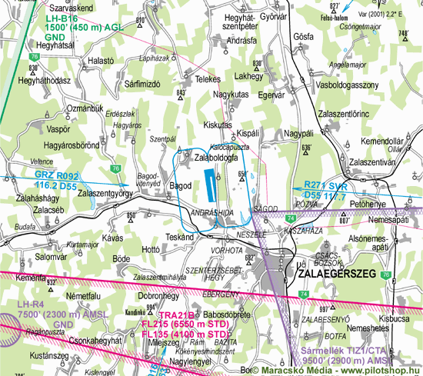

RWY | Dimension | Surface | TORA (m) | LDA (m) | Load | Lights | Pattern
17/35 | 1500x25 | grass | 1500 x 25 | 1500 x 25 |  | nil | LH / RH

NAV AID  nil | NVFR  nil | IFR  nil | ILS  nil

LHZA | ZALAEGERSZEG, HUNGARY
Apt Elev 643’  N46° 53’ 03’’ E16° 47’ 21’’ | 2010-06-09 | ANDRÁSHIDA
Zalaegerszeg Airport 133.425 MHz | Budapest Info West  125.500 MHz

Ground Movement Chart
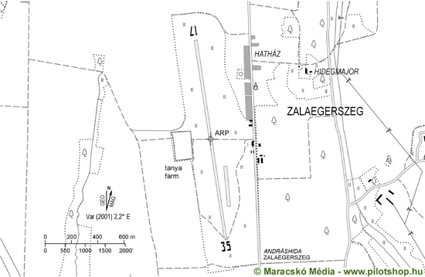

Remarks | 1. Only day VFR flight allowed
Warning | 1. TRA-21A TRA21B
Operator | GRATIS Közlekedési Kft. | OPS | +36-20-9249512
Chief |  | PPR
Address | Hatházi út, Repülõtér | AIS
Zip City | H-8900 Zalaegerszeg | MET
Tel | +36-30-7479634 | Weather info | nil
Fax | +36-92-320303 | Customs | nil
GSM | +36-20-9249512 | Customs Tel.
Email | info@airport-zalaegerszeg.hu | Fuel | nil
Internet | www.airport-zalaegerszeg.hu

© 2010

