 | TOKORCS, HUNGARY
Apt Elev 449’  N47°16’20’’ E017°06’29’’ | 2005-03-11 | TOKORCS
Tokorcs Airport  131.1 MHz | Budapest Info West  125.500 MHz

Visual Approach Chart

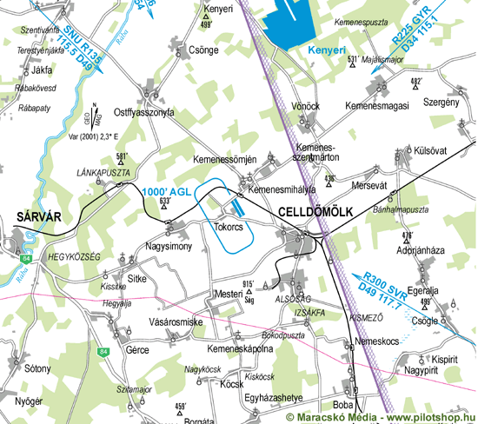

RWY | Dimension | Surface | TORA (m) | LDA (m) | Lights | Pattern
15 | 1000x50 | grass | 1000 x 50 | 1000 x 50 | nil | RH
33 | 1000x50 | grass | 1000 x 50 | 1000 x 50 | nil | LH

NAV AID  nil | NVFR  nil | IFR  nil | ILS  nil

 | TOKORCS, HUNGARY
Apt Elev 449’  N47°16’20’’ E017°06’29’’ | 2005-03-11 | TOKORCS
Tokorcs Airport  131.1 MHz | Budapest Info West  125.500 MHz

Ground Movement Chart
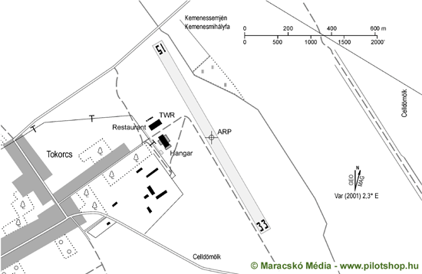

Remarks | 1. Only day VFR flight allowed
Warning | 1. TSA-15 TSA-11
Operator | Aero Ság Kft | OPS | +36-30-9376200
Chief | Fodor Attila | PPR
Address | Kossuth utca 43., Tokorcs | AIS
Zip City | H-9561 | MET
Tel | +36-95-436020 | Weather info | nil
Fax | +36-95-436020 | Customs | nil
GSM | +36-30-9376200 | Customs Tel.
Email | aerosag@cellkabel.hu | Fuel | nil
Internet | aerosag.cellkabel.hu

© 2010

