ARTEMIS
Phase 2 Results: The First Lab Run
What the agents found about earth-abundant solar absorbers, and how well it holds up
Lab session 501042555e83, October 3, 2026 · Repository commit ac74125
Saturday, October 3, 2026
Six AI agents ran the Artemis solar program for about three hours without human help. This document reports what they found, what I checked independently afterwards, and what the result can and cannot claim. Every number comes from the frozen data snapshot, the lab's own records, or analyses I ran and saved in the repository.

1. The answer in brief
The lab found a way to rank earth-abundant crystals (with cadmium, mercury, lead, thallium, arsenic and radioactive elements excluded) so that the expensive efficiency calculation reaches excellent solar absorbers much sooner than the usual rules of thumb. Its method puts near-stable materials first and then orders them by an efficiency predicted from cheap DFT properties and composition, using a forest of randomized decision trees trained on the 7,250 materials JARVIS has already assessed.
On the official held-out test, which the lab was allowed to run once, the method found all four excellent absorbers among 429 candidates after 8 expensive calculations. The textbook rule (stable materials first, then band gap nearest 1.34 eV) needed 20, and random search would need about 344. Because four hits is too few to trust on its own, I repeated the comparison afterwards on 20 larger search pools, using a copy of the final method rebuilt from the lab's report. The rebuilt method needed fewer calculations than the textbook rule in all 20 pools and fewer than the corrected-gap rule in 19, with a median of 14.5 calculations to find ten excellent absorbers, against 26 for the corrected-gap rule, 47.5 for the textbook rule and about 1,161 for random search.
On held-out data the method was about two and a half times faster than the textbook rule. In the later check over twenty overlapping pools it was about three times faster than the textbook rule in the median, and it was faster in every pool.
The search also taught something physical. Stability matters first. The useful band-gap window for these cheap DFT gaps sits near 0.6 to 0.7 eV rather than at the textbook 1.34 eV, because the OptB88vdW method underestimates gaps, and composition carries information that the gap alone does not.

2. What the lab did
The Compiler set up the run, recorded the three reference methods, and then ran seven waves of experiments. In each wave the Planner proposed two or three ideas, Experimenters implemented them in parallel, and the Skeptic re-ran every apparent improvement, read its code for leakage, and tested it again with cross-validation on the training data before the Compiler kept it. Four ideas were kept, each a step up from the last. The lab used 26 of its 60 allowed experiments and stopped by its own rule after three waves brought no kept improvement.
Step kept | Calculations to 9 practice hits | Acceleration on practice set | What changed
Starting rule (gap near 1.34 eV) | 244 | 1.7 | Textbook Shockley-Queisser rule
Stability-gated rule (reference) | 39 | 10.8 | Stable materials first
Corrected-gap rule | 21 | 20.0 | Gap target moved to the DFT scale
Hit classifier | 18 | 23.3 | Learned from training materials
Efficiency regressor | 15 | 28.0 | Predicts SLME instead of yes or no
Final model | 13 | 32.3 | Randomized trees plus element fractions
Practice set: 465 earth-abundant candidates containing 9 excellent absorbers. Numbers from the lab's ledger.
The Skeptic earned its place. It rejected the trial with the highest practice score in the whole run (34.95) because cross-validation on the training data showed the gain was an accident of the small practice set, and it rejected two other trials that matched the best score only by adding complexity. That is the behaviour the program asked for, and it is the main reason the final test result can be trusted at all.

3. Checking the lab's work
I checked the lab's report against the data rather than taking it on trust. Every result the lab recorded carries the same fingerprints as the frozen scoring script and data snapshot in the repository, so nothing was altered during the run. I re-ran the three reference methods on the practice and test sets and obtained exactly the lab's numbers. I confirmed the counts in the report (158 excellent absorbers among the training materials, 9 in the practice pool, 4 in the test pool, 22,784 never-assessed earth-abundant materials), the gap statistics of the training hits, and every value in the recommendation table.
Two statements in the report need small corrections. The straight-line fit between the cheap and the accurate band gap uses 6,110 training materials with non-zero gaps, not 6,029; the fitted coefficients the report gives are exactly right. And the report's count of 19 hits among 152 stable materials with a zero gap actually describes materials with gaps up to 0.05 eV; with a gap of exactly zero the count is 18 of 142. Neither changes any conclusion.
The code of the final model was lost when the session was stopped, because it lived only in the lab's sandbox. I rebuilt it from the report's description and saved it in the repository. The rebuilt model reproduces the lab's practice result exactly, with the ninth hit found at calculation 13 and the same average precision of 0.899, and it reproduces 14 of the lab's 15 recommendations in nearly the same order. That match is strong evidence that the report describes the method completely and that its numbers are honest.

4. Is the speed-up real?
The official test had only four excellent absorbers, so the difference between 8 and 20 calculations rests on where a single material landed. To test the claim properly I pooled every earth-abundant material that JARVIS has assessed, 4,409 in all, and split them at random into two halves twenty times. Each time, one half became the search pool and everything else trained the model, and I counted the calculations each method needed to find ten excellent absorbers.
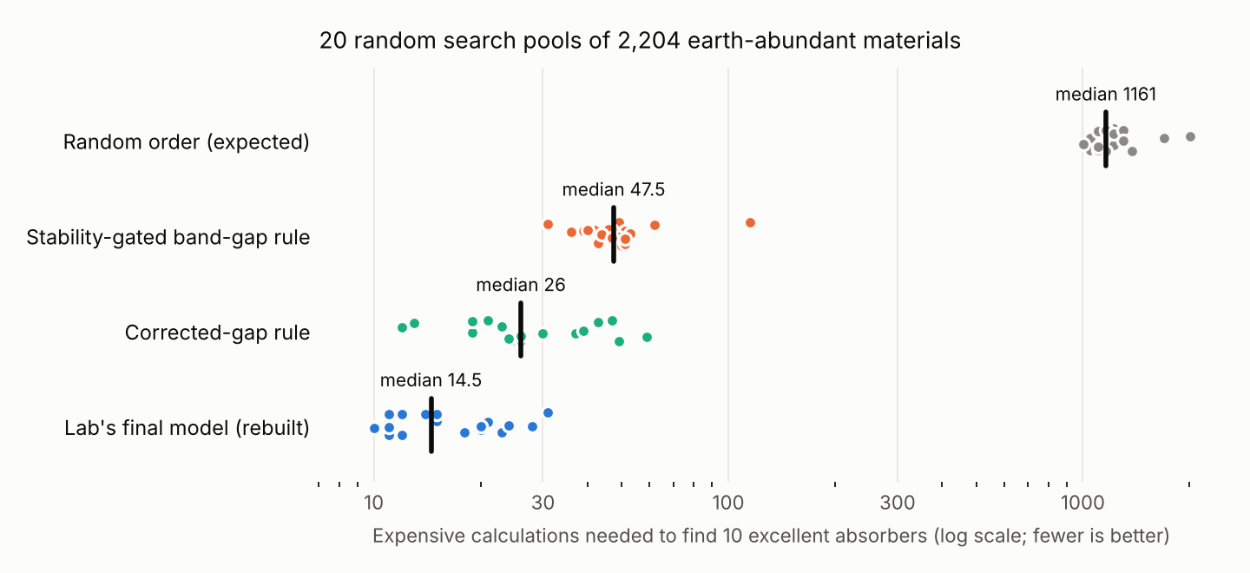
Each dot is one of the 20 search pools; the black bar marks the median. Data: docs/results/phase2_robustness.csv; code: lab/solar/analysis/robustness.py.
Method | Median calculations to 10 hits | Median acceleration vs random | Median average precision
Random order (expected) | 1,161 | 1 | n/a
Stability-gated band-gap rule | 47.5 | 25.3 | 0.239
Corrected-gap rule | 26 | 40.7 | 0.476
Lab's final model (rebuilt) | 14.5 | 89.1 | 0.703

The lab's method beat the stability-gated rule in all 20 pools. The ratio of their calculation counts had a median of 3.35, and in 18 of the 20 pools it was at least 2. The simpler corrected-gap rule the lab discovered also beats the textbook rule clearly, which shows the physical lesson about the gap scale is real and not only a feature of the learned model.
Two cautions keep this honest. This check was designed and run after the official test, so it is supporting evidence rather than a pre-registered result. And the lab chose its method partly by looking at the practice set, whose materials are now spread through these pools, which could flatter the model slightly; the consistency across all twenty pools, and the Skeptic's earlier cross-validation on training data alone, make a large effect from this unlikely. Acceleration against random search also grows with the size of the pool, so the 43 on the small test pool and the 89 here are not in conflict; the comparison with the textbook rule is the stable number.

5. What the search taught
Stability does the first and largest share of the work. Putting near-stable materials first raised the textbook rule's acceleration from about 1.7 to about 11 on the practice set, simply because an excellent absorber must also be stable.
The second lesson concerns the band-gap scale. Every excellent absorber in the training data with a known accurate (TBmBJ) gap lies between 0.92 and 1.66 eV, with a median of 1.35 eV, close to the ideal Shockley-Queisser value. Their cheap OptB88vdW gaps, however, have a median of only 0.66 eV, because that method systematically underestimates gaps. Among stable training materials, about half of those with cheap gaps between 0.3 and 0.8 eV are excellent absorbers, compared with 13 percent between 1.2 and 1.4 eV and 1 percent above 1.8 eV. Aiming the cheap gap at the textbook 1.34 eV therefore looks in the wrong place.
The third lesson is that composition matters beyond the gap. The window shifts with the anion: according to the lab's analysis, the median cheap gap of excellent absorbers is about 1.0 eV for halides and about 0.26 eV for chalcogenides. In the training data the excellent absorbers cluster in alkali halides and fluorides and in compounds of antimony, indium, silver, copper and zinc, and the learned model, which sees the elements directly, roughly doubles what any gap rule achieves. Predicting the efficiency itself worked better than predicting a yes or no label, probably because materials just below the 30 percent line still show which direction is better.

6. What to compute next
These are the lab's top recommendations among the 22,784 earth-abundant materials that JARVIS has never assessed for solar efficiency. Each is a prediction that needs the expensive calculation; none is yet a discovery. The values are JARVIS's cheap DFT results.
Rank | Material | JARVIS ID | Cheap gap (eV) | Above hull (eV/atom) | Note
1 | Rb2NiF6 | JVASP-90503 | 1.606 | 0.000 | On the hull; ranked by composition, as its gap is above the usual window
2 | SrBeBr2 | JVASP-120881 | 1.039 | 0.064 | No literature found
3 | SmS | JVASP-78443 | 0.000 | 0.058 | Metallic at this level; likely false positive
4 | CuCl (F-43m) | JVASP-111073 | 0.586 | 0.000 | Known experimentally as wide-gap; see below
5 | DyS | JVASP-14566 | 0.000 | 0.032 | Metallic at this level; likely false positive
6 | BaZnCl2 | JVASP-114550 | 1.107 | 0.020 | No literature found
7 | CuCl (Pa-3) | JVASP-12510 | 0.590 | 0.011 | As rank 4
8 | Na10CaSn12 | JVASP-59094 | 0.775 | 0.000 | No literature found
9 | Na10SrSn12 | JVASP-59095 | 0.776 | 0.000 | Not searched
10 | SrCaGe | JVASP-10972 | 0.471 | 0.000 | Only unrelated literature
11 | Sr2Ge | JVASP-9128 | 0.388 | 0.000 | Not searched
12 | CuBr | JVASP-12504 | 0.317 | 0.013 | Has gap and band-structure literature
13 | Cu2BrCl | JVASP-100007 | 0.423 | 0.000 | No literature found
14 | BaZnF2 | JVASP-115581 | 1.347 | 0.000 | No literature found
15 | LaS | JVASP-98069 | 0.000 | 0.082 | Metallic at this level; likely false positive
The lab's shortlist, values checked against the snapshot. The rebuilt model gives the same list except that BaGeBr (JVASP-66027) replaces LaS at rank 15.
Twelve of the fifteen are near-stable with a non-zero cheap gap, and they are the natural first calculations. SmS, DyS and LaS have a cheap gap of exactly zero; about one in eight similar training materials is nonetheless an excellent absorber, so they are not impossible, but they belong at the end of the queue. CuCl deserves particular care: experiments describe its common form as a wide-gap material, which would make it a poor absorber despite its rank, and its accurate gap calculation will settle the question quickly. The Materials Project cross-check did not run, because no Materials Project key had been added; with the key, the Scout can report whether each candidate is known experimentally and how stable the Materials Project finds it.

7. What went wrong, and what is fixed
Four things went wrong, none of them in the science. The report-saving step read only the first page of the session's history, and the stop command then deleted the session; the report was recovered from the copy streamed to your computer, and both commands are fixed so that stop refuses to delete anything that has not been saved. The final model's code was lost with the sandbox; it is rebuilt and verified, and future runs will include the code and the shortlist in the lead's final message. The never-assessed pool contained four materials listed twice with identical values; the scoring script now keeps one copy, which changes its fingerprint but not any practice or test score. And the Materials Project check was unavailable for lack of a key.
One design lesson goes into the next version of the program. With only nine practice hits, the rule that a gain below 0.3 in acceleration is noise was far too loose, since a single place in the ranking moves the score by two or three points. The Skeptic's habit of confirming every gain with cross-validation on training data is what protected this run, and the next program will make that the rule rather than the habit.

8. Next steps
The most valuable next step costs almost nothing: add the Materials Project key with python scripts/make_secrets.py materials-project, so the next run can cross-check its recommendations against an independent database. Beyond that, I suggest tightening the keep rule as described above and then moving to Phase 3, the public website, where a visitor can watch a run like this one unfold live and read a report like this at the end.

Sources
JARVIS-Leaderboard, Choudhary et al., npj Computational Materials 10, 93 (2024). https://doi.org/10.1038/s41524-024-01259-w
JARVIS, Choudhary et al., npj Computational Materials 6, 173 (2020). https://doi.org/10.1038/s41524-020-00440-1
JARVIS-DFT 3D release 2021-08-18 (figshare). https://doi.org/10.6084/m9.figshare.6815699
SLME in JARVIS, Choudhary et al., Chem. Mater. 31, 5900 (2019). https://doi.org/10.1021/acs.chemmater.9b02166
Crustal abundances, CRC Handbook 97th edition values. https://en.wikipedia.org/wiki/Abundance_of_elements_in_Earth%27s_crust
Pauling electronegativities used in the rebuilt model, pymatgen periodic table data. https://github.com/materialsproject/pymatgen
Wide-gap γ-CuCl, J. Cryst. Growth (2005). https://doi.org/10.1016/j.jcrysgro.2005.10.053
Lab report, transcript, rebuilt model and robustness data. https://github.com/alessoh/artemis/tree/main/docs/results

