DESIGN YOUR OWN
Nuclear Reactor
Design
A College-Level Manual and Program Guide
H. PETER ALESSO
AI HIVE PUBLICATIONS
Pleasanton, California

Nuclear Reactor Design
A College-Level Manual and Program Guide
H. Peter Alesso © 2026
hpeteralesso.com
AI HIVE Publications, Pleasanton, CA 94566
Edition 2.00
The program described in this manual performs a preliminary conceptual design using approximate methods. Its results are estimates intended for teaching. They are not suitable for engineering design, licensing, or safety analysis.

Contents
Preface 5
1. Introduction and Background 8
1.1 The origin of reactor engineering 8
1.2 Why design is a parametric problem 8
1.3 What the program computes, and what it does not 9
2. Fission and the Neutron Life Cycle 10
2.1 The fission event 10
2.2 Prompt and delayed neutrons 10
2.3 The neutron life cycle 10
2.4 Reactivity 11
3. Moderation, Diffusion, and the Fermi Age 13
3.1 Why slow neutrons 13
3.2 The Fermi age 13
3.3 The diffusion length 13
3.4 The moderator-to-fuel ratio 13
4. Geometry, Buckling, and Critical Size 15
4.1 The one-group criticality condition 15
4.2 Buckling and the three core shapes 15
4.3 Why the sphere is optimal 15
4.4 Critical mass and core size 16
5. Heat Removal and the Unit Cell 19
5.1 Porosity and the coolant channels 19
5.2 Power, power density, and heat flux 19
5.3 Fuel centreline temperature 20
5.4 Thermal limits and the hot channel 20
5.5 Pressure drop and pumping power 21
6. Power Conversion 22
6.1 Two ways to make electricity 22
6.2 The secondary circuit and cycle efficiency 22
7. Control, Protection, and Shielding 24
7.1 The purpose of the control system 24
7.2 Automatic protection 24
7.3 Shielding and radiological hazard 24
8. Getting Started 27
8.1 Opening the program 27
8.2 The workspace 27
8.3 The DESIGN PHASE, step by step 28
8.4 Defining your own materials 28
8.5 The OUTPUT PHASE 28
8.6 Saving, loading, and printing 29
9. Worked Example 1: A Pressurised Water Reactor 31
9.1 Run the default and read the warning signs 31
9.2 Enlarge the core 32
9.3 Uprate the design 33
10. Worked Example 2: A Heavy-Water Reactor 34
11. Worked Example 3: A High-Temperature Gas Reactor 35
12. Worked Example 4: An Open-Loop Propulsion Reactor 37
13. Parametric Studies 39
13.1 Varying the moderator 39
13.2 Varying the fuel 39
13.3 Varying the geometry 40
13.4 Suggested exercises 40
14. When Criticality Fails 41
Glossary 42
References 45
Reactor physics and design 45
Thermal-hydraulics and heat transfer 45
Nuclear data 45
The program 45
Appendix A: Data Tables 46
Table I. Reactor fuels 46
Table II. Reactor moderators 46
Table III. Reactor coolants 46
Table IV. Default values 47
Table V. Secondary loop state points 47
Appendix B: Assumptions and Limitations 49
Appendix C: Reference Plants 50
Appendix D: Equation Summary 51
Appendix E: Worked Example Results 52
Appendix F: Online Resources 53

Preface
The design of a thermal nuclear reactor, together with the power conversion system that turns its heat into electricity, is a complex integration of physics and engineering. It draws on neutron physics, thermal-hydraulics, stability and control, materials science, structural analysis, and radiation shielding. No single calculation settles a reactor concept. Instead, the concept emerges from parametric studies that vary the fundamental choices — fuel, moderator, coolant, geometry, and conversion cycle — and weigh the consequences of each against the design objectives.
This manual accompanies DESIGN YOUR OWN NUCLEAR REACTOR, a program first written in 1993 for Windows 3.1 and now rebuilt to run in any web browser. The program is menu-driven. You select materials and a core shape, you enter a handful of operating parameters, and it computes the critical mass of fuel along with the power, power density, heat flux, coolant velocity, fuel temperature, neutron flux, and cycle efficiency that follow from your choices. Results appear both as summary tables and as a live plant diagram. You can accumulate cases and compare them side by side.
The calculation is a preliminary conceptual one. It uses the thermal group approximation, the homogeneous reactor approximation, and the Fermi age approximation. It assumes no reflector. The numbers it returns are rough estimates, and they are not as accurate as a Monte Carlo simulation of a heterogeneous core. That limitation is the point. Because each case runs instantly, you can sweep a variable across its whole range and watch what happens, which is how engineering intuition is actually built. A student who runs fifty cases in an afternoon learns more about the shape of the design space than one who runs a single high-fidelity calculation.
The manual is organised in three parts. Part I develops the neutron physics that governs criticality. Part II covers the engineering of heat removal and power conversion. Part III is a practical guide to running the program, with four fully worked examples and a chapter on parametric studies. A glossary, a reference list, and six appendices of data close the volume.
The program is free to use and requires no installation. Open a browser and go to:
https://reactor-seven.vercel.app/

PART I
The Physics of Thermal Reactors

1. Introduction and Background

1.1 The origin of reactor engineering
The development of nuclear reactors began with the atomic programme of the Second World War, the Manhattan Project. Those first reactors were built to produce plutonium for weapons. Commercial development afterwards grew out of the same partnership: the United States, the United Kingdom, France, and Canada.
Canada was the first nation to emphasise the civil side. It had hosted major experimental facilities, including the first reactor outside the United States. After the war the British recalled their scientists from Canada to start their own programme, leaving Canada with heavy water production plant and large natural uranium reserves. Canada's NRX research reactor, which went into service in 1947, became the ancestor of the CANDU heavy-water design. The French started their own programme and reached criticality in 1948; by 1956 they had a plutonium-producing reactor that was air-cooled and graphite-moderated. The United Kingdom began with the gas-cooled MAGNOX type, chosen in part because Britain then lacked uranium enrichment capacity.
The United States, with abundant coal, oil, and natural gas, felt no urgency about commercial nuclear power and explored many reactor types instead. What eventually forced convergence was the navy: the demand for a compact, reliable reactor for submarines drove the rapid development of the pressurised water reactor. The PWR, and later the boiling water reactor, became the basis of the American commercial industry. Six basic commercial types are in service today: the PWR, the BWR, the CANDU, the gas-cooled MAGNOX, the advanced gas-cooled reactor, and the high-temperature gas reactor.
Alongside these are the production reactors, a wide variety of research and test reactors, and space and propulsion reactors: fast reactors, aqueous fuel reactors, molten-salt reactors, and breeders. The variety is not accidental. Each design is the answer to a different question. A reactor optimised to produce electricity cheaply on a large site looks nothing like one optimised for minimum mass in a spacecraft.

1.2 Why design is a parametric problem
Four choices dominate a thermal reactor concept, and each one pulls on the others.
- The fuel sets the probability that a neutron absorbed in the fuel produces a fission, and how many neutrons that fission releases.
- The moderator sets the probability that a fast neutron slows to thermal energy without being captured or leaking out.
- The geometry and dimensions set the rate at which neutrons are lost through the surface.
- The coolant absorbs some neutrons, and it determines how fast heat can be carried out of the core and at what temperature — which in turn fixes the efficiency of the conversion cycle.
No choice can be made in isolation. Enlarging the core reduces leakage and helps criticality, but it also increases the mass of fuel you must buy and reduces the power density, which may be exactly what you did not want. Choosing graphite as a moderator buys you a very low absorption cross section, but graphite's long Fermi age means neutrons travel far while slowing down, so the core must be large. Raising the coolant outlet temperature raises the cycle efficiency, but it also raises the fuel centreline temperature towards the melting point. Every gain is paid for somewhere.
This is what the program is for. It makes the cost of asking "what if" close to zero, so you can map the trade surface rather than guess at it.

1.3 What the program computes, and what it does not
Given a fuel, a moderator, a coolant, a core shape and size, and five operating parameters, the program solves for the moderator-to-fuel atom ratio that makes the reactor exactly critical. From that ratio it derives the critical mass of fuel. It then computes the thermal power from the coolant energy balance, and from the power it derives power density, heat flux, fuel centreline temperature, specific power, thermal neutron flux, annual burnup, coolant velocity, Reynolds number, pressure drop, pumping power, secondary flowrate, turbine output, and cycle efficiency.
It does not model burnup over time, fission product poisoning, control rod worth, transients, shielding thickness, structural stress, or cost. It assumes the core is homogeneous — fuel and moderator perfectly mixed rather than arranged in pins and lattices — and it assumes no reflector surrounds the core. A real design would use a reflector, which reduces critical mass substantially. Every result should therefore be read as an order-of-magnitude guide with the right sensitivities, not as a number to build from.
A note on the reconstruction
The original 1993 program contained several leftover debugging statements that pinned primary pressure, pump power, and turbine output to fixed constants, and a misplaced conditional that corrupted coolant velocity for every coolant except helium. These have been corrected in the browser version so that the values respond to your design. Everything else — every cross section, every material property table, every correlation — is carried over unchanged from the original source.

2. Fission and the Neutron Life Cycle

2.1 The fission event
Nuclear fission is the splitting of a heavy nucleus into two fission fragments, accompanied by one to three free neutrons, several gamma rays, and about 200 million electron-volts of energy. Fission occurs with high probability in the fissile nuclides: uranium-233, uranium-235, plutonium-239, and plutonium-241. Of these only U-235 occurs in nature, at about 0.72 per cent of natural uranium. The others are produced artificially by neutron capture followed by radioactive decay.
Only three nuclides are simultaneously stable enough to store, available in practice, and capable of fissioning across the whole neutron energy range from thermal, at 0.025 electron-volts or less, up to millions of electron-volts: U-233, U-235, and Pu-239. The program offers three more — Pu-241, Am-242, and Cm-245 — not because you could build with them, but because including them sharpens the comparison. Americium-242 has a thermal fission cross section of 6000 barns against uranium-235's 582, and seeing what that does to the critical mass teaches something that no amount of reading will.
The energy released per fission is distributed among the kinetic energy of the fragments, which is deposited locally in the fuel and is the source of essentially all the useful heat; the kinetic energy of the neutrons; prompt gamma rays; and the delayed beta and gamma emissions of the fission products. It is the last of these that produces decay heat after shutdown, and that makes a reactor a system you cannot simply switch off.

2.2 Prompt and delayed neutrons
Most neutrons appear essentially instantly, about 10⁻⁴ seconds after the fission. These are prompt neutrons. A small fraction — 0.65 per cent for U-235 — are emitted between 0.2 and 55 seconds after the fission, as certain fission products beta-decay into excited states that promptly shed a neutron. These are the delayed neutrons, and the entire practice of reactor control rests on them.
The reason is arithmetic. If all neutrons were prompt, the mean generation time would be about 10⁻⁴ seconds, and a reactivity insertion of 0.003 would multiply the power by a factor of roughly 8000 in a third of a second. No operator and no mechanical control system could respond to that. The delayed fraction stretches the effective mean generation time by three orders of magnitude, into the range of seconds, which brings reactor power into the domain of human and machine control. A reactor that is critical on prompt neutrons alone — prompt critical — is out of control by definition.

2.3 The neutron life cycle
Follow one generation of neutrons around the cycle. Fast neutrons born in fission may cause further fast fissions, which multiplies their number slightly; this is the fast fission factor ε. Some fast neutrons leak out of the core and are lost, a loss described by the fast non-leakage probability. The survivors slow down through elastic collisions with moderator nuclei; some are captured in the resonance region on the way down, and the fraction that escapes this is the resonance escape probability p. Of the neutrons that reach thermal energy, some are absorbed in the moderator, coolant, or structure rather than in the fuel; the fraction absorbed in fuel is the thermal utilisation f. More thermal neutrons leak out, described by the thermal non-leakage probability. Finally, each thermal neutron absorbed in fuel produces η new fast neutrons on average, and the cycle repeats.
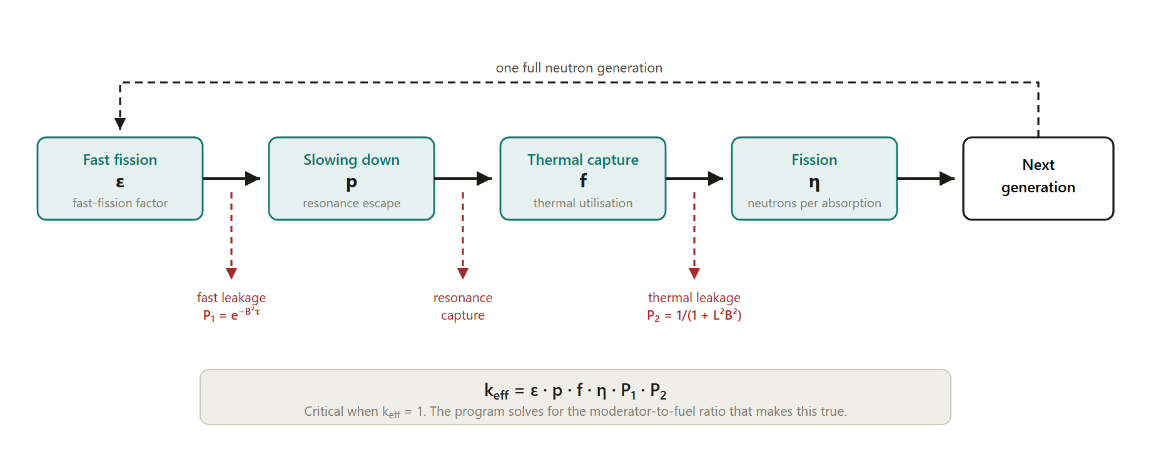
Figure 1. The neutron life cycle. The effective multiplication factor is the product of the four factors and the two non-leakage probabilities. The program solves for the composition that makes this product equal to one.
The effective multiplication factor is the product of all six terms. When it equals one, the neutron population is steady and the reactor is CRITICAL. When it exceeds one, the population grows and the reactor is SUPERCRITICAL. When it falls below one, the population declines and the reactor is SUBCRITICAL. These are statements about the rate of change of the neutron population, not about power level: a reactor can be critical at one watt or at three thousand megawatts.
The two leakage terms are where geometry enters. Both depend on the geometric buckling B², a purely dimensional quantity that measures how sharply the neutron flux must curve to fall to zero at the core boundary. A small core has a large buckling and leaks heavily. A large core has a small buckling and leaks little. This is the single most important structural fact in the whole calculation, and Chapter 4 develops it.

2.4 Reactivity
Reactivity measures how far a reactor is from critical. It is defined as ρ = 1 − 1/k_eff, so that a critical reactor has zero reactivity. Reactivity is inserted into or removed from a core by five mechanisms, and their sum is the net reactivity at any moment.
- Coolant temperature. A change in the average coolant temperature changes the moderator density, which changes the rate at which neutrons slow down and therefore the neutron population. Temperature also changes Doppler broadening, the widening of the resonance absorption peaks in the fuel as thermal motion increases. The combination is the temperature coefficient. Every power reactor is required to have a negative temperature coefficient, so that a rise in temperature inserts negative reactivity and the reactor is self-regulating.
- Pressure. Higher pressure raises moderator density and therefore reactivity. The effect is small in a liquid-cooled reactor and is usually neglected.
- Control rod position. Rods are strong neutron absorbers. Moving them into the flux inserts negative reactivity; withdrawing them inserts positive reactivity. Differential rod worth is the reactivity change per unit of rod travel, and it varies along the rod because the flux varies along the core.
- Fuel depletion and burnable poison depletion. Fuel is consumed as the core runs, which removes reactivity. Burnable poisons are deliberately placed absorbers that burn out on a matched schedule, holding the net change small and extending core life.
- Fission product poisoning. Some fission products, xenon-135 above all, are extremely strong thermal absorbers. Xenon builds up after a power reduction and then decays, producing the characteristic dead time after a shutdown during which the reactor cannot be restarted.
At every point in core life the design must be able to go critical, to shut down, and to be controlled across the full range of possible conditions, with a defined margin. That requirement is what sets the initial fuel enrichment: the cold, clean core must carry enough excess reactivity to cover heating to operating temperature, the Doppler effect, burnup over the whole cycle, fission product poisoning, control rod absorption, and burnable poison loading.

3. Moderation, Diffusion, and the Fermi Age

3.1 Why slow neutrons
A thermal neutron is far more likely to cause fission in U-235 than a fast one — the thermal fission cross section is 582 barns against a fraction of a barn at fission energies. To minimise the critical mass, you therefore want most fissions to be caused by thermal neutrons. That means distributing the fuel inside a moderating material whose job is to slow the fast neutrons down through elastic scattering, without absorbing them along the way.
A good moderator has three properties: a low mass number, so each collision removes a large fraction of the neutron's energy; a high scattering cross section, so collisions are frequent; and a low absorption cross section, so few neutrons are lost in the process. Ordinary water, heavy water, beryllium, and carbon are the classical choices, and all five moderators offered by the program are drawn from that set.
Ordinary water is the best slowing-down agent by a wide margin — hydrogen has almost the same mass as a neutron, so a single head-on collision can stop it dead — but hydrogen also absorbs neutrons, with a cross section of 0.66 barns per water molecule. Heavy water absorbs 330 times less, at 0.002 barns, but slows neutrons less efficiently. That single trade-off explains why light-water reactors need enriched uranium and heavy-water reactors like CANDU can run on natural uranium.

3.2 The Fermi age
The Fermi age τ is not a time. It is an area, measured in cm², and it equals one sixth of the mean square distance a neutron travels in a straight line from its birth as a fast neutron to the moment it reaches thermal energy. It is the natural measure of how far neutrons wander while slowing down.
Fermi age matters because it controls fast leakage. In the age approximation, the probability that a fast neutron survives slowing down without escaping the core is exp(−B²τ). A moderator with a small age keeps the slowing-down process compact, so even a small core can hold onto its fast neutrons. Water's age is 31.4 cm²; graphite's is 350 cm², more than eleven times larger. That is why a graphite-moderated reactor must be physically large: the neutrons simply travel too far while slowing down for a small core to contain them.

3.3 The diffusion length
Once a neutron reaches thermal energy it wanders as a thermal neutron until it is absorbed. The diffusion length squared, L², measures that wandering the same way the age measures the slowing-down phase. In the one-group treatment, the thermal non-leakage probability is 1/(1 + L²B²).
L² varies enormously across moderators — from 7.6 cm² for water to 10,000 cm² for heavy water — and the reason is absorption. A thermal neutron in heavy water is almost never absorbed, so it diffuses a very long way before it finds something to react with. That is excellent for neutron economy and poor for compactness. Table II in Appendix A lists both τ and L² for all five moderators, and comparing the two columns is the fastest way to understand why the five behave so differently.

3.4 The moderator-to-fuel ratio
The relative amounts of moderator and fuel are expressed as the moderator-to-fuel ratio, the number of moderator atoms per fuel atom. This is the quantity the program actually solves for. Everything else about criticality follows from it.
The ratio has an optimum, and the reason is a competition. Too little moderator, and neutrons are not slowed enough; they are lost to resonance capture and to fast leakage before they can cause thermal fission. This is an under-moderated core. Too much moderator, and the moderator itself starts absorbing a significant share of the thermal neutrons, while the fuel becomes so dilute that thermal utilisation collapses. This is an over-moderated core. Power reactors are deliberately built under-moderated, because in that condition a rise in temperature — which expels moderator and reduces the ratio — reduces reactivity, giving the negative temperature coefficient that safety requires.
When the program reports a moderator-to-fuel ratio of 883 for the default case, it is telling you that criticality requires 883 water molecules for every uranium-235 atom. When it reports a negative ratio, it is telling you that no ratio exists that will work: leakage and parasitic absorption exceed what the fuel can supply, and the geometry must change.

4. Geometry, Buckling, and Critical Size

4.1 The one-group criticality condition
Combining the age treatment of slowing down with one-group diffusion theory for thermal neutrons gives a criticality condition that can be written, for a bare homogeneous reactor, as
η · exp(−B²τ) / (1 + L²B²) = 1
where η is the number of fission neutrons produced per thermal neutron absorbed in fuel, τ is the Fermi age of the moderator, L² is the thermal diffusion length squared, and B² is the geometric buckling. The numerator is production discounted by fast leakage; the denominator is the thermal leakage penalty. The program rearranges this expression to solve for the moderator-to-fuel ratio, treating the absorption in fuel, moderator, and coolant explicitly. It holds η at 2.06, the U-235 value, for every fuel — one of the approximations you should keep in mind when comparing fuels.

4.2 Buckling and the three core shapes
Geometric buckling is a property of the shape and size alone. It is the eigenvalue of the flux shape that vanishes at the extrapolated boundary, and it has units of cm⁻². Physically it is a measure of curvature: the more sharply the flux must bend to reach zero at the surface, the larger the buckling, and the more neutrons escape.
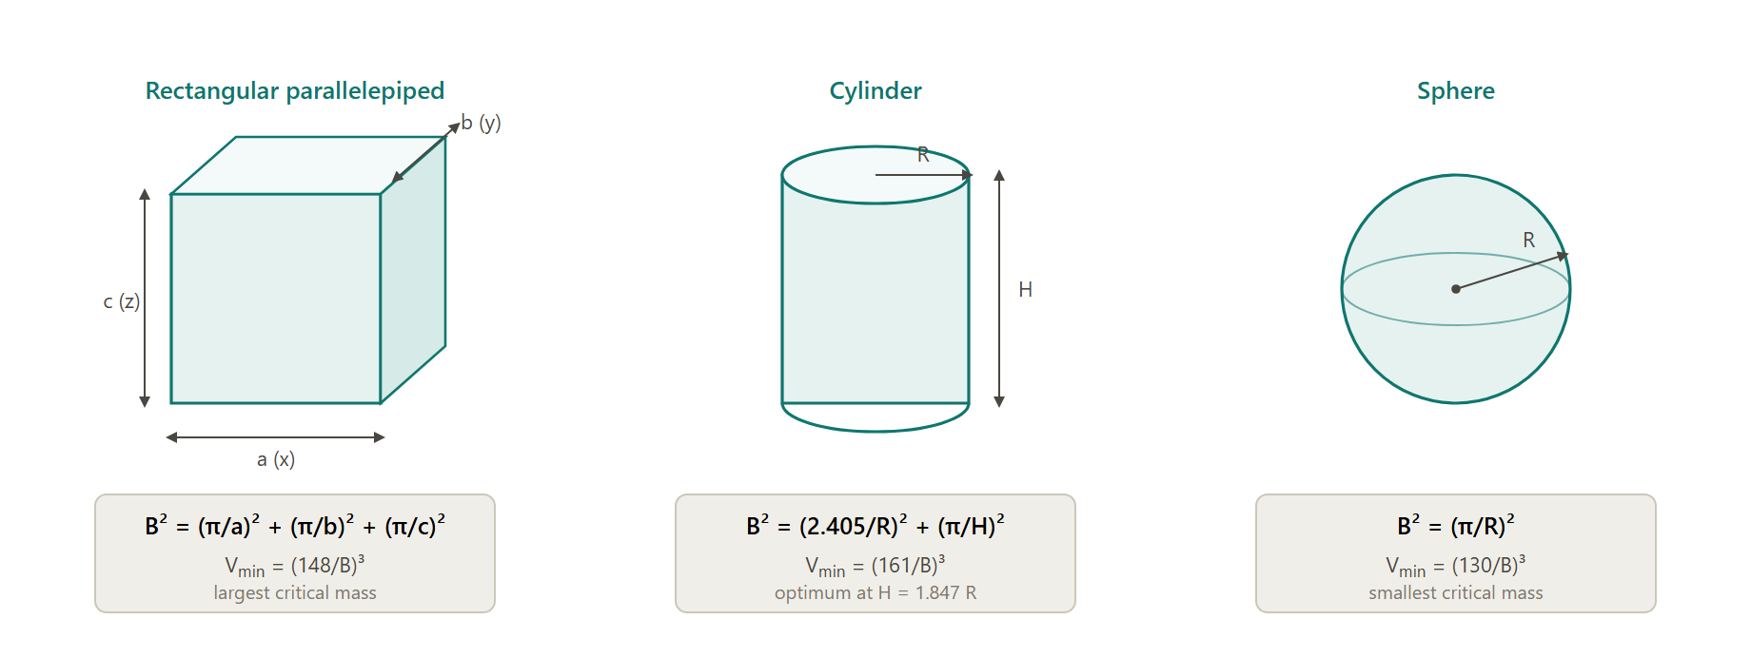
Figure 2. Geometric buckling for the three core shapes offered by the program, with the corresponding minimum critical volumes. Dimensions are entered in centimetres.
For a rectangular parallelepiped with edges a, b, and c, the buckling is the sum of three squared terms, (π/a)² + (π/b)² + (π/c)². For a cylinder of radius R and height H it is (2.405/R)² + (π/H)², where 2.405 is the first zero of the Bessel function J₀ that describes the radial flux shape. For a sphere of radius R it is simply (π/R)².
Because buckling is a sum of inverse-square dimensions, doubling every dimension divides the buckling by four. Small cores leak catastrophically; large cores barely leak at all. The consequence is visible in every result the program produces.

4.3 Why the sphere is optimal
For a given material composition, the critical volume — and therefore the critical mass — is smallest for a sphere. The reason is geometric rather than nuclear. Neutron production happens throughout the volume, but neutron leakage happens only at the surface. The sphere has the smallest surface-to-volume ratio of any shape, so it loses the least.
The classical minimum critical volumes reflect this ordering directly: (130/B)³ for a sphere, (161/B)³ for a cylinder at its optimum proportion of H = 1.847R, and (148/B)³ for a cube. You can verify the ordering in the program. Setting three cores of equal 8 m³ volume in the three shapes, with U-235 in light water, gives the following.

Shape | Dimensions (cm) | B² (cm⁻²) | Nm/Nf | Critical mass (kg)
Cube | 200 × 200 × 200 | 7.402 × 10⁻⁴ | 1036.0 | 100.81
Cylinder, H = 1.847R | R 111.3, H 205.6 | 7.005 × 10⁻⁴ | 1038.9 | 100.53
Sphere | R 124.1 | 6.411 × 10⁻⁴ | 1043.2 | 100.12
Table 1. Three cores of equal volume. The sphere has the lowest buckling and the lowest critical mass, as theory requires. The differences are small at this size because leakage is already low.
The differences are under one per cent here, because an 8 m³ core is large enough that leakage is a minor term. Repeat the comparison at 0.1 m³ and the sphere's advantage becomes dramatic. That is itself a useful lesson: geometry matters most when you are close to the margin.

4.4 Critical mass and core size
The relationship between core size and critical mass is not monotonic, and this surprises most students. Figure 3 plots it for U-235 in light water across the full range the program accepts.
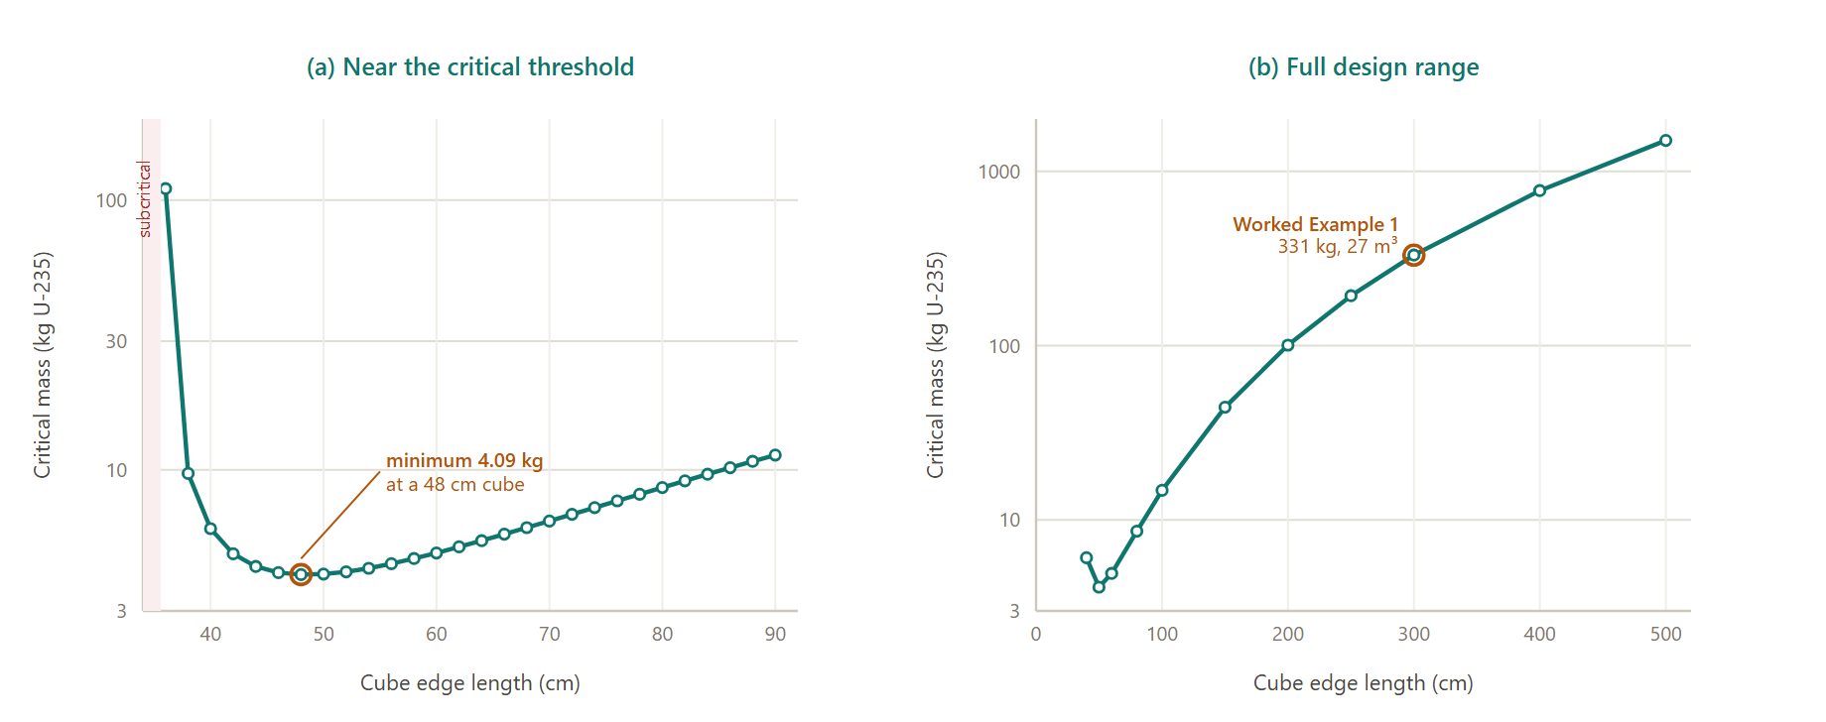
Figure 3. Critical mass against cube edge length for U-235 in light water. Panel (a) resolves the region near the critical threshold; panel (b) shows the full design range. Note the logarithmic vertical scale.
Three regions appear. Below about a 35 cm cube, no moderator-to-fuel ratio achieves criticality at all: leakage dominates completely, and the program refuses the design. Just above that threshold the critical mass falls steeply, from 110 kg at 36 cm to 9.7 kg at 38 cm, as the leakage penalty relaxes. The curve reaches a minimum of 4.09 kg at a cube of about 48 cm edge, roughly 0.11 m³. Beyond that, critical mass rises steadily with volume, reaching 331 kg at 300 cm and 1509 kg at 500 cm.
The minimum exists because two effects run against each other. As the core grows, the required fuel concentration falls — leakage is less punishing, so a more dilute mixture will do. But the volume grows as the cube of the dimension. Below the minimum the concentration term wins; above it the volume term wins. Real power reactors sit far to the right of the minimum, because they are sized for power output and heat removal, not for minimum fuel inventory.

PART II
The Engineering of Heat Removal

5. Heat Removal and the Unit Cell

5.1 Porosity and the coolant channels
Fission deposits its energy almost entirely as kinetic energy of the fission fragments, within a micron or so of where the fission occurred. That heat has to cross from the fuel into the coolant, and the geometry of that crossing sets the limits on the whole design.
The program treats the core as a homogeneous mixture of fuel and moderator, perforated by a regular array of identical coolant channels. A single parameter, the porosity ε, describes the split: it is the fraction of the core volume occupied by coolant. Everything else follows from it and from the tube diameter d.
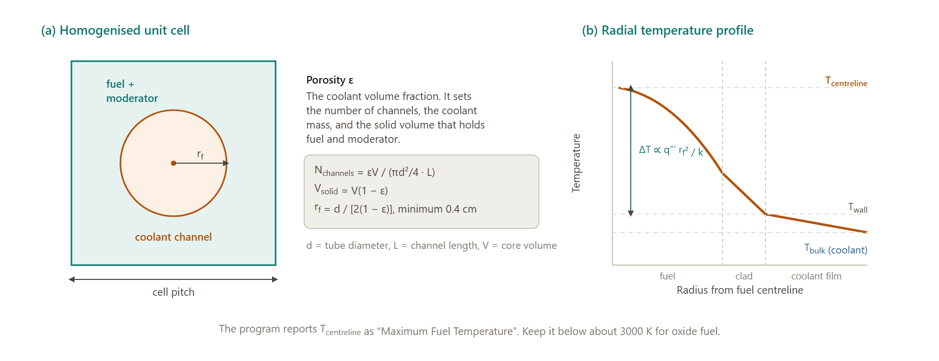
Figure 4. The homogenised unit cell and the resulting radial temperature profile. Porosity sets the number of channels and the solid volume; the fuel radius and the power density together set the centreline temperature.
The number of coolant channels is the total coolant volume divided by the volume of one channel. The solid volume that holds fuel and moderator is V(1 − ε). The mass of moderator is that solid volume times the moderator density, and the mass of coolant in the core is εV times the coolant density. The default porosity of 0.33 in a one cubic metre core with 0.4 cm tubes gives about 26,300 channels — a plausible number for a small core, and one that scales to 236,000 when the core is enlarged to three metres on a side.
Porosity is a genuine design variable with opposing pulls. Raising it gives more flow area, so coolant velocity and pressure drop fall and pumping power falls with them. But it also removes fuel and moderator from the core, which raises the critical mass requirement and cuts the power density. Lowering it does the reverse. There is no universally right answer, only an answer for a given objective.

5.2 Power, power density, and heat flux
The thermal power is fixed entirely by the coolant energy balance. It is the mass flow rate multiplied by the specific heat capacity and by the temperature rise across the core:
P = ṁ · cp · (Tmax − Tmin)
This is worth dwelling on, because it catches people out. The thermal power the program reports has nothing to do with the critical mass or the core size. It is whatever the coolant carries away. If you set a flow rate of 10,000 kg/s of water with a 60 K rise, you get 2633 MW of thermal power whether the core is one cubic metre or twenty-seven. What changes with core size is the power density — the same power spread through a different volume — and every thermal consequence that follows from it.
Power density is the thermal power divided by the solid volume, V(1 − ε). Average heat flux is the thermal power divided by the total channel wall area. Both are the quantities that actually threaten the design. A power density of 3930 MW/m³, which is what the program's demonstration default produces, is more than a hundred times what any operating power reactor sustains, and the heat flux of 798 W/cm² that goes with it is fifteen times the value at Oconee 1. The demonstration case is deliberately compact so that it runs quickly and shows a critical result; it is not a plausible plant. Recognising that, and fixing it, is the substance of Worked Example 1.

5.3 Fuel centreline temperature
Heat generated on the axis of a fuel element must conduct radially outward to reach the coolant. Solving the conduction equation for a cylinder with uniform volumetric heat generation gives a parabolic temperature profile, with the peak on the centreline and a temperature rise proportional to the volumetric heat rate times the square of the fuel radius, divided by the thermal conductivity.
The program computes an effective fuel radius from the tube diameter and the porosity, imposes a floor of 0.4 cm, then adds a fixed 200 K film and cladding allowance to the maximum coolant temperature before adding the conduction rise. The result is reported as Maximum Fuel Temperature.
Two limits bracket this number. Uranium dioxide melts at about 3120 K, and no design may approach it under any transient. Zirconium alloy cladding begins to react rapidly with steam above roughly 1500 K, which is the more restrictive limit in a water reactor. UO₂ has poor thermal conductivity, around 3 W/m·K at operating temperature, so the centreline of a fuel pin runs far hotter than its surface — a temperature difference of 1000 K or more across a few millimetres is normal. That is why fuel pins are thin. Halving the pin radius quarters the centreline temperature rise.
Watch this number in every case you run. It is the fastest way to discover that a design which looks fine on the criticality page is thermally impossible.

5.4 Thermal limits and the hot channel
A thermal designer must ensure that every coolant channel is safe, which is done by ensuring the single most limiting channel is safe. The hot channel is assumed to sit in the hottest region of the core and to have the least favourable dimensions within manufacturing tolerance. Hot channel factors relate its conditions to the core average, and they are typically in the range 2 to 2.5 for the combined radial and axial peaking in a large core.
Four limits govern. There must be no flow oscillations. There must be no hydraulic instabilities. There must be no departure from nucleate boiling. And no temperature anywhere may exceed the allowable peak centreline value, for steady state or for the design transient.
Departure from nucleate boiling deserves particular attention. In nucleate boiling, bubbles form at the heated surface and detach, and heat transfer is extremely efficient. If the heat flux is pushed too high, the bubbles merge into a continuous vapour film that blankets the surface. Vapour conducts heat poorly, so the surface temperature jumps almost instantly by hundreds of degrees, which can destroy the cladding in seconds. The critical heat flux at which this happens depends on pressure, mass flux, and steam quality. The program does not compute a DNB ratio, so the average heat flux it reports must be compared against experience: values of 50 to 60 W/cm² are typical of operating PWRs, and anything far above that should be treated as a warning.

5.5 Pressure drop and pumping power
Coolant velocity follows directly from the flow rate, the density, and the total flow area. From velocity, the program computes the Reynolds number, then the friction factor from the Blasius correlation for smooth turbulent pipe flow:
f = 0.079 · Re⁻⁰·²⁵
and from the friction factor the pressure drop through the core, with a factor of 1.5 applied to account for entrance, exit, and grid losses. The pumping power follows from the pressure drop, the flow area, and the velocity, at an assumed pump efficiency of 0.8.
Pressure drop scales with the square of velocity and pumping power with the cube, which makes velocity the variable to watch. The demonstration default runs water at 35 m/s, giving an 18.8 atm pressure drop and 17.4 MWe of pumping power — around two per cent of gross electrical output consumed just to push coolant. Operating PWRs run at 4 to 6 m/s. Enlarging the core in Worked Example 1 brings the velocity to 3.89 m/s, the pressure drop to 1.21 atm, and the pumping power to 1.12 MWe, all of which are realistic.
Gas coolants are subject to an additional limit. The program caps hydrogen and helium at Mach 0.3, computed from the local sound speed at the maximum coolant temperature. If the requested flow would exceed it, the velocity is clipped and the system pressure is raised to compensate, which is what a real designer would do — gas cooling at high power requires high pressure precisely to keep the volumetric flow, and hence the velocity, manageable. When a case is Mach limited the program says so on the Primary Coolant page.

6. Power Conversion

6.1 Two ways to make electricity
Heat in a coolant is not yet useful work. It must be converted, and the program offers the two fundamental architectures.
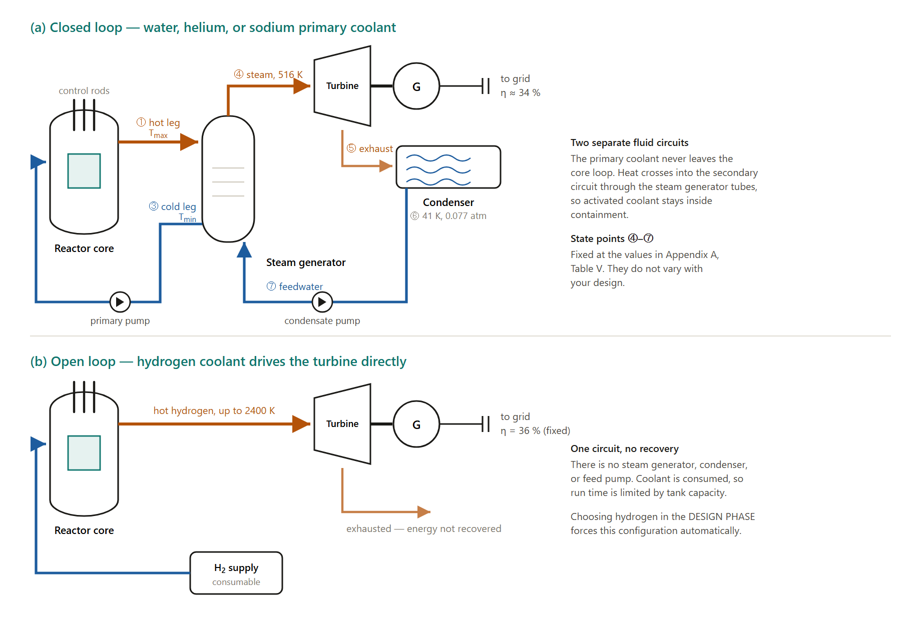
Figure 5. The two power conversion architectures. A closed loop keeps the primary coolant inside containment and transfers heat to a separate steam circuit; an open loop expands the coolant directly through the turbine and discards it.
In a closed loop, the primary coolant circulates through the core and then through a steam generator, where it gives up heat to a physically separate secondary circuit without mixing. The secondary fluid boils, expands through a turbine, condenses, and is pumped back. Water, helium, and sodium coolants all use this arrangement in the program. The advantage is containment: activated primary coolant never leaves the shielded loop, so the turbine hall is accessible during operation. The cost is a heat exchanger and the temperature penalty across it.
In an open loop, the coolant itself expands through the turbine and is then discarded. Selecting hydrogen forces this configuration, and the program removes the steam generator, condenser, and feed pump from the diagram accordingly. Open loops are used where mass matters more than fuel economy — nuclear thermal propulsion above all — because they eliminate an entire heat exchanger and its associated mass. The penalty is severe: the working fluid is consumed, so operating time is bounded by tank capacity, and any activated coolant is released.

6.2 The secondary circuit and cycle efficiency
For the closed loop the program uses a fixed set of secondary state points, tabulated in Appendix A, Table V. Steam leaves the generator at 516 K and 34.9 atm with an enthalpy of 1205 BTU/lb. It expands through the turbine to an exhaust enthalpy of 850 BTU/lb, condenses at 0.077 atm, and is returned as feedwater at 168 BTU/lb.
The secondary mass flow rate is whatever is needed to absorb the reactor's thermal power across the enthalpy rise from feedwater to steam. The turbine output is that flow rate times the enthalpy drop across the turbine. Dividing turbine output by thermal power gives the cycle efficiency, which for these fixed state points comes to 34.2 per cent — a value that matches the efficiency of a real PWR closely, and matches the constant the original program carried as its default.
Because the secondary state points are fixed, the cycle efficiency does not change when you change the primary side. This is a genuine limitation and you should know about it. In reality, raising the primary outlet temperature would let you raise steam conditions and gain efficiency; that is the entire argument for high-temperature gas reactors and for supercritical water designs. The program will not show you that gain. What it will show you correctly is the effect of your choices on the primary side — velocity, pressure drop, pumping power, fuel temperature — and on criticality.
For the open loop the program applies a flat 36 per cent conversion to the thermal power, slightly higher than the closed-loop figure, reflecting the absence of a steam generator temperature penalty.

7. Control, Protection, and Shielding

7.1 The purpose of the control system
Control rods serve four functions: to start the reactor up, to hold the average coolant temperature at its setpoint, to shut the reactor down, and to compensate for the slow changes in core properties over life so that criticality can be maintained. The operator controls the effective multiplication factor by rod motion, and as Chapter 2 explained, that is possible at all only because of delayed neutrons.
The program does not model rods. It computes the composition of an exactly critical core with no rods present, which corresponds to a core at the end of life with all rods fully withdrawn. A real design would carry substantially more fuel than the program's critical mass, with the excess held down by rods and burnable poisons.

7.2 Automatic protection
Many transients develop far too quickly for human diagnosis, so protection is automated. A scram is the rapid insertion of all control rods, complete within about a second. A cutback is a fast but controlled rod insertion, used where a full scram would be excessive. Either may be initiated manually or automatically when a monitored parameter crosses its trip point.
The protection logic maps failure modes to trips. A reactivity excursion — from uncontrolled or over-rapid rod withdrawal, a cold water accident, or loss of coolant — is caught by a high start-up rate scram or an overpower scram. A loss of control from a control system failure, operator error, or a stuck rod is caught by a high outlet temperature scram or an overpower scram. A power-to-flow mismatch from instrument error or control malfunction is caught by the high outlet temperature scram. A coolant failure from loss of flow, loss of coolant, or vessel failure is caught by a loss of flow scram, a high outlet temperature scram, or a low pressure scram.
Interlocks provide a second layer, preventing operators from committing certain errors at all. A cold water interlock, for example, blocks starting flow from a cold loop into the reactor, which would insert a large positive reactivity through the negative temperature coefficient. Beyond the hardware, safe operation depends on trained personnel following explicitly written procedures, in normal operation, in shutdown, and in emergencies.

7.3 Shielding and radiological hazard
A shield surrounds the reactor to reduce radiation to tolerable levels, and it has two components. The thermal shield, close to the core, absorbs most of the energy and protects the pressure vessel from radiation damage and excessive heating. The biological shield, outside it, reduces the dose rate to levels safe for personnel. Lead and steel attenuate gamma rays; hydrogenous material, usually water or concrete, moderates and captures neutrons.
Radioactivity in the primary coolant comes from three sources. Gamma rays from the fuel activate the coolant itself, producing short-lived oxygen and nitrogen isotopes. Erosion and corrosion release metal from surfaces in contact with the coolant — cobalt, iron, and manganese in particular — which then circulate through the core and become activated; cobalt-60 has a long half-life and is the dominant contributor to long-term dose during maintenance. Third, fission products recoil out of any failed fuel, and impurities in the cladding activate and migrate into the coolant.
With an adequate shield, direct radiation is not the limiting hazard. The dose at the site boundary of a well-designed plant at full power is below natural background. The design problems are the ones that involve moving material: controlled discharge of primary coolant, handling of activated components during maintenance, and management of spent fuel.

PART III
Using the Program

8. Getting Started

8.1 Opening the program
The program runs entirely in your browser. There is nothing to install, no account to create, and no data leaves your machine — every calculation happens locally in the page. It works in any current browser on desktop, tablet, or phone, although a screen at least 1200 pixels wide is best because it shows the design controls, the plant diagram, and the results side by side.
1. Open a web browser.
2. Go to https://reactor-seven.vercel.app/
3. The workspace loads with the demonstration reactor already configured and solved. You do not need to press anything to see results.
The demonstration case is a one metre cube of U-235 in light water, water cooled, closed loop, at 470 to 530 K with 10,000 kg/s of flow. It is the same default set the 1993 program started from, and it is listed in full in Appendix A, Table IV.

8.2 The workspace
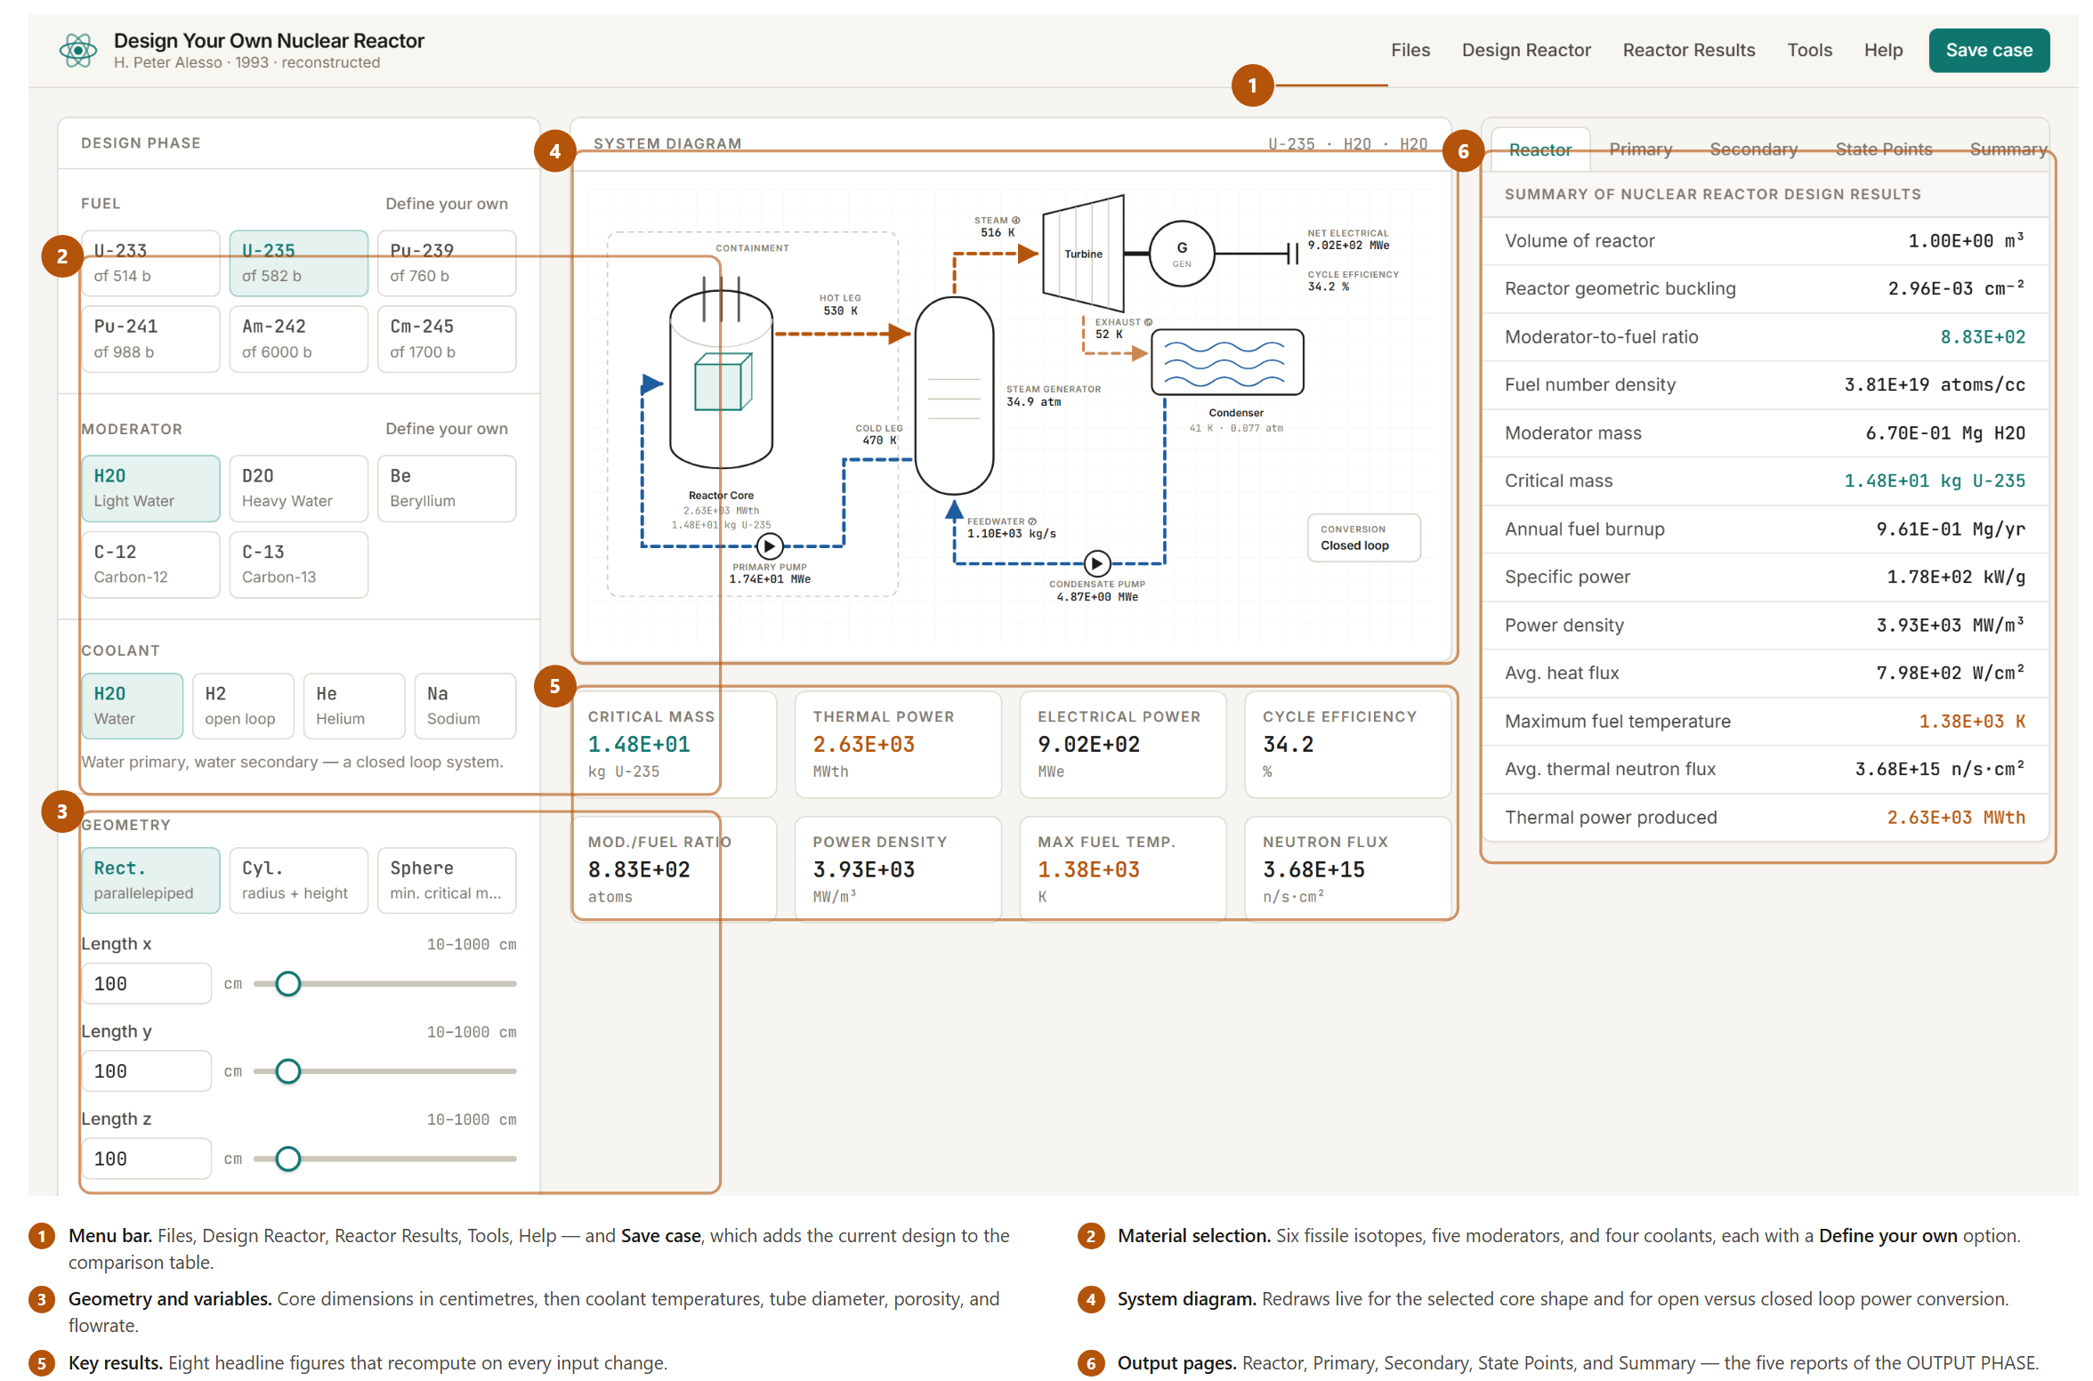
Figure 6. The workspace. Design controls on the left, the live system diagram and headline results in the centre, and the five output pages on the right.
The screen has three columns. On the left is the DESIGN PHASE panel, which holds every input. In the centre is the system diagram, which redraws whenever you change the core shape or the coolant, and below it eight headline results. On the right are the five output pages of the OUTPUT PHASE, selected by the tabs across the top.
There is no calculate button. Every result on the screen recomputes the moment you change any input, which is what makes parametric exploration fast. Drag a slider and watch the critical mass and the fuel temperature move together.

8.3 The DESIGN PHASE, step by step
Work down the left panel in order. The sequence matters, because later choices depend on earlier ones.
1. Select the fuel. Six isotopes are offered: U-233, U-235, Pu-239, Pu-241, Am-242, and Cm-245. Each button shows the thermal fission cross section in barns, so you can see at a glance why the choice matters. Full data is in Appendix A, Table I.
2. Select the moderator. Five materials are offered: light water, heavy water, beryllium, carbon-12, and carbon-13. The relevant properties — Fermi age, diffusion length squared, density, and absorption cross section — are in Appendix A, Table II.
3. Select the coolant. Water, hydrogen, helium, or sodium. Choosing hydrogen switches the plant to an open loop automatically and removes the steam generator and condenser from the diagram. The other three use a closed loop with water as the secondary fluid.
4. Select the geometry, then enter dimensions. Rectangular takes three edge lengths; cylindrical takes a radius and a height; spherical takes a radius. All dimensions are in centimetres, and the allowed range appears above each field. You can type a value or drag the slider.
5. Set the variables. Maximum and minimum coolant temperature in kelvin, coolant tube diameter in centimetres, porosity as a fraction, and coolant flow rate in kilograms per second.
The difference between the maximum and minimum coolant temperatures is the temperature rise across the core, and together with the flow rate it fixes the thermal power. Set these two first when you are targeting a particular power output.

8.4 Defining your own materials
If you have data for a material the program does not offer — an alloyed fuel at a particular enrichment, a mixed oxide, an unusual moderator — use the Define your own button beside the Fuel or Moderator heading. For a fuel you supply the thermal fission cross section, thermal absorption cross section, thermal conductivity, density, atomic mass number, and a name. For a moderator you supply the diffusion length squared, Fermi age, thermal absorption cross section, density, mass number, and a name.
This is how you approach a realistic enrichment. The program's built-in fuels are pure isotopes, so a critical mass of 331 kg of U-235 means 331 kg of the pure isotope. To model 4 per cent enriched UO₂ you would enter effective cross sections weighted for the fuel composition and the density of the oxide, and read the result as a mass of that fuel rather than of pure metal.

8.5 The OUTPUT PHASE
Five pages report the results, reached by the tabs on the right.
- Reactor gives the criticality and core results: volume, buckling, moderator-to-fuel ratio, fuel number density, moderator mass, critical mass, annual burnup, specific power, power density, average heat flux, maximum fuel temperature, average thermal neutron flux, and thermal power.
- Primary reports the primary coolant circuit: porosity, tube diameter, number of channels, coolant density, pressure, flow rate, velocity, Reynolds number, friction factor, core pressure drop, pump power, coolant mass in the core, maximum temperature, and temperature rise.
- Secondary reports the power conversion side: steam conditions, turbine efficiency, cycle efficiency, secondary flow rate, condensate pump power, and electrical output. For an open loop it reports the direct-expansion equivalents instead.
- State Points tabulates temperature, pressure, and enthalpy at each numbered point around the plant. Points 1 to 3 are the primary loop and follow your design; points 4 to 7 are the secondary loop and are fixed.
- Summary lists your current selections and compares your design against two operating plants, Oconee 1 and Pickering, on thermal power, electrical power, core volume, and heat flux.
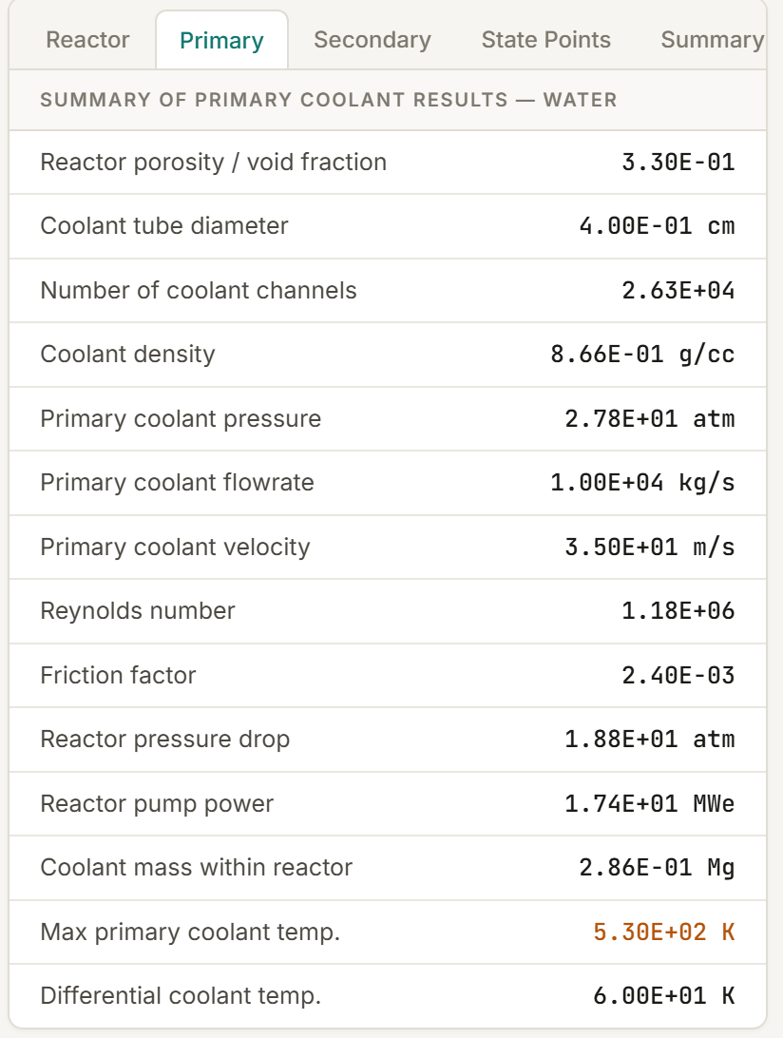
Figure 7. The Primary Coolant output page for the demonstration case. A velocity of 35 m/s and a pressure drop of 18.8 atm are both far above operating practice — the first sign that the default core is too small.

8.6 Saving, loading, and printing
The Files menu holds four commands. Save design writes the current configuration to a JSON file on your computer. Open design reads one back. Print page sends the workspace to your printer or to a PDF. Reset to defaults returns everything to the demonstration case.
Save case, the green button at the top right, is different: it adds the current design to a comparison table below the diagram without leaving the current design. This is the tool for parametric studies, and Chapter 13 uses it.

9. Worked Example 1: A Pressurised Water Reactor
This example takes the demonstration default, shows that it is thermally impossible, and repairs it. It is the most instructive exercise in the manual because the repair is driven entirely by numbers the program reports.

9.1 Run the default and read the warning signs
1. Open https://reactor-seven.vercel.app/ and, if you have been experimenting, choose Files then Reset to defaults.
2. Confirm the settings: U-235 fuel, light water moderator, water coolant, rectangular geometry at 100 × 100 × 100 cm, 530 K maximum and 470 K minimum coolant temperature, 0.4 cm tubes, 0.33 porosity, 10,000 kg/s flow.
3. Read the Reactor output page.

Quantity | Value | Comment
Core volume | 1.00 m³ | Very small for a power reactor
Geometric buckling | 2.96 × 10⁻³ cm⁻² | High — significant leakage
Moderator-to-fuel ratio | 883 | Criticality is achieved
Critical mass | 14.8 kg U-235 | Plausible for this size
Thermal power | 2633 MWth | Comparable to Oconee 1
Power density | 3930 MW/m³ | About 125 times operating practice
Average heat flux | 798 W/cm² | About 15 times operating practice
Maximum fuel temperature | 1380 K | Below the UO₂ melting point
Electrical power | 902 MWe | 34.2 per cent cycle efficiency
Table 2. Demonstration default, Reactor page. The power and efficiency are realistic; the power density and heat flux are not.
The design is critical and it produces a believable 2633 MWth and 902 MWe — figures very close to Oconee 1's 2584 MWth and 886 MWe, which the Summary page shows for comparison. But the power density and heat flux are absurd. Oconee runs at about 31 W/g and 54 W/cm². This design demands 798 W/cm².
Now open the Primary page.

Quantity | Value | Operating practice
Coolant velocity | 35.0 m/s | 4 to 6 m/s
Reynolds number | 1.18 × 10⁶ | Turbulent, as expected
Core pressure drop | 18.8 atm | 1 to 3 atm
Primary pump power | 17.4 MWe | Under 1 per cent of gross output
Number of channels | 26,300 | —
Table 3. Demonstration default, Primary page. Every hydraulic quantity is far outside operating practice.
The diagnosis is now unambiguous. The core is being asked to pass the coolant flow of a full-size power plant through one cubic metre. The heat is generated in the right total amount, but there is nowhere near enough surface area to transfer it, and nowhere near enough flow area to carry it. The fix is not to reduce the power. It is to make the core the right size.

9.2 Enlarge the core
Oconee 1 has a core volume of 30.7 m³. A cube of 300 cm on each side gives 27 m³, which is close enough to compare directly.
1. In the Geometry section, set Length x, Length y, and Length z each to 300 cm.
2. Leave everything else unchanged.
3. Read the Reactor and Primary pages again.

Quantity | 1 m core | 27 m³ core | Oconee 1
Core volume, m³ | 1.00 | 27.0 | 30.7
Buckling, cm⁻² | 2.96 × 10⁻³ | 3.29 × 10⁻⁴ | —
Moderator-to-fuel ratio | 883 | 1066 | —
Critical mass, kg U-235 | 14.8 | 331 | —
Thermal power, MWth | 2633 | 2633 | 2584
Electrical power, MWe | 902 | 902 | 886
Power density, MW/m³ | 3930 | 146 | —
Heat flux, W/cm² | 798 | 29.6 | 54.1
Fuel temperature, K | 1380 | 754 | —
Coolant velocity, m/s | 35.0 | 3.89 | —
Pressure drop, atm | 18.8 | 1.21 | —
Pump power, MWe | 17.4 | 1.12 | —
Coolant channels | 26,300 | 236,000 | —
Table 4. The effect of enlarging the core twenty-sevenfold at constant flow conditions. Power and efficiency are unchanged; every thermal and hydraulic quantity moves into operating range.
Every problem is solved at once, and it is worth being precise about why. The thermal power did not change, because it is set by the coolant energy balance and the flow conditions were not touched. What changed is that the same power is now generated in twenty-seven times the volume, spread over nine times the channel wall area, and carried by coolant through nine times the flow area. Power density falls by a factor of twenty-seven, heat flux by a factor of nine, velocity by a factor of nine, and pressure drop and pumping power by more than that because they scale with higher powers of velocity.
The cost is fuel. The critical mass rises from 14.8 kg to 331 kg, a factor of twenty-two, because a larger core leaks proportionally less and therefore needs a more dilute — but far more voluminous — fuel loading. This is the central trade of thermal reactor design stated in two numbers: you buy thermal feasibility with fuel inventory.
The heat flux at 29.6 W/cm² is now conservative against Oconee's 54.1, which suggests headroom. Confirm it by raising the flow.

9.3 Uprate the design
1. Set Coolant flowrate to 15,000 kg/s.
2. Leave the geometry at 300 cm and the temperatures unchanged.

Quantity | 10,000 kg/s | 15,000 kg/s
Thermal power, MWth | 2633 | 3950
Electrical power, MWe | 902 | 1353
Power density, MW/m³ | 146 | 218
Heat flux, W/cm² | 29.6 | 44.3
Fuel temperature, K | 754 | 766
Coolant velocity, m/s | 3.89 | 5.83
Pressure drop, atm | 1.21 | 2.45
Pump power, MWe | 1.12 | 3.40
Secondary flowrate, kg/s | 1100 | 1660
Table 5. Uprating by 50 per cent flow. Output rises proportionally; heat flux and velocity remain within operating practice.
A 50 per cent increase in flow buys a 50 per cent increase in output, to 3950 MWth and 1353 MWe, while the heat flux reaches only 44.3 W/cm² and the velocity 5.83 m/s — both still inside operating experience. Pumping power triples to 3.40 MWe, which is the price, but it is a quarter of one per cent of gross output. The fuel centreline temperature barely moves, rising from 754 K to 766 K, because it is dominated by the fixed coolant temperature and the film allowance rather than by the conduction term at these power densities.
This is a credible large PWR. Save it: click Save case, and it appears in the comparison table for later reference.

10. Worked Example 2: A Heavy-Water Reactor
Heavy water absorbs 330 times fewer thermal neutrons than light water. The consequence is that a heavy-water reactor can achieve criticality with natural or very slightly enriched uranium — the basis of the Canadian CANDU design. The cost is size, because heavy water's Fermi age of 121 cm² and diffusion length squared of 10,000 cm² both far exceed light water's.
1. Set the moderator to D2O.
2. Set the geometry to Cylindrical, with radius 200 cm and height 370 cm.
3. Set maximum coolant temperature 570 K, minimum 530 K.
4. Set porosity 0.40 and coolant flowrate 17,000 kg/s. Leave tube diameter at 0.4 cm.

Quantity | Value | Pickering (HWR)
Core volume | 46.5 m³ | 265 m³
Geometric buckling | 2.17 × 10⁻⁴ cm⁻² | —
Moderator-to-fuel ratio | 1010 | —
Critical mass | 596 kg U-235 | —
Moderator mass | 30.7 Mg D₂O | —
Thermal power | 3230 MWth | 1742 MWth
Electrical power | 1113 MWe | 508 MWe
Power density | 116 MW/m³ | —
Heat flux | 17.4 W/cm² | 59.2 W/cm²
Coolant velocity | 4.31 m/s | —
Primary pressure | 124 atm | —
Fuel temperature | 789 K | —
Table 6. Heavy-water cylindrical core. Note the low heat flux and the high primary pressure demanded by the 530 to 570 K operating range.
Two features distinguish this case from the PWR. First, the critical mass of 596 kg is well above the light-water design's 331 kg despite a comparable buckling, because heavy water's long diffusion length means thermal neutrons wander a long way and a larger fuel inventory is needed to catch them. Compare the two moderators directly in Chapter 13 and the pattern is clearer.
Second, the primary pressure of 124 atm is a direct consequence of the operating temperature. The program looks up the saturation pressure of water at the minimum coolant temperature and applies a safety factor of two. Running at 530 K requires the primary circuit to be pressurised well above saturation to prevent bulk boiling, and that pressure sets the vessel wall thickness — and much of the cost. Lower the minimum temperature to 470 K and watch the required pressure fall by more than half.
The heat flux of 17.4 W/cm² is very conservative, which reflects the enormous channel surface area created by a 0.4 cm tube in a 46.5 m³ core at 40 per cent porosity — roughly 400,000 channels. A real CANDU uses far fewer, much larger pressure tubes.

11. Worked Example 3: A High-Temperature Gas Reactor
Graphite moderation with helium cooling permits outlet temperatures far above what water allows, because helium does not boil, does not corrode, and absorbs almost no neutrons. The penalty is a very large core — graphite's Fermi age of 350 cm² is eleven times water's — and the difficulty of pumping a gas.
1. Set the fuel to U-235 and the moderator to C-12.
2. Set the coolant to He.
3. Set the geometry to Spherical with radius 250 cm.
4. Set maximum coolant temperature 1000 K, minimum 600 K.
5. Set tube diameter 1.2 cm, porosity 0.30, flowrate 3000 kg/s.

Quantity | Value | Note
Core volume | 65.4 m³ | Large, as graphite requires
Moderator-to-fuel ratio | 97,600 | Two orders above the water cases
Critical mass | 24.9 kg U-235 | Very small — excellent neutron economy
Moderator mass | 87.0 Mg graphite | The core is mostly graphite
Coolant mass in core | 0.00118 Mg | Helium is almost weightless
Thermal power | 6230 MWth | 400 K rise across the core
Power density | 136 MW/m³ | Comparable to the PWR
Heat flux | 95.2 W/cm² | High — check against limits
Coolant velocity | 438 m/s | Mach limited
Primary pump power | 145 MWe | 6.8 per cent of gross output
Fuel temperature | 1300 K | Acceptable for coated particle fuel
Electrical power | 2131 MWe | —
Table 7. Graphite-moderated, helium-cooled spherical core. The Primary page flags this case as Mach limited.
Three results deserve comment.
The moderator-to-fuel ratio of 97,600 is enormous, nearly a hundred times the light-water value. Graphite absorbs so few neutrons — 0.004 barns against water's 0.66 — that an extremely dilute fuel loading still achieves criticality. The consequence is a critical mass of only 24.9 kg in a 65 m³ core, the best neutron economy of any case in this manual. That is the fundamental attraction of graphite.
The Primary page reports that the case is Mach limited. The requested flow of 3000 kg/s of helium through this channel array would exceed Mach 0.3 at 1000 K, so the program clips the velocity to the sonic limit and raises the system pressure to compensate. This is exactly what a real designer does — gas-cooled reactors operate at 40 to 70 atmospheres precisely to keep volumetric flow, and hence velocity, manageable.
The pumping power of 145 MWe is the price. It consumes 6.8 per cent of the gross electrical output, against 0.25 per cent for the uprated PWR. Circulator power is the characteristic burden of gas cooling and it is why gas reactors need high pressure and large flow passages. Try raising the tube diameter from 1.2 cm to 2.5 cm and watch the pumping power collapse — at the cost of heat transfer area and therefore heat flux.

12. Worked Example 4: An Open-Loop Propulsion Reactor
Nuclear thermal propulsion heats hydrogen directly in the core and expands it. There is no secondary circuit, no condenser, and no coolant recovery. Hydrogen is chosen because its very low molecular weight gives the highest exhaust velocity for a given temperature, and beryllium is a natural moderator for a compact core because it is a solid with a short Fermi age.
1. Set the fuel to U-235 and the moderator to Be.
2. Set the coolant to H2. The diagram switches to open loop.
3. Set the geometry to Cylindrical, radius 40 cm and height 90 cm.
4. Set maximum coolant temperature 2400 K, minimum 300 K.
5. Set tube diameter 0.6 cm, porosity 0.50, flowrate 40 kg/s.
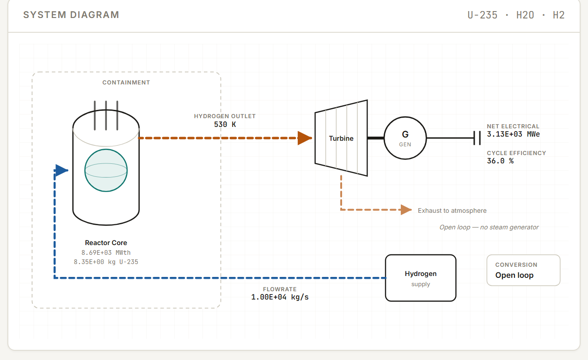
Figure 8. The system diagram for an open loop. The steam generator, condenser, and condensate pump are removed, and the coolant is exhausted rather than recovered.

Quantity | Value | Assessment
Core volume | 0.452 m³ | Compact, as required
Critical mass | 2.74 kg U-235 | Very small
Moderator-to-fuel ratio | 7970 | Beryllium is a weak absorber
Thermal power | 1200 MWth | 2100 K rise across the core
Power density | 5310 MW/m³ | Extremely high
Heat flux | 796 W/cm² | Extremely high
Coolant velocity | 1250 m/s | Mach limited
Maximum fuel temperature | 4570 K | Above the melting point of any fuel
Conversion | 36.0 per cent | Fixed for the open loop
Table 8. An open-loop propulsion core. The fuel temperature result makes this design impossible as entered.
The criticality result is excellent: 2.74 kg of U-235 in less than half a cubic metre. Beryllium is doing exactly what it should, providing moderation with almost no absorption in a compact solid.
The thermal result is fatal. A maximum fuel temperature of 4570 K exceeds the melting point of uranium dioxide, about 3120 K, and of uranium carbide, about 2800 K. Even the refractory carbide fuels developed for the NERVA programme were limited to roughly 3000 K. This design would vaporise its own core.
The exercise is to fix it, and the program shows you the levers. The centreline temperature rise scales with power density and with the square of the fuel radius. Reduce the tube diameter to 0.3 cm and the effective fuel radius halves, quartering the conduction term. Reduce the outlet temperature to 2000 K, which cuts both the power and the base temperature. Or enlarge the core, which cuts the power density directly. Try each in turn and watch which lever moves the number furthest — that habit of asking which variable dominates is the whole point of a parametric tool.
Note also the coolant velocity of 1250 m/s, which the program has clipped to the Mach 0.3 limit for hydrogen at 2400 K. Hydrogen's sound speed at that temperature is enormous, which is why the clip lands so high, and it is the same physics that makes hydrogen the propellant of choice.

13. Parametric Studies
Single cases teach little. What builds intuition is holding everything constant but one variable and watching the response. The Save case button collects designs into a comparison table so you can do this systematically.

13.1 Varying the moderator
Fix a 200 cm cube of U-235 with water coolant, and change only the moderator.

Moderator | Fermi age τ (cm²) | L² (cm²) | σ_abs (barns) | Nm/Nf | Critical mass (kg)
Light water, H₂O | 31.36 | 7.62 | 0.66 | 1036 | 100.8
Heavy water, D₂O | 121 | 10,000 | 0.002 | 384 | 269.1
Beryllium, Be | 84.64 | 441 | 0.01 | 3632 | 106.4
Carbon-12 | 350 | 4121 | 0.004 | 796 | 374.0
Carbon-13 | 350 | 4121 | 0.002 | 807 | 340.7
Table 9. Moderator comparison in a 200 cm cube of U-235, water cooled. Light water gives the lowest critical mass at this size; the graphites give the highest.
Light water wins at this size, with the lowest critical mass, because its very short Fermi age and diffusion length keep the whole neutron economy compact. The graphites are worst, needing three and a half times the fuel, because their 350 cm² Fermi age lets neutrons wander far outside a 200 cm core while slowing down.
Beryllium is the interesting case. It needs a moderator-to-fuel ratio of 3632, three and a half times water's, yet its critical mass is only slightly higher at 106.4 kg. The reason is that beryllium's mass number of 9 is half water's effective 18, so a given atom ratio corresponds to a much smaller mass ratio. This is why beryllium appears in compact reactors where its cost can be justified.
Heavy water's result — 269 kg, worse than light water — is a consequence of core size, not of any deficiency. At 200 cm the core is small enough that heavy water's long diffusion length hurts. Enlarge the core and the ranking changes. That is a study worth running yourself.

13.2 Varying the fuel
Now fix the moderator at light water and vary the fuel.

Fuel | σ_fission (barns) | σ_absorption (barns) | Nm/Nf | Critical mass (kg)
U-233 | 514 | 569 | 868 | 119.3
U-235 | 582 | 679 | 1036 | 100.8
Pu-239 | 760 | 1030 | 1572 | 67.6
Pu-241 | 988 | 1384 | 2112 | 50.7
Cm-245 | 1700 | 2000 | 3052 | 35.7
Am-242 | 6000 | 7700 | 11,749 | 9.2
Table 10. Fuel comparison in a 200 cm cube moderated and cooled by light water. Critical mass falls monotonically with absorption cross section.
The ordering follows the absorption cross section almost exactly. A fuel that absorbs thermal neutrons strongly needs fewer atoms present to capture the same number of neutrons, so the critical mass falls. Americium-242, with a thermal absorption cross section of 7700 barns, requires only 9.2 kg — an eleventh of the U-235 requirement.
Treat that result with care. The program holds η at 2.06 for every fuel, which is the U-235 value; the real figures differ, and for Am-242 the difference matters. Am-242 is also intensely radioactive with a short half-life, exists in gram quantities worldwide, and could not be fabricated into fuel by any known process. The value of the comparison is in the trend, not the absolute number.

13.3 Varying the geometry
Section 4.3 showed that a sphere gives the smallest critical mass for a given volume. Repeat that study at several volumes and you will find the advantage grows as the core shrinks, because leakage is a surface effect and the surface-to-volume ratio dominates small cores. At 8 m³ the sphere saves less than one per cent over a cube; at 0.1 m³ the saving is substantial.

13.4 Suggested exercises
- Find the core size that minimises critical mass for Pu-239 in light water. Compare it with the 48 cm figure for U-235 and explain the difference.
- Hold thermal power at 2000 MWth and find the combination of flow rate and temperature rise that minimises pumping power. What limits you?
- For the graphite and helium design of Chapter 11, find the tube diameter that brings pumping power below 2 per cent of gross output. What happens to the heat flux?
- Using Define Your Own Fuel, model 4 per cent enriched uranium dioxide and compare the required mass with the pure U-235 result.
- Vary porosity from 0.1 to 0.7 in the uprated PWR of Chapter 9 and plot critical mass, heat flux, and pumping power against it. Where would you operate, and why?

14. When Criticality Fails
If your combination of materials and geometry cannot reach criticality, a warning banner appears across the top of the workspace and the affected results are marked.
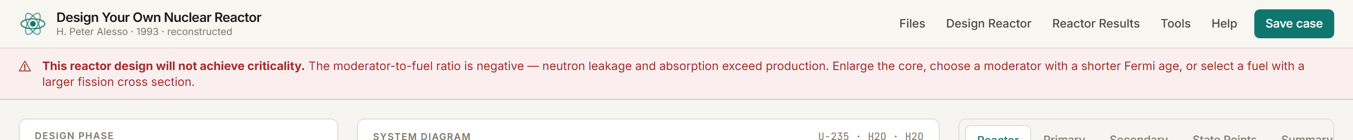
Figure 9. The criticality warning. It appears immediately, and it names the three variables that will fix the problem.
The mathematical signature is a negative moderator-to-fuel ratio. Recall the criticality condition from Section 4.1: the numerator contains the term η·exp(−B²τ) − 1. When the core is small, the buckling B² is large, the exponential is small, and that term goes negative. A negative numerator gives a negative ratio, which has no physical meaning. It is the calculation's way of saying that no amount of fuel will work, because neutrons are leaking out faster than fission can replace them.
Three remedies exist, in order of effectiveness.
- Enlarge the core. This reduces the buckling, which is the direct cause. For U-235 in light water, a cube must be at least about 35 cm on a side; below that no composition is critical. Changing to a spherical shape at the same volume also helps, because a sphere has the lowest buckling of any shape.
- Choose a moderator with a shorter Fermi age. The leakage term is exp(−B²τ), so τ and B² enter as a product. Switching from graphite at 350 cm² to light water at 31.4 cm² has the same effect on fast leakage as reducing the buckling elevenfold.
- Choose a fuel with a larger fission cross section. This raises the production side of the balance. Moving from U-235 to Pu-239 or Am-242 will rescue a design that light water cannot.
A fourth remedy exists in reality but not in this program: add a reflector. Surrounding the core with a layer of moderator scatters escaping neutrons back in, and it can reduce critical mass by a third or more. The program assumes a bare core throughout, so every critical mass it reports is conservative in that specific respect.

Glossary
Absorption cross section The effective target area a nucleus presents to a neutron for absorption, measured in barns. Large values mean strong absorption.
Barn A unit of nuclear cross section equal to 10⁻²⁴ cm². Roughly the geometric cross section of a heavy nucleus.
Boiling water reactor (BWR) A reactor in which the coolant boils inside the core and the resulting steam drives the turbine directly, with no separate steam generator.
Buckling, geometric (B²) A measure of the curvature of the neutron flux, determined entirely by core shape and size, in cm⁻². Large buckling means high leakage.
Burnable poison A neutron absorber deliberately loaded into the core that is consumed as the core runs, offsetting fuel depletion and extending core life.
Burnup The energy extracted from a unit mass of fuel, or equivalently the fraction of heavy atoms fissioned. The program reports annual burnup in megagrams per year.
CANDU The Canadian heavy-water reactor, moderated and cooled by D₂O, capable of running on natural uranium.
Cladding The thin metal tube, usually zirconium alloy or stainless steel, that encloses the fuel and retains fission products.
Closed loop A power conversion arrangement in which the primary coolant transfers heat to a separate secondary fluid through a steam generator and is itself recirculated.
Critical The condition in which the neutron population is exactly steady, k_eff = 1. Says nothing about power level.
Critical mass The minimum mass of fissile fuel that sustains a chain reaction in a given geometry and composition.
Delayed neutrons Neutrons emitted 0.2 to 55 seconds after a fission, from the decay of certain fission products. About 0.65 per cent of the total for U-235; they make reactor control possible.
Departure from nucleate boiling (DNB) The transition from efficient nucleate boiling to film boiling, in which a vapour blanket insulates the surface and the wall temperature rises sharply. A hard limit on heat flux.
Diffusion length (L) The characteristic distance a thermal neutron travels before absorption. L² appears in the thermal leakage term.
Doppler broadening The widening of resonance absorption peaks as fuel temperature rises and nuclear thermal motion increases. A principal source of the negative temperature coefficient.
Enrichment The fraction of fissile isotope in a fuel, usually U-235 in uranium. Natural uranium is 0.72 per cent U-235.
Eta (η) The number of fission neutrons produced per thermal neutron absorbed in fuel. The program uses 2.06, the U-235 value, for all fuels.
Fast fission factor (ε) The ratio of total fission neutrons to those produced by thermal fission alone, accounting for fissions caused by fast neutrons.
Fermi age (τ) One sixth of the mean square distance a neutron travels from birth to thermalisation, in cm². Controls fast leakage through the term exp(−B²τ).
Fissile Capable of fission by neutrons of any energy, including thermal. U-233, U-235, Pu-239, and Pu-241 are the practical fissile nuclides.
Fission The splitting of a heavy nucleus into two fragments, releasing one to three neutrons, gamma rays, and about 200 MeV.
Fission products The nuclides produced by fission and their decay chains. Some, notably xenon-135, are strong neutron absorbers.
Flux, neutron The number of neutrons crossing unit area per unit time, in neutrons per second per cm². Determines reaction rates.
Heat flux Thermal power per unit of heat transfer surface, in W/cm². Limited by departure from nucleate boiling.
Homogeneous reactor An idealisation in which fuel and moderator are uniformly mixed rather than arranged in discrete elements. Used throughout this program.
Hot channel factor The ratio of conditions in the most limiting coolant channel to the core average, typically 2 to 2.5 in a large core.
HTGR High-temperature gas reactor. Graphite moderated, helium cooled, capable of outlet temperatures far above water reactors.
k-effective (k_eff) The effective multiplication factor, the ratio of neutrons in one generation to those in the previous one.
Leakage Loss of neutrons through the core surface. Divided into fast leakage during slowing down and thermal leakage during diffusion.
MAGNOX The early British gas-cooled reactor type, named for its magnesium alloy cladding, fuelled with natural uranium metal.
Moderator A material that slows fast neutrons to thermal energy through elastic scattering, chosen for low mass number and low absorption.
Moderator-to-fuel ratio (Nm/Nf) The number of moderator atoms per fuel atom. The quantity this program solves for. Has an optimum: too low is under-moderated, too high is over-moderated.
Open loop A power conversion arrangement in which the coolant expands through the turbine directly and is discarded. Used in propulsion reactors.
Porosity (ε) The fraction of core volume occupied by coolant. Also called void fraction. Sets channel count and solid volume.
Power density Thermal power per unit of core volume, in MW/m³. A key measure of how hard a core is working.
Pressurised water reactor (PWR) A reactor in which water is held above saturation pressure so it does not boil, and transfers heat to a separate steam circuit.
Prompt neutrons Neutrons emitted essentially instantly at fission, about 10⁻⁴ seconds. The great majority of all fission neutrons.
Reactivity (ρ) A measure of departure from criticality, ρ = 1 − 1/k_eff. Zero at critical.
Reflector A layer of moderating material surrounding the core that scatters escaping neutrons back in, reducing critical mass. Not modelled here.
Resonance escape probability (p) The fraction of neutrons that slow past the resonance absorption region without being captured.
Reynolds number (Re) The dimensionless ratio of inertial to viscous forces in a flow. Above about 4000 the flow is turbulent.
Scram The rapid insertion of all control rods, completing in about one second, to shut the reactor down.
Specific power Thermal power per unit mass of fuel, in kW per gram.
Subcritical k_eff below one; the neutron population declines.
Supercritical k_eff above one; the neutron population grows.
Thermal neutron A neutron in thermal equilibrium with its surroundings, about 0.025 eV at room temperature.
Thermal utilisation (f) The fraction of absorbed thermal neutrons that are absorbed in fuel rather than in moderator, coolant, or structure.
Xenon poisoning The build-up of xenon-135, an extremely strong thermal absorber, after a power reduction. Produces a dead time during which restart is impossible.

References

Reactor physics and design
Glasstone, S., and A. Sesonske. Nuclear Reactor Engineering, 4th ed. New York: Chapman & Hall, 1994.
Lamarsh, J. R., and A. J. Baratta. Introduction to Nuclear Engineering, 3rd ed. Upper Saddle River: Prentice Hall, 2001.
Duderstadt, J. J., and L. J. Hamilton. Nuclear Reactor Analysis. New York: Wiley, 1976.
Weinberg, A. M., and E. P. Wigner. The Physical Theory of Neutron Chain Reactors. Chicago: University of Chicago Press, 1958.
Glasstone, S., and M. C. Edlund. The Elements of Nuclear Reactor Theory. New York: Van Nostrand, 1952.
Bell, G. I., and S. Glasstone. Nuclear Reactor Theory. New York: Van Nostrand Reinhold, 1970.
Knief, R. A. Nuclear Engineering: Theory and Technology of Commercial Nuclear Power, 2nd ed. Washington: Taylor & Francis, 1992.

Thermal-hydraulics and heat transfer
Todreas, N. E., and M. S. Kazimi. Nuclear Systems I: Thermal Hydraulic Fundamentals, 2nd ed. Boca Raton: CRC Press, 2011.
El-Wakil, M. M. Nuclear Heat Transport. La Grange Park: American Nuclear Society, 1978.
Tong, L. S., and J. Weisman. Thermal Analysis of Pressurized Water Reactors, 3rd ed. La Grange Park: American Nuclear Society, 1996.
Rust, J. H. Nuclear Power Plant Engineering. Buchanan: Haralson Publishing, 1979.

Nuclear data
Mughabghab, S. F. Atlas of Neutron Resonances, 5th ed. Amsterdam: Elsevier, 2006.
Chadwick, M. B., et al. "ENDF/B-VII.1 Nuclear Data for Science and Technology." Nuclear Data Sheets 112, no. 12 (2011): 2887–2996.
Etherington, H., ed. Nuclear Engineering Handbook. New York: McGraw-Hill, 1958.
International Atomic Energy Agency. Nuclear Power Reactors in the World. Reference Data Series No. 2. Vienna: IAEA, published annually.

The program
Alesso, H. P. Design Your Own Nuclear Reactor. Microsoft Visual Basic 3 for Windows 3.1, 1993. Original source in the project repository.
Design Your Own Nuclear Reactor, browser edition. https://reactor-seven.vercel.app/
Project repository, including the 1993 sources. https://github.com/alessoh/reactor
United States Nuclear Regulatory Commission. Glossary. https://www.nrc.gov/reading-rm/basic-ref/glossary.html

Appendix A: Data Tables
These are the values the program uses. They are carried over unchanged from the 1993 source and are typical thermal-spectrum figures; consult a current evaluated nuclear data library for design work.

Table I. Reactor fuels

Isotope | Density (g/cc) | Mass number | σ fission (barns) | σ absorption (barns) | k (BTU/hr·ft·°F)
U-233 | 19.0 | 233 | 514 | 569 | 14
U-235 | 19.0 | 235 | 582 | 679 | 14
Pu-239 | 19.0 | 239 | 760 | 1030 | 14
Pu-241 | 19.0 | 241 | 988 | 1384 | 14
Am-242 | 19.0 | 242 | 6000 | 7700 | 14
Cm-245 | 19.0 | 245 | 1700 | 2000 | 14

Cross sections are thermal values at 0.025 eV. All six fuels share a density of 19.0 g/cc and a thermal conductivity of 14 BTU/hr·ft·°F in the program; real values differ, particularly for oxide fuels, whose conductivity is roughly an order of magnitude lower.

Table II. Reactor moderators

Material | L² (cm²) | Fermi age τ (cm²) | Density (g/cc) | σ absorption (barns) | Mass number
Light water, H₂O | 7.617 | 31.36 | 1.00 | 0.66 | 18
Heavy water, D₂O | 10,000 | 121 | 1.10 | 0.002 | 20
Beryllium, Be | 441 | 84.64 | 1.85 | 0.01 | 9
Carbon-12 | 4121 | 350 | 1.90 | 0.004 | 12
Carbon-13 | 4121 | 350 | 1.90 | 0.002 | 13

The two length scales tell the story: Fermi age governs how far neutrons travel while slowing down, and L² governs how far they travel afterwards. Light water is compact in both; the graphites are extended in both.

Table III. Reactor coolants

Coolant | Heat capacity (BTU/lb·°F) | Density range (g/cc) | σ absorption (barns) | Loop
Water, H₂O | 1.00 to 1.37 | 0.67 to 1.00 | 0.66 | Closed
Hydrogen, H₂ | 2.59 to 3.74 | 0.000019 to 0.00083 | 0.33 | Open
Helium, He | 1.242 (constant) | 0.000053 to 0.0034 | 0.007 | Closed
Sodium, Na | 0.300 to 0.331 | 0.72 to 0.93 | 0.525 | Closed

Properties are looked up from step tables keyed on the minimum coolant temperature. Selecting hydrogen forces an open loop; the other three use a closed loop with water as the secondary fluid. Hydrogen and helium are additionally limited to Mach 0.3.

Table IV. Default values

Parameter | Default
Fuel | Uranium-235
Moderator | Light water
Primary coolant | Water
Secondary coolant | Water
Geometry | Rectangular, 100 × 100 × 100 cm
Maximum coolant temperature | 530 K
Minimum coolant temperature | 470 K
Coolant tube diameter | 0.4 cm
Porosity | 0.33
Coolant flowrate | 10,000 kg/s
Power conversion | Closed loop
Resulting coolant pressure | 92 atmospheres

Table V. Secondary loop state points

Point | Location | Temperature | Pressure (atm) | Enthalpy (BTU/lb)
4 | Steam generator outlet | 516 K | 34.9 | 1205
5 | Turbine exhaust | 52 | 0.1436 | 850
6 | Condenser hotwell | 41 | 0.0769 | 68
7 | Feedwater to steam generator | 104 | 34.9 | 168

These four points are fixed and do not vary with your design. The temperatures at points 5, 6, and 7 are labelled as kelvin in the original program, but 41 K is physically impossible for a condenser and the values are consistent with degrees Celsius: 52 °C turbine exhaust, 41 °C condenser, 104 °C feedwater. Read them as Celsius. The enthalpies are self-consistent and produce a cycle efficiency of 34.2 per cent, which is correct for a plant of this type.

Appendix B: Assumptions and Limitations
Every result the program produces rests on the following. Reading this list is the difference between using the program well and being misled by it.
- Criticality is computed using the thermal group approximation, the homogeneous reactor approximation, and the Fermi age approximation. These are the standard hand-calculation methods of the 1950s and 1960s. They capture the correct sensitivities but not the correct absolute values for a heterogeneous lattice.
- The core is bare: no reflector is modelled. A real reflected core reaches criticality with substantially less fuel, often a third less, so every critical mass reported here is conservative in that respect.
- Fuel and moderator are treated as uniformly mixed. Real cores arrange fuel in pins within a moderator lattice, which changes resonance escape and thermal utilisation appreciably.
- The neutron reproduction factor η is held at 2.06, the U-235 value, for every fuel. Comparisons between fuels therefore show the effect of cross sections only, not the full picture.
- Critical mass is given for the pure isotope. Use Define Your Own Fuel to model alloys, oxides, and realistic enrichments.
- Annual burnup assumes continuous operation at 100 per cent power with zero breeding.
- Secondary loop state points are fixed. Cycle efficiency is therefore constant at 34.2 per cent for closed loops regardless of primary conditions, and the efficiency gain that a higher primary temperature would deliver in reality is not shown.
- Open loop conversion is a flat 36 per cent.
- Gas coolants are limited to Mach 0.3, computed at the maximum coolant temperature. When the limit binds, velocity is clipped and system pressure is raised.
- Pressure drop uses the Blasius correlation for smooth turbulent pipe flow with a 1.5 multiplier for form losses. It assumes incompressible flow and neglects elevation and acceleration terms.
- No burnup over time, fission product poisoning, control rod worth, transient behaviour, shielding thickness, structural analysis, or cost estimation is performed.
- Four leftover debugging statements in the 1993 source, which pinned primary pressure, pump power, and turbine output to constants and which corrupted coolant velocity through a misplaced conditional, have been corrected in the browser edition. All physics, material data, and correlations are otherwise unchanged.

Appendix C: Reference Plants
Two operating plants, for comparison against your designs. The Summary output page shows these alongside your current case.

Quantity | Oconee 1 (PWR) | Pickering (HWR) | Units
Thermal power | 2584 | 1742 | MWth
Electrical power | 886 | 508 | MWe
Core volume | 30.7 | 265 | m³
Fuel form | UO₂ | UO₂ | —
Fuel mass | 83,000 | 92,600 | kg
Coolant temperature | 563 to 591 | 523 to 567 | K
Coolant flowrate | 12,600 | 17,700 | kg/s
Power density | 31.1 | 10 | W/g
Average heat flux | 54.1 | 59.2 | W/cm²
Net efficiency | 34.3 | 29.2 | per cent

Appendix D: Equation Summary
The equations the program evaluates, in the order it evaluates them.
Geometric buckling, rectangular B² = (π/a)² + (π/b)² + (π/c)²
Geometric buckling, cylindrical B² = (2.405/R)² + (π/H)²
Geometric buckling, spherical B² = (π/R)²
Coolant channel count N = εV / (πd²/4 · L)
Coolant velocity v = ṁ / (ρ · N · πd²/4)
Reynolds number Re = v · ρ · d / μ
Friction factor (Blasius) f = 0.079 · Re⁻⁰·²⁵
Core pressure drop Δp = 1.5 · 4f · (L/d) · ρv² / (2g)
Thermal power P = ṁ · cp · (Tmax − Tmin)
Power density q = P / [V(1 − ε)]
Average heat flux q" = P / (π d L N)
Fuel centreline temperature Tc = Tmax + 200 + q · rf² / (4 · 1.73 · k)
Criticality condition η · exp(−B²τ) / (1 + L²B²) = 1
Moderator-to-fuel ratio Nm/Nf = [η·exp(−B²τ) − 1]·σaf / [(1 + L²B²)·σ̄a]
Moderator number density Nm = ρm · NA / Am
Critical mass M = V · (Af/Am) · ρm / (Nm/Nf) · 1000
Specific power S = P / M
Thermal neutron flux φ = 3.1 × 10¹⁰ · P / (V · Nf · σf · 10⁻²⁴)
Secondary flowrate ṁ₂ = 1000 P / (h₄ − h₇)
Turbine power W = ṁ₂ · (h₄ − h₅)
Cycle efficiency ηcycle = 100 · W / P
Symbols: a, b, c are rectangular edge lengths; R and H are cylinder radius and height; ε is porosity; V is core volume; d is tube diameter; L is channel length; ṁ is coolant mass flow; ρ is coolant density; μ is viscosity; cp is specific heat; τ is Fermi age; L² is diffusion length squared; σaf is the fuel absorption cross section; σ̄a is the mass-weighted moderator and coolant absorption cross section; Af and Am are fuel and moderator mass numbers; ρm is moderator density; NA is Avogadro's number; h are secondary enthalpies.

Appendix E: Worked Example Results
All four worked examples side by side. Every figure was produced by the program at the settings given in the corresponding chapter.

Quantity | Ex 1 PWR | Ex 2 HWR | Ex 3 HTGR | Ex 4 NTP
Fuel | U-235 | U-235 | U-235 | U-235
Moderator | H₂O | D₂O | C-12 | Be
Coolant | H₂O | H₂O | He | H₂
Geometry | cube 300 | cyl 200/370 | sphere 250 | cyl 40/90
Core volume, m³ | 27.0 | 46.5 | 65.4 | 0.452
Buckling, cm⁻² | 3.29 × 10⁻⁴ | 2.17 × 10⁻⁴ | 1.58 × 10⁻⁴ | 4.83 × 10⁻³
Nm/Nf | 1066 | 1010 | 97,600 | 7970
Critical mass, kg | 331 | 596 | 24.9 | 2.74
Thermal power, MWth | 3950 | 3230 | 6230 | 1200
Electrical power, MWe | 1353 | 1113 | 2131 | 432
Power density, MW/m³ | 218 | 116 | 136 | 5310
Heat flux, W/cm² | 44.3 | 17.4 | 95.2 | 796
Coolant velocity, m/s | 5.83 | 4.31 | 438 | 1250
Pump power, MWe | 3.40 | 2.57 | 145 | 73.1
Fuel temperature, K | 766 | 789 | 1300 | 4570
Efficiency, per cent | 34.2 | 34.2 | 34.2 | 36.0

Example 1 is the uprated case of Section 9.3. Examples 3 and 4 are Mach limited. Example 4's fuel temperature exceeds the melting point of every known fuel form and the design is not feasible as entered; Chapter 12 discusses the remedies.

Appendix F: Online Resources
The program and its sources are freely available.
Run the program
https://reactor-seven.vercel.app/
The browser edition. Nothing to install; all computation happens locally in your browser.
Project repository
https://github.com/alessoh/reactor
The 1993 Visual Basic sources, the original user's manual and tutorial, the installation disk images, and the browser reconstruction.
Tutorial, in-program
https://reactor-seven.vercel.app/
Help then Tutorial. Seven sections covering the physics, geometry, heat removal, control, and background.
Data tables, in-program
https://reactor-seven.vercel.app/
Tools then Appendix A. The same fuel, moderator, and coolant data reproduced in this appendix.
USNRC Glossary
https://www.nrc.gov/reading-rm/basic-ref/glossary.html
Authoritative definitions of regulatory and technical terms.
IAEA Power Reactor Information System
https://pris.iaea.org/
Operating data for every power reactor in the world; useful for benchmarking your designs.
To reproduce any table in this manual, open the program, enter the settings given in the corresponding chapter, and read the output pages. Every figure quoted here came from the program itself.

