**Scanning activity with the tools available in Kali Linux**

1. What Operating System does the website utilise?

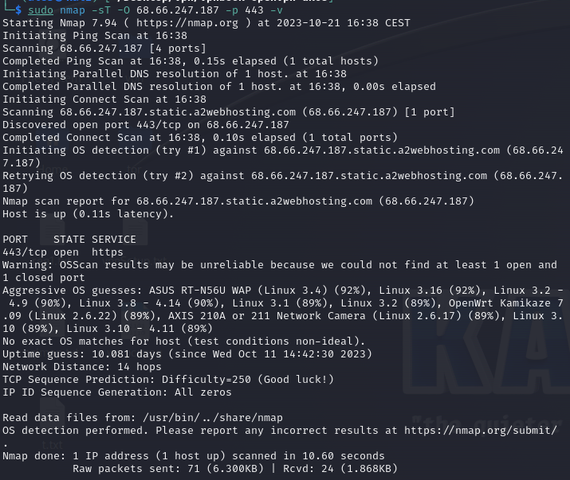

1. What web server software is it running?

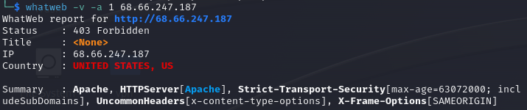

1. Is it running a CMS (Wordpress, Drupal, etc?)

Using two different approaches to scan for CMS I didn’t get the results however, after figuring out who hosts the website, I could say with the high confidence, that the CMS for a website was WordPress, since the hosting provider claimed that they provid best WordPress hosting services:

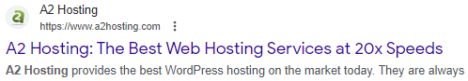

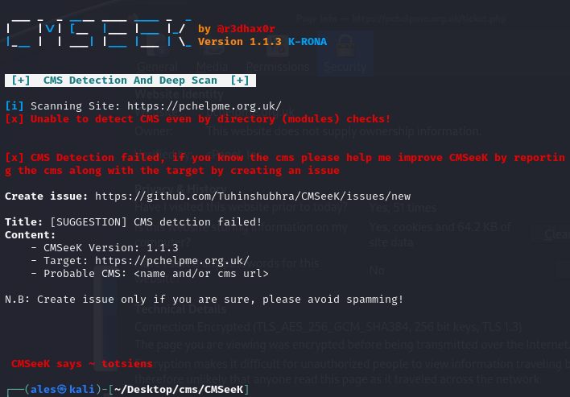

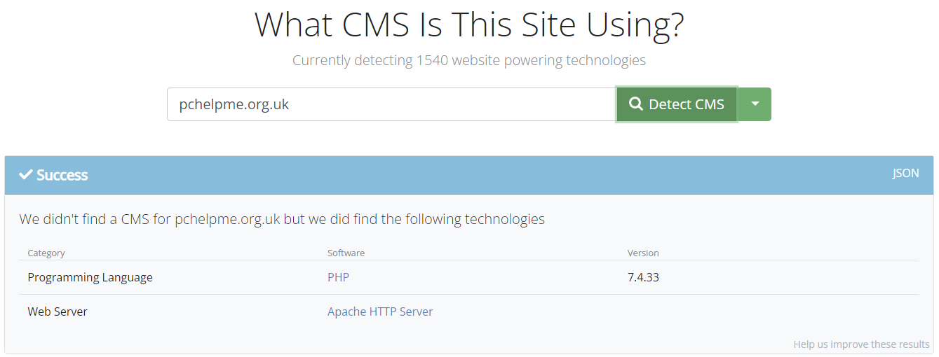

1. What protection does it have (CDN, Proxy, Firewall?)

It Uses Imunify as a firewall:  
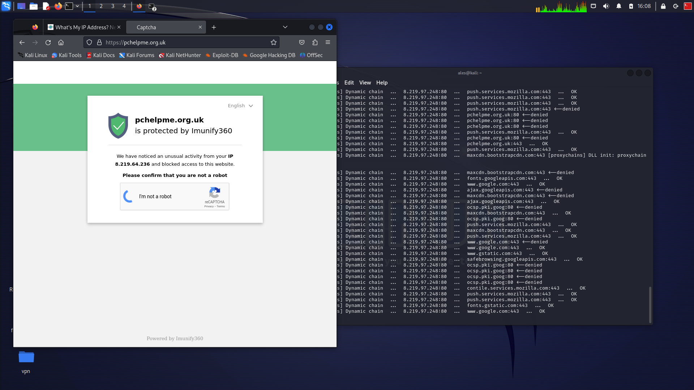

And Avast Certificate:  
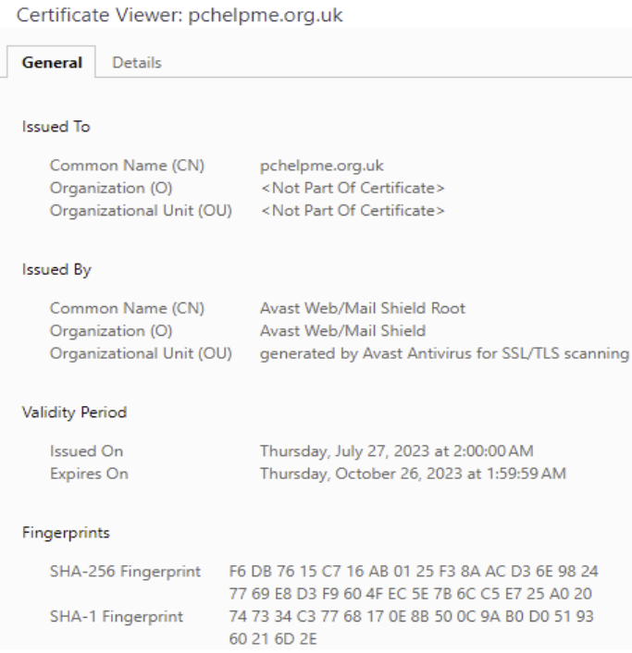

1. Where is it hosted?

a2webhosting.com

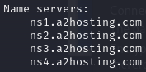

1. Does it have any open ports? Which did you expect to be open?

Nessus found only two open ports, which were /80 and /443, However I didn’t expect, that nmap would find more of them:

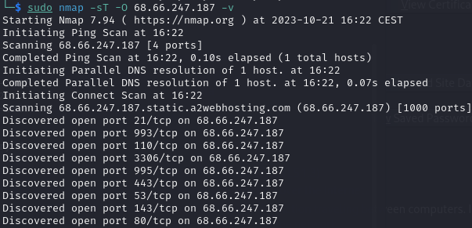

1. Does the site have any known vulnerabilities?

Nessus discovered multiple medium severe vulnerabilities, including high and critical one.

1. What versions of software is it using? Are these patched so that they are up to date?

PHP Version 7.4.33:  
