from flask import Flask

from flask_restful import Api, Resource, reqparse

app = Flask(__name__)

api = Api(app)

users = [

{

"name": "James",

"age": 30,

"occupation": "Network Engineer"

},

{

"name": "Ann",

"age": 32,

"occupation": "Doctor"

},

{

"name": "Jason",

"age": 22,

"occupation": "Web Developer"

}

]

class User(Resource):

def get(self, name):

for user in users:

if(name == user["name"]):

return user, 200

return "User not found", 404

def post(self, name):

parser = reqparse.RequestParser()

parser.add_argument("age")

parser.add_argument("occupation")

args = parser.parse_args()

for user in users:

if(name == user["name"]):

return "User with name {} already exists".format(name), 400

user = {

"name": name,

"age": args["age"],

"occupation": args["occupation"]

}

users.append(user)

return user, 201

def put(self, name):

parser = reqparse.RequestParser()

parser.add_argument("age")

parser.add_argument("occupation")

args = parser.parse_args()

for user in users:

if(name == user["name"]):

user["age"] = args["age"]

user["occupation"] = args["occupation"]

return user, 200

user = {

"name": name,

"age": args["age"],

"occupation": args["occupation"]

}

users.append(user)

return user, 201

def delete(self, name):

global users

users = [user for user in users if user["name"] != name]

return "{} is deleted.".format(name), 200

api.add_resource(User, "/user/<string:name>")

app.run(debug=True)

**Question 1**

Run the API.py code. Take a screenshot of the terminal output. What command did you use to compile and run the code?

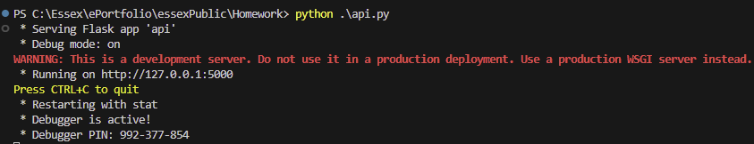

To compile the code I used casual python keyword following by the name of a file.

**Question 2**

Run the following command at the terminal prompt: w3m http://127.0.0.1:5000/user/Ann

What happens when this command is run, and why?

I got this json output in web browser:

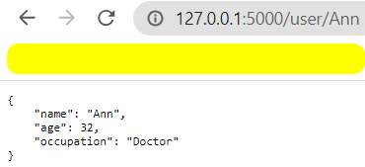

This happened because we made a call to the local host server using Flask library. The call to the link /user/Ann sent a GET request to that user and returned their information.

**Question 3**

Run the following command at the terminal prompt: w3m http://127.0.0.1:5000/user/Adam

What happens when this command is run, and why?

We got this output:

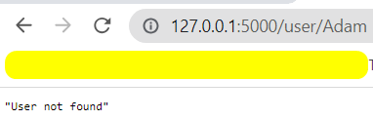

When calling the request on a user that doesn’t exists, we get output message as written in a code itself. It means that the user with the name Adam is not present at the source.

**Question 4**

What capability is achieved by the flask library?

With the use of Flask library, we are able to start the application on a server. Flask provides backend capabilities to support CRUD operations on a server, that communicates with the databases or with the localhost data.