1. **Review each of the code errors returned.**



After correcting the above error, multiple new errors showed up:

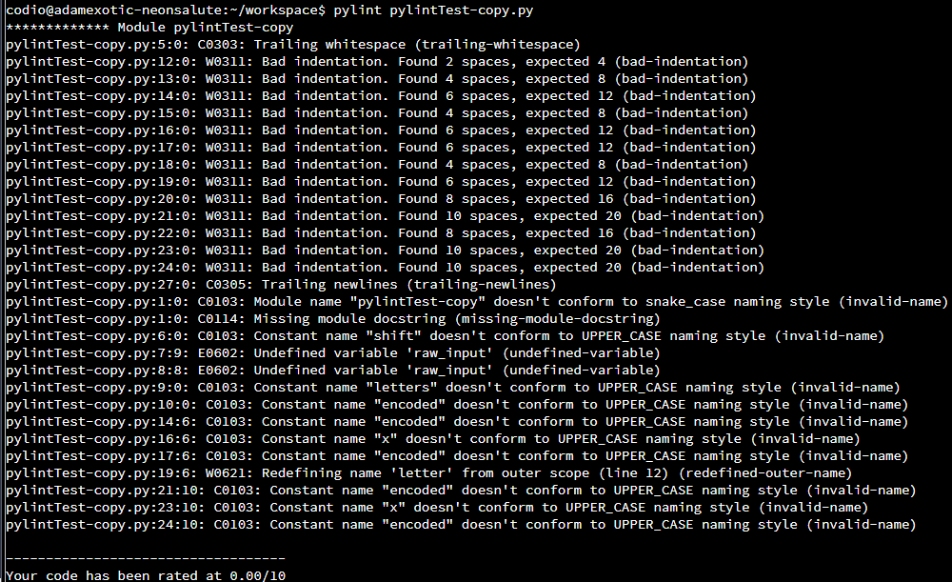

1. **Can you correct each of the errors identified by *pylint*?**

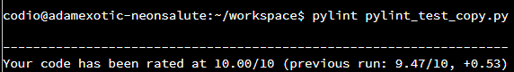  
  
Final Code:

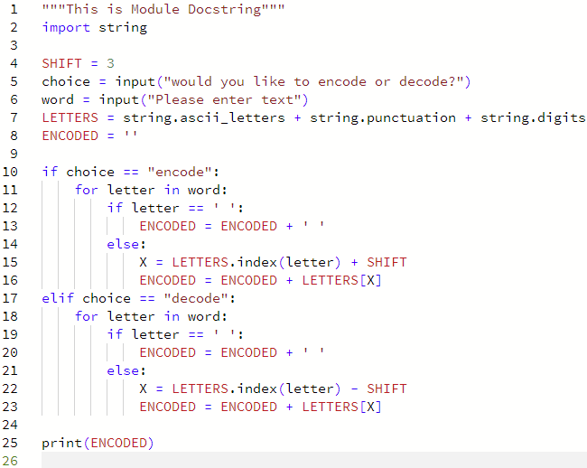

**Appendix:**

**Original code:**