**Questions:**

1. What happens when the code is run?

The code returns the following error:

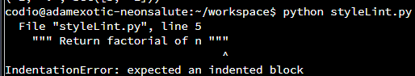

1. Can you modify this code for a more favourable outcome?

Amending the code was straightforward and easy, since the indentation errors are common in Python.

1. What amendments have you made to the code?

I had to indent all lines from 5th line upward. Additionally, return statements had to be indented once more after initial indentation.

**Appendix:**

Original Code:

