**Question:**Refer to the Mertz (2019) resource. Use some Python code which you have developed in the past (Code in appendix) and apply at least 3 of the strategies presented at the source to improve its quality

**Strategy 1** Directory structure:

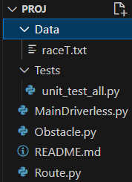

**Strategy 2** Using PyLinters.

Initial score

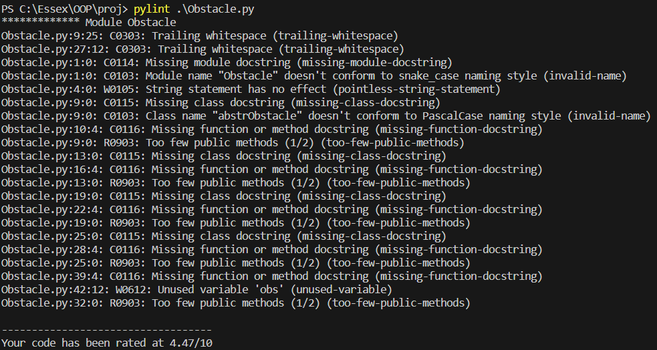

After the recommendations made by Pylinters:

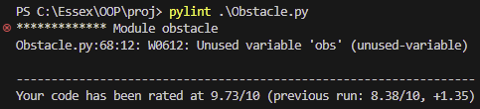

**Strategy 3** Proper Documentation:

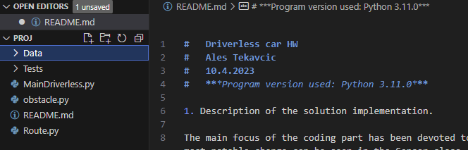

**Appendix** (Initial Code)

import random

from abc import ABC

"""

The first four classes are called, when generate method of the Obstacle class is invoked.

This first three classes (omitting the first class) depict the types of the obstacles.

"""

class abstrObstacle(ABC):

    def type(self):

        pass

class Cyclist(ABC):

    def __init__(self):

        pass

    def type(self):

        return type(self).__name__

class Pedestrian(ABC):

    def __init__(self):

        pass

    def type(self):

        return type(self).__name__

class Vehicle(ABC):

    def __init__(self):

        pass

    def type(self):

        return type(self).__name__

class Obstacle():

    """

    Class that generates random Obstacle objects in random sequence.

    """

    def __init__(self):

        pass

    def generate(self):

        number_of_obstacles = random.randint(0, 2)

        for obs in range(number_of_obstacles):

            obstacle_type = random.randint(1, 3)

            if obstacle_type == 1:

                obstacle = Pedestrian()

                yield obstacle

            elif obstacle_type == 2:

                obstacle = Cyclist()

                yield obstacle

            elif obstacle_type == 3:

                obstacle = Vehicle()

                yield obstacle

            else:

                pass

#o = Obstacle()

#for i in o.generate():

#    print(i.type())