**Progetto #3: SMART HOUSE**

**Motivazione**

Population aging is currently having a significant impact on health care systems. Improvements in medical care are resulting in increased survival into old age, thus cognitive impairments and problems associated with aging will increase. It has been estimated that one billion people will be over the age of 60 by the year 2025. As the burden of healthcare in society increases, the need for finding more effective ways of providing care and support to the disabled and elderly at home becomes more predominant. Automatic health monitoring systems are considered a key technology in this challenge, because they can serve a dual role: (1) to increase the safety and the sense of security of people living on their own; and (2) to allow elderly patients to be self-reliant longer, fostering their autonomy. To this purpose, a smart controller called MOTHER has been introduced to collect data coming from sensors placed in several locations of the smart house.

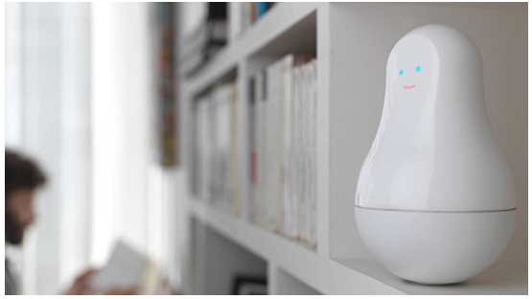

Figure 1: MOTHER

**Sensor Data**

Five different sensor have been adopted to have a complete monitoring system that is able to communicate with a central unit MOTHER. Several activities have been monitored: *Leaving, Toileting, Showering, Sleeping, Breakfast, Dinner, Drink, Idle/Unlabeled, Lunch, Snack, Spare time/TV, Grooming.* Sensor data streams were divided in time slices of constant length. For these experiments, sensor data were segmented in intervals of length Delta_t = 60 seconds. At each time stamp, the following data are available:

Start time End time Activity

-------------------- -------------------- --------

2012-11-11 21:14:00 2012-11-12 00:22:59 Spare_Time/TV

2012-11-12 00:24:00 2012-11-12 00:43:59 Spare_Time/TV

2012-11-12 00:48:00 2012-11-12 00:49:59 Grooming

Start time End time Location Type Place

-------------------- -------------------- -------- -------- -----

2012-11-11 21:14:21 2012-11-12 00:21:49 Seat Pressure Living

2012-11-12 00:22:57 2012-11-12 00:22:59 Door PIR Living

2012-11-12 00:23:14 2012-11-12 00:23:17 Door PIR Kitchen

**Obiettivi del progetto:**

1. Definizione della struttura dati

1. Misurazioni derivanti da sensori, con relativi time stamp
2. Attività svolte

2. Modello HMM

1. Definizione della struttura HMM per inferire l’attività date le osservazioni derivanti dai sensori
2. Stima dei parametri

3. Previsione dell’attività svolta

1. Inferire l’attività dell’utente tramite i dati rilevati dai sensori

4. Analisi dei dati

1. Stimare le capacità predittive del modello rispetto alla ground truth

**Software**

Software utilizzabili:

1. Python:
   1. <http://ghmm.org/>
2. Matlab:
   1. <http://it.mathworks.com/help/stats/hidden-markov-models-hmm.html>
   2. <https://github.com/probml/pmtk3>
3. Java:
   1. <http://mallet.cs.umass.edu/index.php>
4. R: <https://cran.r-project.org/web/packages/HiddenMarkov/index.html>