COP 4610

Homework Assignment 1

Alejandro Vidal

PID 5913959

FIU

Fall 2017

1-) Make File working properly compiling and cleaning the directory

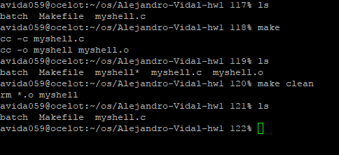

2-) Interactive Mode Running:

Single commands running in the foreground.

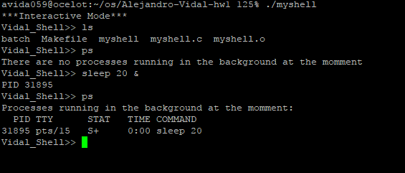Show the result of running command ‘ps’ with and without background processes running.

3-) Running simultaneously foreground processes and background processes.

Prints PID of the background processes and show in with ‘ps’ command.

Properly clean the array of background processes after each process ends to avoid showing defunct processes.

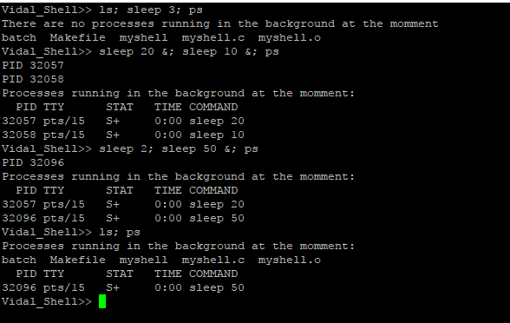

4-) Stop, Resume and Kill commands working properly. Showing the status of the process after each command.

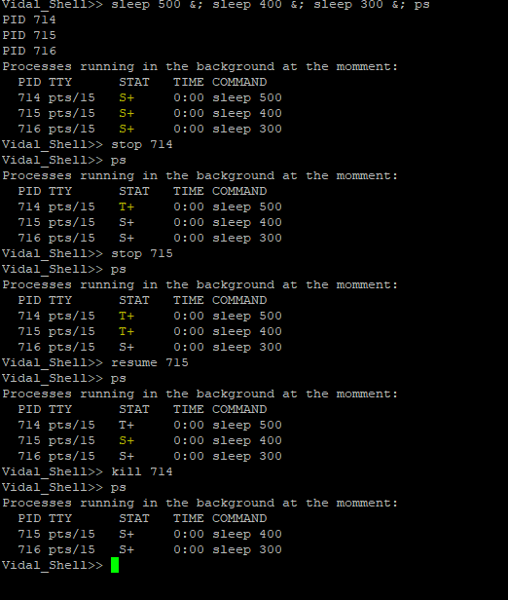

5-) Batch file Mode. Reading and printing the lines of a batch file and executing all the commands until the end of the file.

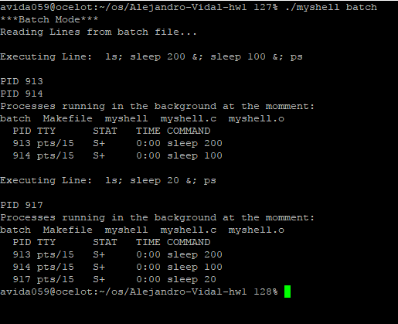

6-) Waiting for all process to finish after exit command

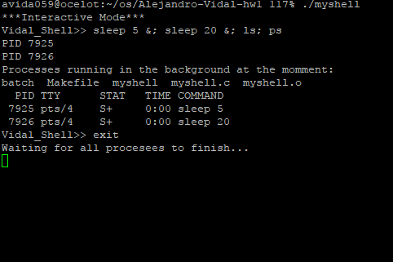

Using quit command to exit after the processes finish:

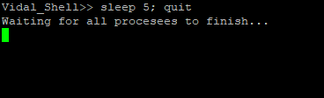

7-) Error validation.

-Trying to run batch mode with more than 2 parameter

-Running command with excess of blank spaces

- Ignoring blank line commands

- Validating wrong command and continue whit the execution

- Trying to run batch mode with an incorrect batch file name.

