COP 4610

Homework Assignment 2

Alejandro Vidal

PID 5913959

FIU

Fall 2017

Importance of this assignment:

With the completion of this assignment I have learnt a lot of interesting thing and how to implementing in Linux OS.

1) Learnt how to download and install a virtual Machine using Virtual Box

2) Learnt how to set up a new Linux OS in a Virtual Machine

3) Learnt how to download, configure, compile and install a new kernel.

4) Learnt how to modify, compile, install, and uninstall a Loadable Kernel Module (LKM).

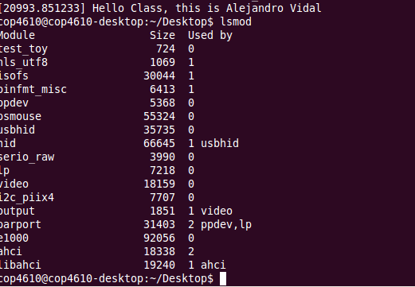

*Module Loaded*

*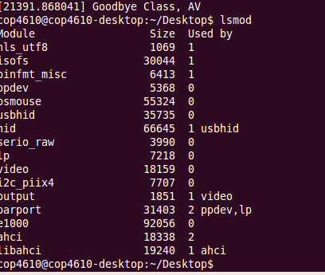*

*Unloaded Module*

*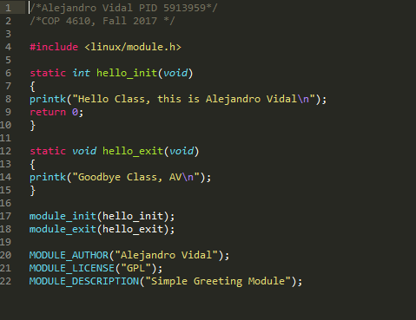*

*Module Code*

5) Learnt how to create and install a new system call the kernel

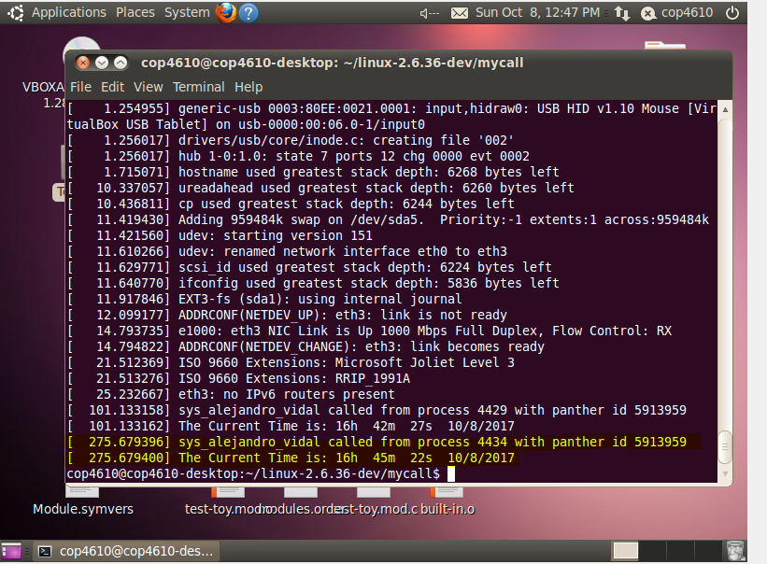

*New system call displaying the pid, panther id and the formatted current time*

*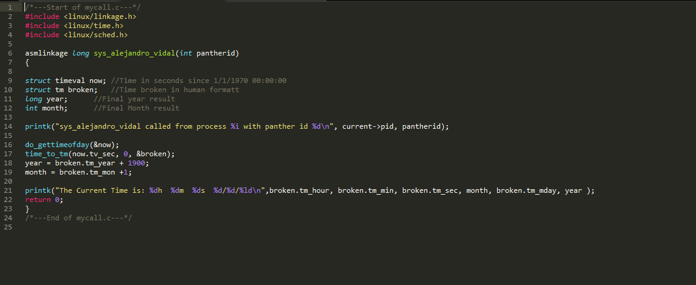*

*New system call code*

*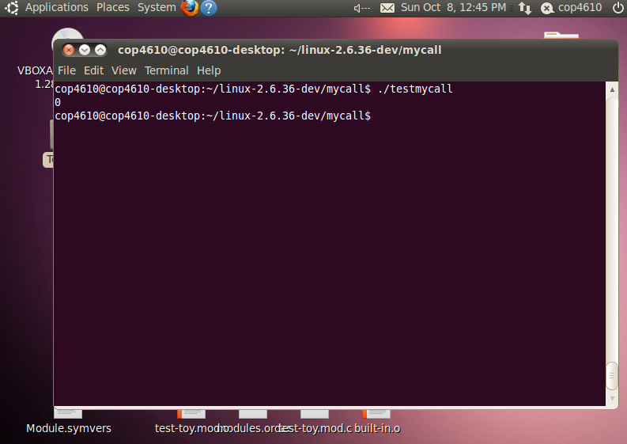*

*Output at user level after calling the program to test the system call*

*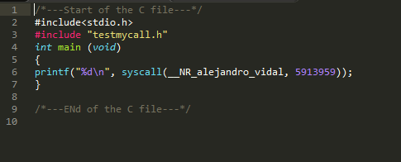*

*Code used to test the system call*