ApexOS - Current System Understanding & Operating Guide
Actual implementation through Build 15 | Initial operating guide draft

1. Purpose and Current State
This guide explains the tangible ApexOS system that exists today. It is written for Andrew and for a capable person coming in cold: enough to understand the system, operate it, explain it, and start sensible troubleshooting without treating this as a technical specification.
The architecture and doctrine documents remain the authority for what ApexOS is intended to become. This guide has a narrower job: describe what was actually built, validated, and committed through Build 15.
Operating truth: ChatGPT is the conversation surface. ApexOS is the local runtime behind it. The product is the executive conversation, while the pipeline, traces, and storage operate behind the scenes.

Current State at a Glance
Status | What it means today
Working and validated | A Personal ChatGPT connector reaches the local MCP server through the OpenAI secure tunnel; the Runtime Engine completes a live OpenAI API call, applies governance checks, retrieves a trace, and captures the interaction in Supabase.
Working but not yet meaningful | The Build 15 test retrieved zero memory items and no situation context. Connectivity is proven; high-fidelity executive intelligence is not yet proven.
Intent, not an operating claim | The broader doctrine, learning loops, and future intelligence capabilities remain the direction of ApexOS. They should not be mistaken for fully exercised behavior in the current build.

This guide does not do: It does not introduce Build 16, change code, redesign architecture, or convert future concepts into current operational promises.

2. What We Actually Built
ApexOS is now a working local executive-runtime prototype. It is not an always-on public website, and it is not a custom chat application that replaces ChatGPT. When the local services are running, your Personal ChatGPT connector can send an executive request into the ApexOS runtime and receive the result back in the same conversation.

The deliverable
Component | Practical role
Local repository | The source code, runtime package, configuration templates, and build history live in the ApexOS GitHub-backed project. The runtime lives under the repository's runtime folder.
ApexOS MCP server | A local service that exposes ApexOS to ChatGPT through the Model Context Protocol. It listens only on 127.0.0.1:3021 in the present configuration.
Runtime Engine | The Node.js / TypeScript orchestration layer that assembles available context, runs governance checks, calls the LLM provider, records the interaction, and produces a trace.
Personal ChatGPT connector | The executive-facing entry point. It connects one relevant Personal ChatGPT conversation to ApexOS; it is not intended to affect unrelated conversations across your account.
OpenAI secure tunnel client | A client-side connector that makes the local MCP service available to the Personal ChatGPT connector while it is running. It replaced the need for a separately managed public tunnel such as Cloudflare.
Supabase and OpenAI Platform | Supabase is the system of record for stored data and captured conversations. The OpenAI Platform API performs the live LLM call and has separate billing from a ChatGPT subscription.

Where it lives: The MCP server and Runtime Engine run on your Windows computer. ChatGPT, the OpenAI Platform API, the secure tunnel service, and Supabase require internet access. Secrets are local configuration, not source code.

What it can and cannot do today
- It can carry a real request from ChatGPT through the local runtime, call the live OpenAI API, and save the interaction.
- It can expose runtime observability through trace retrieval - the operational foundation of the Executive Glass Box.
- It cannot yet be assumed to retrieve the right executive memory, assemble rich situation context, or produce materially differentiated advice on every request.

3. How We Got Here - Builds 1 Through 15
The project deliberately moved from governing documents into small executable slices. The following timeline is a high-level record of what each build contributed to the system now in front of you.

Builds 1-8: Establishing the implementation base
Build | What it added | Why it matters now
1 | Repository and development workflow | Created the controlled implementation home: source control, documentation structure, and the process for building without doctrine drift.
2 | Knowledge foundation | Established the knowledge layer that future retrieval and reasoning depend on.
3 | Memory foundation | Translated the memory architecture into an initial implementation direction for carrying executive history forward.
4 | Context and retrieval | Created the basis for framing a request and finding relevant stored information.
5 | Inference | Added the reasoning layer for interpreting evidence rather than treating stored facts as conclusions.
6 | Recommendation | Added the structure for turning interpretation into actionable options and recommendations.
7 | Outcomes | Added the feedback and results layer needed to test whether decisions actually work.
8 | Supabase schema | Established Supabase as the system of record and created the data foundation that later runtime work could use.

Important context: These early builds were the bridge from completed doctrine to buildable system components. They did not mean that every future intelligence behavior was already operating in production.

Builds 9-15: Making ApexOS executable and reachable
Build | What it added | What changed in the real system
9 | Executive loop validation | Validated the first executable executive loop against the intended flow.
10 | Executive UI | Created an initial web interface and operating surface. It is not the primary executive experience today.
10A | Executive Glass Box | Added runtime observability and a way to inspect the pipeline rather than treat it as a black box.
11 | Executive conversation interface | Defined the conversation experience and the conversation tables later applied in Supabase.
12 | Executive experience decision | Confirmed that ChatGPT, rather than a custom web chat, should be the primary executive interface.
13 | Runtime Engine foundation | Built the TypeScript / Node runtime: a nine-stage pipeline, provider abstraction, HTTP API, CLI testing, Supabase connection, and observability.
14 | MCP server | Built the local ChatGPT-facing bridge. Both stdio and HTTP startup checks succeeded before connectivity work began.
15 | Connectivity and validation | Connected Personal ChatGPT to the local MCP server through the OpenAI secure tunnel; validated the live pipeline, OpenAI API, Supabase, governance checks, trace retrieval, and interaction capture.

Decisions that shaped the current form
- ChatGPT is the front end. ApexOS remains the controlled runtime and system of record behind it.
- The initial connector is local-only and single-user. OAuth / dynamic client registration was explored, then deliberately removed from the running configuration.
- A separately managed Cloudflare URL was not adopted. The OpenAI tunnel client is the bridge used by this system.
- Build 15 is committed. Supabase CLI migration-history reconciliation remains an administrative follow-up, not evidence that the working database setup failed.

4. Build Tools, Storage, and Runtime Boundaries
This view separates the build process from the live system. It answers a practical question that the request-flow diagram does not: where the files and data live, and which tools are involved at each point.
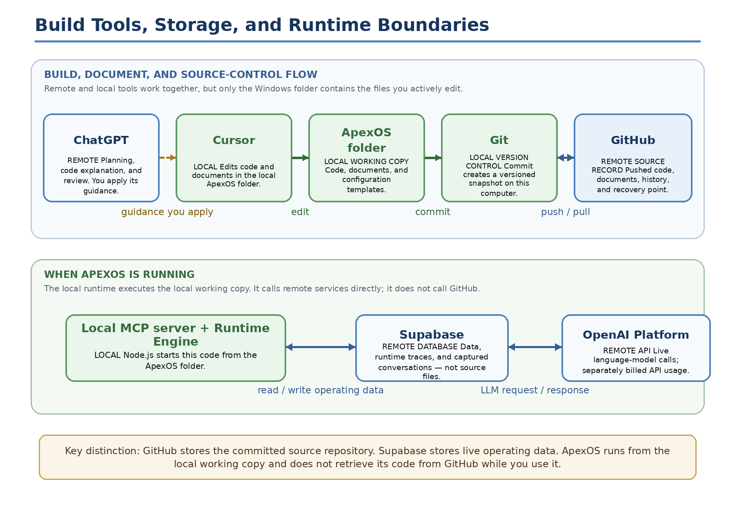
Figure 1. Build tools, source storage, and operating-data boundaries.
Where your files actually live: Your active ApexOS working copy is local on your Windows computer (currently under C:\Users\Andre\Desktop\ApexOS). Cursor edits that local copy. A git commit records a local version; git push sends that committed version to GitHub, where it becomes the remote source record and recovery history.
What Supabase does not do: Supabase does not pull or run your code from GitHub. It is the remote database for live ApexOS records, including stored data, traces, and captured conversations. When you start npm run mcp:http, Node.js runs the code from your local ApexOS folder and calls Supabase and the OpenAI API directly.
Important boundary: ChatGPT is used to plan, explain, and review the build; it does not silently edit the repository. Cursor or another local editor makes the changes. The operational ChatGPT connector is shown in the next system-architecture diagram.

5. Current System Architecture
This is the real current-state system. It intentionally does not recreate the attached conceptual reasoning and learning diagrams, because those diagrams describe the intended architecture rather than the operating deployment.
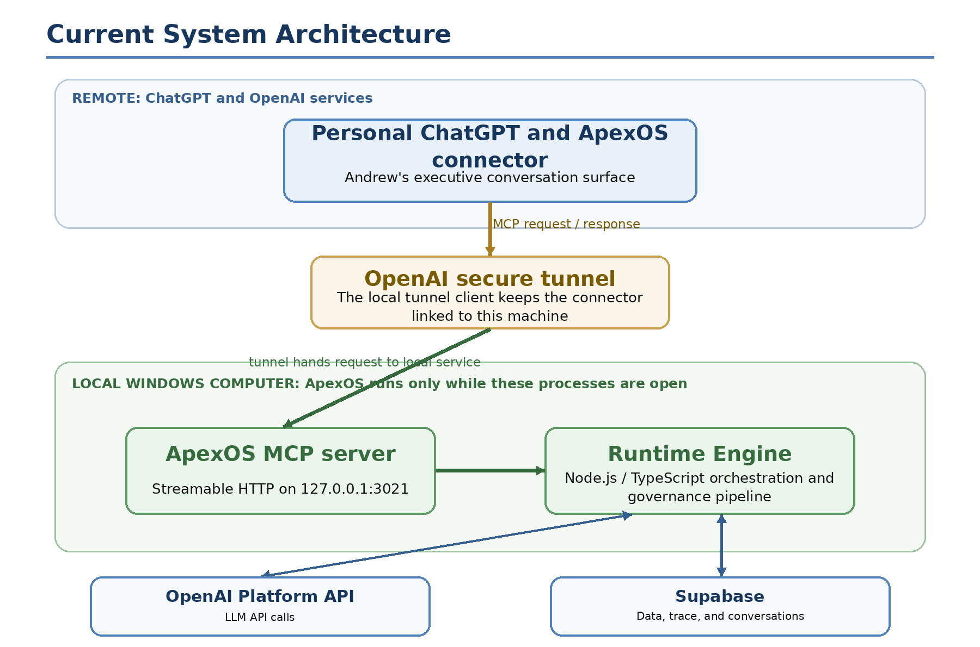
Figure 2. Actual implemented system through Build 15.
The operating boundary: The system has two local processes: the MCP server and the tunnel client. If either stops, ChatGPT cannot complete a request through ApexOS. Supabase and OpenAI are remote services; they do not run on your laptop.
Why the tunnel exists: ChatGPT cannot directly call a service bound only to your computer's loopback address. The tunnel client creates the controlled link from the Personal ChatGPT connector to that local service while avoiding a separately managed public reverse-proxy setup.

6. What Happens When You Submit a Request
ApexOS is designed to feel like a normal conversation. Under that conversation, the runtime has a defined division of responsibility: fixed TypeScript / Node.js code controls the sequence and recordkeeping, while the LLM makes language-based judgments inside the context package it receives.
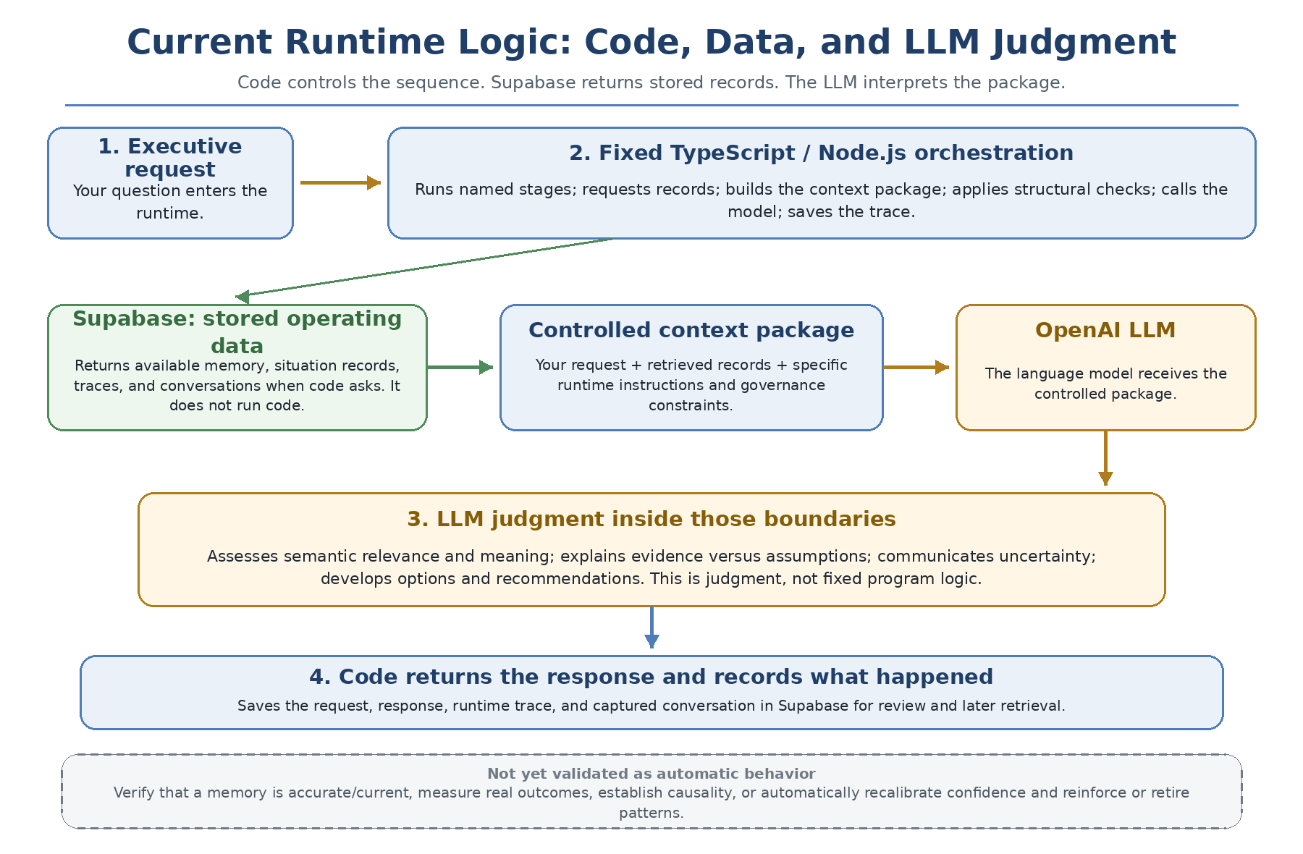
Figure 3. Current responsibility split: code controls the process, the LLM interprets the package, and outcome-driven learning is not yet validated.

How the runtime knows what to do
- The fixed TypeScript / Node.js runtime controls the sequence: it runs named stages, asks Supabase for available records, builds the controlled context package, applies structural checks, calls OpenAI, and saves the response, trace, and conversation.
- The LLM supplies the language judgment: it considers the request and package to assess semantic relevance and meaning, distinguish evidence from assumptions, communicate uncertainty, and form options or recommendations.
- The doctrine documents guide live behavior only where their rules are deliberately encoded in runtime instructions, prompts, checks, or retrieved material. The LLM does not automatically know every doctrine document on every request.

7. Authentication, Accounts, and Security
There are several separate trust relationships in the current system. They should not be conflated just because they are all part of one request path.
Connection | What authenticates it | Current operating choice
Andrew to ChatGPT connector | Your Personal ChatGPT account. | Use the Personal account that owns the connector. A separate Business workspace is not assumed to have the same connector available.
Tunnel client to OpenAI | The configured apexos tunnel profile and OpenAI Platform authorization. | The local client maintains the secure bridge while it is running.
Runtime to OpenAI API | An OpenAI Platform API key in local environment configuration. | The runtime uses it for the live LLM request. Platform usage is separately billed.
Runtime to Supabase | The Supabase project URL and credentials in local environment configuration. | The runtime reads and writes the system record, traces, and captured conversations.
ChatGPT to local MCP server | No separate MCP OAuth or login in the initial configuration. | Intentional: localhost-only, loopback-enforced, single-user initial build. This must be reconsidered before remote or multi-user use.

Important Build 15 decision
OAuth and Dynamic Client Registration were implemented during troubleshooting, then removed after the decision to keep the first version localhost-only and single-user. The server now binds to loopback and rejects non-loopback access. That is a deliberate simplification for this stage, not a general security design for a broader deployment.

API Keys and Credentials Configuration
ApexOS uses two separate OpenAI keys because it performs two different OpenAI functions. Generate them separately in the OpenAI Platform with permissions appropriate to each role. Dashboard names are only labels; the environment variable holding the secret determines its ApexOS role.
Environment variable | Used by | Purpose | Generated in | Stored in
OPENAI_API_KEY | ApexOS Runtime Engine | Makes live model calls | OpenAI Platform | Repository-root .env.local
CONTROL_PLANE_API_KEY | OpenAI tunnel client | Links the Personal ChatGPT connector to the local MCP server | OpenAI Platform | Repository-root .env.local; profile stores reference only
Storage and startup: Both full secret values are stored locally in the repository-root .env.local file. The launcher loads them when ApexOS starts; the tunnel profile stores only env:CONTROL_PLANE_API_KEY, not the actual key. .env.local must remain excluded from GitHub and must never be committed.
Key lifecycle: The OpenAI dashboard generally does not show a full secret again after creation. If a key is lost, generate a replacement. Creating a new key does not invalidate the current one; do not revoke the prior key until the new configuration has been tested successfully.
Supabase is separate: Supabase credentials may also be stored in .env.local for database and API access, but they are separate from the OpenAI keys above.

8. Use ApexOS Today
For normal use, start two local processes, then use the Personal ChatGPT connector. The commands below are intentionally limited to basic operation. They assume the original Windows checkout location has not changed.

Before you start
- Use the Windows machine that contains the ApexOS repository and runtime folder.
- Use your Personal ChatGPT account, not an unrelated account or workspace.
- Confirm internet access and avoid a VPN if Supabase DNS has previously failed.
- Confirm that the OpenAI Platform account has available API billing / credits.

1. Start the local MCP server
Open a terminal, move into the runtime folder, and start the HTTP MCP server. This terminal must remain open while you use ApexOS.
cd C:\Users\Andre\Desktop\ApexOS\runtime
npm run mcp:http
What this does: starts the local ApexOS MCP server and Runtime Engine path on 127.0.0.1:3021. A healthy server exposes a local health endpoint.

2. Start the secure tunnel
Open a second terminal and run the existing apexos tunnel profile. Keep this terminal open too.
tunnel-client run --profile apexos
Optional first check when troubleshooting: tunnel-client doctor --profile apexos. The tunnel must be running when the connector is discovered and whenever ChatGPT makes an MCP call.

3. Use the connector in ChatGPT
- Open Personal ChatGPT and begin or continue an executive/business conversation where ApexOS is relevant.
- Confirm that the ApexOS connector is available in the conversation's connector or tools area.
- Ask the question normally. The intended experience is a natural executive conversation, not manual artifact creation or a separate command interface.
4. Stop it correctly: When finished, press Ctrl+C in the tunnel terminal, then Ctrl+C in the MCP-server terminal. You do not need to stop ChatGPT, Supabase, or the OpenAI Platform - those are remote services. Closing a terminal without a clean stop is usually harmless for this local development setup, but Ctrl+C is the clean operating habit.

9. Interfaces and Verification

Interfaces in plain language
Interface | Purpose | What to know
MCP endpoint | The machine-to-machine entry point for ChatGPT. | It is local streamable HTTP, reached through the connector and tunnel. It is not intended to be a human web page.
Health endpoint | A simple local server check. | Open http://127.0.0.1:3021/health. A JSON response with status ok confirms the server is running.
Runtime Engine | The execution coordinator. | Fixed TypeScript / Node.js code coordinates the process: it retrieves available records, builds the package, calls the LLM, and records the interaction. The LLM supplies semantic judgment.
OpenAI API | The live language-model call. | It requires funded Platform access and a valid local API key. It is distinct from your ChatGPT subscription.
Supabase | The persistent system of record. | It is reached over the internet. The Build 11 conversation tables were applied through the Supabase SQL Editor.

Normal but confusing: The MCP endpoint may return an HTTP 400 if checked like an ordinary browser page. In Build 15, that meant the server was reachable but expected an MCP protocol request. The health endpoint is the basic human-friendly server check.

Layered verification checklist
- MCP server terminal remains open and reports that it is listening.
- http://127.0.0.1:3021/health returns an ok status.
- tunnel-client doctor --profile apexos passes its configuration / target checks when you need to diagnose startup.
- tunnel-client run --profile apexos remains running and reports readiness.
- Personal ChatGPT shows the ApexOS connector as available. A real executive request then completes without a connector, billing, or Supabase error and creates a runtime trace and saved conversation. Build 15 confirmed both; a simple daily trace-view shortcut has not yet been standardized.

10. Troubleshooting Lessons From Build 15
Start at the lowest layer that could explain the symptom. A healthy local server does not by itself prove that the connector, API call, database, trace, and capture all worked.
Symptom | Likely cause | First check | Previously used resolution
ChatGPT cannot find the connector or app | Tunnel is not running, connector discovery happened at the wrong time, or the wrong account is open. | Keep tunnel-client run open; verify you are in Personal ChatGPT. | Start the tunnel first, then revisit the connector configuration / discovery flow.
Health endpoint does not respond | MCP server is not running, started from the wrong folder, or the port is unavailable. | Run npm run mcp:http from the runtime folder and recheck 127.0.0.1:3021/health. | Restart the server from the correct runtime folder.
Live request reports quota or billing failure | OpenAI Platform API billing, credits, or API-key configuration is unavailable. | Check Platform billing and the local .env.local configuration. | Fund the Personal Platform account and use the correct local API key.
Supabase cannot be reached or DNS fails | VPN or network routing interferes with the Supabase hostname. | Turn off VPN and retry basic connectivity. | VPN-off DNS resolution restored Supabase access during Build 15.
Trace or conversation save fails | Required Supabase tables or credentials are missing. | Check Supabase connection values and the conversation tables. | Build 11 conversation tables were applied in the Supabase SQL Editor.

Do not overreact to these signals
- An HTTP 400 at /mcp can mean the MCP service is reachable but expects protocol traffic, not that the server is down.
- The Supabase CLI transport problem affected migration-history reconciliation. It did not invalidate the working SQL Editor application or the tested runtime connection.
- A generic response can mean no useful memory or situation context was retrieved. That is different from a broken connector.

11. Current Limits and the Likely Next Step

What Build 15 proves
- The complete connection path works: Personal ChatGPT connector -> OpenAI secure tunnel -> local MCP server -> Runtime Engine -> OpenAI API and Supabase -> ChatGPT.
- The live runtime pipeline, governance checks, trace retrieval, and interaction capture all completed successfully.
- The initial local-only, single-user security posture works as configured.

What it does not yet prove
- That the right executive memory is retrieved at the right time.
- That situations are being captured and framed with sufficient context to make responses meaningfully specific.
- That recommendations, outcomes, confidence recalibration, and reinforcement are producing validated learning over repeated real-world use.
- That the current security posture is appropriate for anyone beyond the initial single-user, local setup.
Why the Build 15 answer was generic: The runtime was connected, but it retrieved zero memory items and no situation context. The system therefore had a working path but not enough grounded ApexOS data to differentiate its response from an ordinary general-purpose answer.

Likely Build 16 objective - not started here
The next practical objective is intelligence fidelity: use real executive situations and stored records to prove that ApexOS retrieves relevant memory and context, grounds its response in that material, and leaves an inspectable trace. The aim is not more connectivity work. The aim is to demonstrate a response that is materially better because ApexOS was involved.

Operating reminder
Keep this guide current whenever the connection path, authentication approach, start commands, or verified capabilities change. Revisit the Executive Glass Box after sufficient real-world usage to decide, through the established amendment process, whether it should be promoted further into the formal architecture documents.

